SVM = The final values used for the model were sigma = 0.01 and C = 4.
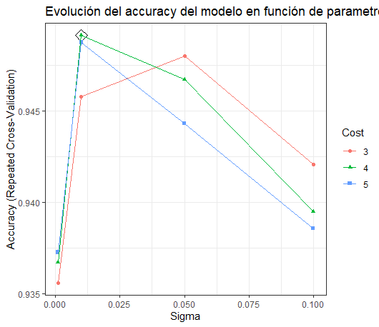
GBM = The final values used for the model were n.trees = 50, interaction.depth = 2, shrinkage = 0.1 and n.minobsinnode = 10.
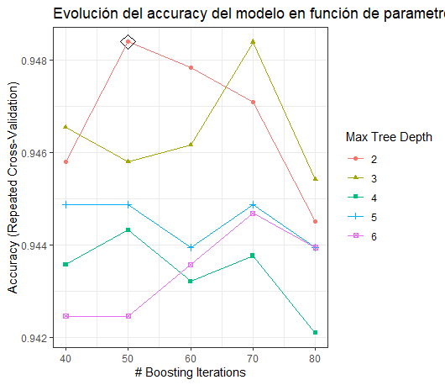
RF = The final values used for the model were mtry = 7, splitrule = gini and min.node.size = 1.
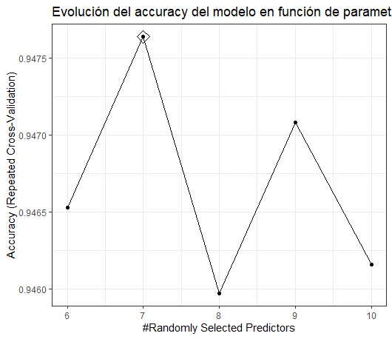
Modelo | Accuracy | Kappa
GBM | 0,947 | 0,872
RF | 0,947 | 0,872
SVM | 0,946 | 0,869
