*In situ* measurements of fuel retention by laser induced desorption spectroscopy in TEXTOR

This content has been downloaded from IOPscience. Please scroll down to see the full text.

View [the table of contents for this issue,](http://iopscience.iop.org/1402-4896/2011/T145) or go to the [journal homepage](http://iopscience.iop.org/1402-4896) for more

Download details:

IP Address: 61.129.42.30

This content was downloaded on 18/12/2016 at 05:13 Please note that [terms and conditions apply.](http://iopscience.iop.org/page/terms)

You may also be interested in:

[Development of laser-based techniques for in situ characterization of the first wall in ITER and](http://iopscience.iop.org/article/10.1088/0029-5515/53/9/093002)

[future fusion device](http://iopscience.iop.org/article/10.1088/0029-5515/53/9/093002)

[s](http://iopscience.iop.org/article/10.1088/0029-5515/53/9/093002)

V. Philipps, A. Malaquias, A. Hakola et al.



[Hom](http://iopscience.iop.org/)

[e](http://iopscience.iop.org/)

[Searc](http://iopscience.iop.org/search)

[h](http://iopscience.iop.org/search)

[Collection](http://iopscience.iop.org/collections)

[s](http://iopscience.iop.org/collections)

[Journal](http://iopscience.iop.org/journals)

[s](http://iopscience.iop.org/journals)

[Abou](http://iopscience.iop.org/page/aboutioppublishing)

[t](http://iopscience.iop.org/page/aboutioppublishing)

[Contact u](http://iopscience.iop.org/contact)

[s](http://iopscience.iop.org/contact)

[My IOPscienc](http://iopscience.iop.org/myiopscience)

[e](http://iopscience.iop.org/myiopscience)

[Feasibility study of laser-induced breakdown spectroscopy for in-situ characterization of deposited layers in fusion devices](http://iopscience.iop.org/article/10.1088/0031-8949/2011/T145/014028)

1. Huber, B Schweer, V Philipps et al.

[Laser techniques implementation for wall surface characterization and conditioning](http://iopscience.iop.org/article/10.1088/0031-8949/2009/T138/014008)

1. Schweer, G Beyene, S Brezinsek et al.

[Plasma–wall interaction, a key issue on the way to a steady state burning fusion device](http://iopscience.iop.org/article/10.1088/0031-8949/2006/T123/004)

V Philipps

[Characterization of hydrocarbon and mixed layers in TEXTOR by laser induced ablation spectroscopy](http://iopscience.iop.org/article/10.1088/0031-8949/2011/T145/014026)

N Gierse, S Brezinsek, T F Giesen et al.

[Plasma–wall interactions for ITER](http://iopscience.iop.org/article/10.1088/0741-3335/45/12A/002)

V Philipps, J Roth and A Loarte

[ERO code benchmarking of ITER first wall beryllium erosion/re-deposition against LIM predictions](http://iopscience.iop.org/article/10.1088/0031-8949/2011/T145/014008)

D Borodin, A Kirschner, S Carpentier-Chouchana et al.

[Progress in plasma-wall-interaction research - contributions from TEXTOR-94](http://iopscience.iop.org/article/10.1088/0741-3335/41/12B/304)

1. Samm and the TEXTOR-94 Team

[Observation of chemical erosion of carbon based wall materials in the TEXTOR tokamak](http://iopscience.iop.org/article/10.1088/0031-8949/1996/T64/011)

1. Philipps, A Pospieszczyk, M Erdweg et al.

IOP PUBLISHING PHYSICA SCRIPTA

Phys. Scr. **T145** (2011) 014027 (4pp) [doi:10.1088/0031-8949/2011/T145/014027](http://dx.doi.org/10.1088/0031-8949/2011/T145/014027)

***In situ* measurements of fuel retention by**

**laser induced desorption spectroscopy in**

**TEXTOR**

**M Zlobinski, V Philipps, B Schweer, A Huber, H Stoschus, S Brezinsek,**

**U Samm and the TEXTOR team**

Institute of Energy and Climate Research—Plasma Physics, Forschungszentrum Jülich GmbH,

Association EURATOM-FZJ, Partner in the Trilateral Euregio Cluster, Jülich, Germany

E-mail: m.zlobinski@fz-juelich.de and zlobinski@gmx.net

Received 29 May 2011

Accepted for publication 8 August 2011

Published 16 December 2011

Online at [stacks.iop.org/PhysScr/T145/014027](http://stacks.iop.org/PhysScr/T145/014027)

# Abstract

In future fusion devices such as ITER tritium retention due to tritium co-deposition in mixed material layers can be a serious safety problem. Laser induced desorption spectroscopy (LIDS) can measure the hydrogen content of hydrogenic carbon layers locally on plasma-facing components, while hydrogen is used as a tritium substitute. For several years, this method has been applied in the TEXTOR tokamak *in situ* during plasma operation to monitor the hydrogen content in space and time. This work shows the LIDS signal reproducibility and studies the effects of different plasma conditions, desorption distances from the plasma and different laser energies using a dedicated sample with constant hydrogen amount. Also the LIDS signal evaluation procedure is described in detail and the detection limits for different conditions in the TEXTOR tokamak are estimated.

PACS numbers: 52.70.Nc, 78.70.−g, 79.20.Ds

(Some figures may appear in colour only in the online journal)

|  |  |
| --- | --- |
| **1. Introduction**  Material erosion and deposition and the associated long-term fuel retention by co-deposition are critical issues for ITER and future fusion devices and requires both fuel retention control and mitigation techniques. As a prerequisite, a space-resolved diagnostic to monitor fuel retention is required. For ITER, laser-based methods, in combination with spectroscopy, are proposed [1] as possible *in situ* methods to characterize fuel retention and material deposition. This contribution reports on the experimental methods and results obtained in the TEXTOR tokamak to determine *in situ* the fuel retention in dedicated wall samples by laser induced desorption spectroscopy (LIDS). Thin amorphous hydrocarbon layers (a-C:H layers), which are grown by plasma–wall interactions in net-deposition areas have been studied by LIDS in TEXTOR earlier [2]. The main focus of the present work is on the assessment of the reproducibility of the LIDS method under changing plasma conditions, laser energies and | distances of desorption position from the last closed flux surface (LCFS).  **2. Sample**  For this study the a-C:H layers formed *in situ* in the scrape-off layer (SOL) of TEXTOR would not have been a good choice because of their inhomogeneous layer thickness and hydrogen content mainly in radial plasma direction. Moreover, they change due to their growth and also due to varying C impurities in the plasma. To overcome these problems and to obtain a high LIDS signal well above the plasma background light, a thick, homogeneous a-C:H layer was used. In order to exclude hydrogen desorption from the 2mm-thick tungsten substrate, it was heated in vacuum (*p* < 10−3 Pa) to 1000◦C and kept at this temperature for several hours. The further production was carried out by Oerlikon Balzers Coating Germany GmbH using plasma-assisted chemical vapour deposition. Firstly, a Cr-based interlayer of around 0.6µm |
| 0031-8949/11/014027+04$33.00 | © 2011 The Royal Swedish Academy of Sciences Printed in the UK |

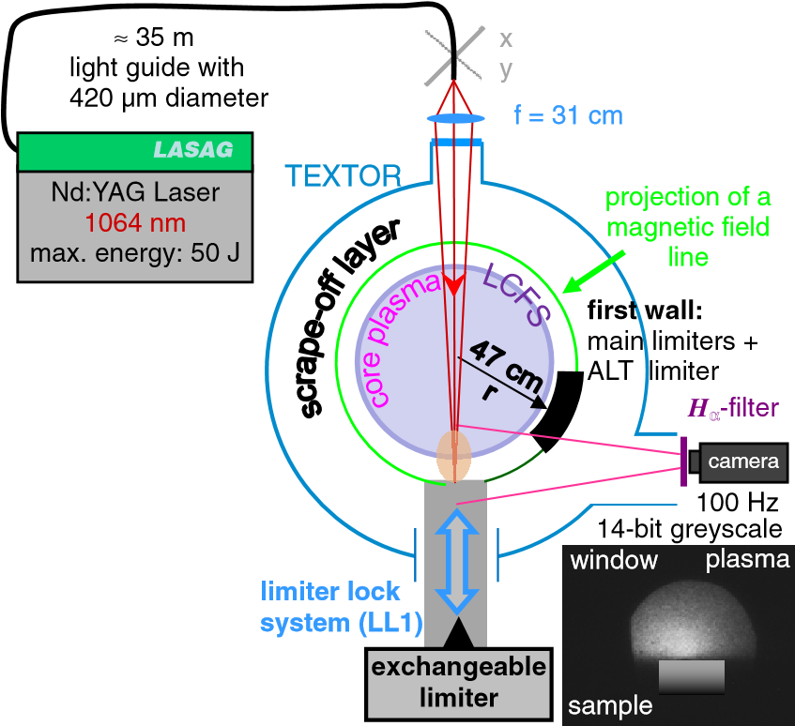

**Figure 1.** Experimental set-up of the *in situ* LIDS at TEXTOR.

was generated for better adhesion of the a-C:H layer. The a-C:H layer on top had a thickness of around 2.5µm. This two-layer system is commercially sold as the BALINIT R DLC layer. This sample was introduced into TEXTOR from the bottom in the material test facility. It was mounted horizontally on a stainless-steel holder and retracted by 2mm from its top surface. Thus, the sample surface was parallel to the magnetic field lines and exposed as little as possible to the plasma. This was done in order to prevent the sample from any change of hydrogen amount by layer build-up or hydrogen depletion due to plasma heating. The distance between the desorption position and the LCFS was changed between discharges as indicated in figure 2.

# Experimental set-up and laser heating

The experimental set-up (figure 1) was as presented in [3] in detail. The Nd:YAG laser at 1064nm wavelength was used with two different heating intensities, of which the higher energetic pulse with 22J initial laser energy is described in the previous reference. It resulted in a strong heating from about 150◦C base temperature to about 3100◦C maximal surface temperature within 3ms that led to a partial destruction and removal of the layer and interlayer. The lower energetic pulse with 15J initial laser energy heated the sample surface to around 2000◦C keeping the layer widely attached to the substrate but unavoidable roughening of the layer due to thermal stresses occurred anyway. By this pulse the laser heated the sample up to about 100µm depth to above 1000◦C. For details of the heating and temperature profile see [3]. In both cases, the desorbed area of circular shape (5.3mm2) showed a darkening of the initial grey to dark-grey colour, which is attributed to the hydrogen depletion and graphitization of the amorphous carbon structure. The low-energy laser pulse was used in the two marked discharges in figure 2. The laser was fired on the same sample position at 2.5, 3.5, 4.5 and 5.5s after the beginning of the discharge (see figure 3).

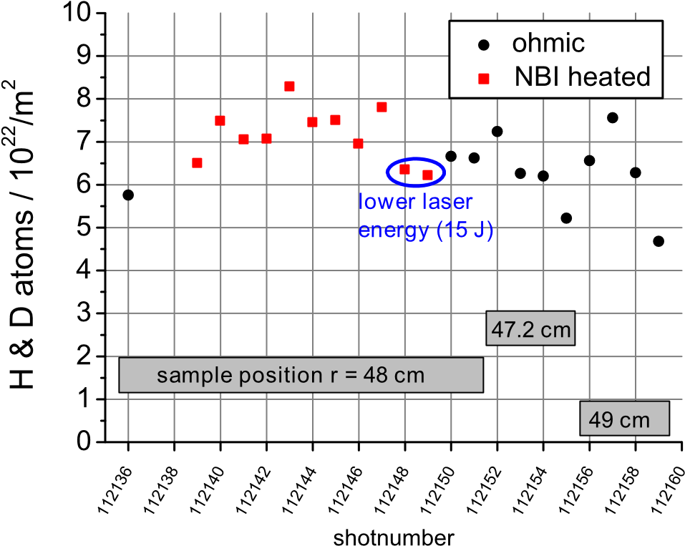

**Figure 2.** Reproducibility of the LIDS measurements in ohmic and NBI-heated plasmas, different desorption positions from the LCFS and different laser energies.

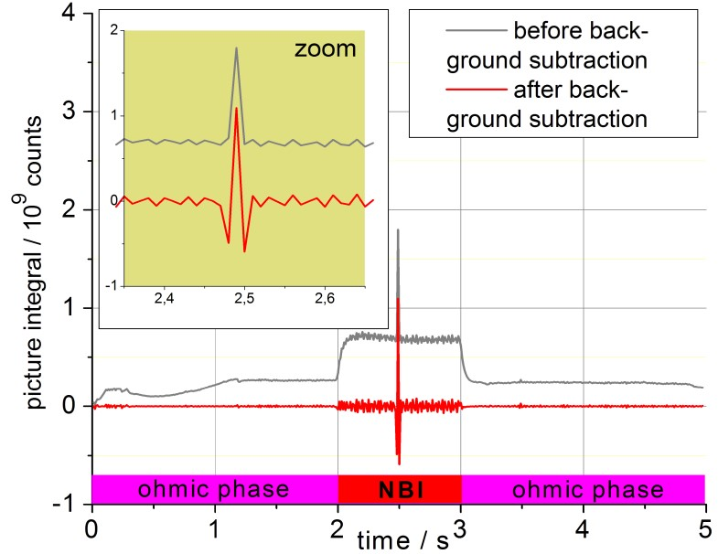

10

×

6

22

H/m

2

detection limit (in NBI):

10

×

3

21

H/m

2

detection limit (ohmic):

4

×

10

20

H/m

2



**laser shots with 1 Hz**

**Figure 3.** Time trace of the integrated Hα light as recorded during one NBI-heated discharge. LIDS detection limits are deduced from the Hα fluctuation amplitudes. The first laser desorption shot at 2.5s is zoomed.

# Plasma conditions

|  |
| --- |
| **44**  **46**    **48**      **50**  **r / cm**  **H**  α  **intensity / counts**  **0**  **%**  **of full dynamic range**  **50%**  **x / cm**  **-4**  **-2**  **0**  **2 4**  **sample**  #112146 NBI 48 cm 22 J #112148 NBI 48 cm 15 J #112154 OH 47 cm 22 J #112158 OH 49 cm 22 J  **Figure 4.** Desorption images, after background subtraction, all in the same false colour scale. |

The global plasma parameters of 350kA plasma current, 2.25T toroidal magnetic field and 2.5×1019 m−3 line-integrated electron density were used in 11 ohmic discharges. The other 11 discharges were additionally heated by neutral beam injector (NBI) 1 to vary plasma conditions and compare the performance of LIDS in harsh conditions. The NBI heating raised the Hα background light in the measurement position by a factor of 3 and increased its fluctuation amplitude by a factor of 8 (see figure 3) on the timescale of the light integration of 10ms. The parameters at the plasma edge and SOL were measured by the supersonic helium beam diagnostic [4]. At the position of the maximum of the LIDS light, which was at the LCFS at around 46cm minor radius for the ohmic case, the electron temperature was around 55eV and the density 4×1018 m−3. In the NBI case, the maximum shifted to around 46.7cm, where a temperature of 62eV and a densitiy of 4.5×1018 m−3 were measured.

# Data evaluation steps

The horizontally observed Hα light emission due to the decay of the H atom after excitation by plasma electron impact is recorded by a digital 100Hz CCD camera. The background reduction is done by subtraction of half of the intensity of the previous and following image. We call the obtained picture the desorption image. This image is then integrated by summing all 0.3Mpixels. The result is converted to the absolute Hα photon number via the calibration factor that is previously obtained during the camera calibration. The calibration had been carried out during a tokamak shut-down, so that a certified Ulbricht sphere as a light standard could be placed at the same position as the desorption light appears during LIDS. In this way, the same optical path was used during calibration and experiment.

To exclude loss of light outside the collection optics, the sample was mounted in the centre of the holder and thus in the centre of the observation volume. Toroidal profiles of the desorption images show that the fraction of uncaptured light is marginal for this sample, so that no visibility correction had to be done.

In order to convert the determined photon number to the atom number the ionization and excitation processes have to be taken into account. In the temperature and density range of the edge and SOL plasma as described in section 4, the hydrogen that mainly (to 86%) desorbs as H2 is first ionized to H+2 and then dissociated to H and H+, leaving only one potential source of line radiation. To account for this pre-ionization a correction factor of 2 has to be applied [5]. As 14% of the hydrogen desorbs as CH4, which has been measured on the same sample in laboratory studies using a quadrupole mass analyser, this inverse atomic yield factor increases to 2.2, since a release of pure CH4 would have to be corrected by a factor of 5.

This amount of neutral hydrogen atoms is then exposed to two competing processes. Atomic excitation by electron impact with subsequent decay produces light emission, whereas final ionization of H to H+ terminates light emission. The ratio of the ionization rate S and excitation rate X along the path from the molecule dissociation to the final atomic ionization (so during the lifetime of the neutral hydrogen atom) has been measured in many previous experiments as the S/XB value (considering also the branching ratio B) and together with theoretical calculations comprised in the ADAS database [6]. This value is dependent on the electron density and temperature along the path of the H atom. They are obtained by edge diagnostics (He- or Li-beams, Langmuir probes, Thomson scattering, etc; here the supersonic He-beam). The electron density and temperature at the radial position of the light maximum are then taken to look up the corresponding S/XB value from the ADAS database.

Finally, the obtained amount of desorbed H atoms is normalized by the desorption area, which for layers with good attachment and heat contact to the substrate, as in this case, is equal to the size of the nearly top-hat-like laser beam.

# Results and discussion

The hydrogen content of the 22 desorbed positions evaluated according to the procedure in section 5 is shown in figure 2. The overall standard deviation from the average value is 13%, which we see as satisfactory, when the change of plasma conditions, the change of distance to the LCFS and the energy change of the laser pulse are kept in mind. The increasing fluctuations amplitude and level of the background light in the NBI-heated discharges (see figure 3) do not lead to a significant change of the resulting value. It is only a factor of 1.1 higher compared to the average in the ohmic discharges. Also the scatter of the values does not increase but is even smaller than in the ohmic case due to the constant sample position. The change of laser energy does not affect the LIDS value as long as total desorption is achieved in the first pulse. The second laser pulse proves that more than 90% of the hydrogen is desorbed. Usually, the signal in the second desorption is below 3% of the first one and always below 6%. Consecutive pulses yield much less, if anything at all. This energy insensibility also shows that an overheating with destruction of a major fraction of the layer, which is also accompanied with carbon release into the plasma, does not alter the results significantly.

The LIDS method also seems not to be very sensitive to moderate changes in local plasma parameters. In figure 4, the position change of the light emission maxima is marked with a cross. It follows the colder and thinner areas of the plasma. Thus, the corresponding values of density and temperature and therefore of the S/XB value do not vary much. In this case, the difference between the two plasma scenarios results in an S/XB value that is only a factor of 1.04 higher for the NBI plasma. Its absolute value is 15.1.

The change of the distance to the LCFS has a significant effect on the shape of the Hα light. Further away from the sample into the plasma region, where excitation can take place, the atoms can spread more toroidally thus giving a broader light pattern. But the image integral does not change. So as long as all the light is collected by the detection optics, the calculated hydrogen amount is correct.

The fluctuation amplitudes of the Hα light (see figure 3) dominate the detection limit of the LIDS system at least for the background subtraction method presented in section 5. For the ohmic discharges a value of 3×1021 Hm−2 and for the NBI-heated discharges a lower limit of 4×1021 Hm−2 has been determined.

# Summary and outlook

With a standard deviation of 13% the reproducibility of the LIDS signal is good. The LIDS measurement is insensitive to moderate plasma parameter changes because the main light emission region follows the plasma. The distance of the desorption spot from the LCFS is unimportant as long as all the desorption-induced Hα light is collected. Overheating of the wall by the laser does not alter the LIDS signal so that a big temperature margin towards higher temperatures can be selected to be sure of total desorption in the first laser pulse.

A cross-check of the absolute value of the hydrogen content of the sample with *ex situ* laser desorption showed only a discrepancy factor of 1.03. For an application in future fusion reactors a coaxial set-up is proposed, of which a

prototype will be installed in 2011 at TEXTOR to improve the light collection and to demonstrate the feasibility to operate LIDS from a single port.

# Acknowledgments

This work was supported by the EFDA under contract no. WP09-DTM-01–3.1 and by the GRK1203 of the DFG.

Published under license from EURATOM.

# References

1. Huber A *et al* 2011 *Fusion Eng. Des.* at press

(doi:[10.1016/j.fusengdes.2011.01.090)](http://10.1016/j.fusengdes.2011.01.090)

1. Schweer B *et al* 2009 *J. Nucl. Mater.* [**390–391**](http://dx.doi.org/10.1016/j.jnucmat.2009.01.108)[576–80](http://dx.doi.org/10.1016/j.jnucmat.2009.01.108)
2. Zlobinski M *et al* 2011 *Fusion Eng. Des.* at press (doi:[10.1016/j.fusengdes.2011.02.030)](http://10.1016/j.fusengdes.2011.02.030)
3. Schmitz O *et al* 2008 *AIP Conf. Proc.* [**993**](http://dx.doi.org/10.1063/1.2909095)[135–42](http://dx.doi.org/10.1063/1.2909095)
4. Brezinsek S *et al* 2005 *Plasma Phys. Control. Fusion*

[**47**](http://dx.doi.org/10.1088/0741-3335/47/4/003)[615–34](http://dx.doi.org/10.1088/0741-3335/47/4/003)

1. The ADAS Project 2011 *Atomic Data and Analysis Structure* [www.adas.ac.uk](http://www.adas.ac.uk/)