-CS for low-dose widely applied to CT (gen refs, well known pubs)
[9]
-SR Micro:
Red dose [1]
Red dose (proj), spars [2] [3] [8][12][15] [16][18]
Scan objects 2 by 2 [5]
-SR nano Reg, no low-dose (red flux, num proj)

-SR nano low-dose (phase, tomo), bone:
[10] [19]
-Most Novel Methods Large Scale IP (>10GB) other applications? (also interesting to be included after rest)

[1] Longo, R., Arfelli, F., Bellazzini, R., Bottigli, U., Brez, A., Brun, F., ... & Fanti, V. (2016). Towards breast tomography with synchrotron radiation at Elettra: first images. Physics in medicine and biology, 61(4), 1634.
- CdTe single photon counting detector
- state-of-the-art CT reconstruction and phase retrieval algorithms
- patial coherence of the SR beam and the long distance between sample and detector
- algebraic reconstruction technique to low-dose phase-retrieved data sets (about 5 mGy)
- ontrast-to-noise ratio was reduced by 30%
- PhC techniques to tomographic imaging
- standard FBP algorithm and an iterative SART (simultaneous algebraic reconstruction technique) algorithm.
- micro-CT? Resolution? Regularization (phase, tomo)?
- The PIXIRAD pixel pitch is 60 μm and the isotropic voxel size of the presented images of
breast tissue samples is (120 μm) 3
- A bilateral filter was combined with the iterative reconstruction in order to improve image
regularization. This type of filter takes two parameters: a spatial filter parameter, α d , which
controls the amount of smoothing differences in coordinates, and a range filter parameter α r ,
which accounts for smoothing differences in intensities. In this work α d is expressed in pixel units, while α r is expressed in cm −1
- phase retrieval filter following the Homogeneous Transport of Intensity (TIE-Hom) Algorithm (Paganin et al 2002) was applied prior to the actual reconstruction, with a fixed value of the δ/β ratio, namely 2508. This value was extracted from a publicly available database (https://ts-imaging.net/
Services/Simple/ICUtilXdata.aspx) for the adipose tissue at 38 keV
- The projections obtained by applying the phase retrieval algorithm were normalized to the same average intensity as the projections without phase retrieval. The phase retrieval pre-processing were applied to the data sampled at 60 μm pixel size, even if the image was reconstructed with 120 μm pixel size

[2] Melli, S. A., Wahid, K. A., Babyn, P., Cooper, D. M., & Gopi, V. P. (2016). A sparsity-based iterative algorithm for reconstruction of micro-CT images from highly undersampled projection datasets obtained with a synchrotron X-ray source. Review of Scientific Instruments, 87(12), 123701.
- Using a combination of gradient-based Douglas-Rachford splitting and discrete packet shrinkage denoising methods
- Regularization on tomo
- Using synchrotron X-ray radiation sources can provide a spatial resolution between 1 and 10 μm Micro-CT
- Synthetic head phantom and a femoral cortical bone sample imaged in the biomedical imaging and therapy bending magnet beamline at the Canadian Light Source

[3] Melli, S. A., Wahid, K. A., Babyn, P., Montgomery, J., Snead, E., El-Gayed, A., ... & Wesolowski, M. (2016). A compressed sensing based reconstruction algorithm for synchrotron source propagation-based X-ray phase contrast computed tomography. Nuclear Instruments and Methods in Physics Research Section A: Accelerators, Spectrometers, Detectors and Associated Equipment, 806, 307-317.
- Douglas–Rachford splitting and randomized Kaczmarz algorithms to solve large-scale total variation based optimization in a compressed sensing framework to reconstruct 2D
-resolution, nano? 18.67 mm 18.67 mm pixel size
-CS
-low dose, type? 30 keV
The algorithm proposed in this paper aims to recover the image from sparse-view synchrotron source propagation-based phase contrast data using a combination of Douglas–Rachford splitting (DRS) and randomized Kaczmarz algorithms to optimize large-scale TV-based optimization in a compressed sensing framework.
Beamline at the Canadian Light Source
distance of 13.2 m from the source

[4] Tromba, G., Pacilè, S., Nesterets, Y. I., Brun, F., Dullin, C., Dreossi, D., ... & Thompson, D. (2016, June). Phase-Contrast Clinical Breast CT: Optimization of Imaging Setups and Reconstruction Workflows. In International Workshop on Digital Mammography (pp. 625-634). Springer International Publishing.
- propagation-based phase-contrast imaging (PBI)
- micro?
- No reg, no spars?
- Worshop! (dont include workshops or conf unless it is what we wabt to do)

[5] Lu, Y., Yang, Z., Zhao, J., & Wang, G. (2012). TV-based image reconstruction of multiple objects in a fixed source-detector geometry. Journal of X-ray science and technology, 20(3), 277-289.
- The reconstruction scheme performs SART reconstruction and TV minimization alternatingly.
- synchrotron radiation micro-CT
- the scanning time can be reduced by about 46% (for two objects) and 67% (for four objects) respectively, improving the imaging facility throughput significantly.
- Low-dose? no

[6] He, P., Yu, H., Bennett, J., Ronaldson, P., Zainon, R., Butler, A., ... & Wang, G. (2013). Energy-discriminative performance of a spectral micro-CT system. Journal of X-ray Science and Technology, 21(3), 335-345.
- Ordered-subset simultaneous algebraic reconstruction techniques (OS-SART) to reconstruct sample images
- effective to reduce noise and suppress artifacts
- good energy-discriminative performance and provides more attenuation information than the conventional CT
https://www.ncbi.nlm.nih.gov/pmc/articles/PMC3824963/
-SR → no!

[7] Cao, Q., Zbijewski, W., Sisniega, A., Yorkston, J., Siewerdsen, J. H., & Stayman, J. W. (2016). Multiresolution iterative reconstruction in high-resolution extremity cone-beam CT. Physics in Medicine and Biology, 61(20), 7263.
- the proposed multiresolution algorithm significantly reduces the computational burden of high resolution iterative CBCT reconstruction
-Micro CT? High Resolution? No SR! Unless High Resol is very high or CS (include or CT is low dose)!

[8] Gaass, T., Potdevin, G., Bech, M., Noël, P. B., Willner, M., Tapfer, A., ... & Haase, A. (2013). Iterative reconstruction for few-view grating-based phase-contrast CT—An in vitro mouse model. EPL (Europhysics Letters), 102(4), 48001.
- The sampling density of the data is reduced by a factor of up to 20 and iteratively reconstructed
- grating-based PCCT phase-contrast computed tomography
- Contrast fidelity and the reproduction of details is presented in all reconstructed objects.
- we demonstrate the feasibility of the CS-based algorithm on few-view measurements of in vitro
mouse specimen using both, a high-brilliance synchrotron source and a conventional X-ray tube.
micro CT (resolution). grating periods: p1=4.79 μm, p2=2.40 μm; intergrating distance: d(G1,G2) =408 mm
Use l1-norm minimization to make data sparse
look at [15,17]
phase cont
Low-dose? 901 projections over 360 degrees with four phase steps were acquired at an X-ray energy of 35 keV and an exposure time of 1 s rec on 151 proj
Reg in tomo

[9] Han, X., Bian, J., Eaker, D. R., Kline, T. L., Sidky, E. Y., Ritman, E. L., & Pan, X. (2011). Algorithm-enabled low-dose micro-CT imaging. IEEE transactions on medical imaging, 30(3), 606-620.
- adaptive-steepest-descent-projection-onto-convex-sets (ASD-POCS) algorithm
- reconstructs an image through minimizing the image total-variation and enforcing data constraints
- quality comparable to that obtained with existing algorithms, while using one-sixth to one quarter of the 361-view data
- No SR, include as gen ref CT. Also include review paper by Pan Inv Prob

[10] Liang, Z., Guan, Y., Liu, G., Bian, R., Zhang, X., Xiong, Y., & Tian, Y. (2013, September). Reconstruction of limited-angle and few-view nano-CT image via total variation iterative reconstruction. In SPIE Optical Engineering+ Applications (pp. 885113-885113). International Society for Optics and Photonics.
- TV
- Low-dose nano!! TV. Application and data (sim, exp)? Near field? Specify differe from our work
- Conf Rec, publish paper already? No [20]
- See ref [3-6] as general ref for nano
- SR
- itérative
- OS-SART
- L1 norm

[11] Yi, L. J. S. (2012). L_1-Norm-Based Differential Phase-Contrast Computerized Tomography Reconstruction Algorithm with Sparse Angular Resolution [J]. Acta Optica Sinica, 3, 014.
- contrast computerized tomography(DPC-CT) I
- ART-L1 algorithm which fuse the L1 constraint into the ART algorithm
- ignificantly improve the image quality of the sparse angular DPC-CT reconstructions
- SR? no nano? Low dose. Differential means? Maybe specify details

[12] Yang, X., Hofmann, R., Dapp, R., Van de Kamp, T., dos Santos Rolo, T., Xiao, X., ... & Stotzka, R. (2015). TV-based conjugate gradient method and discrete L-curve for few-view CT reconstruction of X-ray in vivo data. Optics express, 23(5), 5368-5387.
- minimisation of the total variation (TV)
- Lagrangian multiplier fashion with the parameter value determined by appealing to a discrete L-curve in conjunction with a conjugate gradient method
- Applying optimised CGTV to reconstruct phantom and in vivo data,
- parallel-beam imaging experiments using synchrotron radiation
- SR phase? undulator imaging beamline
- Resolution:
For imaging the weevil, white-beam illumination with a critical energy of E c ∼ 15 keV, a
propagation distance of z = 50 cm, a photon flux density of ∼ 10 13 phs/mm 2 /s, an effective pixel size of ∆x = 3.7 μm
The frog embryo was imaged at the undulator imaging beamline 32-ID of APS subject to monochromatic (∆E/E ∼ 10 −4 ), highly coherent X-ray illumination of energy E = 30 keV, a photon flux density of ∼ 10 12 phs/mm 2 /s, a propagation distance of z = 70 cm, an effective pixel size of ∆x = 1.3 μm, and a field of view of (3.328 × 2.808 mm) 2 , corresponding to 2560 × 2160 pixels
- Sampling: one fifth of angular, equidistantly-spaced projections (80) are extracted out of 400 projections, while in the frog case a third (167)

https://www.osapublishing.org/DirectPDFAccess/5F158C26-F8B7-5337-9439733FC4CF6A26_312333/oe-23-5-5368.pdf?da=1&id=312333&seq=0&mobile=no

[13] [Mengjie, L., Jing, L., & Yi, S. (2014). Sparse Angular Differential Phase-Contrast Computed Tomography Reconstruction Using L~ 1-Norm and Curvelet Constraints. Acta Optica Sinica, 1, 015.
- ombining L1 norm,curvelet coefficient constraint and dassical algebra reconstruction technique(ART)
- significantly improve the image quality of the sparse angular DPC-CT reconstructions
- SR, nano?

[14] Tang, Y., Peng, J., Yue, S., & Xu, J. (2012, October). A primal dual proximal point method of Chambolle-Pock algorithms for ℓ 1-TV minimization problems in image reconstruction. In Biomedical Engineering and Informatics (BMEI), 2012 5th International Conference on (pp. 12-16). IEEE.
- CT image reconstruction model which combines the TV regularization and ℓ1 data error term
- primal dual proximal point method of Chambolle-Pock algorithm to solve the proposed optimization problem
-SR, micro? Otherwise no (conf paper)

[15] Fahimian, B. P., Mao, Y., Cloetens, P., & Miao, J. (2010). Low-dose x-ray phase-contrast and absorption CT using equally sloped tomography. Physics in medicine and biology, 55(18), 5383.
- nonlocal means total variational model
- reduce the number of projections by 60–75% in parallel beam modalities (EST better than FBP)
- SR absorption 15KeV Phase-Contrast 24 KeV
- 30 mico 30 μ m
- micro SR
- iterative Fourier-based reconstruction,
Could mention better than TV?
EST

[16] Zhao, Y., Brun, E., Coan, P., Huang, Z., Sztrókay, A., Diemoz, P. C., ... & Bravin, A. (2012). High-resolution, low-dose phase contrast X-ray tomography for 3D diagnosis of human breast cancers. Proceedings of the National Academy of Sciences, 109(45), 18290-18294.
- reduce the radiation dose and acquisition time by ∼74% relative to conventional phase contrast X-ray tomography
- maintaining high image resolution and image contrast.
- equally sloped tomography
- pseudopolar grid and the pseudopolar fast Fourier transform (PPFFT)
micro (92 μm)
collimated X-ray beam with energy of 60 keVmonochromatized
- SR
EST

[17] Xia, D., Xiao, X., Bian, J., Han, X., Sidky, E. Y., De Carlo, F., & Pan, X. (2011). Image reconstruction from sparse data in synchrotron-radiation-based microtomography. Review of Scientific Instruments, 82(4), 043706.
- review of reconstruction algorithms
- FBP algorithm / The ASD-POCS algorithm / POCS and EM algorithms
The image reconstruction problem can be expressed as a con-
strained optimization formulation 20, 21 below:

“TV” is the image TV, matrix M is the linear imaging model, i.e., the Radon transform and g # is the projection data vector
[18] Li, X., & Luo, S. (2011). A compressed sensing-based iterative algorithm for CT reconstruction and its possible application to phase contrast imaging. Biomedical engineering online, 10(1), 73.
- minimizes the l 1 -norm of the sparse image as the constraint factor for the iteration procedure.
- The results show that the CS-based iterative algorithm can yield images with quality comparable to that obtained with existing FBP and traditional algebraic reconstruction technique (ART) algorithms.
SR
15keV
The distance between the synchrotron radiation source and the sample was approximately 43 m
10.9×10.9μm2 per pixel

[19] Rashed, E. A., & Kudo, H. (2012). Statistical image reconstruction from limited
projection data with intensity priors. Physics in medicine and biology, 57(7), 2039.
- The proposed framework is based on the fact that, in many CT imaging applications, some physical and anatomical structures and the corresponding attenuation information of the scanned object can be a priori known.
- L 1 norm distance between the reconstructed image and the available intensity priors
35 KeV
0.5 × 0.5 μm pixel size
1500 view angles over 180 ◦ with an exposure time of 300 ms/view
150, 100 and 50 projection views
and reconstruction was implemented using FBP, ART-TV and OS-iMAP methods. We have
used 8, 12 and 16 iterations for the OS-iMAP algorithm to reconstruct images from 150,
100 and 50 projections, respectively. Almost the same number of iterations was used to
obtain the ART-TV image with highest image quality.

[20] Liang, Z., Guan, Y., Chen, S., & Tian, Y. (2015). Whole Cells Imaged by Hard X-ray Transmission Microscopy. In Advanced Microscopy in Mycology (pp. 89-107). Springer International Publishing.

[21] Chao, W., Fischer, P., Tyliszczak, T., Rekawa, S., Anderson, E., & Naulleau, P. (2012). Real space soft x-ray imaging at 10 nm spatial resolution. Optics express, 20(9), 9777-9783.
- Nano
No SR but extendable
10nm spatial resolution
- Fresnel zone plate
No Low-dose
No CS
see ref [7]

[22] Arcadu, F., Marone, F., & Stampanoni, M. (2017). Fast iterative reconstruction of data in full interior tomography. Journal of Synchrotron Radiation, 24(1).

missing info: [4][7][11][13][14]

[14]: workshops
Douglas splitting and wavelet shrinkage on Micro-SR-CT imaging 1 . Using
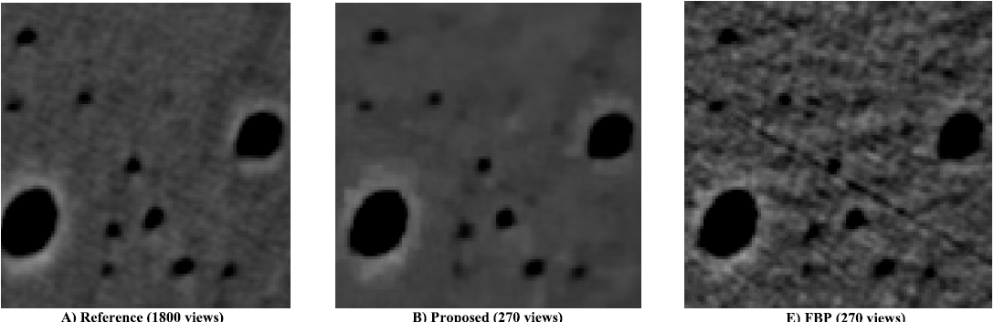
270 of 1800 projections to reconstruction with a resolution of 18μm.

S. A. Melli, K. A. Wahid, P. Babyn, D. M. Cooper, and V. P. Gopi. A
sparsity-based iterative algorithm for reconstruction of micro-ct images from
highly undersampled projection datasets obtained with a synchrotron x-ray
source.
Review of Scientific Instruments, 87(12):123701

Use of ordered subset intensity-based maximizing the a posteriori
(OS-iMAP) 1 . From 1500 projections reconstruct using 100 of
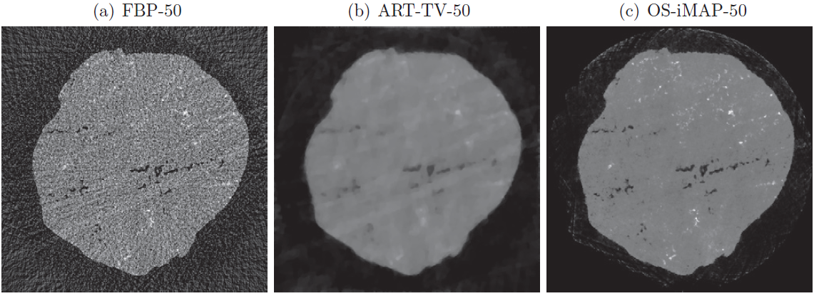
them with a resolution of 0.5μm.

E. A. Rashed and H. Kudo. Statistical image reconstruction from limited
projection data with intensity priors.
Physics in medicine and biology, 57(7):2039

Microcomputed tomography: approaches and applications in bioengineering
- review of importence of micro-CT

Contrast-transfer-function phase retrieval based on compressed sensing (2017)
- Phase retrieval
- new contrast-transfer-function (CTF) phase-retrieval method based on the alternatingdirection method of multipliers (ADMM-CTF)
- iterative algorithm
- highly noisy single-distance projection microscopy data
- lower amountof artifacts and enhanced signal-to-noise ratio

application
http://onlinelibrary.wiley.com/doi/10.1002/jbmr.2324/full

Reconstruction of limited-angle and few-view nano-CT image via total variation iterative reconstruction

As the head is located within the central 160 × 160 pixel
portion of the field of view, according to the Nyquist radial sampling criteria, the number projections
required to avoid streaking artifacts for a pixel phantom is approximately 160 2( π / 2) ~ 360 projections
(Kak and Slaney, 2001)

