# HTML | Div Tag

he div tag is known as Division tag. The div tag is used in HTML to make divisions of content in the web page like (text, images, header, footer, navigation bar, etc). Div tag has both open(<div>) and closing (</div>) tag and it is mandatory to close the tag. The Div is the most usable tag in web development because it helps us to separate out data in the web page and we can create a particular section for particular data or function in the web pages.

* Div tag is Block level tag
* It is a generic container tag
* It is used to the group of various tags of HTML so that sections can be created and style can be applied to them.

As we know Div tag is block-level tag in this example div tag contain entire width. It will be displayed div tag each time on a new line, not on the same line.

<html>

   <head>

      <title>div tag</title>

<style type=text/css>

p{

  background-color:gray;

  margin: 10px;

}

div

{

  color: white;

  background-color: 009900;

  margin: 2px;

  font-size: 25px;

}

</style>

</head>

 <body>

   <div > div tag   </div>

   <div > div tag   </div>

   <div > div tag   </div>

   <div > div tag   </div>

   </body>

</html>

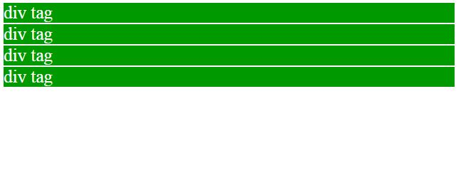

<html>

   <head>

      <title>gfg</title>

      <style type=text/css>

         p{

         color: white;

         background-color: 009900;

         width: 400px;

         }

         h1

         {

         color: white;

         background-color: 009900;

         width: 400px;

         }

         h2

         {

         color: white;

         background-color: 009900;

         width: 400px;

         }

      </style>

   </head>

   <body>

      <h1>GeeksforGeeks</h1>

      <p>How many times were you frustrated while looking out

       for a good collection of programming/algorithm/interview

       questions? What did you expect and what did you get?

       This portal has been created to provide well written,

       well thought and well-explained solutions for selected

       questions.

      </p>

      <h2>GeeksforGeeks</h2>

      <p>GCET is an entrance test for the extensive classroom

      program by GeeksforGeeks to build and enhance Data

      Structures and Algorithm concepts, mentored by Sandeep

      Jain (Founder & CEO, GeeksforGeeks).He has 7 years of

      teaching experience and 6 years of industry experience.

      </p>

   </body>

</html>

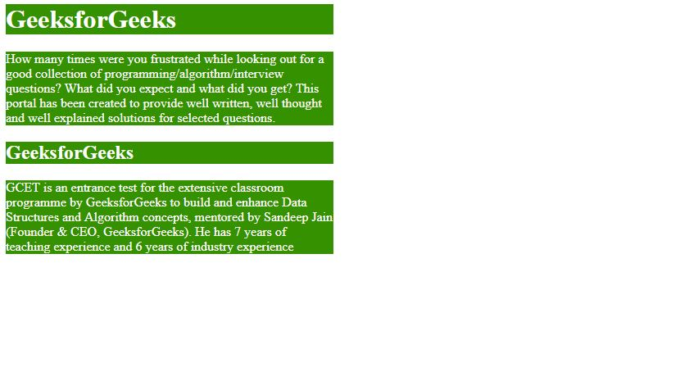

**Creating Web Layout using Div Tag** The div tag is a container tag inside div tag we can put more than one HTML element and can group together and can apply CSS for them. div tag can be used for creating a layout of web pages in the below examples shows creating a web layout we can also create web layout using tables tag but table tags are very complex to modify the layout The div tag is very flexible in creating web layouts and easy to modify. in below example will show grouping of HTML element using div tag and create block-wise web layout.

<html>

   <head>

      <title>gfg</title>

      <style type=text/css>

         .leftdiv

         {

         float: left;

         }

         .middlediv

         {

         float: left;

         background-color:gray

         }

         .rightdiv

         {

         float: left;

         }

         div{

         padding : 1%;

         color: white;

         background-color: 009900;

         width: 30%;

         border: solid black;

         }

      </style>

   </head>

   <body>

      <div class="leftdiv">

         <h1>GeeksforGeeks</h1>

         <p>How many times were you frustrated while looking out

         for a good collection of programming/algorithm/interview

         questions? What did you expect and what did you get?

         This portal has been created to provide well written,

         well thought and well-explained solutions for selected

         questions.

      </p>

         <h2>GeeksforGeeks</h2>

         <p>GCET is an entrance test for the extensive classroom

         programme by GeeksforGeeks to build and enhance Data

         Structures and Algorithm concepts, mentored by Sandeep

         Jain (Founder & CEO, GeeksforGeeks).He has 7 years of

         teaching experience and 6 years of industry experience.

      </p>

      </div>

      <div class="middlediv">

         <h1>GeeksforGeeks</h1>

         <p>How many times were you frustrated while looking out

         for a good collection of programming/algorithm/interview

         questions? What did you expect and what did you get?

         This portal has been created to provide well written,

         well thought and well-explained solutions for selected

         questions.

         </p>

         <h2>GeeksforGeeks</h2>

         <p>GCET is an entrance test for the extensive classroom

         programme by GeeksforGeeks to build and enhance Data

         Structures and Algorithm concepts, mentored by Sandeep

         Jain (Founder & CEO, GeeksforGeeks).He has 7 years of

         teaching experience and 6 years of industry experience.

         </p>

      </div>

      <div class="rightdiv">

         <h1>GeeksforGeeks</h1>

         <p>How many times were you frustrated while looking out

         for a good collection of programming/algorithm/interview

         questions? What did you expect and what did you get?

         This portal has been created to provide well written,

         well thought and well-explained solutions for selected

         questions.

         </p>

         <h2>GeeksforGeeks</h2>

         <p>How many times were you frustrated while looking out

         for a good collection of programming/algorithm/interview

         questions? What did you expect and what did you get?

         This portal has been created to provide well written,

         well thought and well-explained solutions for selected

         questions.

         </p>

      </div>

   </body>

</html>

