Client and Server model

* A client and server networking model is a model in which computers such as servers provide the network services to the other computers such as clients to perform a user based tasks. This model is known as client-server networking model.
* The application programs using the client-server model should follow the given below strategies:

https://mail.google.com/mail/u/0/

* An application program is known as a client program, running on the local machine that requests for a service from an application program known as a server program, running on the remote machine.
* A client program runs only when it requests for a service from the server while the server program runs all time as it does not know when its service is required.
* A server provides a service for many clients not just for a single client. Therefore, we can say that client-server follows the many-to-one relationship. Many clients can use the service of one server.
* Services are required frequently, and many users have a specific client-server application program. For example, the client-server application program allows the user to access the files, send e-mail, and so on.

Client

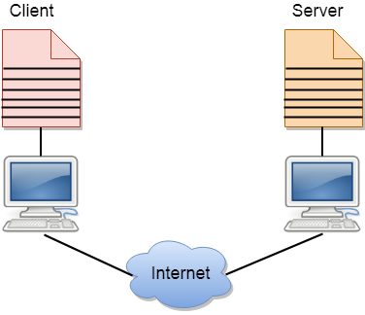A client is a program that runs on the local machine requesting service from the server.

Server

A server is a program that runs on the remote machine providing services to the clients. When the client requests for a service, then the server opens the door for the incoming requests, but it never initiates the service.

A server program is an infinite program means that when it starts, it runs infinitely unless the problem arises. The server waits for the incoming requests from the clients. When the request arrives at the server, then it responds to the request.

HTTP vs HTTPS

What is HTTP?

An HTTP stands for Hypertext Transfer Protocol. The HTTP protocol provides communication between different communication systems. In short, we can say that the HTTP protocol allows us to transfer the data from the server to the client.

An [HTTP](https://www.javatpoint.com/http)

is a stateless protocol as each transaction is executed separately without having any knowledge of the previous transactions, which means that once the transaction is completed between the web browser and the server, the connection gets lost.

What is HTTPS?

The full form of HTTPS is Hypertext Transfer Protocol Secure. The [HTTP](https://www.javatpoint.com/http-tutorial)

protocol does not provide the security of the data, while HTTP ensures the security of the data. Therefore, we can say that HTTPS is a secure version of the HTTP protocol. This protocol allows transferring the data in an encrypted form. The use of HTTPS protocol is mainly required where we need to enter the bank account details. The HTTPS protocol is mainly used where we require to enter the login credentials. In modern browsers such as chrome, both the protocols, i.e., HTTP and HTTPS, are marked differently.

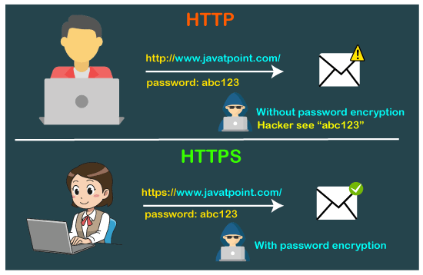

The HTTPS protocol is secured due to the SSL protocol. The SSL protocol encrypts the data which the client transmits to the server. If someone tries to steal the information which is being communicated between the client and the server, then he/she would not be able to understand due to the encryption. This is the main difference between the HTTP and HTTPS that the HTTP does not contain SSL, whereas the HTTPS contains SSL that provides secure communication between the client and the server.

HTTP vs HTTPS performance

The speed of [HTTP](https://www.javatpoint.com/http-interview-questions)

is faster than the HTTPS as the HTTPS contains SSL protocol, while HTTP does not contain an SSL protocol. This additional feature of SSL in HTTPS makes the page loading slower.

What is HTTP?

The Hypertext Transfer Protocol (HTTP) is designed to enable communications between clients and servers.

HTTP works as a request-response protocol between a client and server.

Example: A client (browser) sends an HTTP request to the server; then the server returns a response to the client. The response contains status information about the request and may also contain the requested content.

HTTP Methods

* **GET**
* **POST**

The two most common HTTP methods are: GET and POST.

The GET Method

GET is used to request data from a specified resource.

Note that the query string (name/value pairs) is sent in the URL of a GET request:

/test/demo_form.php?name1=value1&name2=value2

The POST Method

POST is used to send data to a server to create/update a resource.

The data sent to the server with POST is stored in the request body of the HTTP request:

POST /test/demo_form.php HTTP/1.1  
Host: w3schools.com  
  
name1=value1&name2=value2

## Get vs. Post

There are many differences between the Get and Post request. Let's see these differences:

|  |  |
| --- | --- |
| **GET** | **POST** |
| 1) In case of Get request, only **limited amount of data**can be sent because data is sent in header. | In case of post request, **large amount of data**can be sent because data is sent in body. |
| 2) Get request is **not secured**because data is exposed in URL bar. | Post request is **secured**because data is not exposed in URL bar. |
| 4) Get request is **idempotent**. It means second request will be gn ignored until response of first request is delivered | Post request is **non-idempotent.** |
| 5) Get request is **more efficient**and used more than Post. | Post request is **less efficient**and used less than get. |

Servlet:

**Servlet** technology is used to create a web application (resides at server side and generates a dynamic web page).

* Servlet is a technology which is used to create a web application.
* Servlet is a web component that is deployed on the server to create a dynamic web page.

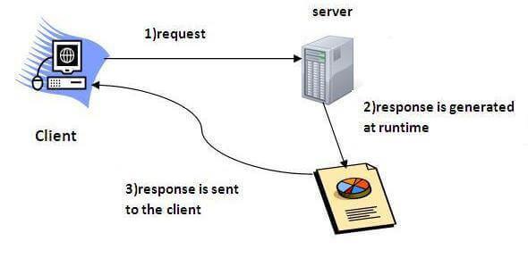

### What is a web application?

A web application is an application accessible from the web. A web application is composed of web components like Servlet, JSP, Filter, etc. and other elements such as HTML, CSS, and JavaScript. The web components typically execute in Web Server and respond to the HTTP request.

# Web Terminology

|  |  |
| --- | --- |
| **Servlet Terminology** | **Description** |
| [Website: static vs dynamic](https://www.javatpoint.com/website-static-vs-dynamic) | It is a collection of related web pages that may contain text, images, audio and video. |
| [HTTP](https://www.javatpoint.com/http) | It is the data communication protocol used to establish communication between client and server. |
| [HTTP Requests](https://www.javatpoint.com/http-requests) | It is the request send by the computer to a web server that contains all sorts of potentially interesting information. |
| [Get vs Post](https://www.javatpoint.com/get-vs-post) | It gives the difference between GET and POST request. |
| [Container](https://www.javatpoint.com/container) | It is used in java for dynamically generating the web pages on the server side. |
| [Server: Web vs Application](https://www.javatpoint.com/server-web-vs-application) | It is used to manage the network resources and for running the program or software that provides services. |
| [Content Type](https://www.javatpoint.com/content-type) | It is HTTP header that provides the description about what are you sending to the browser. |