Testing Framework for Java
To perform unit testing, we need to create test cases. The unit test case is a code which ensures that the program logic works as expected.

Types of unit testing
There are two ways to perform unit testing: 1) manual testing 2) automated testing.

1) Manual Testing
If you execute the test cases manually without any tool support, it is known as manual testing. It is time consuming and less reliable.

2) Automated Testing
If you execute the test cases by tool support, it is known as automated testing. It is fast and more reliable.

Annotations for Junit testing
The Junit 4.x framework is annotation based, so let's see the annotations that can be used while writing the test cases.
@Test annotation specifies that method is the test method.
@Test(timeout=1000) annotation specifies that method will be failed if it takes longer than 1000 milliseconds (1 second).
@BeforeClass annotation specifies that method will be invoked only once, before starting all the tests.
@Before annotation specifies that method will be invoked before each test.
@After annotation specifies that method will be invoked after each test.
@AfterClass annotation specifies that method will be invoked only once, after finishing all the tests.

Example:

Here’re some basic JUnit annotations you should understand:
- @BeforeClass – Run once before any of the test methods in the class, public static void
- @AfterClass – Run once after all the tests in the class have been run, public static void
- @Before – Run before @Test, public void
- @After – Run after @Test, public void
- @Test – This is the test method to run, public void
P.S Tested with JUnit 4.12
BasicAnnotationTest.java

import org.junit.*;

public class BasicAnnotationTest {

// Run once, e.g. Database connection, connection pool
@BeforeClass
public static void runOnceBeforeClass() {
System.out.println("@BeforeClass - runOnceBeforeClass");
}

// Run once, e.g close connection, cleanup
@AfterClass
public static void runOnceAfterClass() {
System.out.println("@AfterClass - runOnceAfterClass");
}

// Should rename to @BeforeTestMethod
// e.g. Creating an similar object and share for all @Test
@Before
public void runBeforeTestMethod() {
System.out.println("@Before - runBeforeTestMethod");
}

// Should rename to @AfterTestMethod
@After
public void runAfterTestMethod() {
System.out.println("@After - runAfterTestMethod");
}

@Test
public void test_method_1() {
System.out.println("@Test - test_method_1");
}

@Test
public void test_method_2() {
System.out.println("@Test - test_method_2");
}

}

Assert class
The org.junit.Assert class provides methods to assert the program logic.

Methods of Assert class
The common methods of Assert class are as follows:
- void assertEquals(boolean expected,boolean actual): checks that two primitives/objects are equal. It is overloaded.
- void assertTrue(boolean condition): checks that a condition is true.
- void assertFalse(boolean condition): checks that a condition is false.
- void assertNull(Object obj): checks that object is null.
- void assertNotNull(Object obj): checks that object is not null.

- package com.javatpoint.logic;
- public class Calculation {

- public static int findMax(int arr[]){
- int max=0;
- for(int i=1;i<arr.length;i++){
- if(max<arr[i])
- max=arr[i];
- }
- return max;
- }
- }

Write the test case
Here, we are using JUnit 4, so there is no need to inherit TestCase class. The main testing code is written in the testFindMax() method. But we can also perform some task before and after each test, as you can see in the given program.

- package com.javatpoint.testcase;

- import static org.junit.Assert.*;
- import com.javatpoint.logic.*;
- import org.junit.Test;

- public class TestLogic {

- @Test
- public void testFindMax(){
- assertEquals(4,Calculation.findMax(new int[]{1,3,4,2}));
- assertEquals(-1,Calculation.findMax(new int[]{-12,-1,-3,-4,-2}));
- }
- }
download this example

To run this example, right click on TestLogic class -> Run As -> 1Junit Test.
Output:Assertion Error
Let's see the output displayed in eclipse IDE.
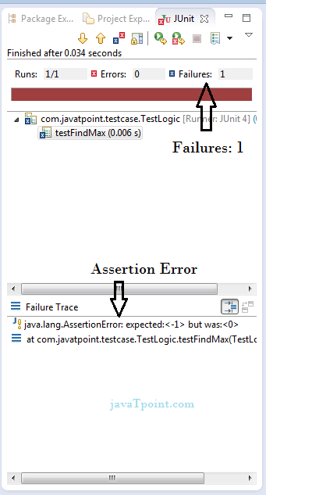
As you can see, when we pass the negative values, it throws AssertionError because second time findMax() method returns 0 instead of -1. It means our program logic is incorrect.

Correct program logic
As you can see, program logic to find the maximum number for the given array is not correct because it doesn't return -1 in case of negative values. The correct program logic is given below:

- package com.javatpoint.logic;
- public class Calculation {

- public static int findMax(int arr[]){
- int max=arr[0];//arr[0] instead of 0
- for(int i=1;i<arr.length;i++){
- if(max<arr[i])
- max=arr[i];
- }
- return max;
- }
- }
If you run the junit program again, you will see the following output.
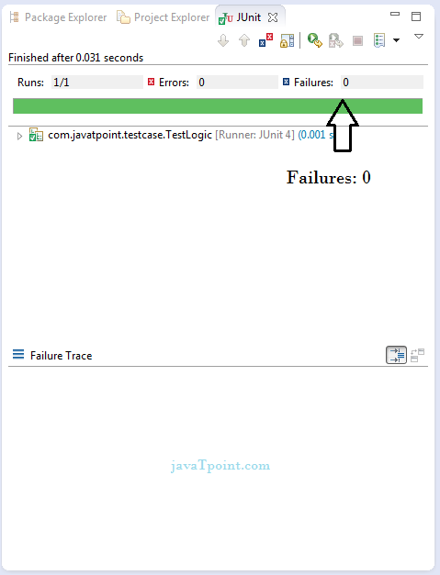

Another example of Junit framework

Write the program code

- package com.javatpoint.logic;
- public class Calculation {
- //method that returns maximum number
- public static int findMax(int arr[]){
- int max=0;
- for(int i=1;i<arr.length;i++){
- if(max<arr[i])
- max=arr[i];
- }
- return max;
- }
- //method that returns cube of the given number
- public static int cube(int n){
- return n*n*n;
- }
- //method that returns reverse words
- public static String reverseWord(String str){

- StringBuilder result=new StringBuilder();
- StringTokenizer tokenizer=new StringTokenizer(str," ");

- while(tokenizer.hasMoreTokens()){
- StringBuilder sb=new StringBuilder();
- sb.append(tokenizer.nextToken());
- sb.reverse();

- result.append(sb);
- result.append(" ");
- }
- return result.toString();
- }
- }

Write the test case

- package com.javatpoint.testcase;

- import static org.junit.Assert.assertEquals;
- import org.junit.After;
- import org.junit.AfterClass;
- import org.junit.Before;
- import org.junit.BeforeClass;
- import org.junit.Test;
- import com.javatpoint.logic.Calculation;

- public class TestCase2 {

- @BeforeClass
- public static void setUpBeforeClass() throws Exception {
- System.out.println("before class");
- }
- @Before
- public void setUp() throws Exception {
- System.out.println("before");
- }

- @Test
- public void testFindMax(){
- System.out.println("test case find max");
- assertEquals(4,Calculation.findMax(new int[]{1,3,4,2}));
- assertEquals(-2,Calculation.findMax(new int[]{-12,-3,-4,-2}));
- }
- @Test
- public void testCube(){
- System.out.println("test case cube");
- assertEquals(27,Calculation.cube(3));
- }
- @Test
- public void testReverseWord(){
- System.out.println("test case reverse word");
- assertEquals("ym eman si nahk",Calculation.reverseWord("my name is khan");
- }
- @After
- public void tearDown() throws Exception {
- System.out.println("after");
- }

- @AfterClass
- public static void tearDownAfterClass() throws Exception {
- System.out.println("after class");
- }

- }
Output:before class
before
test case find max
after
before
test case cube
after
before
test case reverse word
after
after class

JUnit5 Architecture
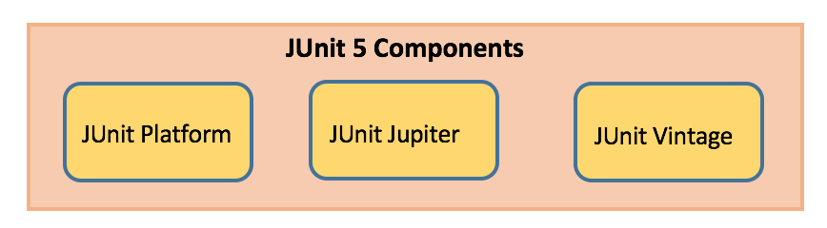

JUnit Platform
- Launches testing frameworks on the JVM
- Has TestEngine API used to build a testing framework that runs on the JUnit platform

JUnit Jupiter
- Blend of new programming model for writing tests and extension model for extensions
- Addition of new annotations like @BeforeEach, @AfterEach, @AfterAll, @BeforeAll etc.

JUnit Vintage
- Provides support to execute previous JUnit version 3 and 4 tests on this new platform

JUnit Maven Dependencies
To implement JUnit5 based test cases in a project, add the following dependency to the pom.xml file of the project:
- JUnit 5 Library

<dependency>
<groupId>org.junit.jupiter</groupId>
<artifactId>junit-jupiter-engine</artifactId>
<version>5.1.1</version>
<scope>test</scope>
</dependency>
<dependency>
<groupId>org.junit.platform</groupId>
<artifactId>junit-platform-runner</artifactId>
<version> 1.1.1</version>
<scope>test</scope>
</dependency>
- JUnit5 maven surefire provider to execute the unit tests where IDE does not have JUnit5 support (if IDE has support then this point is not required)

<plugin>
<artifactId>maven-surefire-plugin</artifactId>
<version>2.19.1</version>
<dependencies>
<dependency>
<groupId>org.junit.platform</groupId>
<artifactId>junit-platform-surefire-provider</artifactId>
<version>1.0.2</version>
</dependency>
</dependencies>
</plugin>

JUnit5 New Features
It requires Java 8 or higher at runtime. But one can still test code which is compiled using previous Java versions. There are various new features got introduced in it.

JUnit Annotations
Listed below are some commonly used annotations provided in it:
Annotation | Description
@Test | Denotes a test method
@DisplayName | Declares a custom display name for the test class or test method
@BeforeEach | Denotes that the annotated method should be executed before each test method
@AfterEach | Denotes that the annotated method should be executed after each test method
@BeforeAll | Denotes that the annotated method should be executed before all test methods
@AfterAll | Denotes that the annotated method should be executed after all test methods
@Disable | Used to disable a test class or test method
@Nested | Denotes that the annotated class is a nested, non-static test class
@Tag | Declare tags for filtering tests
@ExtendWith | Register custom extensions

package com.journaldev;

import org.junit.jupiter.api.AfterAll;
import org.junit.jupiter.api.AfterEach;
import org.junit.jupiter.api.BeforeAll;
import org.junit.jupiter.api.BeforeEach;
import org.junit.jupiter.api.Disabled;
import org.junit.jupiter.api.DisplayName;
import org.junit.jupiter.api.Test;

public class JUnit5Sample1Test {

@BeforeAll
static void beforeAll() {
System.out.println("**--- Executed once before all test methods in this class ---**");
}

@BeforeEach
void beforeEach() {
System.out.println("**--- Executed before each test method in this class ---**");
}

@Test
void testMethod1() {
System.out.println("**--- Test method1 executed ---**");
}

@DisplayName("Test method2 with condition")
@Test
void testMethod2() {
System.out.println("**--- Test method2 executed ---**");
}

@Test
@Disabled("implementation pending")
void testMethod3() {
System.out.println("**--- Test method3 executed ---**");
}

@AfterEach
void afterEach() {
System.out.println("**--- Executed after each test method in this class ---**");
}

@AfterAll
static void afterAll() {
System.out.println("**--- Executed once after all test methods in this class ---**");
}

}
We can run above JUnit test class in Eclipse -> Run As -> JUnit Test.

JUnit Assertions
Every test method must be evaluated against condition to true using assertions so that the test can continue to execute. JUnit Jupiter assertions are kept in the org.junit.jupiter.api.Assertions class. All of the methods are static.
Assertion | Description
assertEquals(expected, actual) | Fails when expected does not equal actual
assertFalse(expression) | Fails when expression is not false
assertNull(actual) | Fails when actual is not null
assertNotNull(actual) | Fails when actual is null
assertAll() | Group many assertions and every assertion is executed even if one or more of them fails
assertTrue(expression) | Fails if expression is not true
assertThrows() | Class to be tested is expected to throw an exception

@Test
void testAssertEqual() {
assertEquals("ABC", "ABC");
assertEquals(20, 20, "optional assertion message");
assertEquals(2 + 2, 4);
}

@Test
void testAssertFalse() {
assertFalse("FirstName".length() == 10);
assertFalse(10 > 20, "assertion message");
}

@Test
void testAssertNull() {
String str1 = null;
String str2 = "abc";
assertNull(str1);
assertNotNull(str2);
}

@Test
void testAssertAll() {
String str1 = "abc";
String str2 = "pqr";
String str3 = "xyz";
assertAll("numbers",
() -> assertEquals(str1,"abc"),
() -> assertEquals(str2,"pqr"),
() -> assertEquals(str3,"xyz")
);
//uncomment below code and understand each assert execution
/*assertAll("numbers",
() -> assertEquals(str1,"abc"),
() -> assertEquals(str2,"pqr1"),
() -> assertEquals(str3,"xyz1")
);*/
}

@Test
void testAssertTrue() {
assertTrue("FirstName".startsWith("F"));
assertTrue(10 {
throw new IllegalArgumentException("Illegal Argument Exception occured");
});
assertEquals("Illegal Argument Exception occured", exception.getMessage());
}

JUnit5 Imports
Its test classes need org.junit.jupiter.api.Test import statement and not org.junit.Test. Also, the test methods need not be a public and local package.

import org.junit.jupiter.api.Test;

JUnit5 Assumptions
Assumptions are static methods in the org.junit.jupiter.api.Assumptions class. They will execute a test only when the specified condition met otherwise test will be aborted. The aborted test will not cause build failure. When an assumption fails, org.opentest4j.TestAbortedException is thrown and the test is skipped.
Assumptions | Description
assumeTrue | Execute the body of lamda when the positive condition hold else test will be skipped
assumeFalse | Execute the body of lamda when the negative condition hold else test will be skipped
assumingThat | Portion of the test method will execute if an assumption holds true and everything after the lambda will execute irrespective of the assumption in assumingThat() holds

@Test
void testAssumeTrue() {
boolean b = 'A' == 'A';
assumeTrue(b);
assertEquals("Hello", "Hello");
}

@Test
@DisplayName("test executes only on Saturday")
public void testAssumeTrueSaturday() {
LocalDateTime dt = LocalDateTime.now();
assumeTrue(dt.getDayOfWeek().getValue() == 6);
System.out.println("further code will execute only if above assumption holds true");
}

@Test
void testAssumeFalse() {
boolean b = 'A' != 'A';
assumeFalse(b);
assertEquals("Hello", "Hello");
}

@Test
void testAssumeFalseEnvProp() {
System.setProperty("env", "prod");
assumeFalse("dev".equals(System.getProperty("env")));
System.out.println("further code will execute only if above assumption hold");
}

@Test
void testAssumingThat() {
System.setProperty("env", "test");
assumingThat("test".equals(System.getProperty("env")),
() -> {
assertEquals(10, 10);
System.out.println("perform below assertions only on the test env");
});

assertEquals(20, 20);
System.out.println("perform below assertions on all env");
}

