**What is Cloud Computing?**

**Cloud Computing** is defined as storing and accessing of data and computing services over the internet. It doesn’t store any data on your personal computer

The term cloud refers to a network or the internet.

It is a technology that uses remote servers on the internet to store, manage, and access data online rather than local drives. The data can be anything such as files, images, documents, audio, video, and more.

**Examples of Cloud Computing Services:** AWS, Azure, Google

 The main purpose of cloud computing is to give access to data centers to many users. Users can also access data from a remote server.

Why Cloud Computing?

Small as well as large IT companies, follow the traditional methods to provide the IT infrastructure. That means **for any IT company, we need a Server Room that is the basic need of IT companies**.

In that server room, there should be a database server, mail server, networking, firewalls, routers, modem, switches, QPS (Query Per Second means how much queries or load will be handled by the server), configurable system, high net speed, and the maintenance engineers.

To establish such IT infrastructure, we need to spend lots of money. To overcome all these problems and to reduce the IT infrastructure cost, Cloud Computing comes into existence.

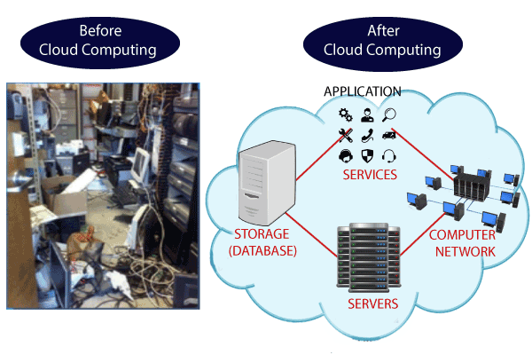

Let’s learn Cloud Computing basics with an example –

Whenever you travel through a bus or train, you take a ticket for your destination and hold back to your seat till you reach your destination. Likewise other passengers also takes ticket and travel in the same bus with you and it hardly bothers you where they go. When your stop comes you get off the bus thanking the driver. Cloud computing is just like that bus, carrying [data and information](https://www.guru99.com/difference-information-data.html) for different users and allows to use its service with minimal cost.

## Why the Name Cloud?

The term “Cloud” came from a network design that was used by network engineers to represent the location of various network devices and there inter-connection. The shape of this network design was like a cloud.

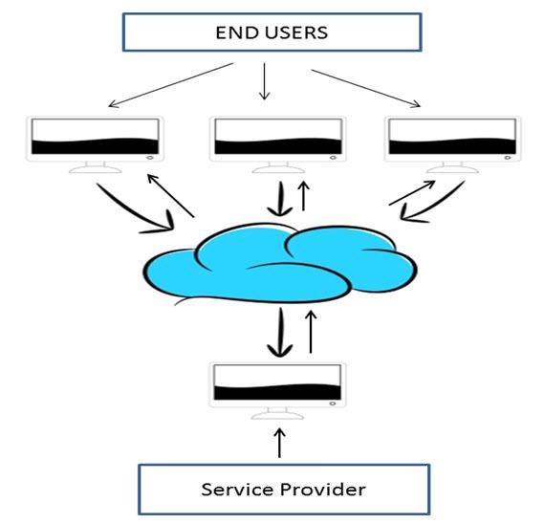

# **Cloud Computing Architecture**

As we know, cloud computing technology is used by both small and large organizations to **store the information** in cloud and **access** it from anywhere at anytime using the internet connection.

Cloud computing architecture is a combination of **service-oriented architecture** and **event-driven architecture**.

Cloud computing architecture is divided into the following two parts -

* Front End
* Back End

The below diagram shows the architecture of cloud computing -

53.4M

1K

C++ vs Java

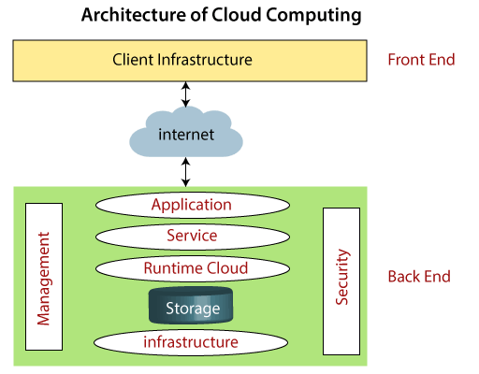

### **Front End**

The front end is used by the client. It contains client-side interfaces and applications that are required to access the cloud computing platforms. The front end includes web servers (including Chrome, Firefox, internet explorer, etc.), thin & fat clients, tablets, and mobile devices.

### **Back End**

The back end is used by the service provider. It manages all the resources that are required to provide cloud computing services. It includes a huge amount of data storage, security mechanism, virtual machines, deploying models, servers, traffic control mechanisms, etc.

#### **Note: Both front end and back end are connected to others through a network, generally using the internet connection.**

## Components of Cloud Computing Architecture

There are the following components of cloud computing architecture -

**1. Client Infrastructure**

Client Infrastructure is a Front end component. It provides GUI (Graphical User Interface)  to interact with the cloud.

**2. Application**

The application may be any software or platform that a client wants to access.

**3. Service**

A Cloud Services manages that which type of service you access according to the client’s requirement.

Cloud computing offers the following three type of services:

**i. Software as a Service (SaaS) –**It is also known as **cloud application services**. Mostly, SaaS applications run directly through the web browser means we do not require to download and install these applications. Some important example of SaaS is given below –

**Example:** Google Apps, Salesforce Dropbox, Slack, Hubspot, Cisco WebEx.

**ii. Platform as a Service (PaaS) –** It is also known as **cloud platform** **services**. It is quite similar to SaaS, but the difference is that PaaS provides a platform for software creation, but using SaaS, we can access software over the internet without the need of any platform.

**Example:** Windows Azure, Force.com, Magento Commerce Cloud, OpenShift.

**iii. Infrastructure as a Service (IaaS) –**It is also known as **cloud infrastructure services**. It is responsible for managing applications data, middleware, and runtime environments.

**Example:** Amazon Web Services (AWS) EC2, Google Compute Engine (GCE), Cisco Metapod.

**4. Runtime Cloud**

Runtime Cloud provides the **execution and runtime environment** to the virtual machines.

**5. Storage**

Storage is one of the most important components of cloud computing. It provides a huge amount of storage capacity in the cloud to store and manage data.

**6. Infrastructure**

It provides services on the **host level**, **application level**, and **network level**. Cloud infrastructure includes hardware and software components such as servers, storage, network devices, virtualization software, and other storage resources that are needed to support the cloud computing model.

**7. Management**

Management is used to manage components such as application, service, runtime cloud, storage, infrastructure, and other security issues in the backend and establish coordination between them.

**8. Security**

Security is an in-built back end component of cloud computing. It implements a security mechanism in the back end.

**9. Internet**

The Internet is medium through which front end and back end can interact and communicate with each other.