Name: Goudamy Sockalingam

Student id: 009417148

**Assignment-1**

**Mark:**

Mark tag is used in HTML-5 for highlighting text. Without Mark tag, this could be done by calling a JavaScript which sets the background color for the font as yellow. This would be reflected in HTML using document.write() function that would be called within script tags.

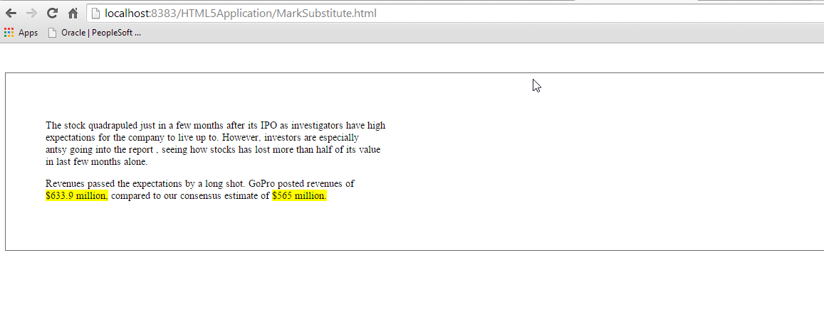

**Auto complete Search:**

Auto complete is used to specify the entire search key word based on the input that the user provides. In HTML-5 datalist tag is used for this purpose.

The same functionality can be accomplished by using JavaScript. Here, when the user checks BookList Radio button and places his cursor on the text box, java script function will be triggered and 100 books pertaining to Technologies would be displayed. Scientist radio button will display the list of scientist.

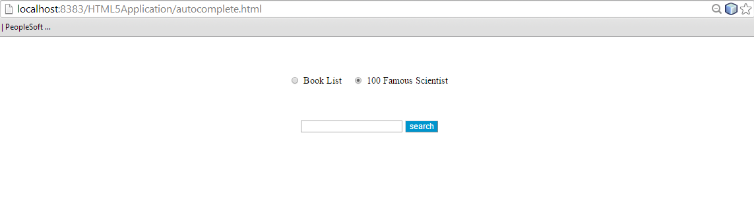

When the user starts entering an input, the options would narrow down the search results based on the input. This is done by checking the input and the number of alphabets entered, the books/scientist names that matches the substring is retrieved and displayed. When the user removes the cursor from text box, the list will be hidden.

