Name: Goudamy Sockalingam

Student ID: 009417148

**Registration Page**

**Part 1:  Create a registration page:**

The basic registration page:

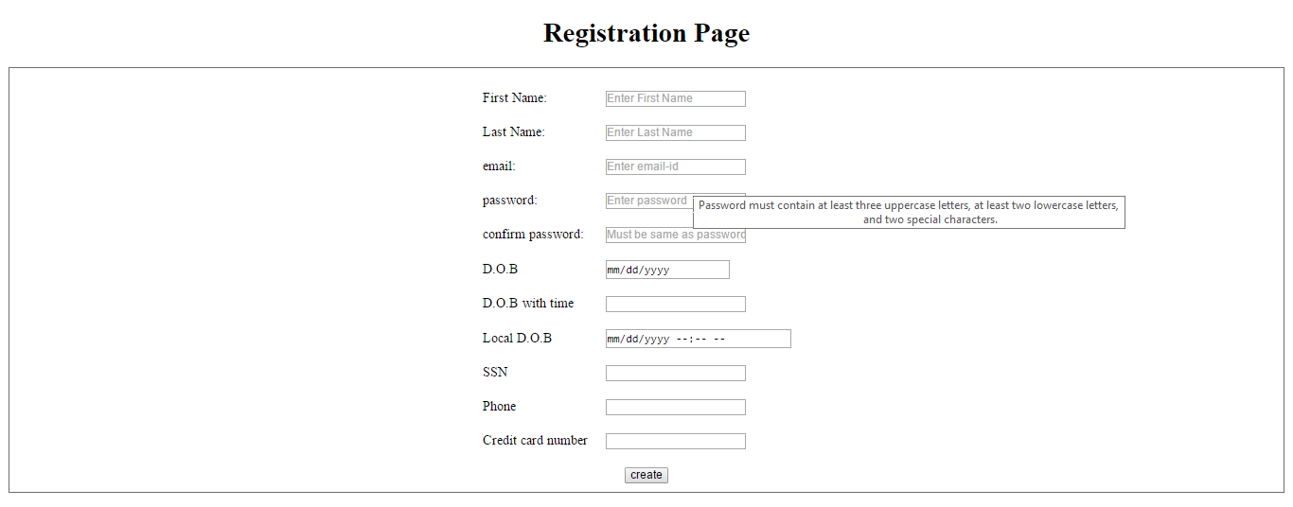

When the user provides password, it would check the password strength on the fly.

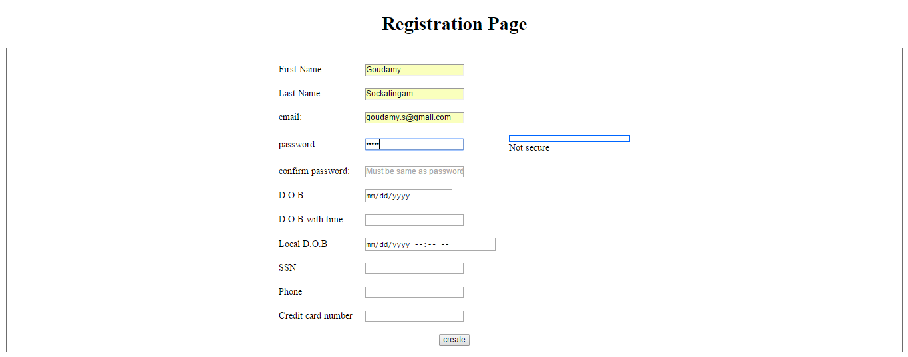

The progress bar would depict the strength as below:

* If password contains 3 Uppercase letters, 2 Lowercase letters and 2 special characters, then Password strength is **Normal**
* If password contains 3 Uppercase letters, 2 Lowercase letters and ***3-5*** special characters, then Password strength is **Medium**
* If password contains 3 Uppercase letters, 2 Lowercase letters and ***greater than*** ***5*** special characters, then Password strength is **Strong**

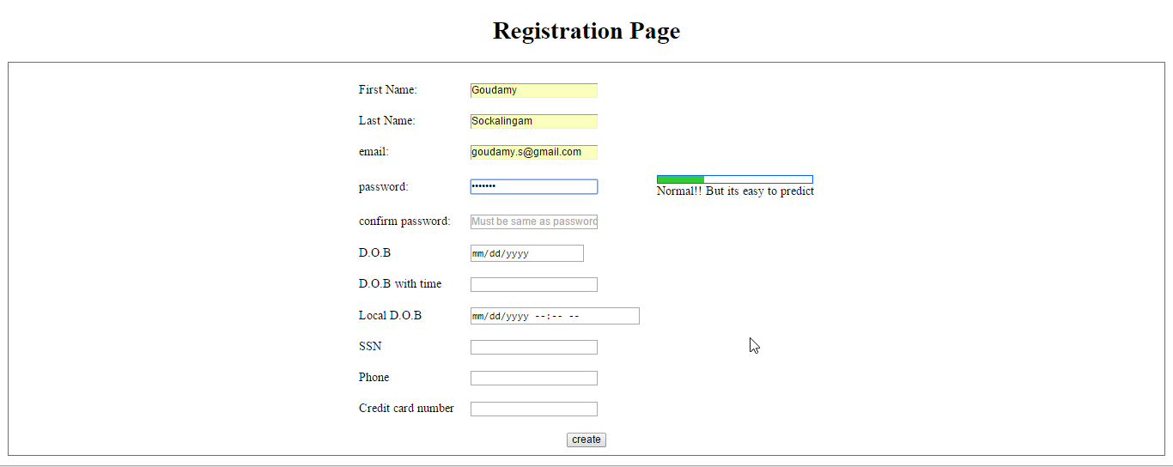

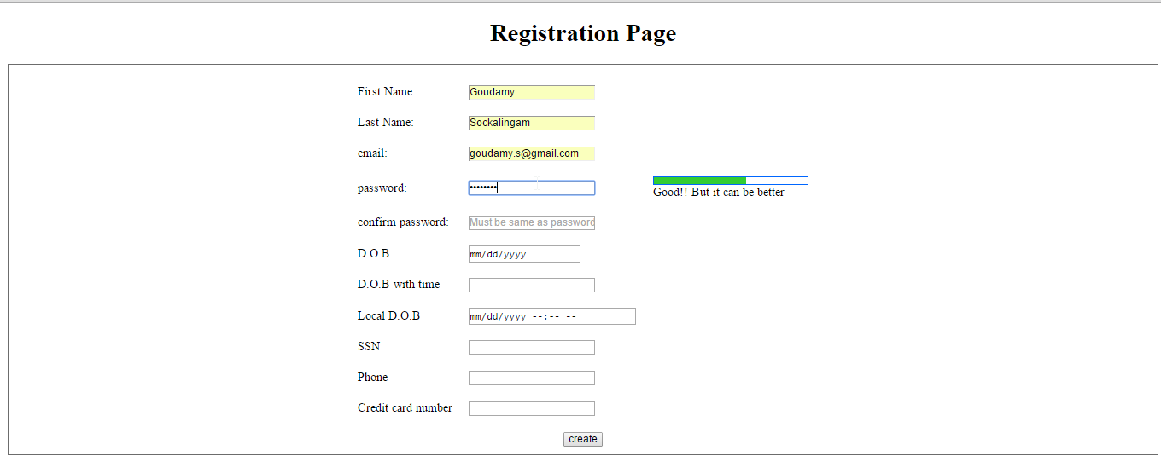

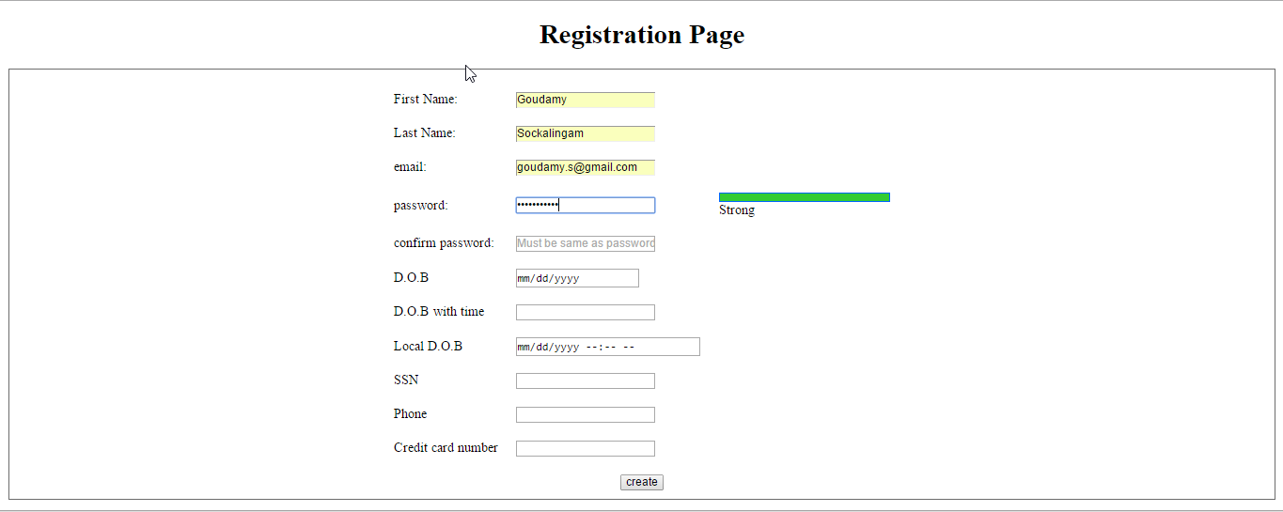

If the password and confirm password doesn’t match , then an alert window is used to display the message

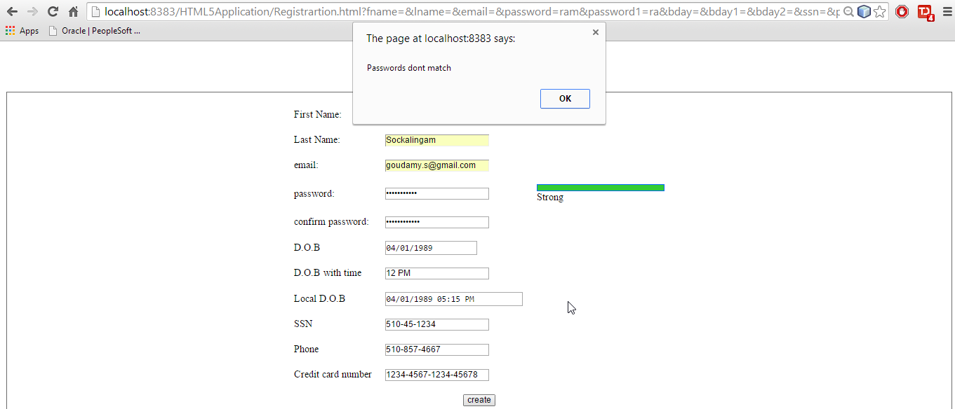

**Part 2:  Using HTML5 create pattern** for

* SSN
* US phone number
* Credit card number (12 digit / 16 digit)

Pattern(XXX-XX-XXXX) is created for the SSN. If the pattern is not followed, it would display a message as below.

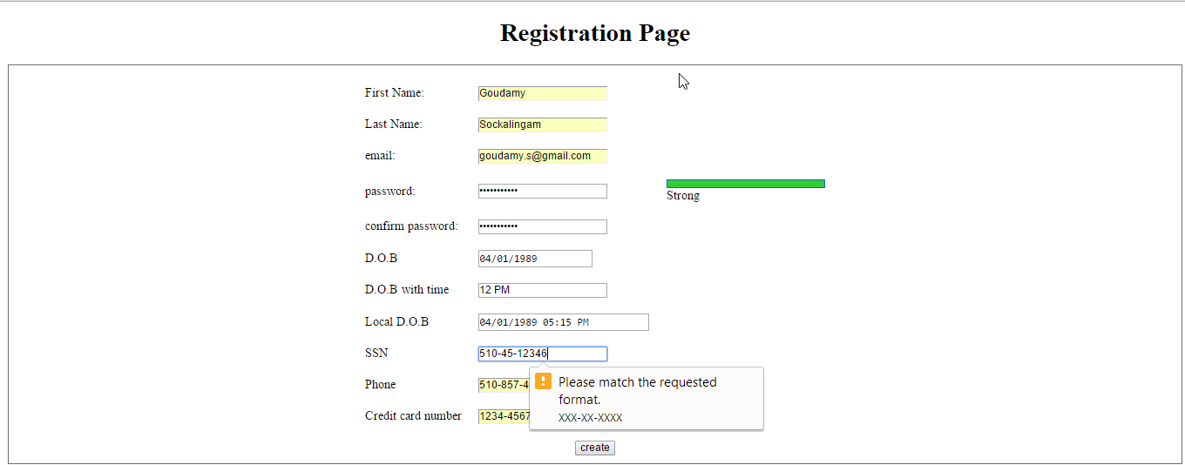

Pattern(XXX-XXX-XXXX) is created for the Phone number. If the pattern is not followed, it would display a message as below.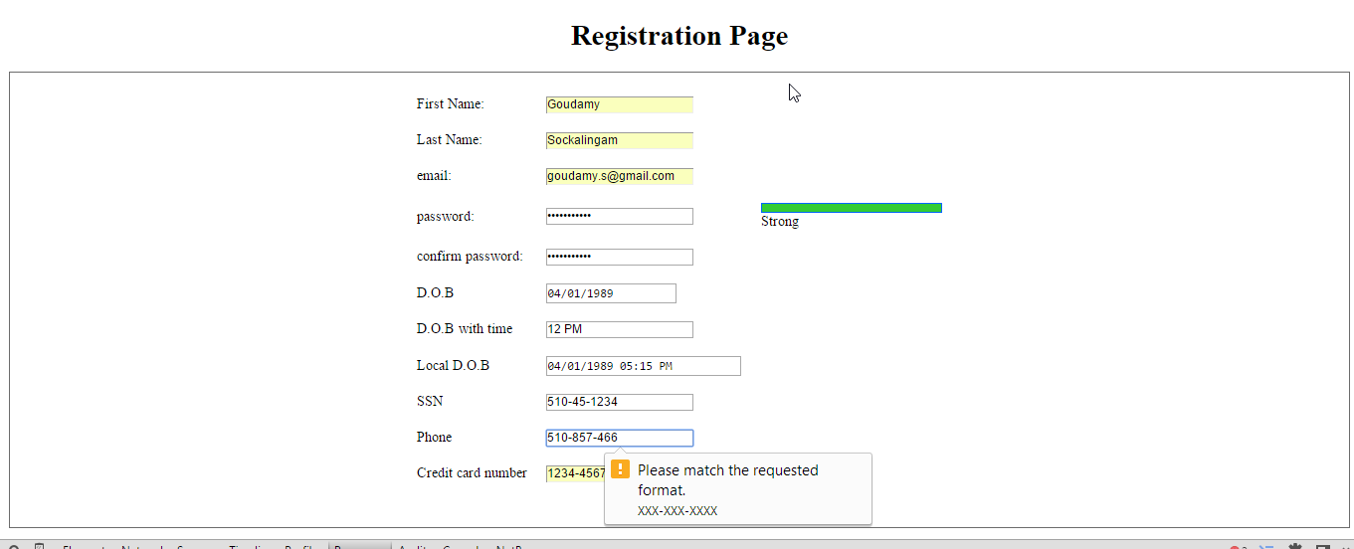

Pattern(XXXX-XXXX-XXXX-XXXX) is created for the Credit card number. If the pattern is not followed, it would display a message as below.

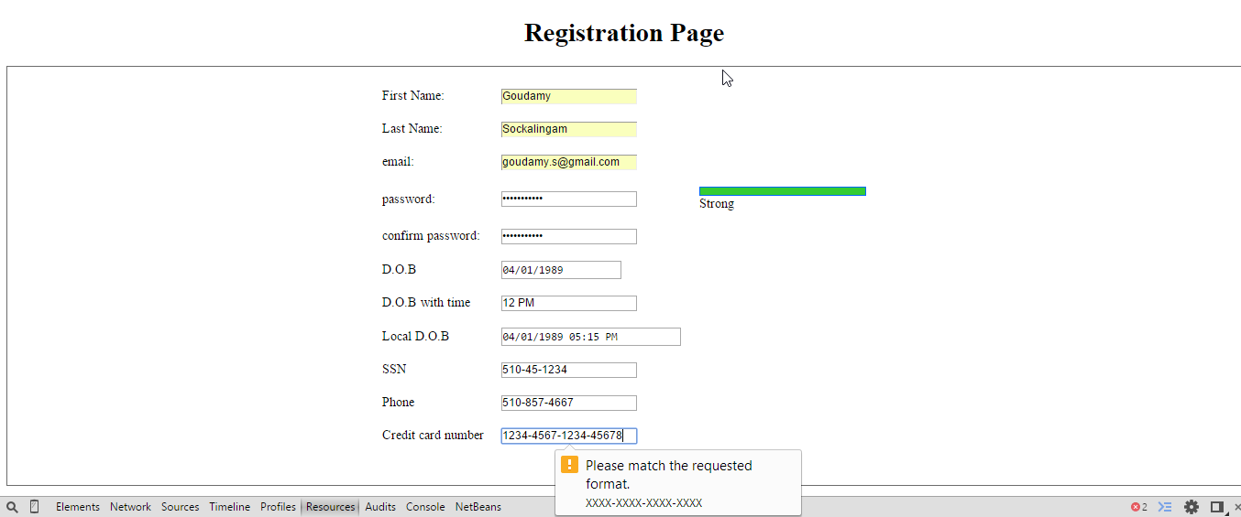

**Part 3: Store all the data that has been created so far in Session storage.**

Once the create button is pressed, the values would be saved as session variables. The screenshot below displays the session details that are stored in java script console.

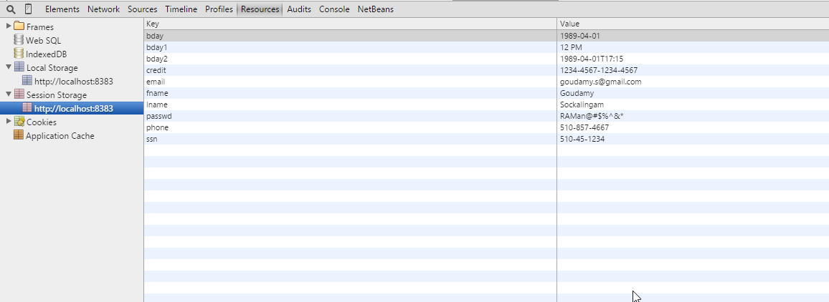

**Part 4: Using “modernizr”, check for local storage across various browsers:**

Modernizer is used to check if the browser supports local storage. Modernizr.localstorage is the function that is used for this process. The code is checked for various browsers such as Google chrome, Mozilla Firefox and Internet explorer and all the 3 browsers supports local storage.

**Chrome:**

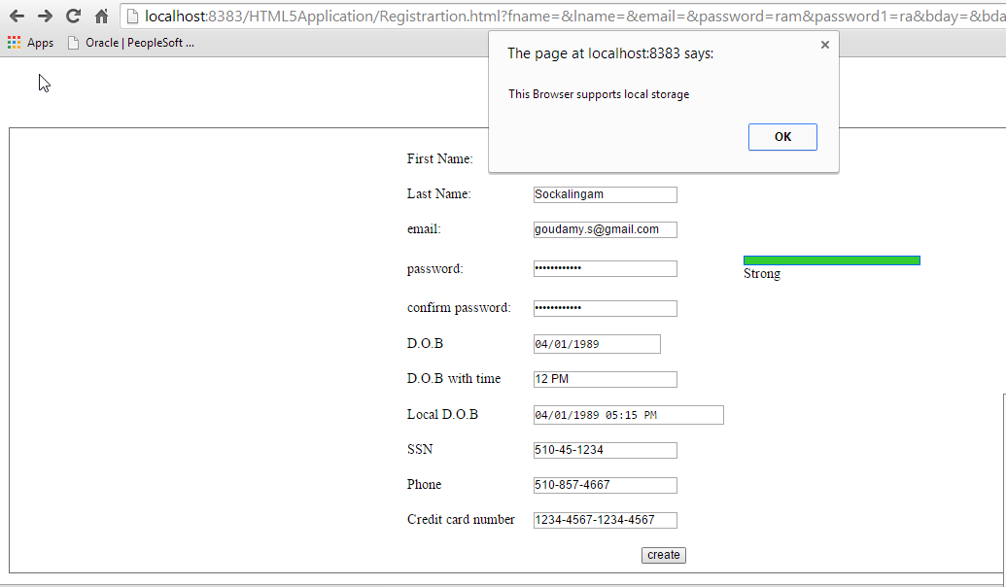

**Mozilla Firefox:**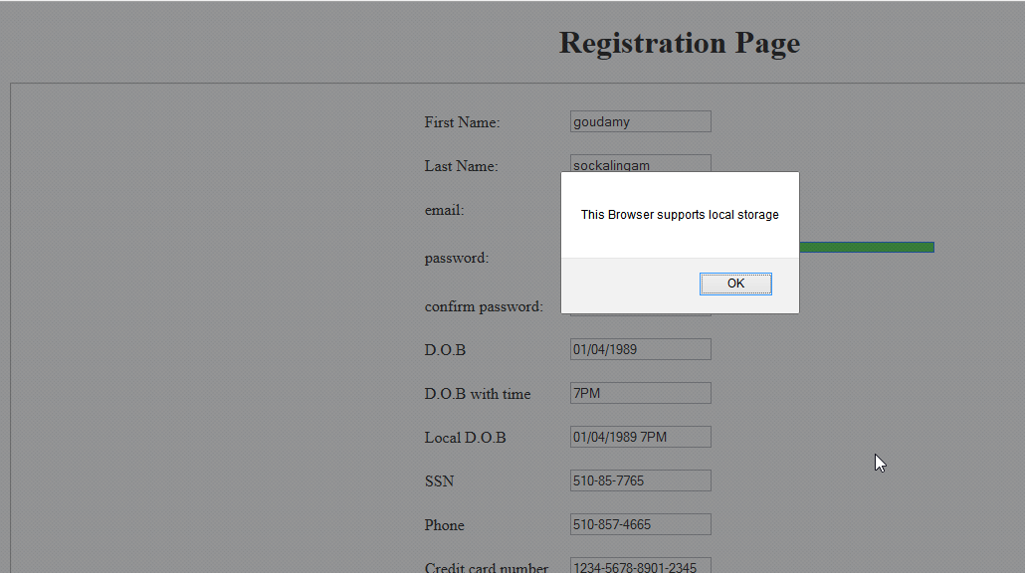

**Internet Explorer:**

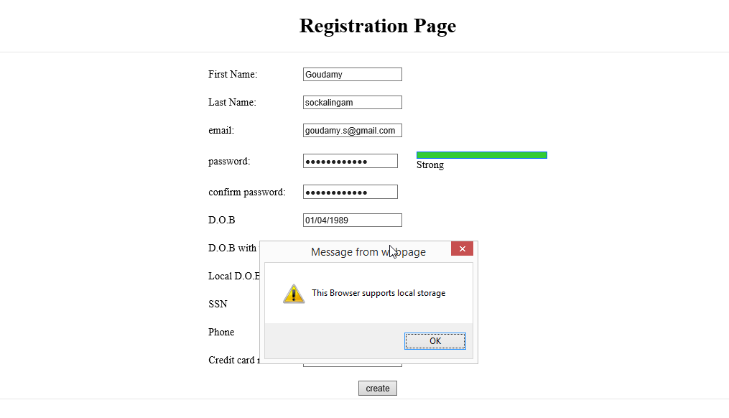

**Part 5**

**Events triggered when**

* **internet connection is lost**
* **internet connection is retrieved**

The navigator.onLine is the event that is used to check if the internet connection is lost or retrieved.

If internet connection is lost then navigator.onLine is false.

If internet connection is retrieved, navigator.onLine becomes true.

**Part 6: If Browser is Offline mode detected, store all the values to local storage.**

Browser can be turned to offline mode using File->work offline in Mozilla Firefox.

Navigator.onLine is always displays true in google chrome despite of offline/online mode. So, I tested this feature in Mozilla Firefox.

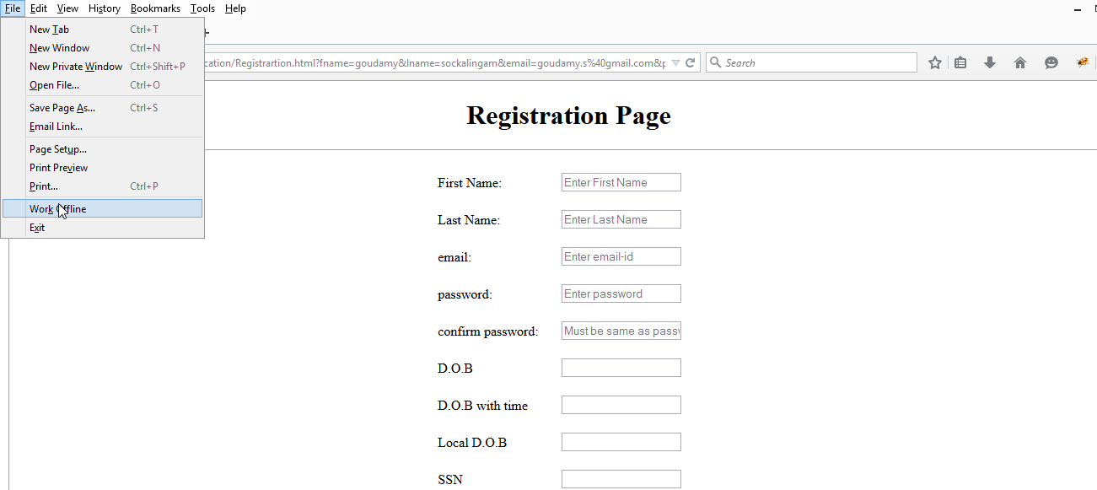

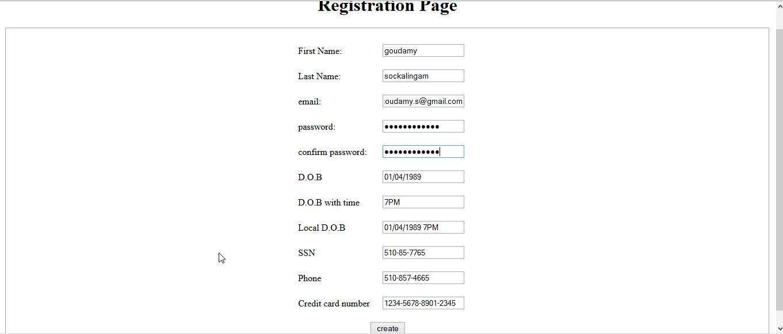

When the browser is turned to offline mode, it stores the values in local storage.

