Name: Goudamy Sockalingam

Student-ID: 009417148

**JS Library (User Registration)**

The registration page looks as below.

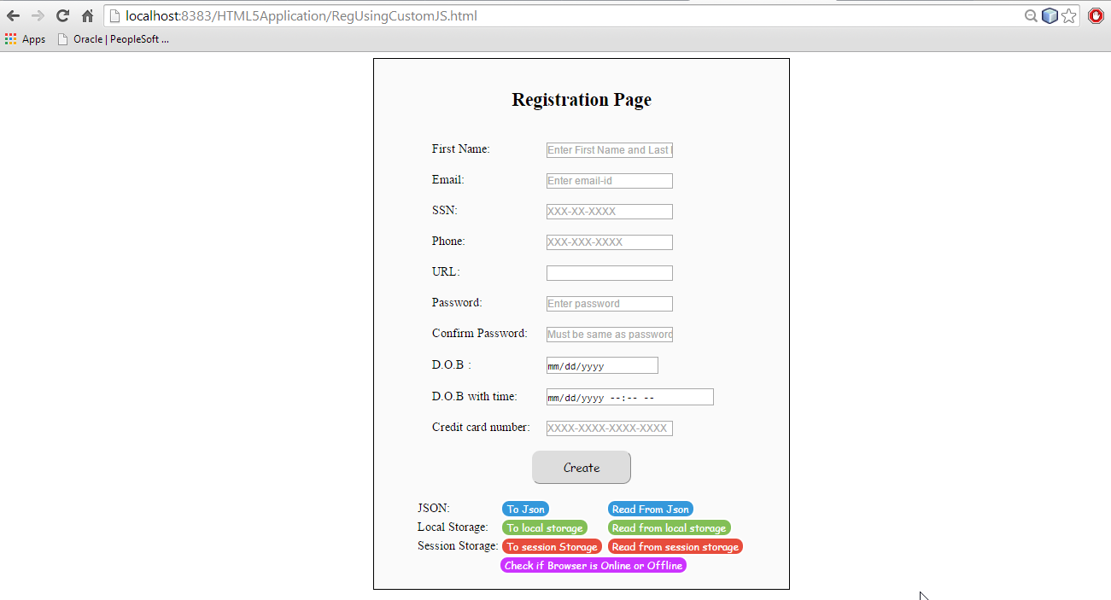

User could enter the details and save it as JSON format or local storage or session storage. To explain better, I have entered different details for all 3 formats.

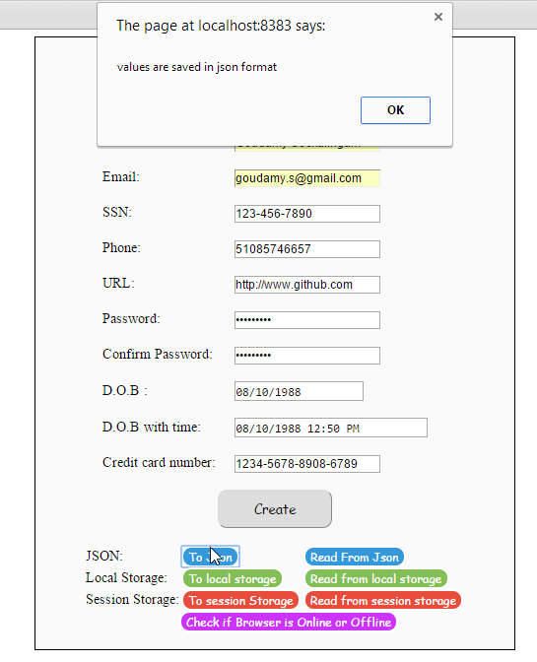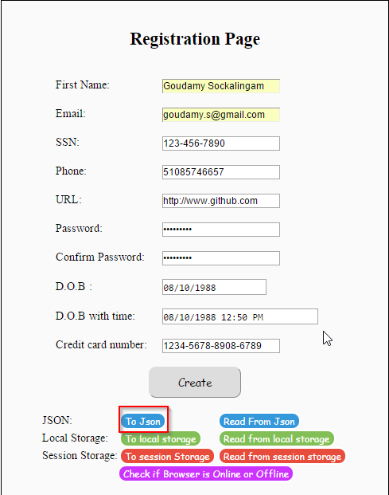For JSON format, name is Goudamy Sockalingam and pertaining information is entered. Once To JSON button is clicked, a confirmation message is displayed stating the details are saved.

For local storage, details pertaining to name Ram Kathiresan is saved.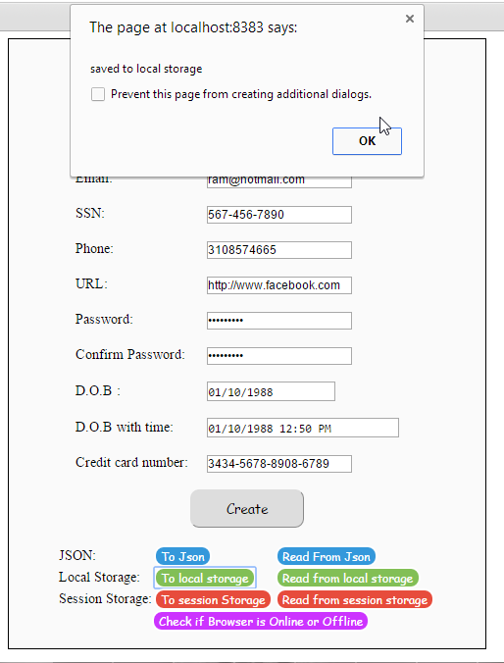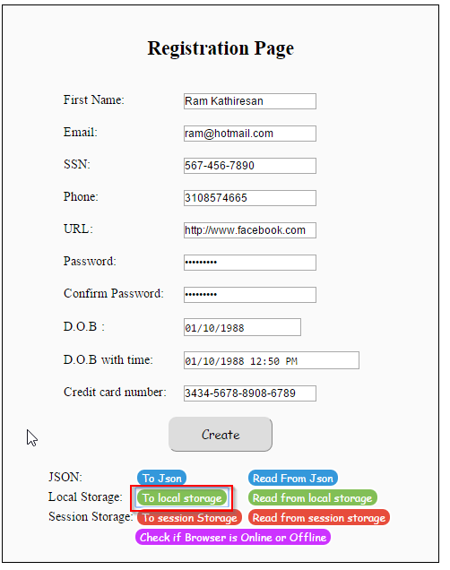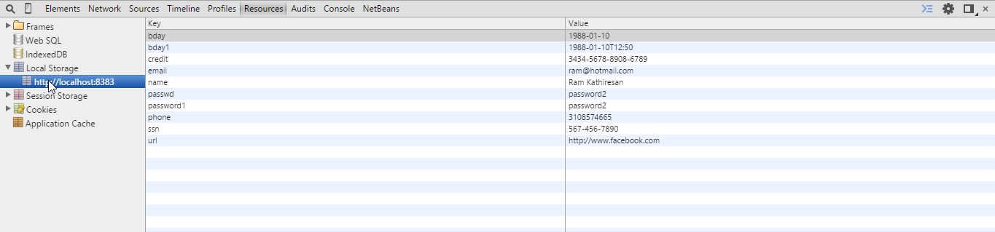

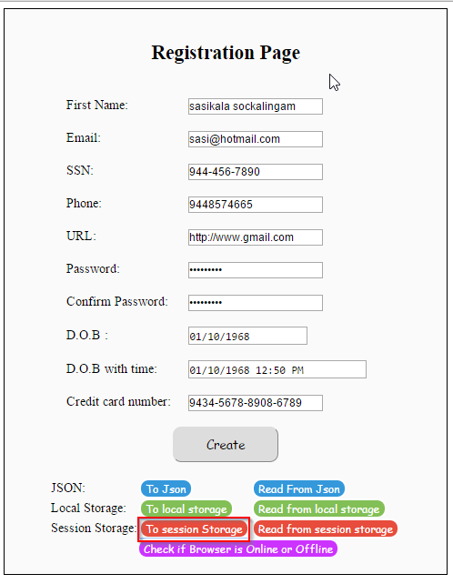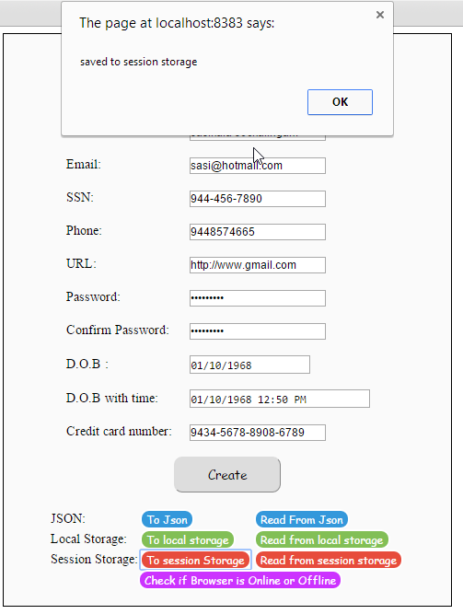For session data, values pertaining to user Sasikala Sockalingam is stored.

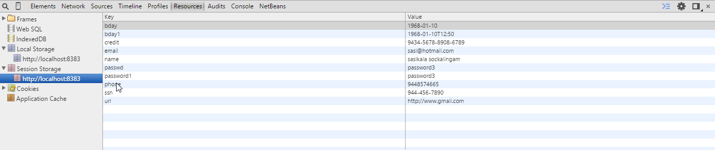

Once the user clicks, read from JSON, information corresponding to Goudamy is displayed on the registration form

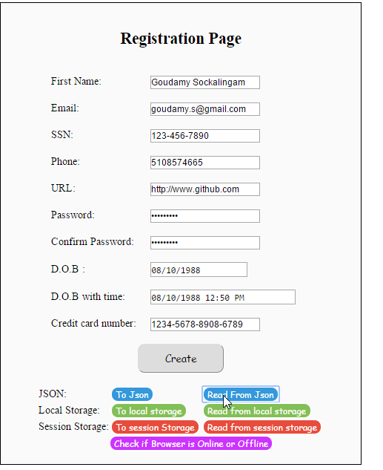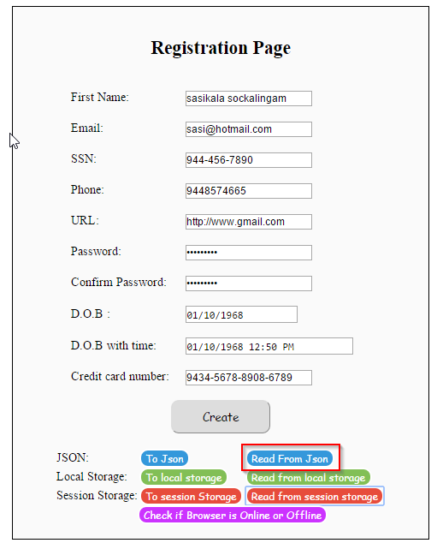

Once the user clicks, read from local storage, information corresponding to Ram Kathiresan is displayed on the registration form

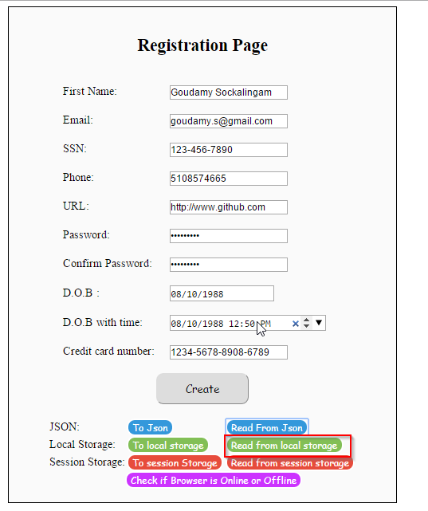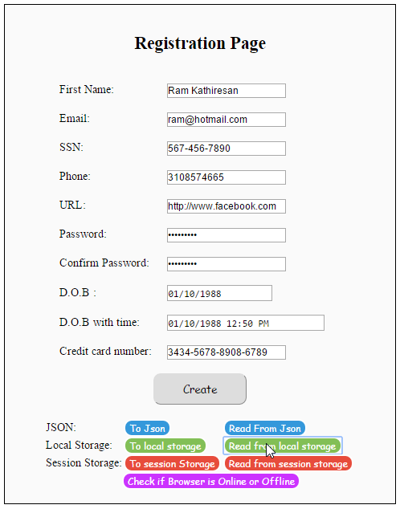

Once the user clicks, read from session storage information corresponding to sasikala is displayed on the registration form

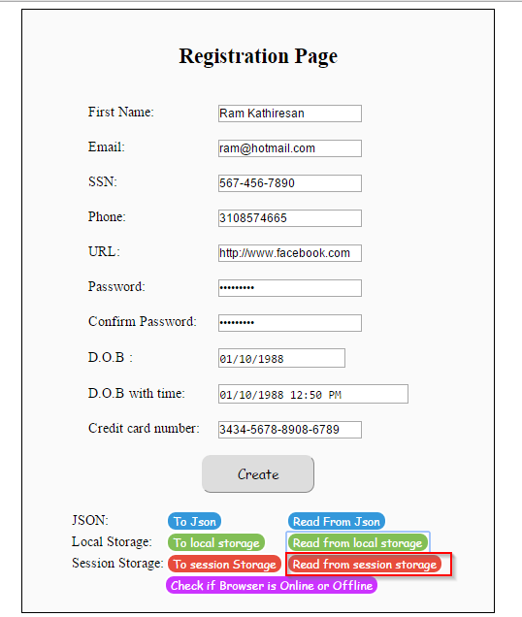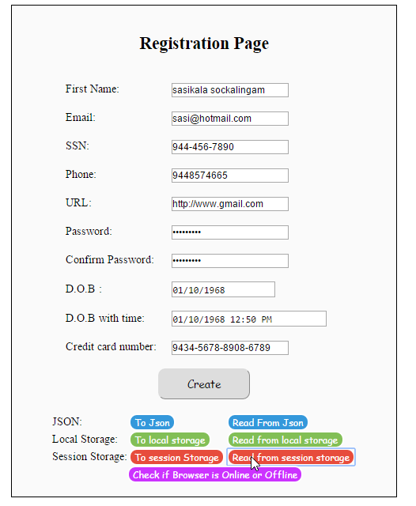

When the user clicks on “Create”, email-Id and phone number should be checked if it is a valid email-ID/Phone number.

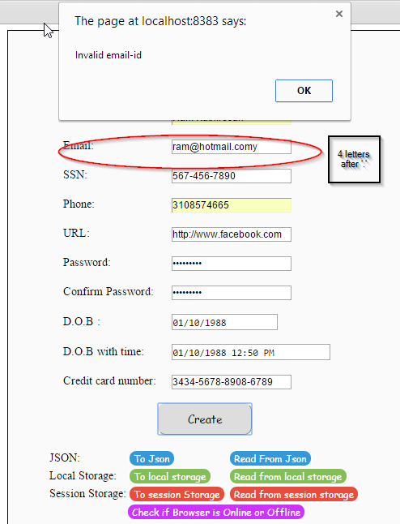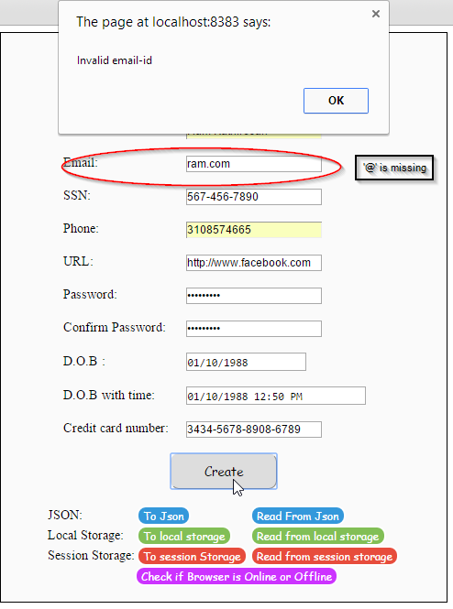

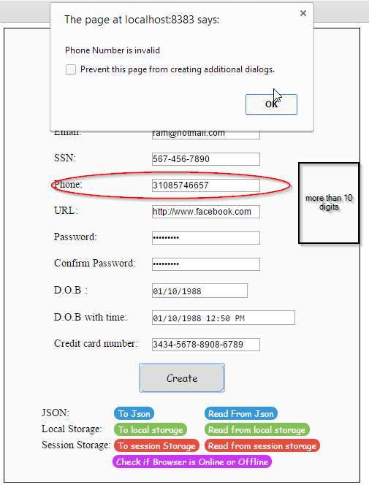

When the user clicks on “Check if the browser is online or offline”, function- onlineCheck() is invoked in JS library to make sure if the browser is online or offline. A browser is turned offline by going to File->work offline in Mozilla Firefox.

