1. Create VPC with 2 private and 2 public subnets.

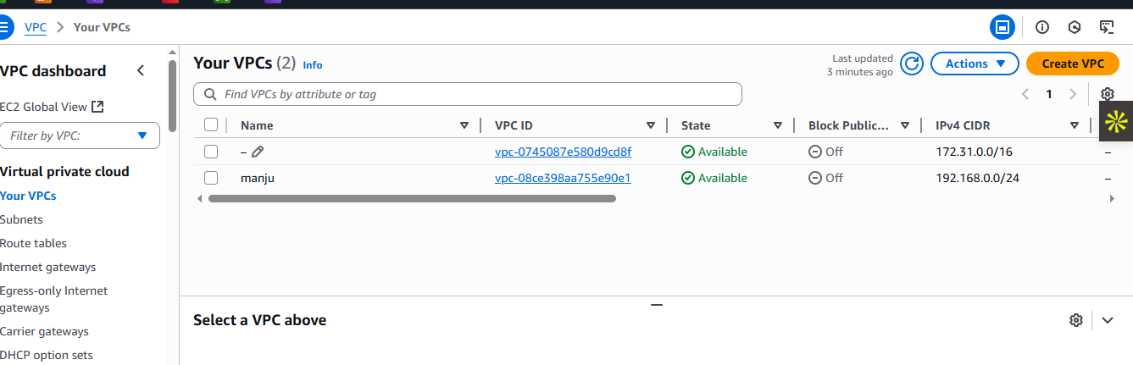

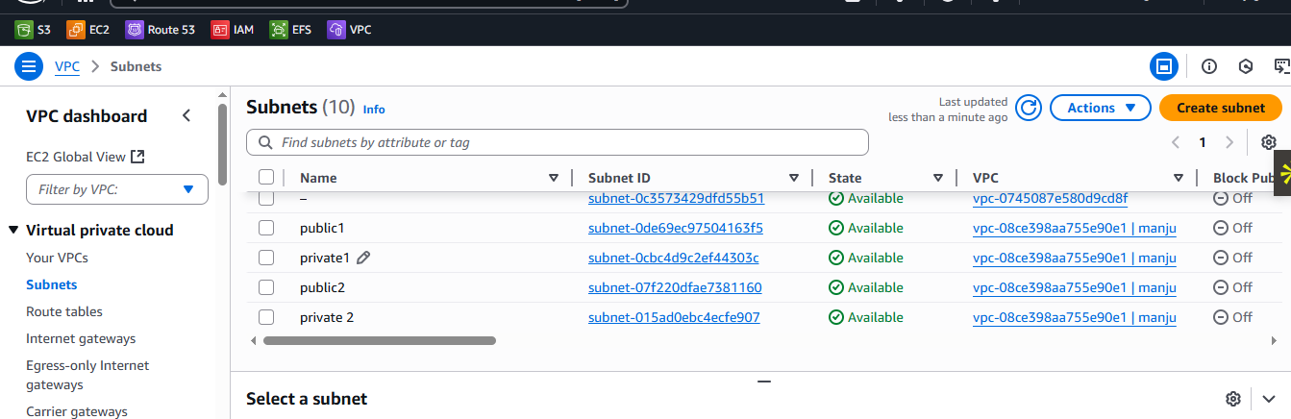

1. Enable DNS Hostname in VPC

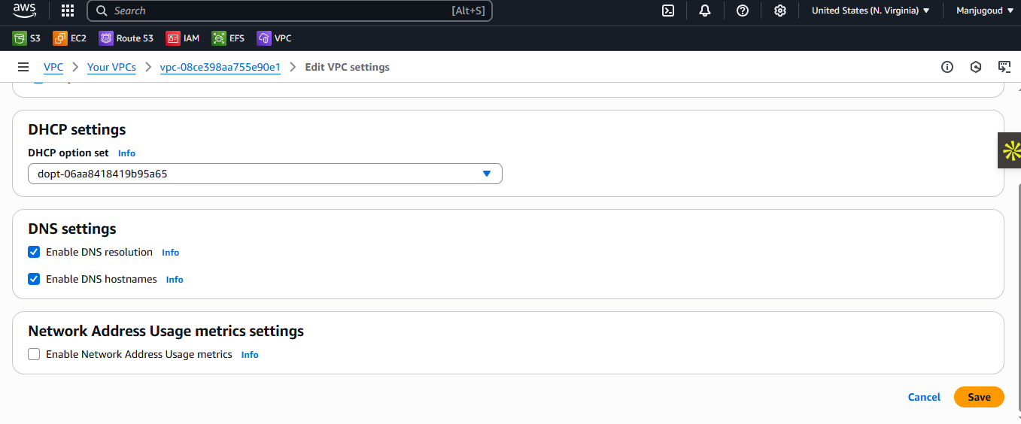

1. Enable Auto Assign Public ip in 2 public subnets

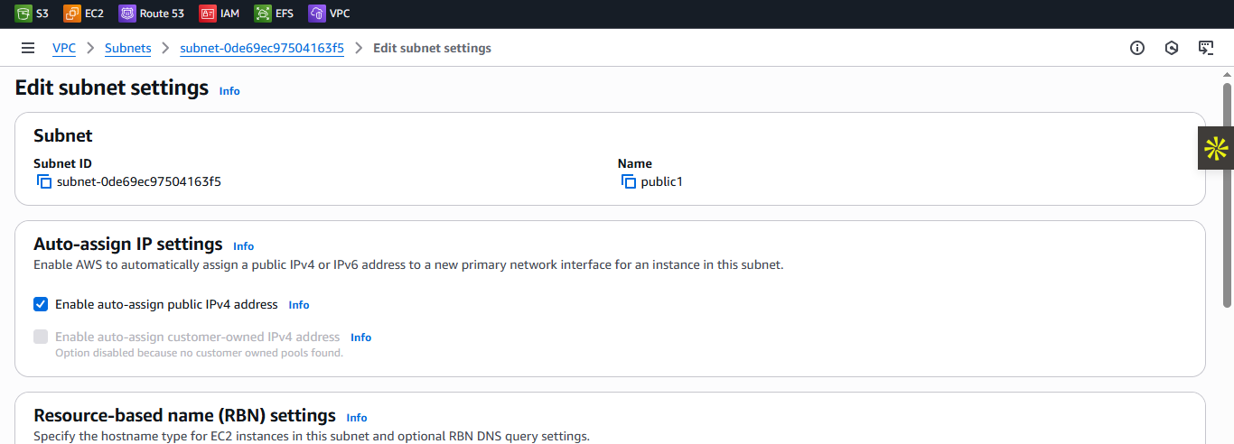

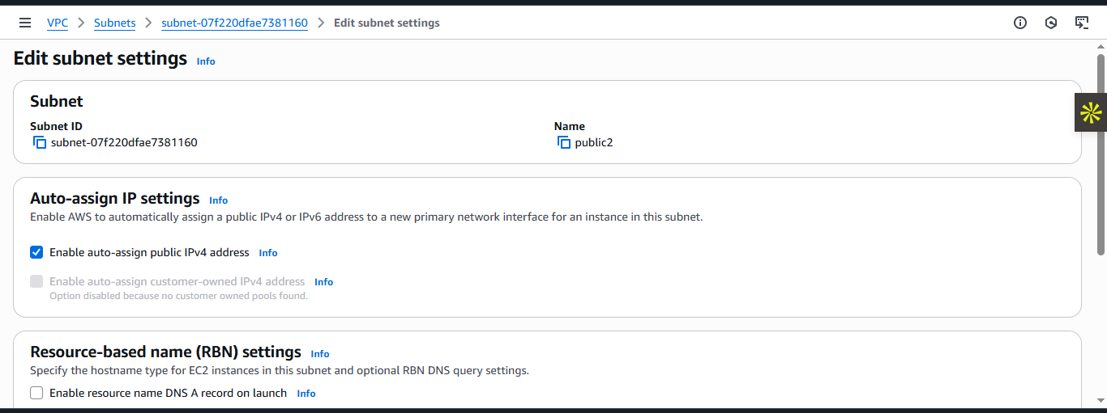

1. Add 2 private subnets in private route table

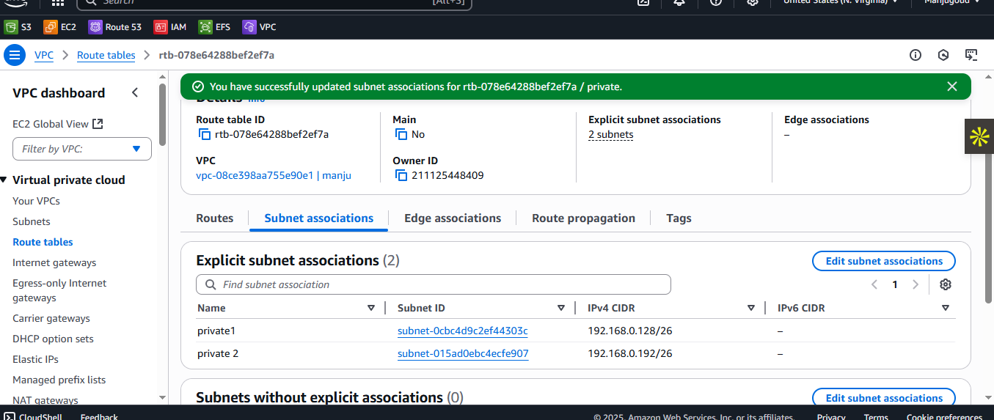

6) Add 2 public subnets in public route table

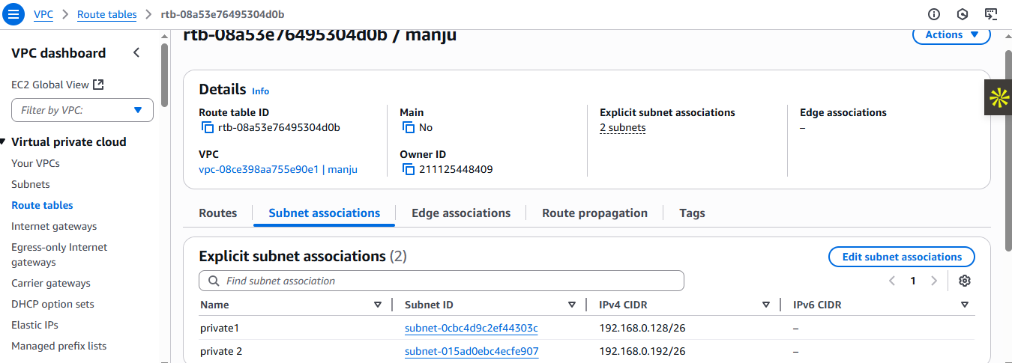

1. Public route table will have the routes to internet and local

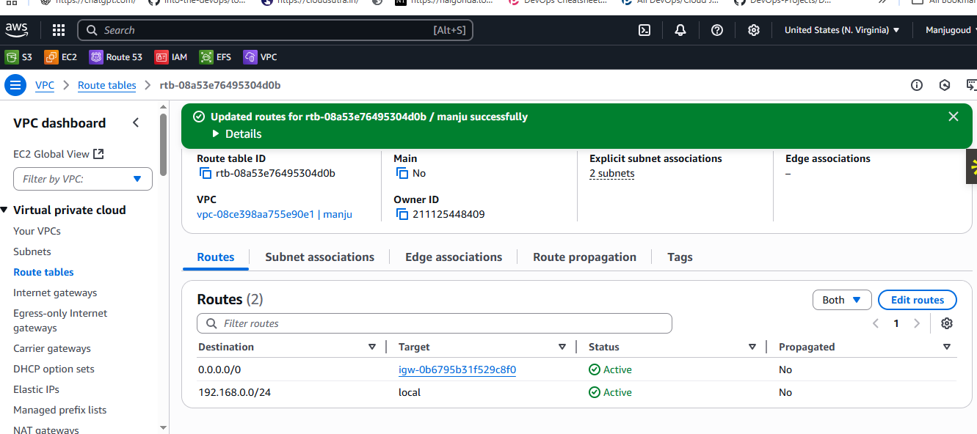

1. Create Ec2 in public subnet with t2micro and install php

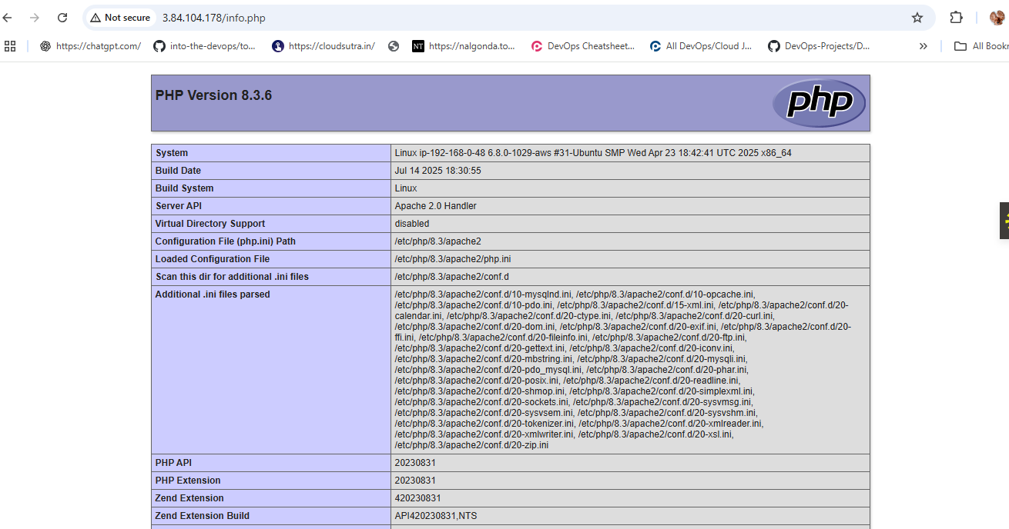here we created public insatance with public subnet and launched instance with VPC and installed apache and php and started the php.

1. Configure Nat gateway in public subnet and connect to private Instance

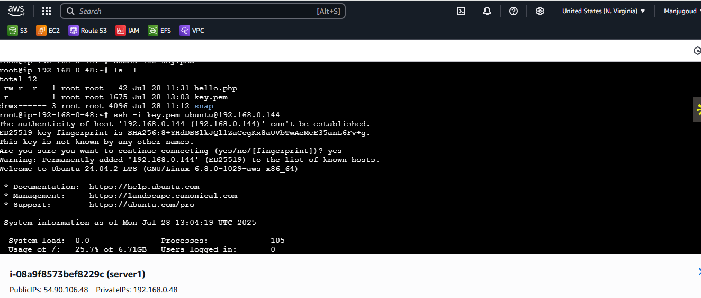

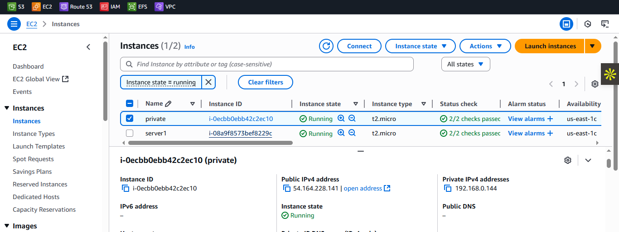here I created VPC and subnets(public and private),routetable(public and private),IGW, added IGW to public routetable,created NATgateway and added that NAT into public routetable.now launched 1 instances (public) In that we need to do [ping@192.168.0.144](mailto:ping@192.168.0.144) PRIVATE IP of private instance

1. Install Apache Tomcat in private ec2 and deploy a sample app.

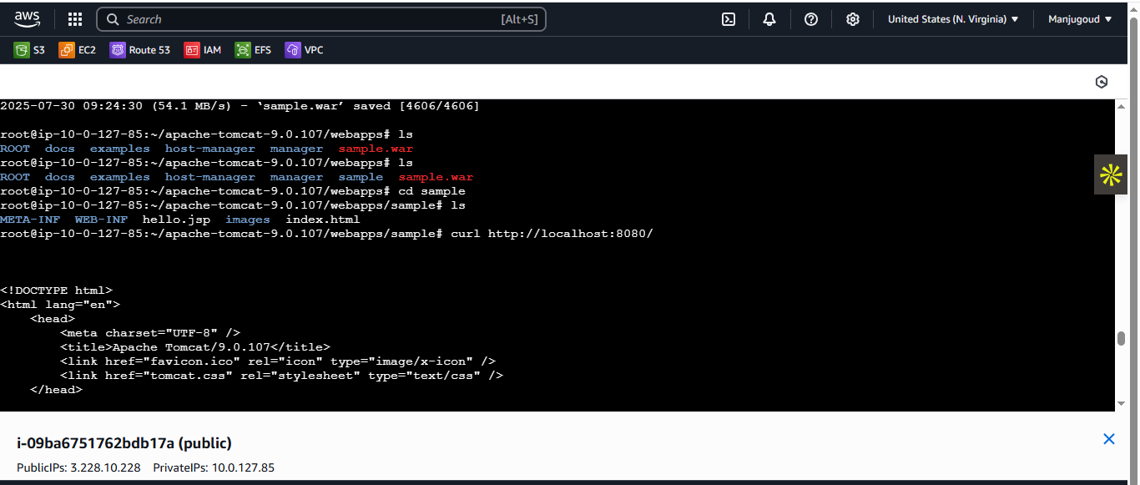

Her we created a VPC, 2 SUBNETS(PUBLIC AND Private),internetgateway should attached to public subnet,create 2 routetable(public,privte), Now create NAT GATEWAY select PUBLIC IP select connection as public and allocate ELasticIP. Now add natgateway and IGW in public routetable.AND add subnet associations for public and private. Now launch 2 instances one is public and another is private. Now SSH in public instance do PING@PRIVATE IP of private instance. Congrats you have connected insternet for private IP.In that we need to download TOMCAT and deploy sample app.

1. Configure VPC flow logs and store the logs in s3 and CloudWatch.

