VPC -02

1. Create one VPC,with 1 one public subnet and 1 private subnet.

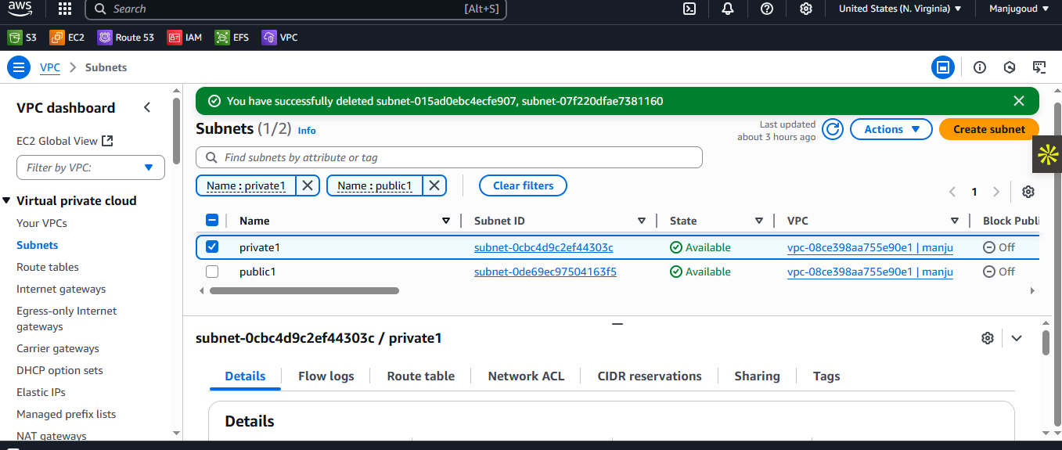

1. Enable VPC peering for cross region.

N.Virgina-Region

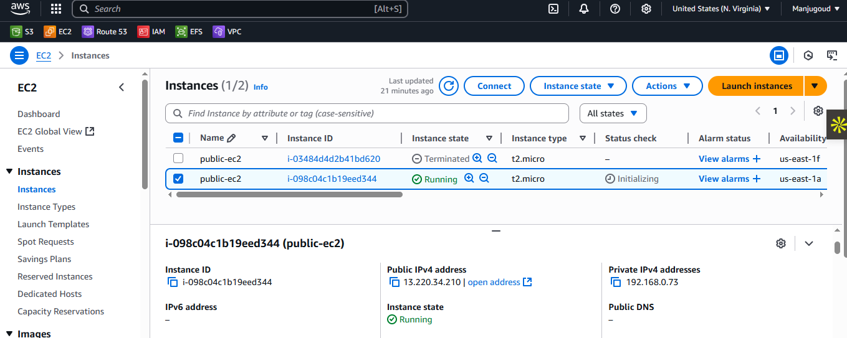

Ohio’s- Region

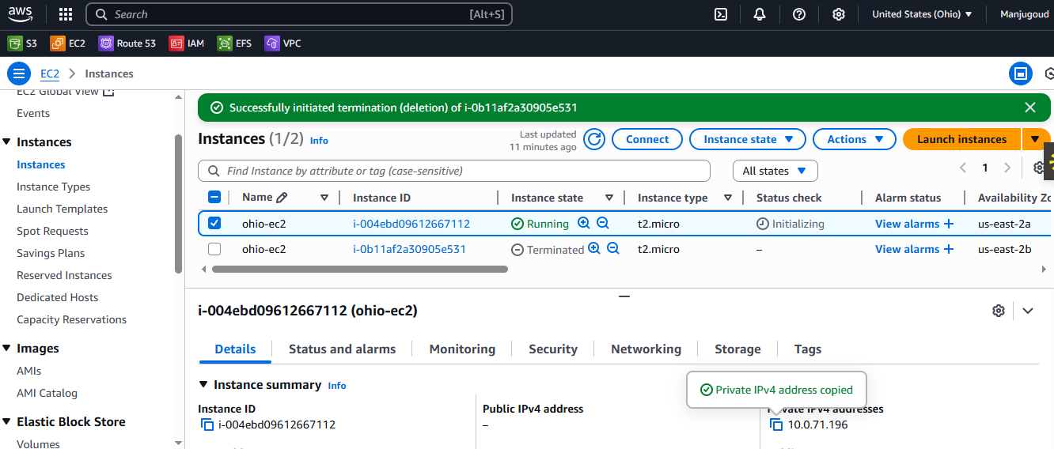

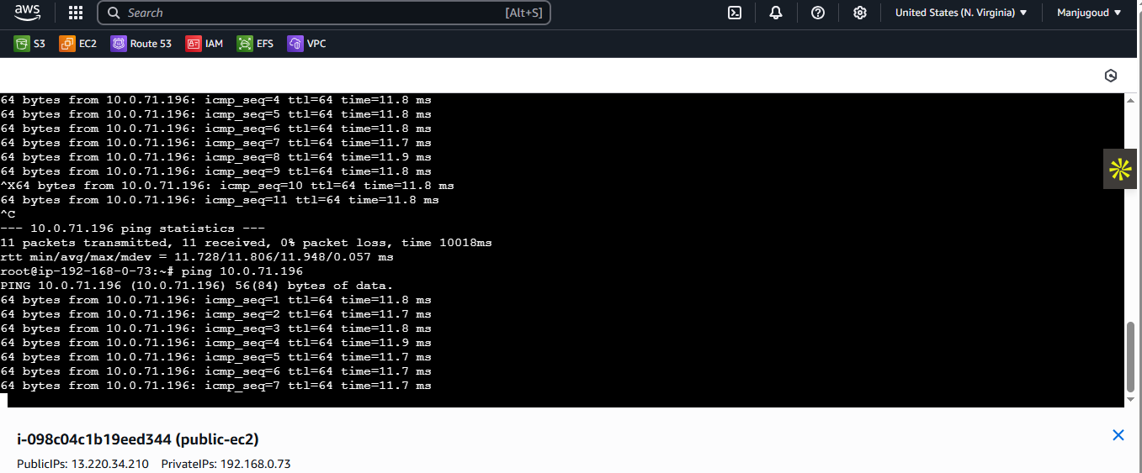

Here I launched VPC in both the regions and configured routetable, connected internet-gateway and created subnets. Next we need to create a peering connection and send the request to receiver region(ohio) and we need to accpt the request in ohio region, next we need to add route table in N.VIRGIINA(OHIO’S-CIDR IP) and in OHIO’S- routetable we need to add(N.VIRGINA’S-CIDR IP) and launch the instances in both of the region and now ssh the N.VIRGINA’S instance and do ping with private IP of OHIO’s

(\*\*\*\*imp\*\* we need to enable the ICMP-IPV4 in both the security group).

1. Enable VPC peering for cross account. (You can collaborate with your friend and do this task).

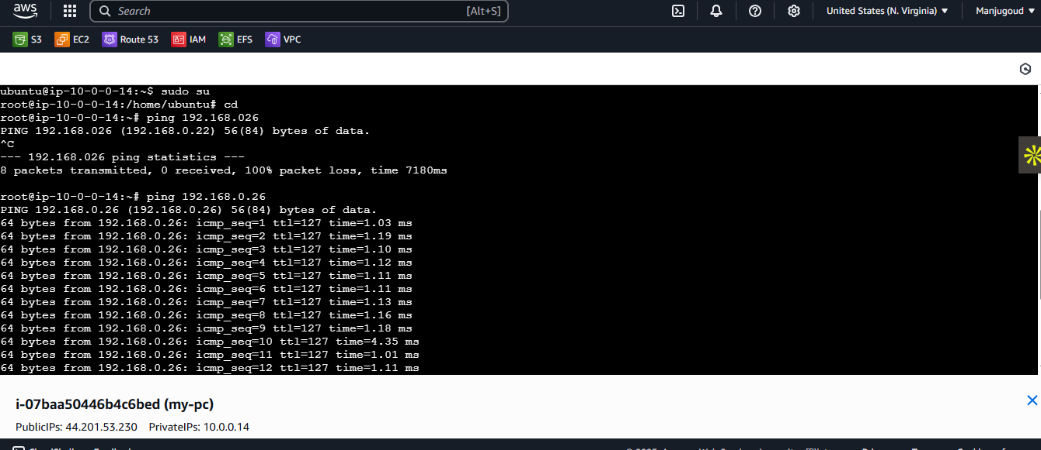

In this I had created a VPC and subnets, route-table, internet-gateway and I launched peering connection from one account to another and that another account’s of your VPC’ID and ACCOUNT ID of your friend. Next we need to add your frind’s CIDR IP to your route table add-PEERING CONNECTION and save.Now we need to launch an instance of public with subnet and with SG and launch. Do we need to do SSH and ping privateIP of your’s friend

4) Setup VPC Transist gateway.

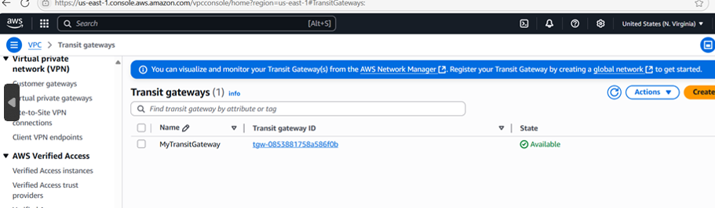

5) Setup VPC End Point..

