1. Install nginx and run nginx on port number 81.

Vi /etc/nginx/conf./nginx.conf

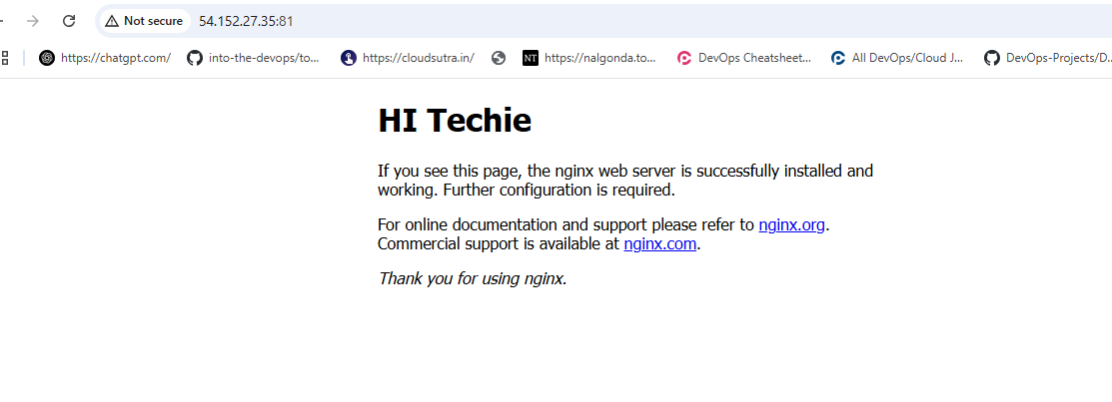

2) Deploy a sample index.html file on nginx.

Cd /usr/share/nginx/html

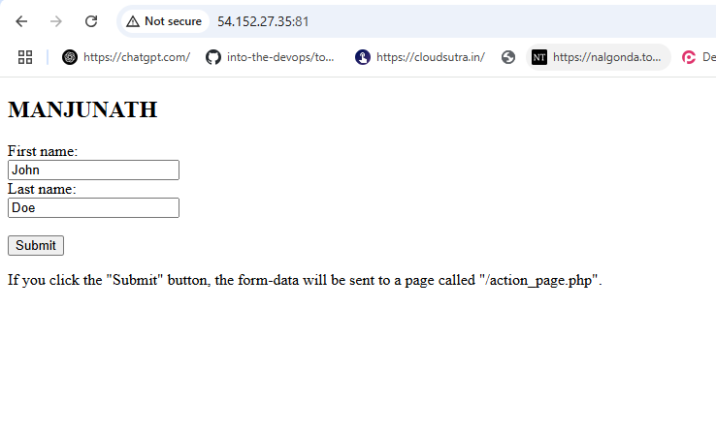

3) Install Apache and run Apache on port number 82



4) Deploy a sample index.html file on Apache.

Vi /var/www/html

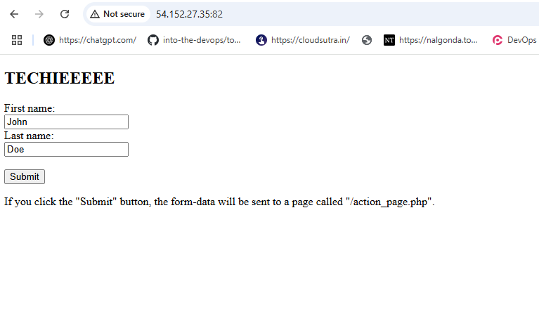

5) Install Apache tomcat on port number 8082

Cd conf/ 🡺 vi server.xml here we change port no

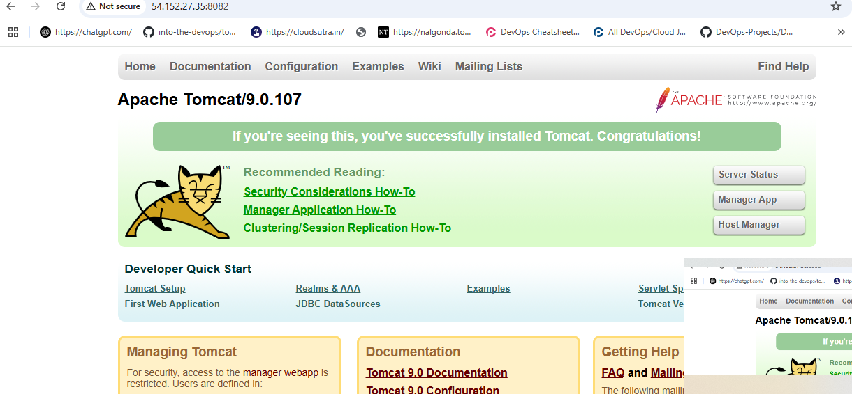

6) Deploy a sample app on webapps

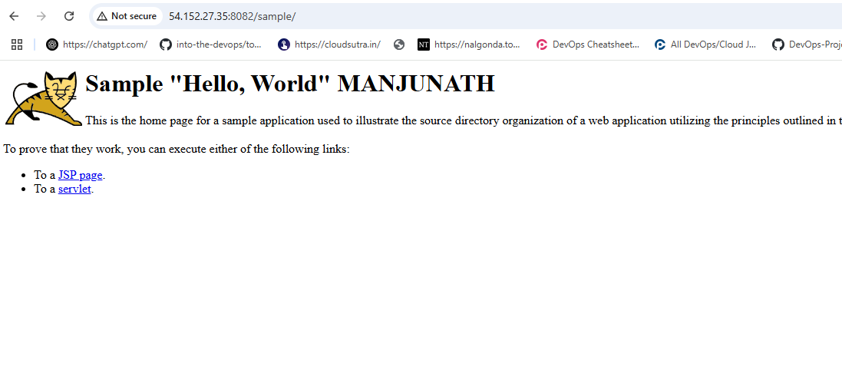

7) Create a tomcat.service file for tomcat.

To create a tomcat.service file we need toinstall tomcat first from wget url of tomcat and go to path sudo vi /etc/systemd/system/tomcat.service nxt we need to paste the tomcat service file from browser with java version included and the java version should match the tomcat.serice file

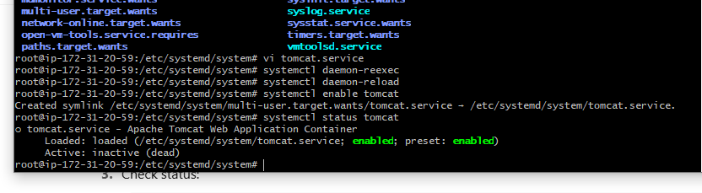

8) Configure HA Proxy server

Initially we need to launch 3 ec2 instances with names HA,APACHE,NGINX ssh the 3 instances and launch nginx, apache in both the instances and In third instance install HA proxy and configure it by using sudo nano /etc/conf/haproxy.conf and add front as port:80 and backend add apache and nginx’s public IP with port no:80 check and get exit and restart the HA proxy and now copy the HA public IP and paste in brwser with port80 and refresh it again and again you will get 2 servers serving in single IP add which is HA proxy’s IP.

