Angular 8

## What is Angular 8?

Angular 8 is a client-side TypeScript based framework which is used to create dynamic web applications. It is very similar to its previous versions except having some extensive features.

**These are the most prominent features of Angular 8:**

* Angular 8 supports TypeScript 3.4
* Angular 8 supports Web Workers
* The new compiler for Angular 8 is Ivy Rendering Engine
* Angular 8 provides dynamic imports for lazy-loaded modules.
* Improvement of ngUpgrade

# Angular 8 Introduction

Angular is the most popular JavaScript framework and platform for developing client-side (front-end) mobile and desktop web apps or single page applications (SPAs).

Angular community has released its latest version known as Angular 8. If you are familiar with previous version of Angular, it will not be difficult for you. You can easily upgrade your older version of Angular to latest version Angular 8.

## What is Angular 8?

Angular 8 is an open-source, client-side TypeScript based JavaScript framework. It is written in TypeScript and complied into JavaScript. Angular 8 is used to create **dynamic web applications**. It is very similar to its previous versions except having some extensive features.

### What is a dynamic web application?

A dynamic web application is simply a dynamic website. i.e. [www.gmail.com](https://www.gmail.com/), [www.facebook.com](https://www.facebook.com/), [www.yahoo.com](https://www.yahoo.com/) etc. which has a tendency to change data/information with respect to 3 parameters:

Hello Java Program for Beginners

* Time-to-time (eg. news update webs applications)
* Location-to-location (eg. Weather-report web applications)
* User-to-user (eg. Gmail, Facebook type applications)

## Angular Previous Versions

* **AngularJS (also known as Angular 1.0):** AngularJS is a JavaScript based open-source frontend web framework developed and maintained by Google. AngularJS can be added to an HTML page with a <script> tag. Because AngularJS was the first version of the Angular, so it is also known as Angular 1. AngularJS was first released on October 20, 2010 by a team of Google.
* **Angular 2:** Angular 2 was a complete rewrite of AngularJS. It was first released in May 2016 and the final version was released on September 14, 2016.
* **Angular 4:** Angular 4 was the updated version of Angular 2. The Google team skipped the Angular 3 to avoid the confusion due to the misalignment of the router package's version which was already distributed as v3.3.0.
* **Angular 5:** Angular 5 was the improved version of the previous one. It was released on November 1, 2017 and improved the support for progressive web apps.
* **Angular 6:** Angular 6 Angular 6 was released on May 4, 2018. It was a major released focused on ng update, ng add, Angular Elements, Angular Material + CDK Components, Angular Material Starter Components, CLI Workspaces, Library Support, Tree Shakable Providers, Animations Performance Improvements, and RxJS v6.
* **Angular 7:** Angular 7 was released on October 18, 2018. It was focused on Application Performance, Angular Material & CDK, Virtual Scrolling, Improved Accessibility etc.
* **Angular 8:** Angular 8 is the latest version running nowadays. Angular 8 is released on May 28, 2019. It is mainly focused on Differential loading, Dynamic imports for lazy routes, web workers and Angular Ivy as an opt-in support. It also supports TypeScript 3.4.

# Features and Advantages of Angular 8

The Angular community has released its latest version Angular 8 with an impressive list of changes and improvements including the much awaited Ivy compiler as an opt-in feature.

**Most prominent features of Angular 8:**

* Support TypeScript 3.4
* Supports Web Workers
* Preview of Ivy available
* Lazy loading
* Improvement of ngUpgrade

## TypeScript 3.4

Angular 8 supports TypeScript 3.4 and it is required to run your Angular 8 project. So, you have to upgrade your TypeScript version to 3.4. TypeScript 3.4 introduces a new flag called --incremental. The incremental tells TypeScript to save information about the project graph from the last compilation. Every time the TypeScript is invoked with --incremental, it will use that information to detect the least costly way to type-check and emit changes to your project.

## Web workers class

JavaScript is single threaded, so it is common for more critical tasks like data calls to take place asynchronously. Web Workers facilitates you to run the CPU intensive computations in the background thread, freeing the main thread to update the user interface.

Web workers can also be helpful, if your application is unresponsive while processing data.

If you want to outsource such a calculation to a background, we must first create the web worker using the Angular CLI.

## Preview of Ivy and Bazel available

After the release of Angular 8, a preview version of Ivy is now available for testing. Ivy is the new rendering engine that produces small bundle size and Bazel is the new build system. Both are ready for proper use with Angular 8. The preview of these two should be available shortly. Ivy is a new compiler/runtime of Angular and Angular 8 is a first release to offer a switch to opt-in into Ivy officially.

To use Ivy in your project, you can instruct the Angular CLI to enable Ivy in your project using the --enable-ivy switch:

1. $ ng new angular-project --enable-ivy

Ivy is supposed to be a by default rendering engine in Angular version 9.

Bazel provides one of the newest features of Angular 8 as a possibility to build your CLI application more quickly.

**The main advantages of Bazel are:**

* The incremental build and tests.
* It provides a chance to make your backends and frontends with a same tool.
* It has a possibility to have remote builds and cache on the build farm.
* Dynamic imports for lazy-loaded modules

## Lazy Loading

Angular 8 facilitates you to use standard dynamic import syntax instead of a custom string for lazy-loaded modules.

**It means lazy-loaded import that looked like this:**

1. { path: '/student', loadChildren: './student/student.module#StudentModule' }

**Will be looked like this:**

1. { path: '/student', loadChildren: () =**>** import('./student/student.module').then(s =**>** s.StudentModule) }

## Improvement of ngUpgrade

The Angular CLI is continuously improving. Now, the ng build, ng test and ng run are equipped by 3rd-party libraries and tool. For example, AngularFire already makes use of these new capabilities with a deploy command.

# Angular 8 Installation

(How to install Angular 8 or Angular 8 Environment setup)

Before to setup environment for Angular development using the Angular CLI tool, you must have installed Node.js on your system and set a development environment and npm package manager.

## Install Node.js

Angular requires Node.js version 10.9.0 or later. You can download it from <https://nodejs.org/en/>

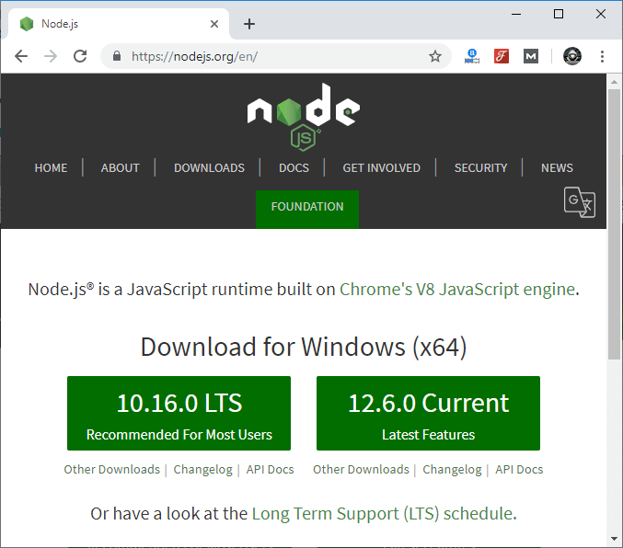

After downloading, you have to install it on your system.

HTML Tutorial

See how to install Node.js on Windows: [**Click Here**](https://www.javatpoint.com/install-nodejs)

See how to install Node.js on Linux/ Ubuntu/ CentOS: [**Click Here**](https://www.javatpoint.com/install-nodejs-on-linux-ubuntu-centos)

Once you have installed Node.js on your system, open node.js command prompt.

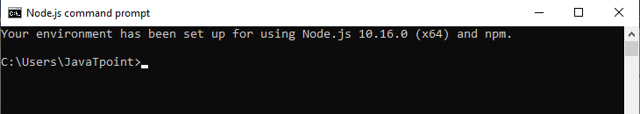

* To check your version, run **node -v** in a terminal/console window.

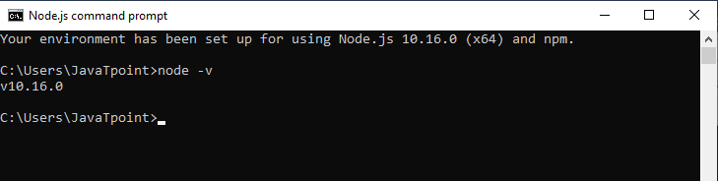

## Use npm to Install Angular CLI

Use the following command to install Angular CLI

1. npm install -g @angular/cli

Or

1. npm install -g @angular/cli@latest

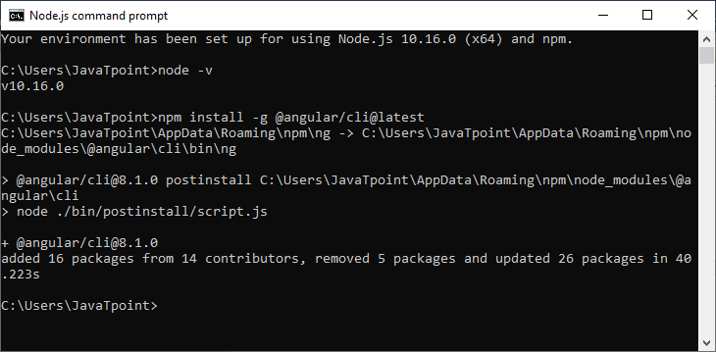

Or

Just go to Angular CLI official website <https://cli.angular.io/>

You will see the whole cli command to create an Angular app. You need to run the first command to install Angular CLI. These steps are same for Windows and Mac.

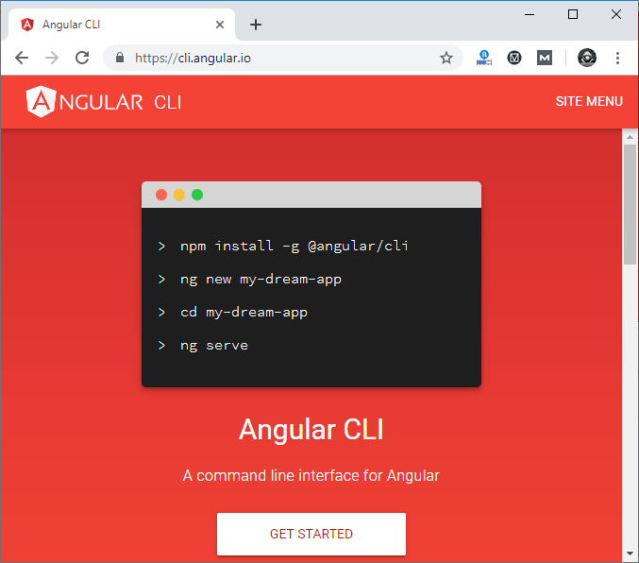

## Check your Installed versions

* To check Node and Angular CLI version, use ng --version command.

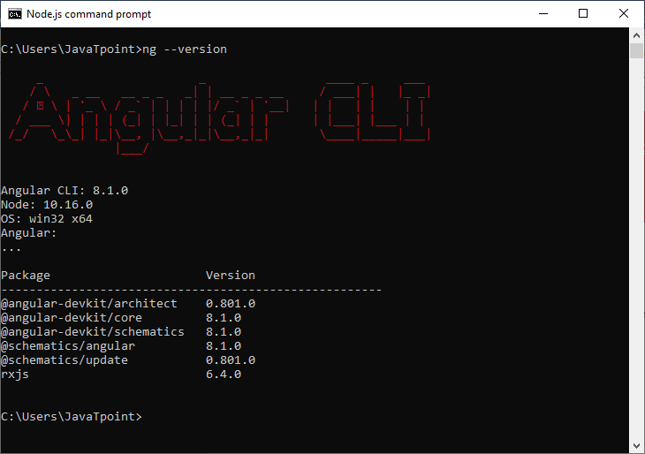

Now, Angular 8 is installed on your system.