What is TypeScript?

TypeScript is an open-source pure object-oriented programing language. It is a strongly typed superset of JavaScript which compiles to plain JavaScript. It contains all elements of the JavaScript. It is a language designed for large-scale JavaScript application development, which can be executed on any browser, any Host, and any Operating System. The TypeScript is a language as well as a set of tools. TypeScript is the ES6 version of JavaScript with some additional features.

TypeScript Introduction

TypeScript cannot run directly on the browser. It needs a compiler to compile the file and generate it in JavaScript file, which can run directly on the browser. The TypeScript source file is in ".ts" extension. We can use any valid ".js" file by renaming it to ".ts" file. TypeScript uses TSC (TypeScript Compiler) compiler, which convert Typescript code (.ts file) to JavaScript (.js file).

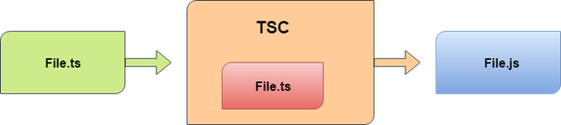

## Why use TypeScript?

We use TypeScript because of the following benefits.

* TypeScript supports Static typing, Strongly type, Modules, Optional Parameters, etc.
* TypeScript supports object-oriented programming features such as classes, interfaces, inheritance, generics, etc.
* TypeScript is fast, simple, and most importantly, easy to learn.
* TypeScript provides the error-checking feature at compilation time. It will compile the code, and if any error found, then it highlighted the mistakes before the script is run.
* TypeScript supports all JavaScript libraries because it is the superset of JavaScript.
* TypeScript support reusability because of the inheritance.
* TypeScript make app development quick and easy as possible, and the tooling support of TypeScript gives us autocompletion, type checking, and source documentation.
* TypeScript has a definition file with .d.ts extension to provide a definition for external JavaScript libraries.
* TypeScript supports the latest JavaScript features, including ECMAScript 2015.
* TypeScript gives all the benefits of ES6 plus more productivity.
* Developers can save a lot of time with TypeScript.

|  |  |
| --- | --- |
| **JavaScript** | **TypeScript** |
| 1. | It doesn't support strongly typed or static typing. | It supports strongly  typed or static typing  feature. |
| 2. | Netscape developed it in 1995. | Anders Hejlsberg  developed  it in 2012. |
| 3. | JavaScript source file is in ".js" extension. | TypeScript source  file is in ".ts"  extension. |
| 4. | It is directly run on the browser. | It is not directly  run on the  browser. |
| 5. | It is just a scripting language. | It supports  object-oriented  programming concept like classes, interfaces, inheritance, generics, etc. |
| 6. | It doesn't support optional parameters. | It supports optional  parameters. |
| 7. | It is interpreted language that's why it highlighted the errors at runtime. | It compiles the code and  highlighted errors during the development time. |
| 8. | JavaScript doesn't support modules. | TypeScript gives support  for modules. |
| 9. | In this, number, string are the objects. | In this, number,  string are the interface. |
| 10. | JavaScript doesn't support generics. | TypeScript supports  generics. |
| 11. | **Example:**  <script>  function addNumbers(a, b) {  return a + b;  }  var sum = addNumbers(15, 25);  document.write('Sum of the numbers is: ' + sum);  </script> | **Example:**  function  addNumbers(a, b) {  return a + b;  }  var sum =  addNumbers(15, 25);  console.lo |

# Features of TypeScript

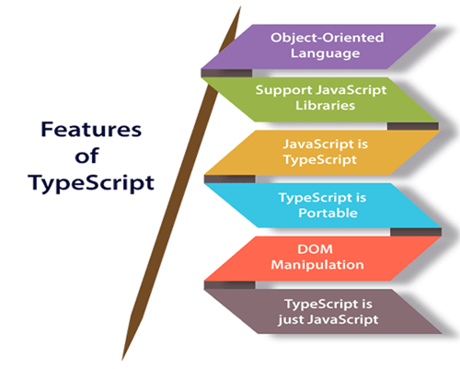

# TypeScript Installation

In this section, we will learn how to install TypeScript, pre-requisites before installation of TypeScript, and in how many ways we can install TypeScript.

### Pre-requisite to install TypeScript

1. Text Editor or IDE
2. Node.js Package Manager (npm)
3. The TypeScript compiler

### Ways to install TypeScript

There are two ways to install TypeScript:

1. Install TypeScript using Node.js Package Manager (npm).
2. Install the TypeScript plug-in in your IDE (Integrated Development Environment).

### Install TypeScript using Node.js Package Manager (npm)

**Step-1** Install Node.js. It is used to setup TypeScript on our local computer.

To install Node.js on Windows, go to the following link: [**https://www.javatpoint.com/install-nodejs**](https://www.javatpoint.com/install-nodejs)

19.7M

414

Java Try Catch

To install Node.js in Linux/Ubuntu/CentOS, go to the following link: [**https://www.javatpoint.com/install-nodejs-on-linux-ubuntu-centos**](https://www.javatpoint.com/install-nodejs-on-linux-ubuntu-centos)

To verify the installation was successful, enter the following command in the Terminal Window.

1. $ node -v
2. $ npm -v

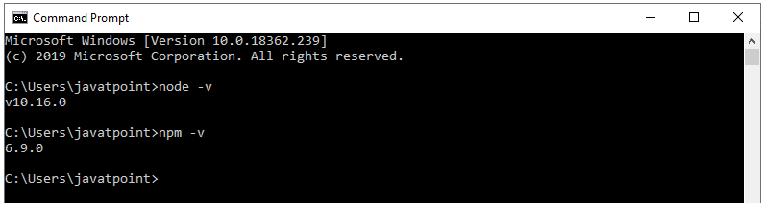

**Step-2** Install TypeScript. To install TypeScript, enter the following command in the Terminal Window.

1. $ npm install typescript --save-dev         //As dev dependency
2. $ npm install typescript -g                      //Install as a global module
3. $ npm install typescript@latest -g          //Install latest if you have an older version

**Step-3** To verify the installation was successful, enter the command **$ tsc -v** in the Terminal Window.

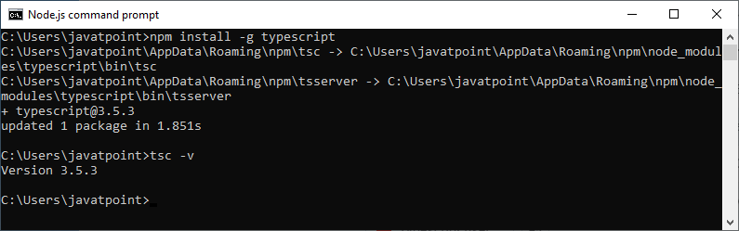

### Install TypeScript plug-in in your IDE

**Step-1** Install IDE like Eclipse, Visual Studio, WebStorm, Atom, Sublime Text, etc. Here, we install Eclipse. To install Eclipse, go to the following link:

**In Windows:** [**https://www.javatpoint.com/javafx-how-to-install-eclipse**](https://www.javatpoint.com/javafx-how-to-install-eclipse)

**In Ubantu:** [**https://www.javatpoint.com/how-to-install-eclipse-in-ubuntu**](https://www.javatpoint.com/how-to-install-eclipse-in-ubuntu)

**In CentOS:** [**https://www.javatpoint.com/how-to-install-eclipse-on-centos**](https://www.javatpoint.com/how-to-install-eclipse-on-centos)

**Step-2** Install TypeScript plug-in.

* Open Eclipse and go to **Help->Eclipse Market Place**.
* Search for **TypeScript** and choose **TypeScript IDE**, Click Install.

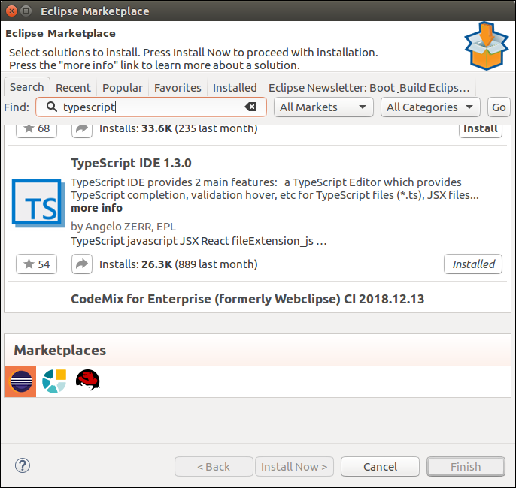

* In the next window, select **Features** which you want to install, and click **Confirm**.
* A new window will open, select **Accept Terms and Condition**, Click **Next**, and follow the on-screen instructions.
* Now **restart** Eclipse. To verify the TypeScript, go to **New->Other->TypeScript**. Once the TypeScript shows in the window, it means that TypeScript is successfully installed on your machine.

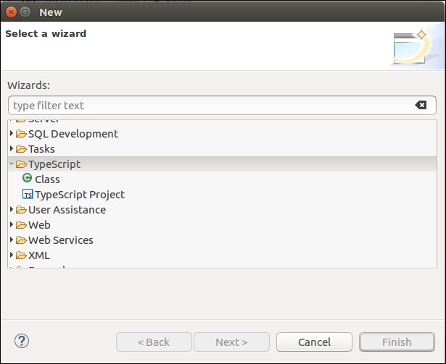

## Online Compiler for TypeScript

We can also run our script online with the official compiler. To do this, go to the below link. [**https://www.typescriptlang.org/play/index.html**](https://www.typescriptlang.org/play/index.html)

The following screen appears. Now, you can do any TypeScript program on this.

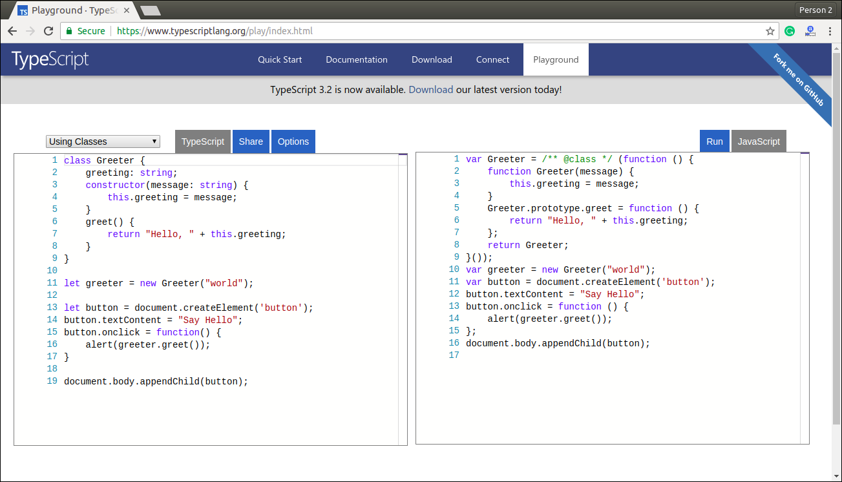

# ypeScript First Program

In this section, we are going to learn how we can write a program in TypeScript, how to compile it, and how to run it. Also, we will see how to compiles the program and shows the error, if any.

Let us write a program in the text editor, save it, compile it, run it, and display the output to the console. To do this, we need to perform the following steps.

**Step-1** Open the Text Editor and write/copy the following code.

1. function greeter(person) {
2. **return** "Hello, " + person;
3. }
4. let user = 'JavaTpoint';
5. console.log(greeter(user));

**Step-2** Save the above file as "**.ts**" extension.

**Step-3** Compile the TypeScript code. To compile the source code, open the **command prompt**, and then goes to the file directory location where we saved the above file. For example, if we save the file on the desktop, go to the terminal window and type: - **cd Desktop/folder_name**. Now, type the following command tsc **filename.ts** for compilation and press **Enter**.

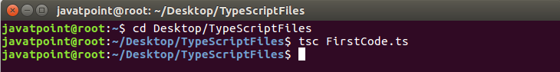

It will generate JavaScript file with ".js" extension at the same location where the TypeScript source file exists. The below ".js" file is the output of TypeScript (.ts) file.

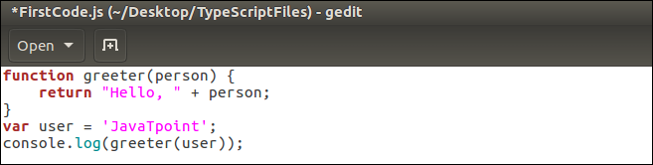

#### NOTE: If we directly run ".ts" file on the web browser, it will throw an error message. But after the compilation of ".ts" file, we will get a ".js" file, which can be executed on any browser.

**Step-4** Now, to run the above JavaScript file, type the following command in the terminal window: node filename.js and press Enter. It gives us the final output as:

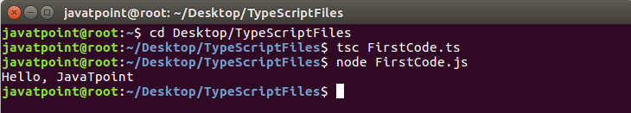

## Compile-Time error

TypeScript always gives an error at compilation time. For this, we need to write the program in TypeScript, compile it, and see the error, if found.

**Step 1** Open the Text Editor and write/copy the following code.

1. function addNumbers(a, b) {
2. **return** a + b;
3. }
4. var sum = addNumbers("JavaTpoint", 25);
5. console.log('Sum of the numbers is: ' + sum);

**Step-2** Save the above file as "**.ts**" extension.

**Step-3** Compile the TypeScript code. To compile the source code, open the **command prompt**, and then goes to the file directory location where we saved the above file. For example, if we save the file on the desktop, go to the terminal window and type: - **cd Desktop/folder_name**. Now, type the following command **tsc filename.ts** for compilation and press **Enter**.

This TypeScript source file will generate an error which can be shown in the following image.

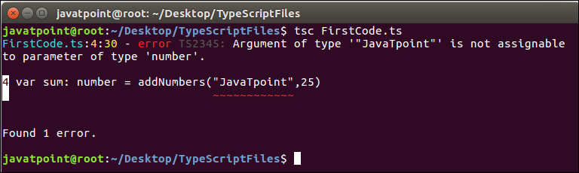

#### NOTE: This program gives an error because we were taking the variable "a" and "b" as of number type. But, we were passing the variable "a" as the string and variable "b" as the number.