What is Cloud Computing

The term cloud refers to a network or the internet. It is a technology that uses remote servers on the internet to store, manage, and access data online rather than local drives. The data can be anything such as files, images, documents, audio, video, and more.

## Why Cloud Computing?

Small as well as large IT companies, follow the traditional methods to provide the IT infrastructure. That means **for any IT company, we need a Server Room that is the basic need of IT companies**.

In that server room, there should be a database server, mail server, networking, firewalls, routers, modem, switches, QPS (Query Per Second means how much queries or load will be handled by the server), configurable system, high net speed, and the maintenance engineers.

To establish such IT infrastructure, we need to spend lots of money. To overcome all these problems and to reduce the IT infrastructure cost, Cloud Computing comes into existence.

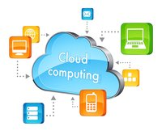

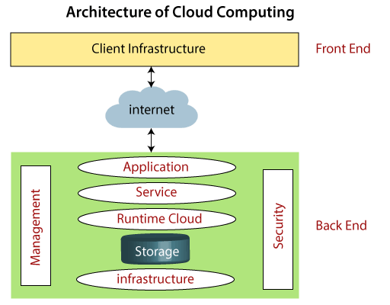

### Front End

The front end is used by the client. It contains client-side interfaces and applications that are required to access the cloud computing platforms. The front end includes web servers (including Chrome, Firefox, internet explorer, etc.), thin & fat clients, tablets, and mobile devices.

### Back End

The back end is used by the service provider. It manages all the resources that are required to provide cloud computing services. It includes a huge amount of data storage, security mechanism, virtual machines, deploying models, servers, traffic control mechanisms, etc.

#### Note: Both front end and back end are connected to others through a network, generally using the internet connection.

## Components of Cloud Computing Architecture

There are the following components of cloud computing architecture -

**1. Client Infrastructure**

Client Infrastructure is a Front end component. It provides GUI (Graphical User Interface)  to interact with the cloud.

**2. Application**

The application may be any software or platform that a client wants to access.

**3. Service**

A Cloud Services manages that which type of service you access according to the client’s requirement.

Cloud computing offers the following three type of services:

**i. Software as a Service (SaaS) –**It is also known as **cloud application services**. Mostly, SaaS applications run directly through the web browser means we do not require to download and install these applications. Some important example of SaaS is given below –

**Example:** Google Apps, Salesforce Dropbox, Slack, Hubspot, Cisco WebEx.

**ii. Platform as a Service (PaaS) –** It is also known as **cloud platform** **services**. It is quite similar to SaaS, but the difference is that PaaS provides a platform for software creation, but using SaaS, we can access software over the internet without the need of any platform.

**Example:** Windows Azure, Force.com, Magento Commerce Cloud, OpenShift.

**iii. Infrastructure as a Service (IaaS) –**It is also known as **cloud infrastructure services**. It is responsible for managing applications data, middleware, and runtime environments.

**Example:** Amazon Web Services (AWS) EC2, Google Compute Engine (GCE), Cisco Metapod.

**4. Runtime Cloud**

Runtime Cloud provides the **execution and runtime environment** to the virtual machines.

**5. Storage**

Storage is one of the most important components of cloud computing. It provides a huge amount of storage capacity in the cloud to store and manage data.

**6. Infrastructure**

It provides services on the **host level**, **application level**, and **network level**. Cloud infrastructure includes hardware and software components such as servers, storage, network devices, virtualization software, and other storage resources that are needed to support the cloud computing model.

**7. Management**

Management is used to manage components such as application, service, runtime cloud, storage, infrastructure, and other security issues in the backend and establish coordination between them.

**8. Security**

Security is an in-built back end component of cloud computing. It implements a security mechanism in the back end.

**9. Internet**

The Internet is medium through which front end and back end can interact and communicate with each other.

# How does cloud computing work

Assume that you are an executive at a very big corporation. Your particular responsibilities include to make sure that all of your employees have the right hardware and software they need to do their jobs. To buy computers for everyone is not enough. You also have to purchase software as well as software licenses and then provide these softwares to your employees as they require. Whenever you hire a new employee, you need to buy more software or make sure your current software license allows another user. It is so stressful that you have to spend lots of money.

But, there may be an alternative for executives like you. So, instead of installing a suite of software for each computer, you just need to load one application. That application will allow the employees to log-in into a Web-based service which hosts all the programs for the user that is required for his/her job. Remote servers owned by another company and that will run everything from e-mail to word processing to complex data analysis programs. It is called cloud computing, and it could change the entire computer industry.

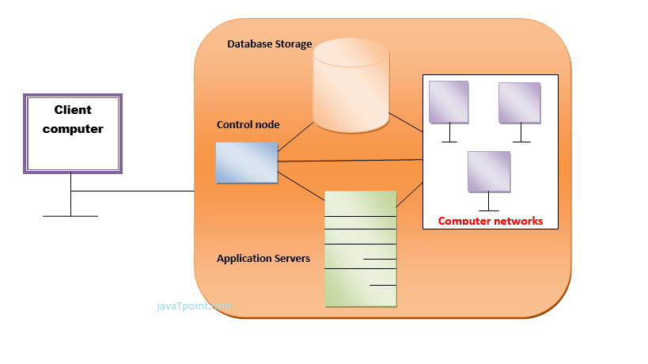

In a cloud computing system, there is a significant workload shift. Local computers have no longer to do all the heavy lifting when it comes to run applications. But cloud computing can handle that much heavy load easily and automatically. Hardware and software demands on the user's side decrease. The only thing the user's computer requires to be able to run is the cloud computing interface software of the system, which can be as simple as a Web browser and the cloud's network takes care of the rest.

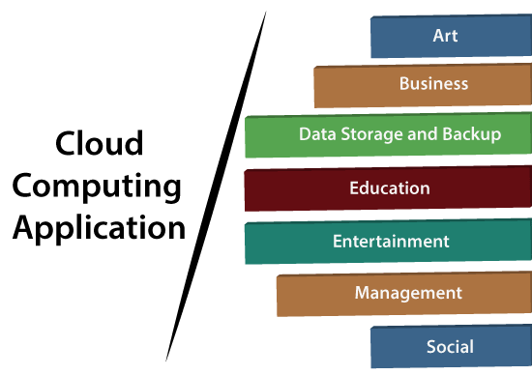

# Types of Cloud

There are the following 4 types of cloud that you can deploy according to the organization's needs-

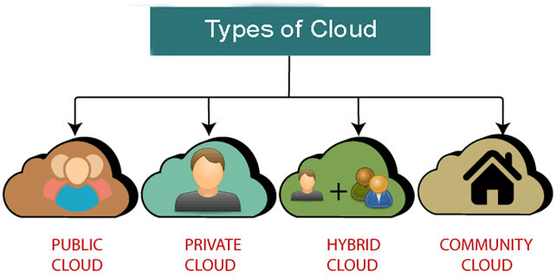

* [Public Cloud](https://www.javatpoint.com/types-of-cloud#Public)
* [Private Cloud](https://www.javatpoint.com/types-of-cloud#Private)
* [Hybrid Cloud](https://www.javatpoint.com/types-of-cloud#Hybrid)
* [Community Cloud](https://www.javatpoint.com/types-of-cloud#Community)

## Public Cloud

Public cloud is **open to all** to store and access information via the Internet using the pay-per-usage method.

In public cloud, computing resources are managed and operated by the Cloud Service Provider (CSP).

**Example:** Amazon elastic compute cloud (EC2), IBM SmartCloud Enterprise, Microsoft, Google App Engine, Windows Azure Services Platform.

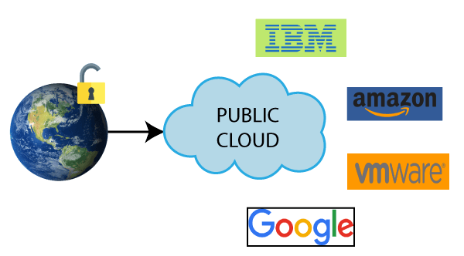

### Advantages of Public Cloud

There are the following advantages of Public Cloud -

* Public cloud is owned at a lower cost than the private and hybrid cloud.
* Public cloud is maintained by the cloud service provider, so do not need to worry about the maintenance.
* Public cloud is easier to integrate. Hence it offers a better flexibility approach to consumers.
* Public cloud is location independent because its services are delivered through the internet.
* Public cloud is highly scalable as per the requirement of computing resources.
* It is accessible by the general public, so there is no limit to the number of users.

### Disadvantages of Public Cloud

* Public Cloud is less secure because resources are shared publicly.
* Performance depends upon the high-speed internet network link to the cloud provider.
* The Client has no control of data.

**To Read More** [**Click Here**](https://www.javatpoint.com/public-cloud)

## Private Cloud

Private cloud is also known as an **internal cloud** or **corporate cloud**. It is used by organizations to build and manage their own data centers internally or by the third party. It can be deployed using Opensource tools such as Openstack and Eucalyptus.

Based on the location and management, National Institute of Standards and Technology (NIST) divide private cloud into the following two parts-

* On-premise private cloud
* Outsourced private cloud

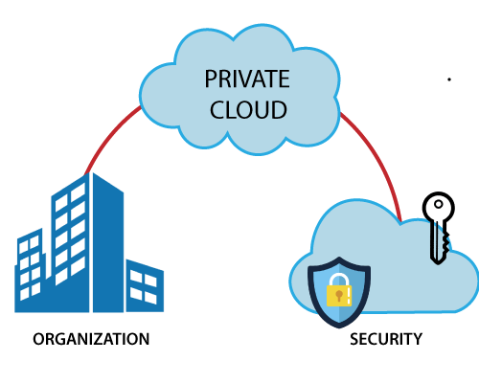

### Advantages of Private Cloud

There are the following advantages of the Private Cloud -

* Private cloud provides a high level of security and privacy to the users.
* Private cloud offers better performance with improved speed and space capacity.
* It allows the IT team to quickly allocate and deliver on-demand IT resources.
* The organization has full control over the cloud because it is managed by the organization itself. So, there is no need for the organization to depends on anybody.
* It is suitable for organizations that require a separate cloud for their personal use and data security is the first priority.

### Disadvantages of Private Cloud

* Skilled people are required to manage and operate cloud services.
* Private cloud is accessible within the organization, so the area of operations is limited.
* Private cloud is not suitable for organizations that have a high user base, and organizations that do not have the prebuilt infrastructure, sufficient manpower to maintain and manage the cloud.

**To Read More** [**Click Here**](https://www.javatpoint.com/private-cloud)

## Hybrid Cloud

Hybrid Cloud is a combination of the public cloud and the private cloud. we can say:

**Hybrid Cloud = Public Cloud + Private Cloud**

Hybrid cloud is partially secure because the services which are running on the public cloud can be accessed by anyone, while the services which are running on a private cloud can be accessed only by the organization's users.

**Example:** Google Application Suite (Gmail, Google Apps, and Google Drive), Office 365 (MS Office on the Web and One Drive), Amazon Web Services.

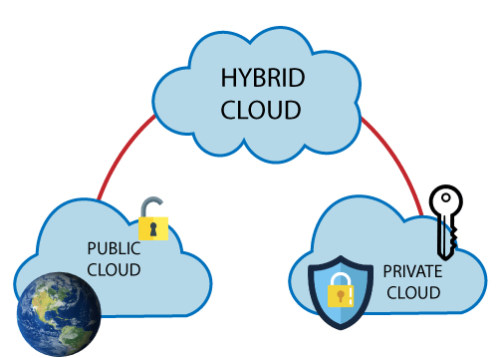

### Advantages of Hybrid Cloud

There are the following advantages of Hybrid Cloud -

* Hybrid cloud is suitable for organizations that require more security than the public cloud.
* Hybrid cloud helps you to deliver new products and services more quickly.
* Hybrid cloud provides an excellent way to reduce the risk.
* Hybrid cloud offers flexible resources because of the public cloud and secure resources because of the private cloud.

### Disadvantages of Hybrid Cloud

* In Hybrid Cloud, security feature is not as good as the private cloud.
* Managing a hybrid cloud is complex because it is difficult to manage more than one type of deployment model.
* In the hybrid cloud, the reliability of the services depends on cloud service providers.

**To Read More** [**Click Here**](https://www.javatpoint.com/hybrid-cloud)

## Community Cloud

Community cloud allows systems and services to be accessible by a group of several organizations to share the information between the organization and a specific community. It is owned, managed, and operated by one or more organizations in the community, a third party, or a combination of them.

**Example:** Health Care community cloud

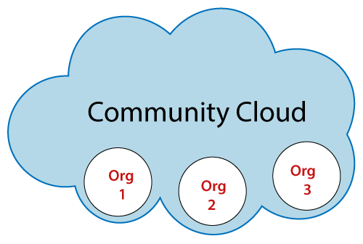

### Advantages of Community Cloud

There are the following advantages of Community Cloud -

* Community cloud is cost-effective because the whole cloud is being shared by several organizations or communities.
* Community cloud is suitable for organizations that want to have a collaborative cloud with more security features than the public cloud.
* It provides better security than the public cloud.
* It provdes collaborative and distributive environment.
* Community cloud allows us to share cloud resources, infrastructure, and other capabilities among various organizations.

### Disadvantages of Community Cloud

* Community cloud is not a good choice for every organization.
* Security features are not as good as the private cloud.
* It is not suitable if there is no collaboration.
* The fixed amount of data storage and bandwidth is shared among all community members

## What is Cloud Computing?

Cloud computing is a term referred to storing and accessing data over the internet. It doesn’t store any data on the hard disk of your personal computer. In cloud computing, you can access data from a remote server.

## What is AWS?

The full form of AWS is Amazon Web Services. It is a platform that offers flexible, reliable, scalable, easy-to-use and, cost-effective cloud computing solutions.

AWS is a comprehensive, easy to use computing platform offered Amazon. The platform is developed with a combination of infrastructure as a service (IaaS), platform as a service (PaaS) and packaged software as a service (SaaS) offerings.

## Important AWS Services

Amazon Web Services offers a wide range of different business purpose global cloud-based products. The products include storage, databases, analytics, networking, mobile, development tools, enterprise applications, with a pay-as-you-go pricing model.

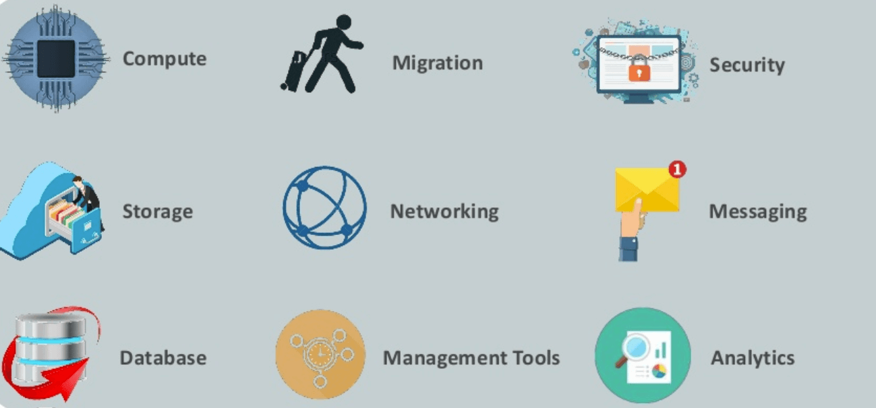Important AWS Services

**Here, are essential AWS services.**

### AWS Compute Services

Here, are Cloud Compute Services offered by Amazon:

26.9M

246

How to write a TEST CASE Software Testing Tutorial

1. **EC2(Elastic Compute Cloud)-** EC2 is a virtual machine in the cloud on which you have OS level control. You can run this cloud server whenever you want.
2. **LightSail-** This cloud computing tool automatically deploys and manages the computer, storage, and networking capabilities required to run your applications.
3. **Elastic Beanstalk-** The tool offers automated deployment and provisioning of resources like a highly scalable production website.
4. **EKS (Elastic Container Service for Kubernetes)-** The tool allows you toKubernetes on Amazon cloud environment without installation.
5. **AWS Lambda-** ThisAWS service allows you to run functions in the cloud. The tool is a big cost saver for you as you to pay only when your functions execute.