**BATCH**- **2**

**iBOUTIQUE SHOP**

**ENTITY RELATIONSHIP DIAGRAM**

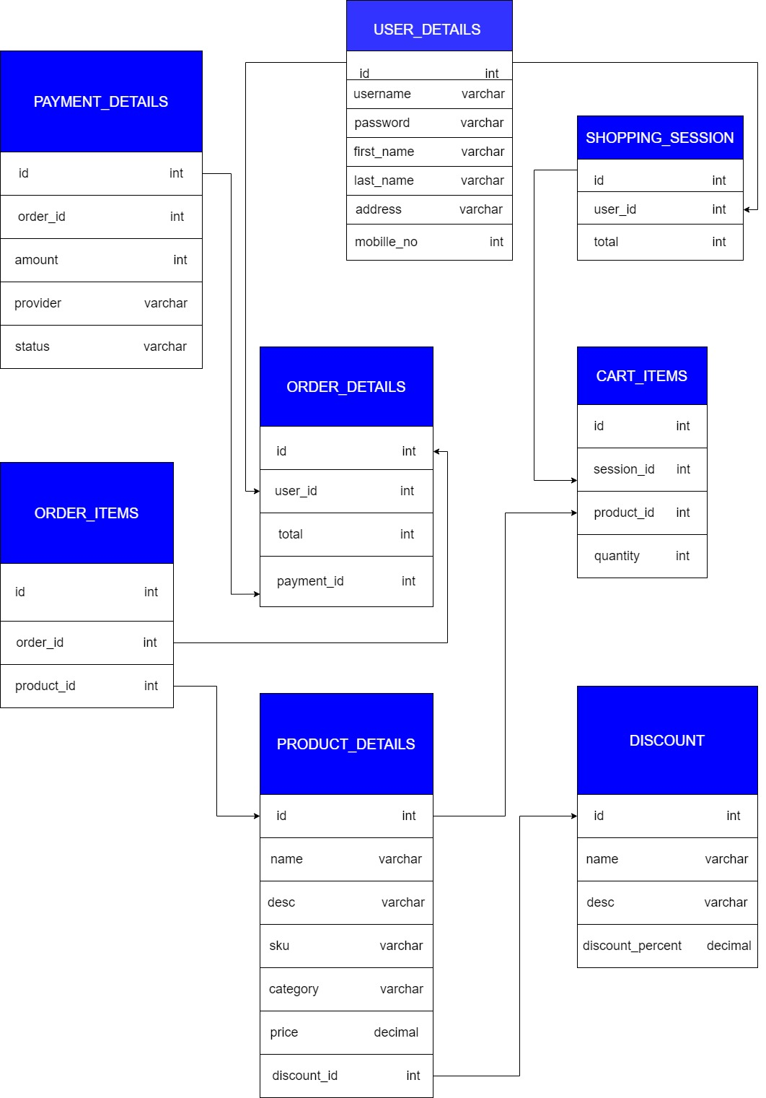

**DATABASE**

create table user_table (user_id int primary key,

username varchar(45) unique not null,

password varchar(45) not null ,

first_name varchar(45) not null ,

last_name varchar(45) not null ,

address varchar(55) not null ,

mobile_no numeric(13) unique not null);

create table shopping_session(shopping_id int primary key ,

user_id int not null ,

total int not null,

foreign key (user_id) references user_table(user_id));

create table discount (discount_id int primary key,

dis_name varchar(45) not null,

dis_desc varchar(500) not null,

discount_percentage int not null);

create table product ( product_id int primary key,

pro_name varchar(45) not null ,

pro_desc varchar(500) not null ,

sku varchar(50) not null ,

category varchar(500) not null,

price int not null,

discount_id int,

foreign key (discount_id) references discount (discount_id));

create table cart_item (cart_id int not null ,

shopping_id int ,

product_id int,

foreign key(shopping_id) references shopping_session(shopping_id),

foreign key(product_id) references product(product_id));

create table payments_details (payment_id int primary key ,

order_details_id int not null ,

amount int not null,

provider varchar(45) not null,

status varchar(45) not null);

create table order_details(order_details_id int primary key ,

user_id int ,

total int not null,

payment_id int ,

foreign key (payment_id) references payments_details (payment_id),

foreign key(user_id) references user_table(user_id));

create table order_items(order_items_id int not null,

order_details_id int,

product_id int ,

foreign key(product_id) references product(product_id) ,

foreign key(order_details_id) references order_details(order_details_id));