Designing an AI Model Architecture
Automated Pneumonia Detection from Chest X-Ray Images Using a Transfer-Learning Convolutional Neural Network
Week 2 Task — Model Architecture Design and Planning

1. Research Problem Recap
The research problem addressed in this project is the automated screening of pneumonia from chest X-ray (CXR) images. Radiologist-based diagnosis is time-consuming, subject to inter-observer variability, and constrained by specialist availability in under-resourced clinical settings. The goal is to design an AI model that classifies a chest X-ray image as NORMAL or PNEUMONIA with high sensitivity, so it can act as a triage or second-opinion tool for clinicians.

1.1 Key Challenges Identified
- Limited and imbalanced labeled medical imaging data (pneumonia-positive cases typically outnumber normal cases in public datasets, or vice versa depending on source).
- High cost of false negatives — a missed pneumonia case is clinically more dangerous than a false alarm, so recall/sensitivity must be prioritized without collapsing precision.
- Visual similarity between normal lung opacities and early-stage pneumonia infiltrates, requiring a model with strong fine-grained feature extraction.
- Risk of overfitting given comparatively small medical datasets relative to deep CNN capacity.
- Need for interpretability so that clinicians can trust and verify model predictions rather than treat it as a black box.
- Computational and deployment constraints in clinical settings (should run on modest hardware, ideally near real-time).

2. Selected Framework and Overall Approach
PyTorch was selected as the development framework because of its dynamic computation graph (convenient for research iteration and debugging), first-class support for pretrained vision backbones via torchvision, and straightforward path to production through TorchScript/ONNX export. The overall approach is transfer learning: rather than training a CNN from scratch on a relatively small medical dataset, a network pretrained on ImageNet is reused as a fixed feature extractor and then selectively fine-tuned. This directly addresses the 'limited data' and 'overfitting' challenges identified above, since the backbone already encodes general-purpose visual features (edges, textures, shapes) that transfer well to radiographic images.
Backbone chosen: ResNet50. Residual connections mitigate vanishing gradients in deep networks, the architecture is well-benchmarked on medical imaging transfer-learning tasks in the literature, and its depth (50 layers) offers a strong accuracy/compute trade-off compared to shallower (VGG) or heavier (ResNet152, EfficientNet-B7) alternatives.

3. Model Architecture
The diagram below shows the complete forward pass of the proposed model, from raw input image to the final probability output.
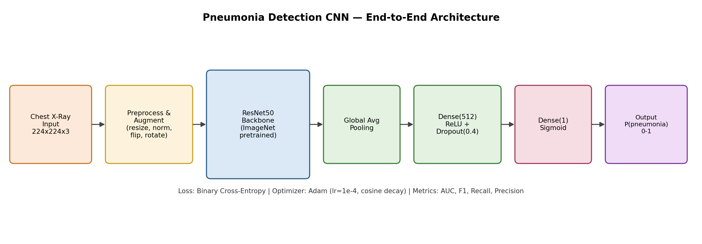
Figure 1. End-to-end model architecture: preprocessing, ResNet50 backbone, and custom classification head.

3.1 Layer-by-Layer Explanation
Component | Description | Purpose
Input | 224x224x3 RGB tensor (grayscale CXR replicated across 3 channels) | Matches ResNet50's expected ImageNet input shape
Preprocessing | Resize, normalize with ImageNet mean/std | Aligns input distribution with pretrained backbone's expected statistics
Augmentation (train only) | Random horizontal flip, ±10° rotation, brightness/contrast jitter | Increases effective dataset size and robustness to positioning/exposure variation
ResNet50 backbone | 50-layer residual CNN, ImageNet-pretrained, ending in global average pooling | Extracts hierarchical visual features (edges → textures → lung-opacity patterns)
Global Average Pooling | Reduces final 7x7x2048 feature map to a 2048-length vector | Reduces parameters and overfitting risk vs. a flattened fully-connected layer
Dense(512) + ReLU + Dropout(0.4) | Fully connected bottleneck layer with 40% dropout | Learns task-specific combinations of backbone features while regularizing against overfitting
Dense(1) + Sigmoid | Single logit passed through sigmoid | Produces a calibrated probability of pneumonia for binary classification

4. Data Preprocessing and Pipeline
Data handling follows a staged pipeline that separates concerns between raw ingestion, splitting, transformation, and class-balanced sampling, illustrated below.
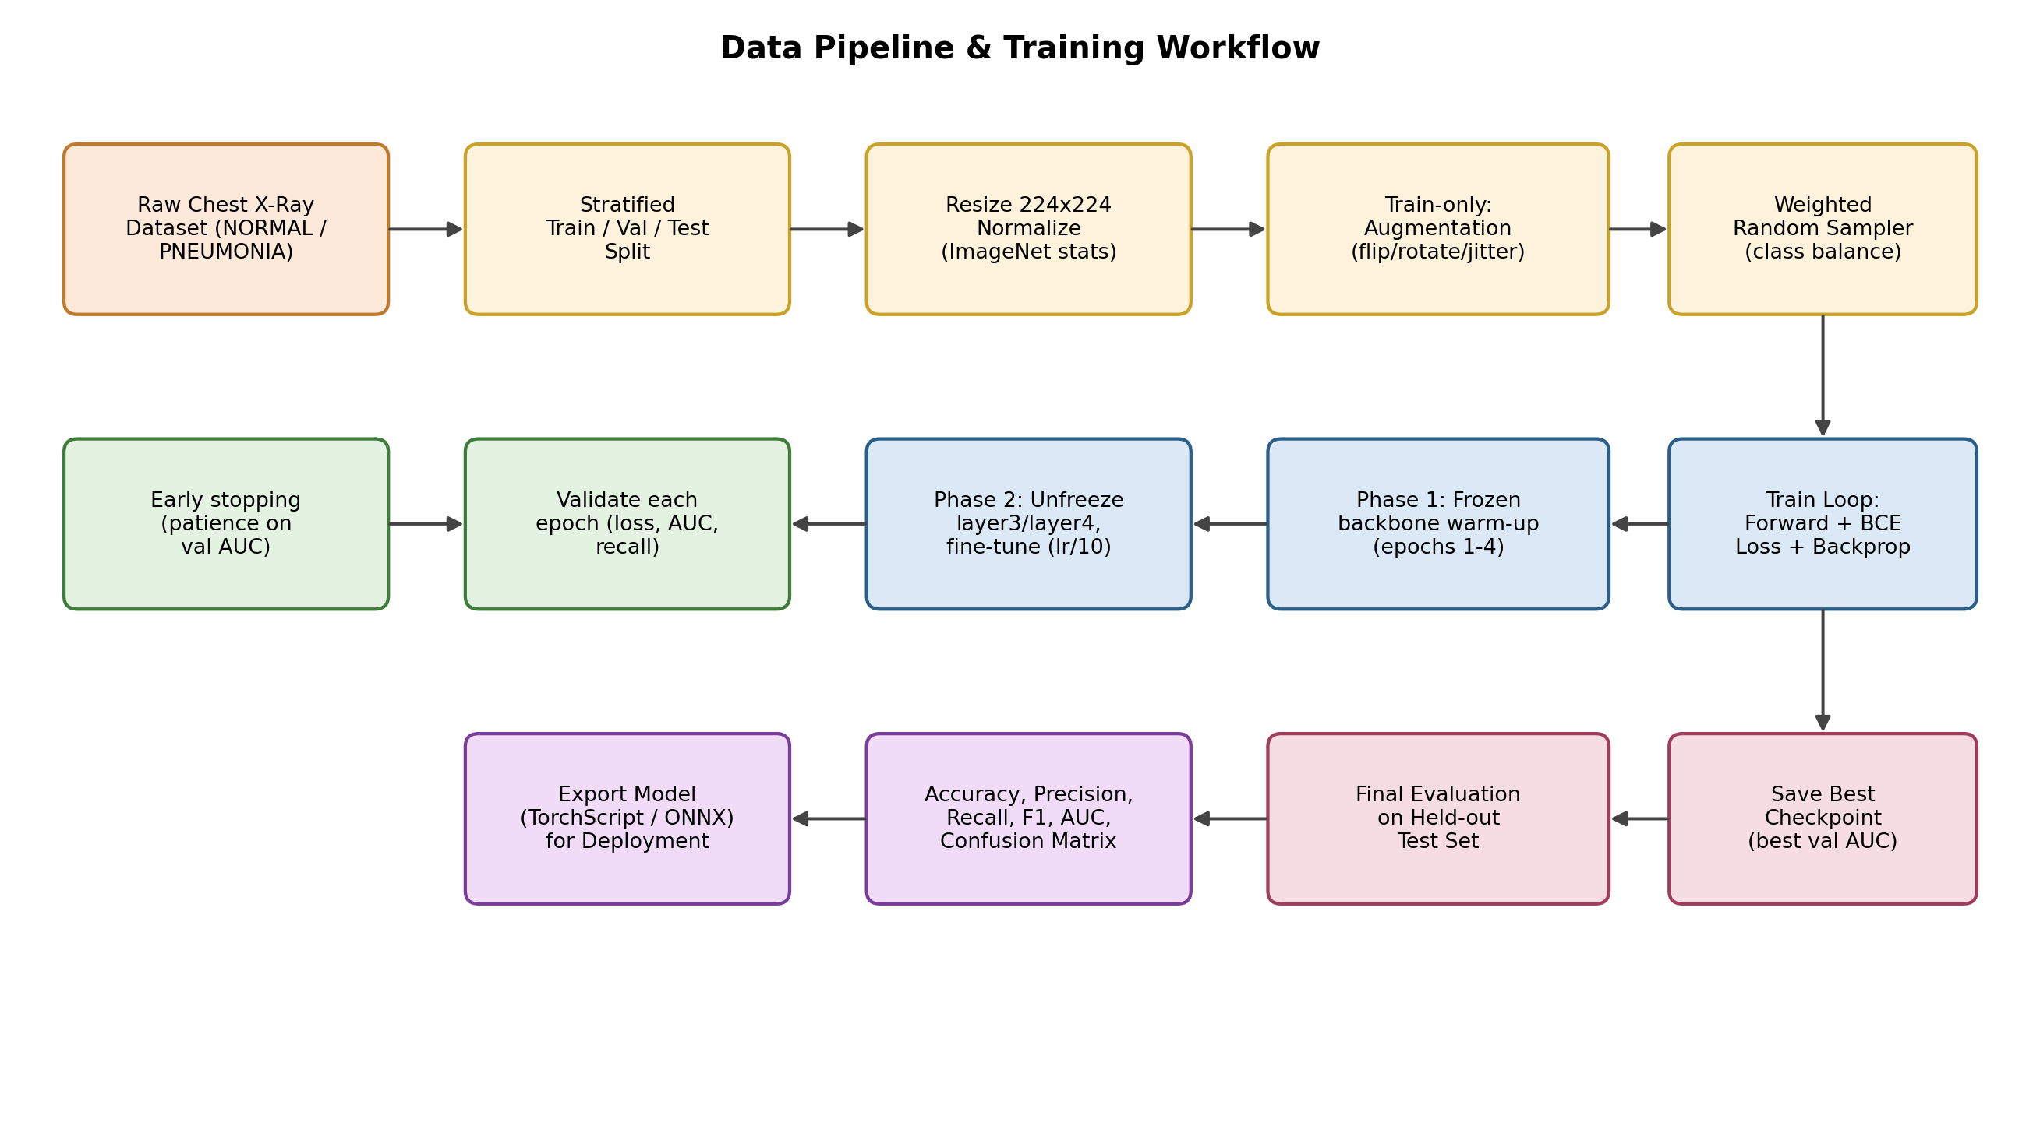
Figure 2. Data pipeline and training workflow, including staged fine-tuning and early stopping.

4.1 Preprocessing and Augmentation Strategy
- All images resized to 224x224 to match the ResNet50 input contract.
- Pixel values normalized using ImageNet channel mean/std so the pretrained backbone receives inputs in its expected distribution.
- Training-set-only augmentation (flip, rotation, color jitter) reduces overfitting without distorting validation/test evaluation.
- Stratified train/validation/test split preserves the NORMAL:PNEUMONIA ratio across splits so evaluation metrics are not biased by an accidental class skew.
- A WeightedRandomSampler inversely weights each class by its frequency during training, directly addressing class imbalance rather than relying on post-hoc threshold tuning alone.

4.2 Training Strategy: Staged Fine-Tuning
Training proceeds in two phases rather than fine-tuning the entire backbone from epoch one:
- Phase 1 (warm-up): the ResNet50 backbone is frozen; only the new classification head is trained. This lets the randomly-initialized head stabilize without corrupting the pretrained weights with large early gradients.
- Phase 2 (fine-tuning): starting at a configurable epoch (default: 5), the last two residual blocks (layer3, layer4) are unfrozen and trained at a 10x lower learning rate, allowing the backbone to adapt its higher-level features to radiographic textures specifically.
Binary cross-entropy is used as the loss function (appropriate for single-label binary classification), optimized with Adam and a cosine annealing learning-rate schedule. Early stopping on validation AUC (rather than validation loss) is used because AUC is threshold-independent and more clinically meaningful for an imbalanced diagnostic task.

5. Design Rationale, Benefits, and Challenges

5.1 Rationale for Key Decisions
Decision | Rationale
Transfer learning over training from scratch | Small medical datasets cannot reliably train a 25M-parameter CNN from random initialization without severe overfitting; pretrained features transfer well to imaging tasks.
ResNet50 over deeper/shallower nets | Strong accuracy-to-compute ratio; residual connections avoid vanishing gradients; widely validated in medical-imaging transfer-learning literature.
Global average pooling over flattening | Removes ~100M+ parameters that a flattened FC layer would need, sharply reducing overfitting risk.
Weighted sampling over oversampling/undersampling | Balances class exposure per batch without discarding data (undersampling) or duplicating exact images verbatim (naive oversampling).
AUC-based early stopping | Threshold-independent metric that better reflects ranking quality for an imbalanced clinical classification task than raw accuracy.
Staged fine-tuning | Prevents catastrophic forgetting of useful pretrained features that a single high learning rate across the whole network could cause.

5.2 Anticipated Benefits
- Faster convergence and better generalization than training from scratch, given the limited dataset size typical of medical imaging tasks.
- Reduced overfitting through dropout, global average pooling, and staged fine-tuning.
- Class-imbalance-aware training reduces the risk of a model that trivially predicts the majority class.
- Modular design (backbone + head) makes it easy to swap in alternative backbones (EfficientNet, DenseNet) for future experimentation.

5.3 Anticipated Challenges and Mitigations
Challenge | Mitigation
Domain gap between ImageNet (natural images) and radiographs | Fine-tune deeper backbone layers (Phase 2) instead of relying purely on frozen features.
Overfitting on a small/moderate dataset | Dropout, data augmentation, weight decay via Adam, early stopping.
Class imbalance skewing predictions toward the majority class | WeightedRandomSampler plus monitoring recall/F1/AUC rather than raw accuracy.
Lack of interpretability for clinical trust | Post-hoc Grad-CAM visualization can highlight the image regions driving each prediction (see Section 6).
Dataset shift across hospitals/scanners in deployment | Plan for periodic re-validation and fine-tuning on site-specific data before clinical rollout.

6. Potential Modifications and Scalability

6.1 Architectural Extensions
- Extend the sigmoid output to a softmax over multiple classes (e.g., NORMAL / BACTERIAL PNEUMONIA / VIRAL PNEUMONIA / COVID-19) with minimal architectural change — only the final Dense layer and loss function need updating.
- Add a Grad-CAM or attention-map module for explainability, overlaying a heatmap on the input X-ray to show which regions most influenced the prediction.
- Experiment with alternative or ensembled backbones (EfficientNetV2, DenseNet121, Vision Transformer) and compare AUC/F1 to select the best performer for the specific dataset.
- Incorporate patient metadata (age, symptom duration) via a small auxiliary MLP fused with image features for a multimodal model.

6.2 Scalability Considerations
- Data scalability: the ImageFolder-based pipeline and WeightedRandomSampler scale directly to larger datasets; for very large corpora, switching to a streaming WebDataset/TFRecord format would avoid loading full file lists into memory.
- Compute scalability: the training loop is compatible with PyTorch DistributedDataParallel for multi-GPU training with no architectural changes, enabling larger batch sizes and faster iteration as data volume grows.
- Deployment scalability: exporting the trained model to TorchScript or ONNX allows serving via lightweight inference servers (TorchServe, ONNX Runtime, or NVIDIA Triton), supporting horizontal scaling behind a load balancer for hospital-network-wide usage.
- Continual learning: the staged-fine-tuning mechanism already implemented can be reused periodically to adapt the model to new hospitals' imaging equipment without retraining from scratch.

7. Conclusion
The proposed architecture — a ResNet50 transfer-learning backbone with a lightweight, regularized classification head — directly targets the challenges identified in the research problem: limited labeled data, class imbalance, overfitting risk, and the clinical need for high recall. The staged fine-tuning strategy, imbalance-aware sampling, and AUC-driven model selection form a coherent design where every component maps back to a specific challenge. The architecture is intentionally modular so that backbones, output heads, and interpretability modules can be swapped or extended as the project scales toward multi-class diagnosis or multi-site deployment.

8. References
He, K., Zhang, X., Ren, S., & Sun, J. (2016). Deep Residual Learning for Image Recognition. CVPR.
Rajpurkar, P. et al. (2017). CheXNet: Radiologist-Level Pneumonia Detection on Chest X-Rays with Deep Learning. arXiv:1711.05225.
Selvaraju, R. R. et al. (2017). Grad-CAM: Visual Explanations from Deep Networks via Gradient-based Localization. ICCV.
Kermany, D. S. et al. (2018). Identifying Medical Diagnoses and Treatable Diseases by Image-Based Deep Learning. Cell.
PyTorch and torchvision official documentation, pytorch.org.

