Designing an AI Model Architecture
AI-Based Fake News Detection | Week 2

Submission description (200+ words). This Week 2 report turns the research problem from Week 1 into a complete, technically justified AI model architecture. The design treats fake-news detection as supervised text classification while explicitly separating statistical prediction from factual verification. The proposed pipeline begins with raw headline and article text, applies deterministic preprocessing, converts text into TF-IDF unigram and bigram features, and compares Multinomial Naive Bayes with Logistic Regression. Logistic Regression is selected because it gives the stronger held-out F1 result in the implemented prototype while remaining fast and interpretable. The architecture contains an offline training path and an online inference path so that the fitted vectorizer and model are reused consistently at prediction time. The design also includes an uncertainty state for low-confidence inputs and a lightweight explanation layer based on model coefficients. This report explains the role of every major component, the data flow, design rationale, expected benefits, limitations, scalability options, and the boundary between model confidence and factual truth. The architecture is deliberately practical: it is reproducible on ordinary hardware and can later be upgraded to stronger semantic models, source-aware signals, evidence retrieval, or multilingual approaches. The report therefore satisfies the Week 2 planning requirement while creating a technically coherent foundation for the Week 3 simulation, Week 4 data engineering, and Week 5 evaluation work.

Requirement-by-requirement compliance
✓ Detailed architecture with component interactions and data flow.
✓ Algorithms, model components, preprocessing and feature extraction are explained.
✓ Design choices are justified with benefits and limitations.
✓ Potential modifications and scalability are discussed.
✓ Architecture diagram/flowchart is included.
✓ Word-document report and 200+ word submission description are included.

1. Research problem and architecture objective
The system estimates whether a supplied news item resembles REAL or FAKE examples in its training distribution. It is not a fact-checking authority. The architecture therefore includes an explicit UNCERTAIN state when model confidence is below the selected operating threshold.

2. Component architecture
- Input layer: headline and article body.
- Preprocessing layer: lowercase, URL/HTML removal, alphabetic tokenization, stop-word removal and Porter stemming.
- Feature layer: TF-IDF with unigrams and bigrams, maximum 15,000 features.
- Model layer: Multinomial Naive Bayes baseline and Logistic Regression candidate.
- Decision layer: select the best model by held-out F1; expose REAL/FAKE/UNCERTAIN at inference.
- Explanation layer: top contributing lexical features from the linear model.
- Persistence layer: save the fitted vectorizer and selected model for repeatable inference.

3. Offline versus online data flow
Offline training uses the labeled dataset, cleans and splits it, fits TF-IDF only on training data, trains both candidates, evaluates them, and saves artifacts. Online inference applies the same cleaning function, transforms the text with the saved vectorizer, predicts with the saved classifier, and displays the statistical result. Keeping the preprocessing function shared between training and inference prevents pipeline drift.

4. Algorithm rationale
TF-IDF is a strong lightweight baseline for sparse news text because it is fast, memory-efficient, and interpretable. Naive Bayes is a useful reference model. Logistic Regression is selected in the implemented system because its held-out F1 is higher and its coefficients allow simple contribution analysis.

5. Benefits and challenges
Benefits include low computational cost, reproducibility, transparent preprocessing, quick inference, and easy deployment. Challenges include dataset bias, source leakage, topic drift, limited semantic understanding, paraphrase sensitivity, and the inability to establish truth from article wording alone.

6. Scalability and modification plan
The modular architecture can replace TF-IDF with contextual embeddings, compare linear SVM or transformer models, add source/temporal metadata, introduce retrieval-based evidence, and support multilingual processing. However, better data and stronger validation should come before expensive model complexity.
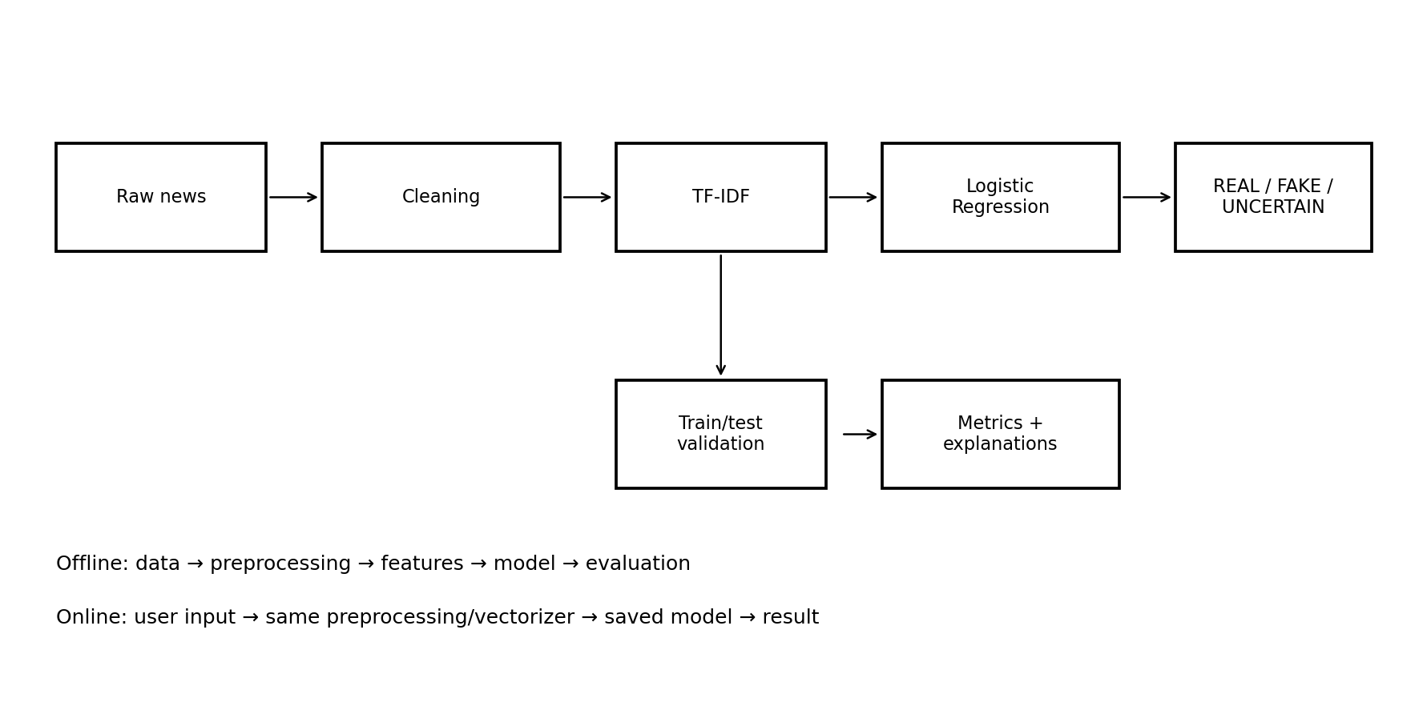
Figure 1. End-to-end model architecture showing training, validation and online inference.

References
- scikit-learn TfidfVectorizer: https://scikit-learn.org/stable/modules/generated/sklearn.feature_extraction.text.TfidfVectorizer.html
- scikit-learn LogisticRegression: https://scikit-learn.org/stable/modules/generated/sklearn.linear_model.LogisticRegression.html
- scikit-learn Model Evaluation: https://scikit-learn.org/stable/modules/model_evaluation.html
- Streamlit Documentation: https://docs.streamlit.io/
- Fake/Real News Dataset repository: https://github.com/joolsa/fake_real_news_dataset
- Wang (2017), LIAR dataset: https://aclanthology.org/P17-2067/
- Thorne et al. (2018), FEVER: https://doi.org/10.18653/v1/N18-1074
- Shu et al. (2020), FakeNewsNet: https://doi.org/10.1089/big.2020.0062
- Vosoughi, Roy & Aral (2018): https://doi.org/10.1126/science.aap9559
- Oshikawa, Qian & Wang (2020): https://aclanthology.org/2020.lrec-1.747/
- Zhou & Zafarani (2020): https://doi.org/10.1145/3395046

