暨南大学本科实验报告专用纸
课程名称 Windows编程实验 成绩评定
实验项目名称 Windows编程模型 指导教师 刘晓翔
实验项目编号 01 实验项目类型 验证性 实验地点 C301
学生姓名 赵俊文 学号 2022104002
学院 智能科学与工程学院 系 专业 人工智能
实验时间 2024 年 3 月 20 日 上 午～ 3 月 20 日 上 午
温度 ℃湿度
- 实验目的
掌握Windows编程模型与内部运行机制，掌握Windows入口函数、创建窗口、消息循环和窗口过程函数。
- 实验内容和要求
利用Visual C++6.0 Win32开发工具编写程序，通过Windows API实现一个窗口界面程序。
- 主要仪器设备
仪器：PC机
实验环境： Windows操作系统
- 实验步骤与调试
1.编写入口函数，并在WinMain中创建窗口，实现消息循环
int WINAPI WinMain(
HINSTANCE hInstance,
HINSTANCE hPrevInstance,
LPSTR lpCmdLine,
int nCmdShow
)
{
WNDCLASS MyWnd;
MyWnd.cbClsExtra = NULL;
MyWnd.cbWndExtra = NULL;
MyWnd.hbrBackground = (HBRUSH)GetStockObject(WHITE_BRUSH);
MyWnd.hCursor = LoadCursor(NULL, IDC_CROSS);
MyWnd.hIcon = LoadIcon(NULL, IDI_QUESTION);
MyWnd.hInstance = hInstance;
MyWnd.lpfnWndProc = MyWndProc;
MyWnd.lpszClassName = "Hello";
MyWnd.lpszMenuName = NULL;
MyWnd.style = CS_HREDRAW | CS_VREDRAW;
RegisterClass(&MyWnd);
//子类
WNDCLASS MyWnd_child;
MyWnd_child.cbClsExtra = NULL;
MyWnd_child.cbWndExtra = NULL;
MyWnd_child.hbrBackground = (HBRUSH)GetStockObject(WHITE_BRUSH);
MyWnd_child.hCursor = LoadCursor(NULL, IDC_CROSS);
MyWnd_child.hIcon = LoadIcon(NULL, IDI_QUESTION);
MyWnd_child.hInstance = hInstance;
MyWnd_child.lpfnWndProc = DefWindowProc;
MyWnd_child.lpszClassName = "ZJW";
MyWnd_child.lpszMenuName = NULL;
MyWnd_child.style = CS_HREDRAW | CS_VREDRAW;
RegisterClass(&MyWnd_child);

HWND hWnd;
hWnd = CreateWindow("Hello","Windows编程",WS_OVERLAPPEDWINDOW,
0,0,800,600,
NULL,NULL,hInstance,NULL);
HWND hWnd_child;
hWnd_child = CreateWindow("ZJW","Windows编程",WS_CHILD | WS_VISIBLE | WS_OVERLAPPEDWINDOW,
0,0,400,300,
hWnd,NULL,hInstance,NULL);
ShowWindow(hWnd,SW_SHOW);
UpdateWindow(hWnd);
MSG msg;
while(GetMessage(&msg,NULL,0,0))
{
TranslateMessage(&msg);
DispatchMessage(&msg);
}

return 0;
}
2.窗口过程函数
#include <windows.h>
#include <stdio.h>

LRESULT CALLBACK MyWndProc(
HWND hwnd,
UINT uMsg,
WPARAM wParam,
LPARAM lParam
);

int WINAPI WinMain(
HINSTANCE hInstance,
HINSTANCE hPrevInstance,
LPSTR lpCmdLine,
int nCmdShow
)
{
WNDCLASS MyWnd;
MyWnd.cbClsExtra = NULL;
MyWnd.cbWndExtra = NULL;
MyWnd.hbrBackground = (HBRUSH)GetStockObject(WHITE_BRUSH);
MyWnd.hCursor = LoadCursor(NULL, IDC_CROSS);
MyWnd.hIcon = LoadIcon(NULL, IDI_QUESTION);
MyWnd.hInstance = hInstance;
MyWnd.lpfnWndProc = MyWndProc;
MyWnd.lpszClassName = "Hello";
MyWnd.lpszMenuName = NULL;
MyWnd.style = CS_HREDRAW | CS_VREDRAW;
RegisterClass(&MyWnd);
//子类
WNDCLASS MyWnd_child;
MyWnd_child.cbClsExtra = NULL;
MyWnd_child.cbWndExtra = NULL;
MyWnd_child.hbrBackground = (HBRUSH)GetStockObject(WHITE_BRUSH);
MyWnd_child.hCursor = LoadCursor(NULL, IDC_CROSS);
MyWnd_child.hIcon = LoadIcon(NULL, IDI_QUESTION);
MyWnd_child.hInstance = hInstance;
MyWnd_child.lpfnWndProc = DefWindowProc;
MyWnd_child.lpszClassName = "ZJW";
MyWnd_child.lpszMenuName = NULL;
MyWnd_child.style = CS_HREDRAW | CS_VREDRAW;
RegisterClass(&MyWnd_child);

HWND hWnd;
hWnd = CreateWindow("Hello","Windows编程",WS_OVERLAPPEDWINDOW,
0,0,800,600,
NULL,NULL,hInstance,NULL);
HWND hWnd_child;
hWnd_child = CreateWindow(,"XYX","Windows编程",WS_CHILD | WS_VISIBLE | WS_OVERLAPPEDWINDOW,
0,0,400,300,
hWnd,NULL,hInstance,NULL);

ShowWindow(hWnd,SW_SHOW);
UpdateWindow(hWnd);

MSG msg;
while(GetMessage(&msg,NULL,0,0))
{
TranslateMessage(&msg);
DispatchMessage(&msg);
}

return 0;

}

LRESULT CALLBACK MyWndProc(
HWND hwnd,
UINT uMsg,
WPARAM wParam,
LPARAM lParam
)
{
switch(uMsg){
case WM_PAINT:
HDC hpaintDC;
PAINTSTRUCT ps;
hpaintDC=BeginPaint(hwnd,&ps);
TextOut(hpaintDC,255,50,"你好你好",strlen("你好你好"));
EndPaint(hwnd,&ps);
break;
case WM_CHAR:
char str[255];
sprintf(str,"char is %d",wParam);
MessageBox(hwnd,str,"按键响应",0);
break;
case WM_LBUTTONDOWN:
MessageBox(hwnd,"鼠标左键按下","鼠标响应",0);
HDC hDC;
hDC = GetDC(hwnd);
TextOut(hDC,255,100,"刚刚按了鼠标左键",strlen("刚刚按了鼠标左键"));
ReleaseDC(hwnd,hDC);
break;
case WM_CLOSE:
if(IDYES == MessageBox(hwnd,"真的要退出吗？","退出",MB_YESNO))
DestroyWindow(hwnd);
break;
case WM_DESTROY:
PostQuitMessage(0);
break;
default:
return DefWindowProc(hwnd,uMsg,wParam,lParam);

}
return 0;
}
- 实验结果与分析
1.实验结果
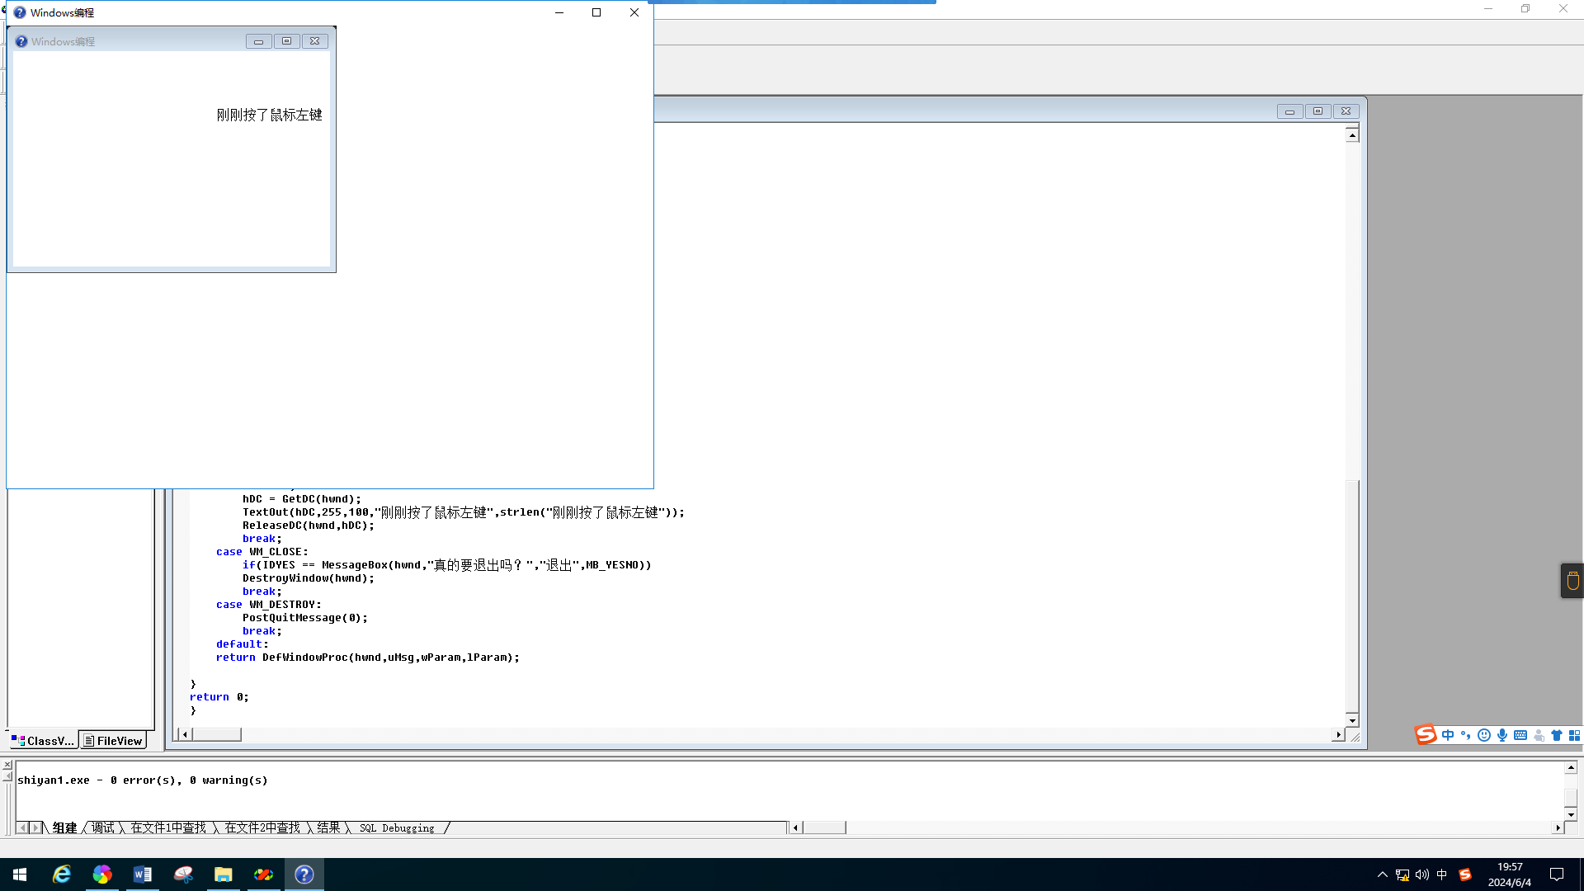

2.分析和总结
通过本次实验，我初步掌握了通过Windows API实现一个简单的窗口界面程序的方法和步骤。了解了窗口的窗口的设计注册和创建的过程，消息和消息队列，GetMessage,DispachMessage，窗口过程函数等对消息接收和处理的函数，初步掌握了Windows编程模型与内部的运行机制。

