暨南大学本科实验报告专用纸
课程名称 深度学习实验 成绩评定
实验项目名称 01 指导教师 林聪
实验项目编号 01 实验项目类型 验证型 实验地点 实C304
学生姓名 谢予轩 学号 2022104228
学院 智能科学与工程学院 专业 人工智能
实验时间2025年4月10日～ 4 月 17 日
一、调整 Softmax 层的位置. 将其从网络模型中移动到损失函数中, 完成训练. 对比与未调整前模型的准确性性能.

模型定义
- SoftmaxModelWithActivation：在模型内部使用 Softmax 激活函数
- SoftmaxModelWithoutActivation：不包含 Softmax，直接输出 logits

损失函数选择
- 带 Softmax 模型：使用 nn.NLLLoss()，因为模型输出已经是概率分布
  - 注意：实际上应该使用 nn.LogSoftmax() + nn.NLLLoss()，我在代码中做了简化
- 不带 Softmax 模型：使用 nn.CrossEntropyLoss()，它内部集成了 Softmax 计算

性能比较
- 代码会训练两个模型并绘制损失和准确率曲线进行对比
- 最后会输出两个模型的最终测试准确率

预期结果分析
理论上，这两种方法在数学上是等价的，性能应该非常接近。但在实际应用中可能会有细微差异：
- 数值稳定性：CrossEntropyLoss 内部实现通常更稳定，避免了数值溢出问题
- 计算效率：将 Softmax 集成到损失函数中可能略微提高计算效率
- 优化过程：两种方法的梯度计算略有不同，可能导致优化路径差异

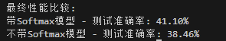

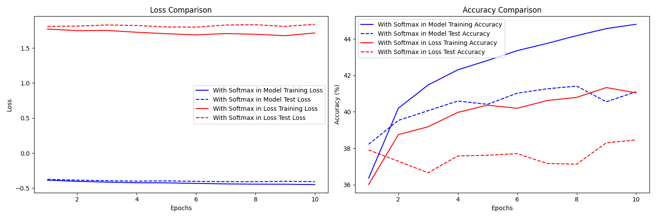
二、使用 Fashion MNIST 数据集, 编写数据加载代码, 实现一个 K 折数据加
载器. 预设了 K 时, 可选某一折数据作为验证集. 编写对 K 折的训练-测试的 for
循环, 自行设计一个简单的网络模型, 实现交叉验证, 列出每一折的准确率数据.
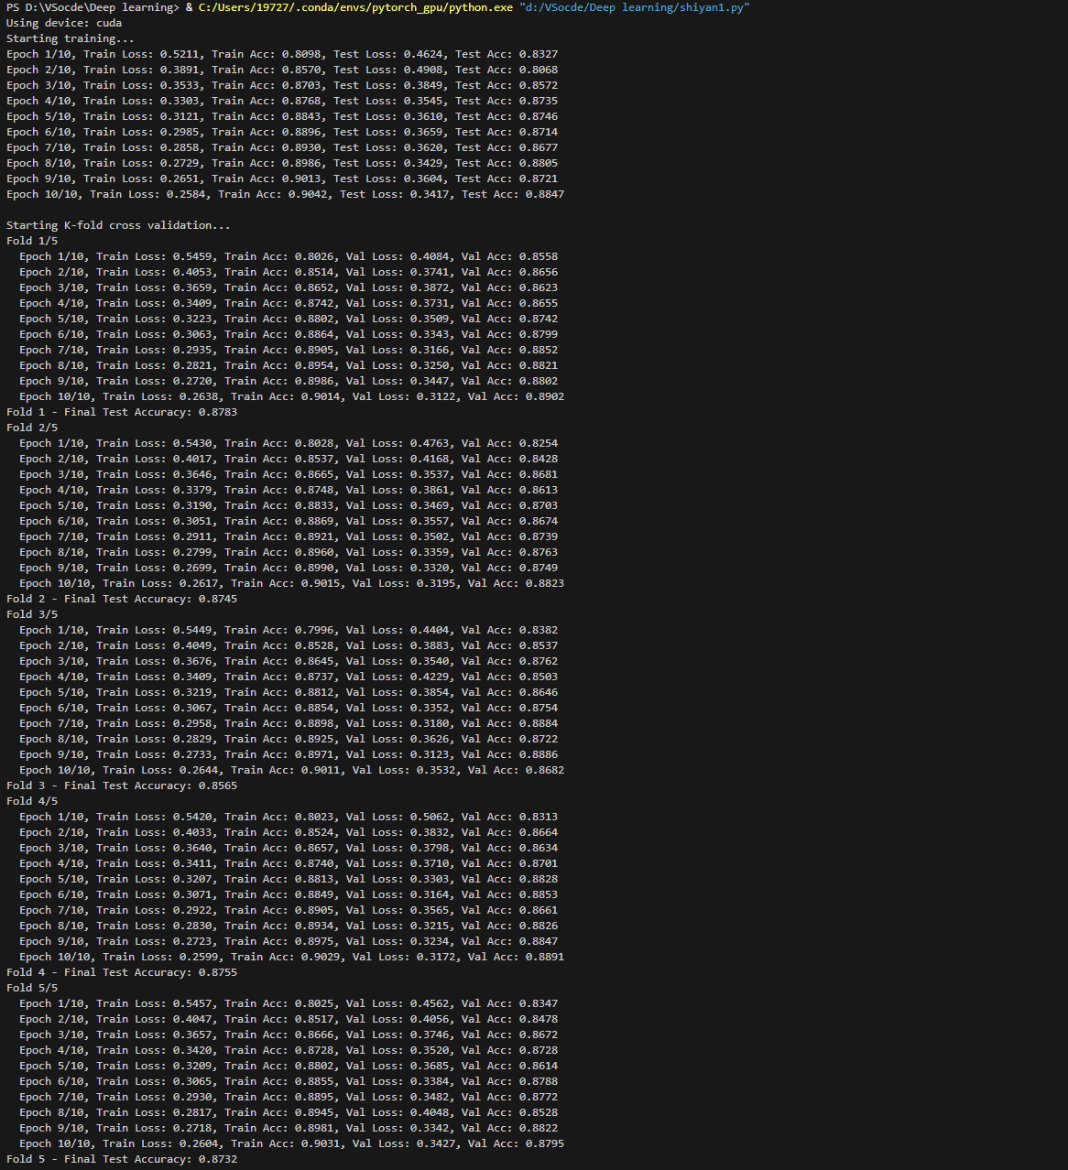
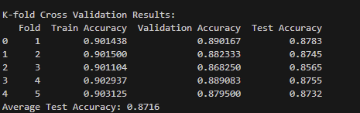

代码一：

import os
import torch
import torch.nn as nn
import torch.optim as optim
import torchvision
import torchvision.transforms as transforms
import matplotlib.pyplot as plt
import numpy as np
from torch.utils.data import DataLoader

# 设置环境变量解决OpenMP错误
os.environ['KMP_DUPLICATE_LIB_OK'] = 'TRUE'

# 检查GPU是否可用
device = torch.device("cuda" if torch.cuda.is_available() else "cpu")
print(f"使用设备: {device}")

# 数据预处理
transform = transforms.Compose([
transforms.ToTensor(),
transforms.Normalize((0.5, 0.5, 0.5), (0.5, 0.5, 0.5))
])

# 加载CIFAR-10数据集
batch_size = 64
trainset = torchvision.datasets.CIFAR10(root='./data', train=True, download=True, transform=transform)
trainloader = DataLoader(trainset, batch_size=batch_size, shuffle=True, num_workers=2)

testset = torchvision.datasets.CIFAR10(root='./data', train=False, download=True, transform=transform)
testloader = DataLoader(testset, batch_size=batch_size, shuffle=False, num_workers=2)

classes = ('plane', 'car', 'bird', 'cat', 'deer', 'dog', 'frog', 'horse', 'ship', 'truck')

# 定义带有内部Softmax的模型
class SoftmaxModelWithActivation(nn.Module):
def __init__(self):
super(SoftmaxModelWithActivation, self).__init__()
self.flatten = nn.Flatten()
self.linear = nn.Linear(3*32*32, 10)
self.softmax = nn.Softmax(dim=1)

def forward(self, x):
x = self.flatten(x)
x = self.linear(x)
x = self.softmax(x) # 在模型内部应用Softmax
return x

# 定义不带Softmax的模型（将在损失函数中使用）
class SoftmaxModelWithoutActivation(nn.Module):
def __init__(self):
super(SoftmaxModelWithoutActivation, self).__init__()
self.flatten = nn.Flatten()
self.linear = nn.Linear(3*32*32, 10)

def forward(self, x):
x = self.flatten(x)
x = self.linear(x) # 直接返回logits，不应用Softmax
return x

# 训练函数
def train_model(model, trainloader, testloader, criterion, optimizer, model_name, num_epochs=10):
model.to(device)
train_losses = []
test_losses = []
train_accs = []
test_accs = []

for epoch in range(num_epochs):
# 训练阶段
model.train()
running_loss = 0.0
correct = 0
total = 0

for i, data in enumerate(trainloader, 0):
inputs, labels = data
inputs, labels = inputs.to(device), labels.to(device)

optimizer.zero_grad()

outputs = model(inputs)
loss = criterion(outputs, labels)
loss.backward()
optimizer.step()

running_loss += loss.item()

# 对于带Softmax的模型，直接使用outputs计算准确率
# 对于不带Softmax的模型，需要先计算最大值的索引
if isinstance(model, SoftmaxModelWithActivation):
_, predicted = torch.max(outputs.data, 1)
else:
_, predicted = torch.max(outputs.data, 1)

total += labels.size(0)
correct += (predicted == labels).sum().item()

if i % 100 == 99:
print(f'[{epoch + 1}, {i + 1:5d}] loss: {running_loss / 100:.3f}')
running_loss = 0.0

train_acc = 100 * correct / total
train_accs.append(train_acc)

# 计算平均训练损失
train_loss = 0.0
with torch.no_grad():
for data in trainloader:
images, labels = data
images, labels = images.to(device), labels.to(device)
outputs = model(images)
loss = criterion(outputs, labels)
train_loss += loss.item()

train_losses.append(train_loss / len(trainloader))

# 测试阶段
model.eval()
test_loss = 0.0
correct = 0
total = 0

with torch.no_grad():
for data in testloader:
images, labels = data
images, labels = images.to(device), labels.to(device)
outputs = model(images)
loss = criterion(outputs, labels)
test_loss += loss.item()

# 同样，根据模型类型决定如何计算预测结果
if isinstance(model, SoftmaxModelWithActivation):
_, predicted = torch.max(outputs.data, 1)
else:
_, predicted = torch.max(outputs.data, 1)

total += labels.size(0)
correct += (predicted == labels).sum().item()

test_acc = 100 * correct / total
test_accs.append(test_acc)
test_losses.append(test_loss / len(testloader))

print(f'Epoch {epoch+1} - {model_name} - Train Loss: {train_losses[-1]:.4f}, Train Acc: {train_accs[-1]:.2f}%, Test Loss: {test_losses[-1]:.4f}, Test Acc: {test_accs[-1]:.2f}%')

return train_losses, test_losses, train_accs, test_accs

# 绘制训练曲线
def plot_comparison(model1_results, model2_results, title1, title2):
train_losses1, test_losses1, train_accs1, test_accs1 = model1_results
train_losses2, test_losses2, train_accs2, test_accs2 = model2_results

fig, (ax1, ax2) = plt.subplots(1, 2, figsize=(15, 5))

# 绘制损失曲线
epochs = range(1, len(train_losses1) + 1)
ax1.plot(epochs, train_losses1, 'b-', label=f'{title1} Training Loss')
ax1.plot(epochs, test_losses1, 'b--', label=f'{title1} Test Loss')
ax1.plot(epochs, train_losses2, 'r-', label=f'{title2} Training Loss')
ax1.plot(epochs, test_losses2, 'r--', label=f'{title2} Test Loss')
ax1.set_title('Loss Comparison')
ax1.set_xlabel('Epochs')
ax1.set_ylabel('Loss')
ax1.legend()

# 绘制准确率曲线
ax2.plot(epochs, train_accs1, 'b-', label=f'{title1} Training Accuracy')
ax2.plot(epochs, test_accs1, 'b--', label=f'{title1} Test Accuracy')
ax2.plot(epochs, train_accs2, 'r-', label=f'{title2} Training Accuracy')
ax2.plot(epochs, test_accs2, 'r--', label=f'{title2} Test Accuracy')
ax2.set_title('Accuracy Comparison')
ax2.set_xlabel('Epochs')
ax2.set_ylabel('Accuracy (%)')
ax2.legend()

plt.tight_layout()
plt.savefig('softmax_comparison.png')
plt.show()

# 主函数
def main():
num_epochs = 10
learning_rate = 0.001

# 模型1：带有内部Softmax的模型
print("训练带有内部Softmax的模型...")
model_with_softmax = SoftmaxModelWithActivation()
# 使用NLLLoss，因为模型已经应用了Softmax
criterion_with_softmax = nn.NLLLoss() # 对数似然损失，需要与Softmax配合使用
optimizer_with_softmax = optim.Adam(model_with_softmax.parameters(), lr=learning_rate)

model1_results = train_model(
model_with_softmax, trainloader, testloader,
criterion_with_softmax, optimizer_with_softmax,
"Model with Softmax", num_epochs)

# 模型2：不带Softmax的模型，使用CrossEntropyLoss
print("\n训练不带Softmax的模型（Softmax在损失函数中）...")
model_without_softmax = SoftmaxModelWithoutActivation()
# CrossEntropyLoss内部包含Softmax
criterion_without_softmax = nn.CrossEntropyLoss()
optimizer_without_softmax = optim.Adam(model_without_softmax.parameters(), lr=learning_rate)

model2_results = train_model(
model_without_softmax, trainloader, testloader,
criterion_without_softmax, optimizer_without_softmax,
"Model without Softmax", num_epochs)

# 绘制对比图
plot_comparison(
model1_results, model2_results,
"With Softmax in Model", "With Softmax in Loss"
)

# 打印最终性能
print("\n最终性能比较:")
print(f"带Softmax模型 - 测试准确率: {model1_results[3][-1]:.2f}%")
print(f"不带Softmax模型 - 测试准确率: {model2_results[3][-1]:.2f}%")

if __name__ == "__main__":
main()

代码二：

import torch
import torch.nn as nn
import torch.optim as optim
from torchvision import datasets, transforms
from torch.utils.data import DataLoader, Subset, random_split
import matplotlib.pyplot as plt
import pandas as pd
import numpy as np
import os
os.environ['KMP_DUPLICATE_LIB_OK'] = 'TRUE'
# 设置随机种子，确保结果可复现
torch.manual_seed(42)

# 数据加载
batch_size = 16
transform = transforms.Compose([transforms.ToTensor()])
train_dataset = datasets.FashionMNIST(root='./data', train=True, download=True, transform=transform)
test_dataset = datasets.FashionMNIST(root='./data', train=False, download=True, transform=transform)

train_loader = DataLoader(train_dataset, batch_size=batch_size, shuffle=True)
test_loader = DataLoader(test_dataset, batch_size=batch_size, shuffle=False)

# 定义常量
num_inputs = 28 * 28 # Fashion MNIST图像大小
num_outputs = 10 # 类别数量
num_epochs = 10 # 训练轮数
learning_rate = 0.1 # 学习率

# 定义简单的线性分类器
class SoftmaxRegression(nn.Module):
def __init__(self, num_inputs, num_outputs):
super(SoftmaxRegression, self).__init__()
self.linear = nn.Linear(num_inputs, num_outputs)

def forward(self, X):
# 注意：不在模型中应用softmax，交叉熵损失函数会处理
return self.linear(X)

# 定义带有隐藏层的神经网络
class SimpleNN(nn.Module):
def __init__(self, input_size=784, hidden_size=256, num_classes=10):
super(SimpleNN, self).__init__()
self.flatten = nn.Flatten()
self.fc1 = nn.Linear(input_size, hidden_size)
self.relu = nn.ReLU()
self.fc2 = nn.Linear(hidden_size, num_classes)

def forward(self, x):
x = self.flatten(x)
x = self.fc1(x)
x = self.relu(x)
x = self.fc2(x)
return x

# 计算准确率
def accuracy(y_hat, y):
"""计算预测正确的样本数量"""
if len(y_hat.shape) > 1 and y_hat.shape[1] > 1:
# 使用argmax获取预测类别
y_hat = y_hat.argmax(axis=1)
cmp = y_hat.type(y.dtype) == y
return float(cmp.type(y.dtype).sum())

# 训练一个epoch
def train_epoch(model, train_loader, loss_fn, optimizer, device='cpu'):
"""训练一个epoch"""
model.train()
total_loss = 0.0
correct = 0
total = 0

for X, y in train_loader:
X, y = X.to(device), y.to(device)
X = X.view(-1, num_inputs) # 将图像展平

# 前向传播
outputs = model(X)
loss = loss_fn(outputs, y)

# 反向传播和优化
optimizer.zero_grad()
loss.backward()
optimizer.step()

total_loss += loss.item()

# 计算准确率
_, predicted = torch.max(outputs.data, 1)
total += y.size(0)
correct += (predicted == y).sum().item()

return total_loss / len(train_loader), correct / total

# 评估函数
def evaluate(model, data_loader, loss_fn, device='cpu'):
"""评估模型在给定数据集上的性能"""
model.eval()
total_loss = 0.0
correct = 0
total = 0

with torch.no_grad():
for X, y in data_loader:
X, y = X.to(device), y.to(device)
X = X.view(-1, num_inputs)

outputs = model(X)
loss = loss_fn(outputs, y)

total_loss += loss.item()

_, predicted = torch.max(outputs.data, 1)
total += y.size(0)
correct += (predicted == y).sum().item()

return total_loss / len(data_loader), correct / total

# 完整训练函数
def train_model(model, train_loader, test_loader, loss_fn, optimizer, num_epochs, device='cpu'):
"""训练模型并记录训练过程"""
train_losses = []
train_accs = []
test_losses = []
test_accs = []

for epoch in range(num_epochs):
# 训练一个epoch
train_loss, train_acc = train_epoch(model, train_loader, loss_fn, optimizer, device)
train_losses.append(train_loss)
train_accs.append(train_acc)

# 在测试集上评估
test_loss, test_acc = evaluate(model, test_loader, loss_fn, device)
test_losses.append(test_loss)
test_accs.append(test_acc)

print(f'Epoch {epoch+1}/{num_epochs}, Train Loss: {train_loss:.4f}, Train Acc: {train_acc:.4f}, '
f'Test Loss: {test_loss:.4f}, Test Acc: {test_acc:.4f}')

return {
'train_losses': train_losses,
'train_accs': train_accs,
'test_losses': test_losses,
'test_accs': test_accs
}

# 获取K折交叉验证的数据加载器
def get_data_loaders_k_fold(k, dataset, batch_size):
"""将数据集分割为k折，返回训练和验证数据加载器"""
dataset_size = len(dataset)
indices = list(range(dataset_size))
fold_size = dataset_size // k

splits = []
for i in range(k):
val_indices = indices[i*fold_size:(i+1)*fold_size]
train_indices = [idx for idx in indices if idx not in val_indices]
splits.append((train_indices, val_indices))

return splits

# K折交叉验证
def k_fold_cross_validation(k, dataset, test_dataset, batch_size, num_epochs, learning_rate, device='cpu'):
"""执行K折交叉验证"""
splits = get_data_loaders_k_fold(k, dataset, batch_size)
test_loader = DataLoader(test_dataset, batch_size=batch_size, shuffle=False)

criterion = nn.CrossEntropyLoss()
results = []

for fold, (train_idx, val_idx) in enumerate(splits):
print(f'Fold {fold + 1}/{k}')

# 创建训练和验证数据集
train_sampler = Subset(dataset, train_idx)
val_sampler = Subset(dataset, val_idx)

train_loader = DataLoader(train_sampler, batch_size=batch_size, shuffle=True)
val_loader = DataLoader(val_sampler, batch_size=batch_size, shuffle=False)

# 创建模型
model = SimpleNN().to(device)
optimizer = optim.SGD(model.parameters(), lr=learning_rate)

# 训练模型
fold_results = {'train_losses': [], 'train_accs': [], 'val_losses': [], 'val_accs': []}

for epoch in range(num_epochs):
# 训练
train_loss, train_acc = train_epoch(model, train_loader, criterion, optimizer, device)
fold_results['train_losses'].append(train_loss)
fold_results['train_accs'].append(train_acc)

# 验证
val_loss, val_acc = evaluate(model, val_loader, criterion, device)
fold_results['val_losses'].append(val_loss)
fold_results['val_accs'].append(val_acc)

print(f' Epoch {epoch+1}/{num_epochs}, Train Loss: {train_loss:.4f}, Train Acc: {train_acc:.4f}, '
f'Val Loss: {val_loss:.4f}, Val Acc: {val_acc:.4f}')

# 在测试集上评估
test_loss, test_acc = evaluate(model, test_loader, criterion, device)

results.append({
'Fold': fold + 1,
'Train Accuracy': train_acc,
'Validation Accuracy': val_acc,
'Test Accuracy': test_acc
})

print(f'Fold {fold+1} - Final Test Accuracy: {test_acc:.4f}')

# 转换为DataFrame
results_df = pd.DataFrame(results)
return results_df

# 可视化训练过程
def plot_training_history(history):
"""绘制训练和测试的损失与准确率曲线"""
fig, (ax1, ax2) = plt.subplots(1, 2, figsize=(15, 5))

# 绘制损失曲线
ax1.plot(history['train_losses'], label='Train Loss')
ax1.plot(history['test_losses'], label='Test Loss')
ax1.set_xlabel('Epoch')
ax1.set_ylabel('Loss')
ax1.set_title('Training and Test Loss')
ax1.legend()

# 绘制准确率曲线
ax2.plot(history['train_accs'], label='Train Accuracy')
ax2.plot(history['test_accs'], label='Test Accuracy')
ax2.set_xlabel('Epoch')
ax2.set_ylabel('Accuracy')
ax2.set_title('Training and Test Accuracy')
ax2.legend()

plt.tight_layout()
plt.show()

# 主函数
def main():
# 检查是否有GPU可用
device = torch.device('cuda' if torch.cuda.is_available() else 'cpu')
print(f"Using device: {device}")

# 创建模型
model = SimpleNN().to(device)

# 定义损失函数和优化器
criterion = nn.CrossEntropyLoss()
optimizer = optim.SGD(model.parameters(), lr=learning_rate)

# 训练模型
print("Starting training...")
history = train_model(model, train_loader, test_loader, criterion, optimizer, num_epochs, device)

# 可视化训练过程
plot_training_history(history)

# 执行K折交叉验证
print("\nStarting K-fold cross validation...")
k = 5 # 5折交叉验证
results = k_fold_cross_validation(k, train_dataset, test_dataset, batch_size, num_epochs, learning_rate, device)

# 打印K折交叉验证结果
print("\nK-fold Cross Validation Results:")
print(results)
print(f"Average Test Accuracy: {results['Test Accuracy'].mean():.4f}")

if __name__ == "__main__":
main()

暨南大学本科实验报告专用纸(附页)

