**暨南大学本科实验报告专用纸**

课程名称 深度学习实验 成绩评定

实验项目名称 图像分类的迁移学习 指导教师 林聪

实验项目编号 03 实验项目类型 验证型

学生姓名 赵俊文 学号 2022104002

学院 智能科学与工程学院 专业 人工智能

实验时间 2025 年 5 月 2 日～ 5 月 9 日 上 午

1. **实验目的**

* 分别加载 ResNet-18 和 VGG-16 模型的预训练权重, 并对现有框架进行修改
* 通过在新数据集上训和练验证,利用模型微调方式实现迁移学习.输出训练曲线图. 对比曲线图与准确率

1. **主要仪器设备**

**仪器：** PC

**实验环境：** Windows11,Python3.10,Pytorch11.8

1. **源程序**

源程序在实验步骤与调试中给出。

1. **实验步骤与调试**
2. **下载热狗数据集**

import torch

import torch.nn as nn

from torchvision import datasets, transforms, models

from torch.utils.data import DataLoader

import matplotlib.pyplot as plt

import os

import zipfile

import requests

# 下载数据集

url = 'http://d2l-data.s3-accelerate.amazonaws.com/hotdog.zip'

save_path = 'hotdog.zip'

if not os.path.exists('hotdog'):

    print("Downloading dataset...")

    r = requests.get(url, stream=True)

    with open(save_path, 'wb') as f:

        for chunk in r.iter_content(chunk_size=8192):

            if chunk:

                f.write(chunk)

    with zipfile.ZipFile(save_path, 'r') as zip_ref:

        zip_ref.extractall('.')

    os.remove(save_path)

print("Dataset downloaded and extracted.")

1. **数据预处理与加载**

# 数据预处理

transform_train = transforms.Compose([

    transforms.RandomResizedCrop(224),

    transforms.RandomHorizontalFlip(),

    transforms.ToTensor(),

    transforms.Normalize(mean=[0.485, 0.456, 0.406], std=[0.229, 0.224, 0.225])

])

transform_test = transforms.Compose([

    transforms.Resize(256),

    transforms.CenterCrop(224),

    transforms.ToTensor(),

    transforms.Normalize(mean=[0.485, 0.456, 0.406], std=[0.229, 0.224, 0.225])

])

# 加载数据集

train_dataset = datasets.ImageFolder('hotdog/train', transform=transform_train)

test_dataset = datasets.ImageFolder('hotdog/test', transform=transform_test)

batch_size = 32

train_loader = DataLoader(train_dataset, batch_size=batch_size, shuffle=True, num_workers=4)

test_loader = DataLoader(test_dataset, batch_size=batch_size, shuffle=False, num_workers=4)

# 检查设备

device = torch.device("cuda" if torch.cuda.is_available() else "cpu")

print(f"Using device: {device}")

1. **训练与验证函数**
2. ResNet-18

def build_resnet18():

    model = models.resnet18(weights=models.ResNet18_Weights.IMAGENET1K_V1)

    num_ftrs = model.fc.in_features

    model.fc = nn.Linear(num_ftrs, 2)

    model = model.to(device)

    return model

1. VGG-16

def build_vgg16():

    model = models.vgg16(weights=models.VGG16_Weights.IMAGENET1K_V1)

    num_ftrs = model.classifier[6].in_features

    model.classifier[6] = nn.Linear(num_ftrs, 2)

    model = model.to(device)

    return model

1. **训练与验证函数**

def train_model(model, criterion, optimizer, num_epochs=10):

    train_losses, train_accs, val_losses, val_accs = [], [], [], []

    best_acc = 0.0

    for epoch in range(num_epochs):

        model.train()

        running_loss = 0.0

        correct = 0

        total = 0

        # 训练阶段

        for inputs, labels in train_loader:

            inputs, labels = inputs.to(device), labels.to(device)

            optimizer.zero_grad()

            outputs = model(inputs)

            loss = criterion(outputs, labels)

            loss.backward()

            optimizer.step()

            running_loss += loss.item()

            _, predicted = outputs.max(1)

            total += labels.size(0)

            correct += predicted.eq(labels).sum().item()

        # 计算训练指标

        train_loss = running_loss / len(train_loader)

        train_acc = correct / total

        train_losses.append(train_loss)

        train_accs.append(train_acc)

        # 验证阶段

        model.eval()

        val_loss = 0.0

        val_correct = 0

        val_total = 0

        with torch.no_grad():

            for inputs, labels in test_loader:

                inputs, labels = inputs.to(device), labels.to(device)

                outputs = model(inputs)

                loss = criterion(outputs, labels)

                val_loss += loss.item()

                _, predicted = outputs.max(1)

                val_total += labels.size(0)

                val_correct += predicted.eq(labels).sum().item()

        # 计算验证指标

        val_loss = val_loss / len(test_loader)

        val_acc = val_correct / val_total

        val_losses.append(val_loss)

        val_accs.append(val_acc)

        # 更新最佳准确率

        if val_acc > best_acc:

            best_acc = val_acc

        print(f'Epoch {epoch+1}/{num_epochs}')

        print(f'Train Loss: {train_loss:.4f} Acc: {train_acc:.4f}')

        print(f'Val Loss: {val_loss:.4f} Acc: {val_acc:.4f}\n')

    return train_losses, train_accs, val_losses, val_accs, best_acc

1. **训练模型并保存结果**

# 训练ResNet-18

print("Training ResNet-18...")

model_resnet = build_resnet18()

criterion = nn.CrossEntropyLoss()

optimizer_resnet = torch.optim.SGD(model_resnet.parameters(), lr=0.001, momentum=0.9)

train_loss_res, train_acc_res, val_loss_res, val_acc_res, best_resnet = train_model(model_resnet, criterion, optimizer_resnet, 10)

# 训练VGG-16

print("Training VGG-16...")

model_vgg = build_vgg16()

optimizer_vgg = torch.optim.SGD(model_vgg.parameters(), lr=0.001, momentum=0.9)

train_loss_vgg, train_acc_vgg, val_loss_vgg, val_acc_vgg, best_vgg = train_model(model_vgg, criterion, optimizer_vgg, 10)

1. **绘制训练曲线**

def plot_curves(model_name, train_loss, train_acc, val_loss, val_acc):

    plt.figure(figsize=(12, 5))

    plt.subplot(1, 2, 1)

    plt.plot(train_loss, label='Train Loss')

    plt.plot(val_loss, label='Val Loss')

    plt.title(f'{model_name} Loss')

    plt.xlabel('Epoch')

    plt.legend()

    plt.subplot(1, 2, 2)

    plt.plot(train_acc, label='Train Acc')

    plt.plot(val_acc, label='Val Acc')

    plt.title(f'{model_name} Accuracy')

    plt.xlabel('Epoch')

    plt.legend()

    plt.show()

plot_curves('ResNet-18', train_loss_res, train_acc_res, val_loss_res, val_acc_res)

plot_curves('VGG-16', train_loss_vgg, train_acc_vgg, val_loss_vgg, val_acc_vgg)

1. **输出结果表格**

print("| 模型 | 训练准确率 | 测试准确率 |")

print("| --- | --- | --- |")

print(f"| ResNet-18 | {train_acc_res[-1]:.4f} | {val_acc_res[-1]:.4f} |")

print(f"| VGG-16 | {train_acc_vgg[-1]:.4f} | {val_acc_vgg[-1]:.4f} |")

1. **实验结果与分析**
2. **热狗数据集下载**

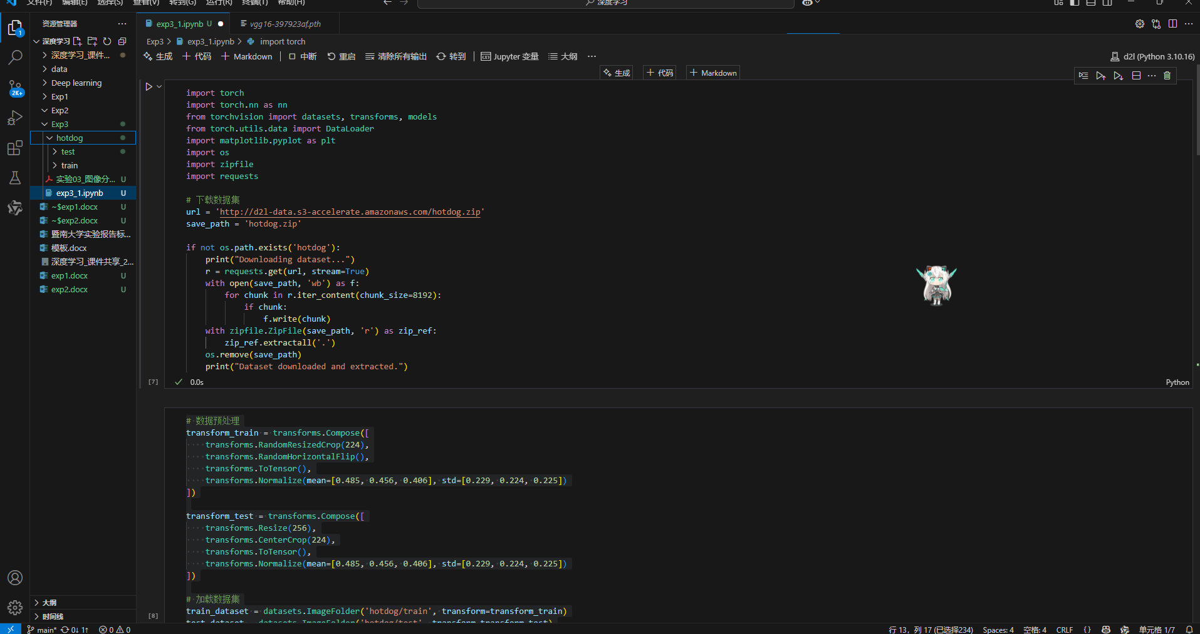

1. **数据预处理和加载数据集**

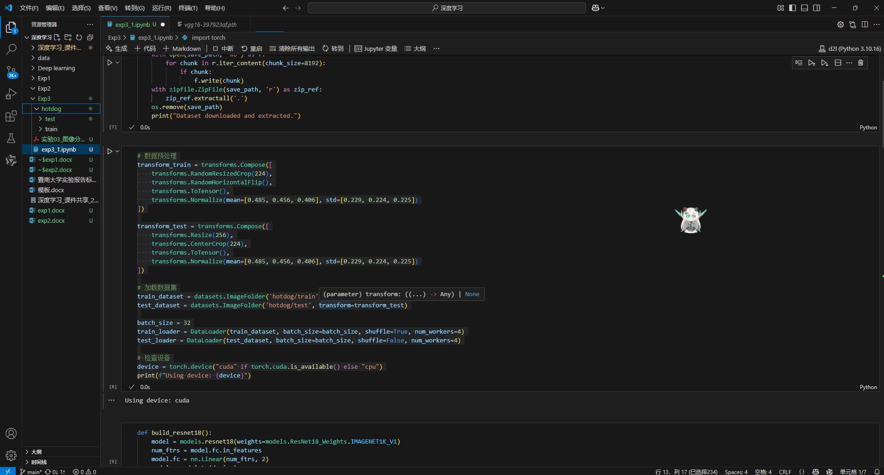

1. **模型训练与验证**
2. ResNet-18

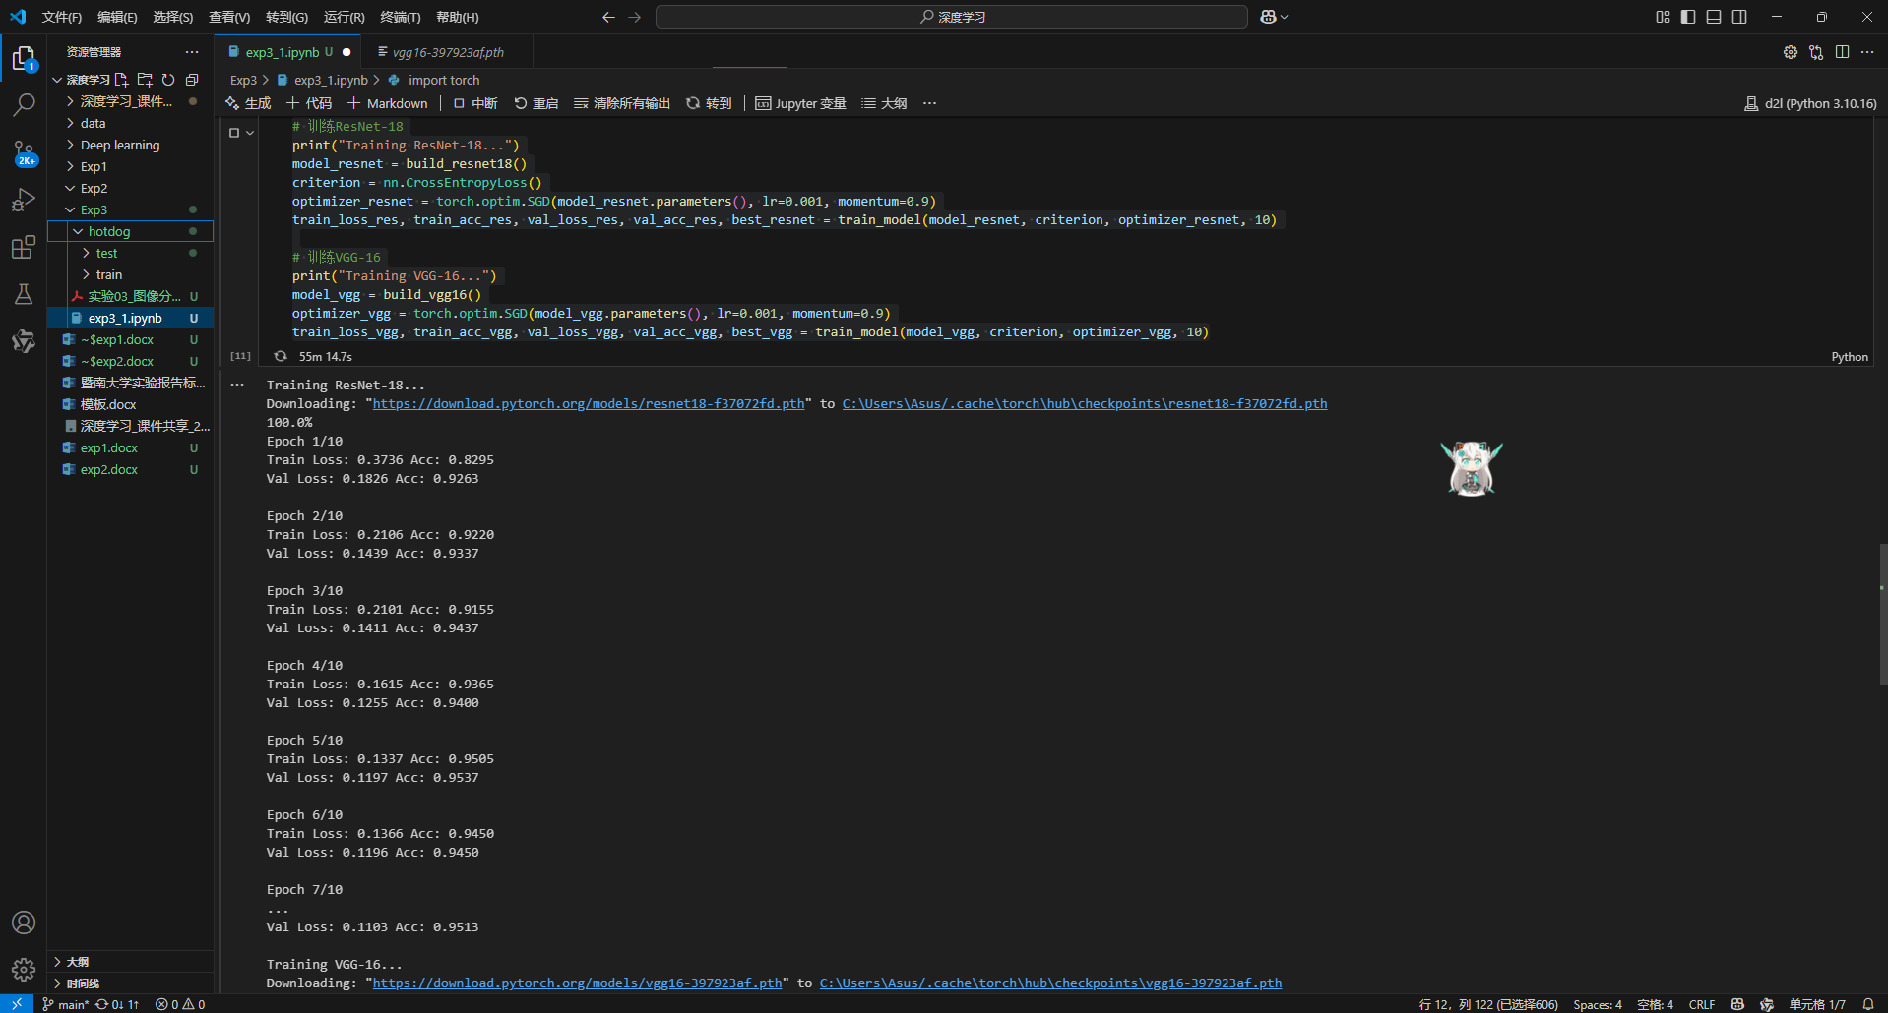

1. VGG-16

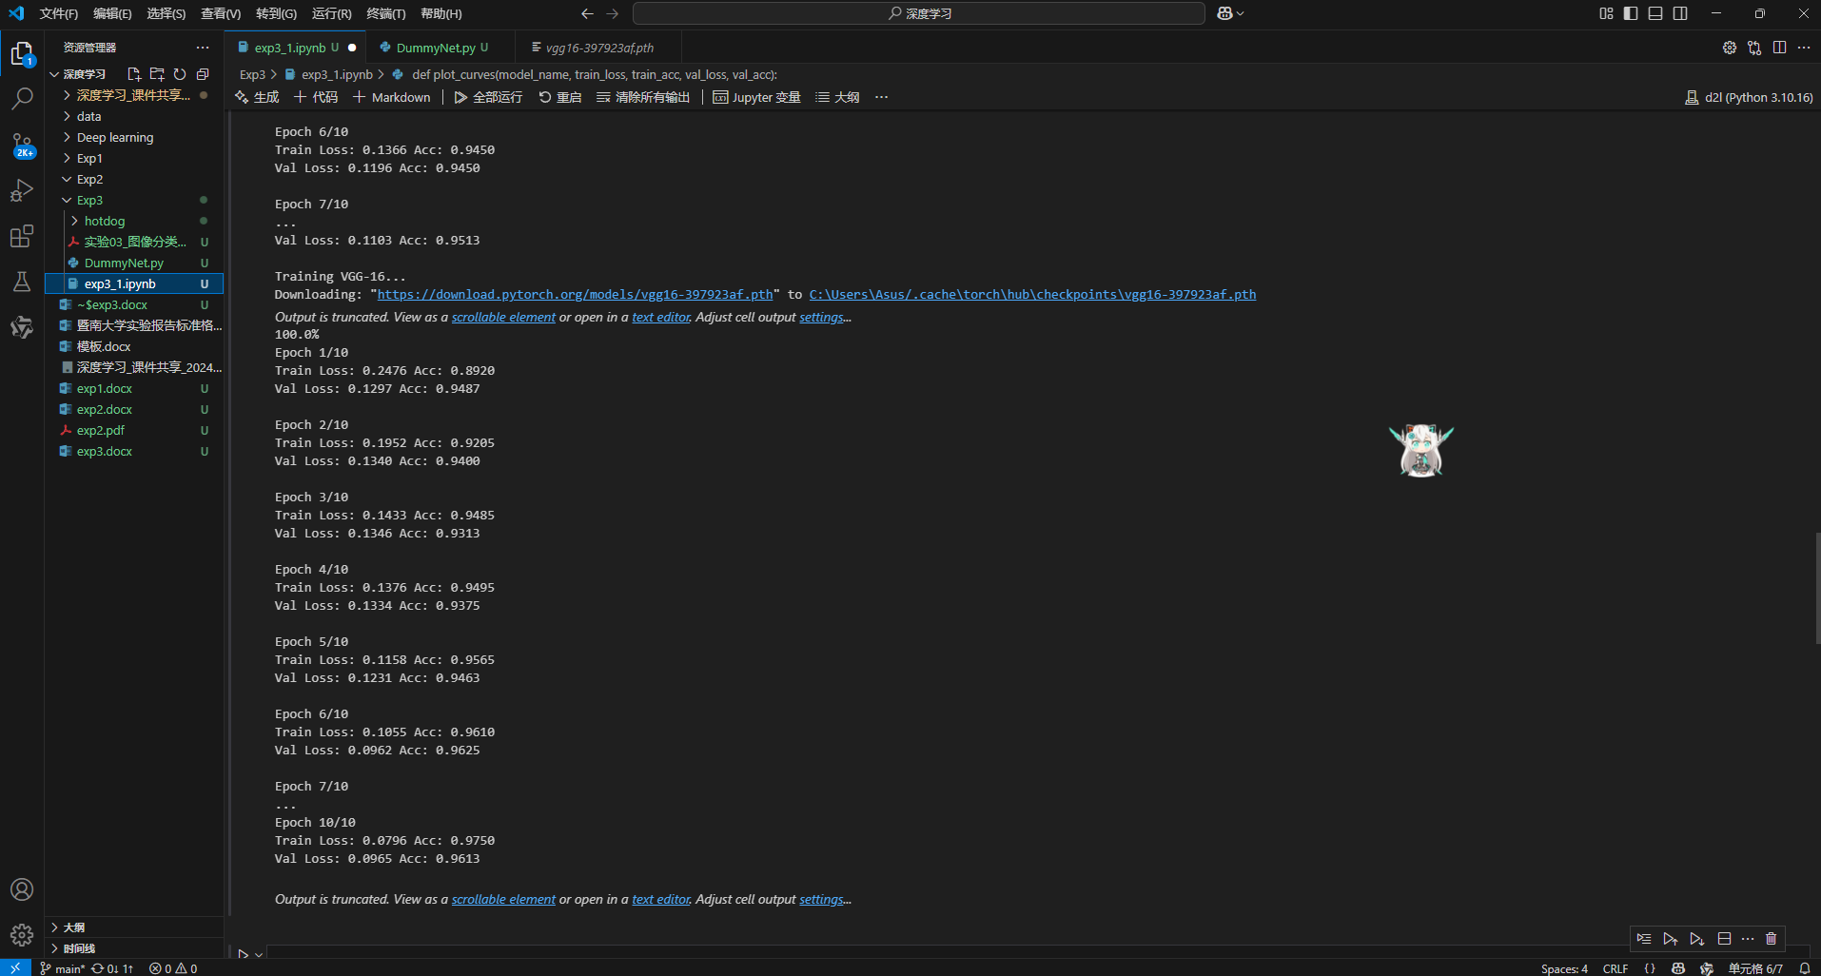

1. **训练曲线**
2. ResNet-18

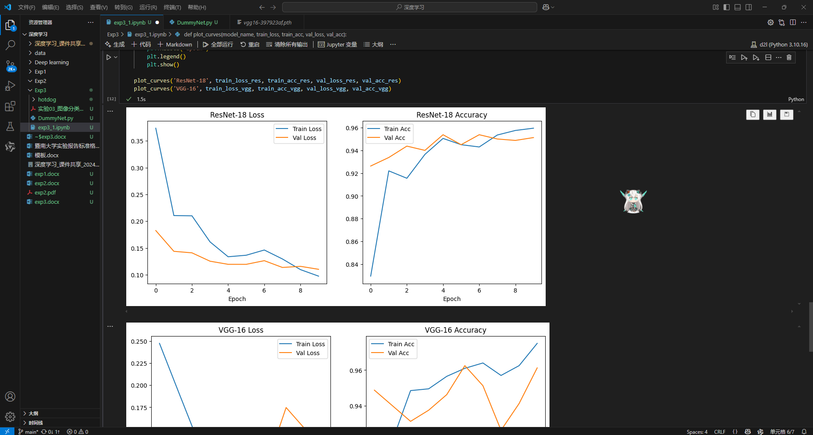

1. VGG-16

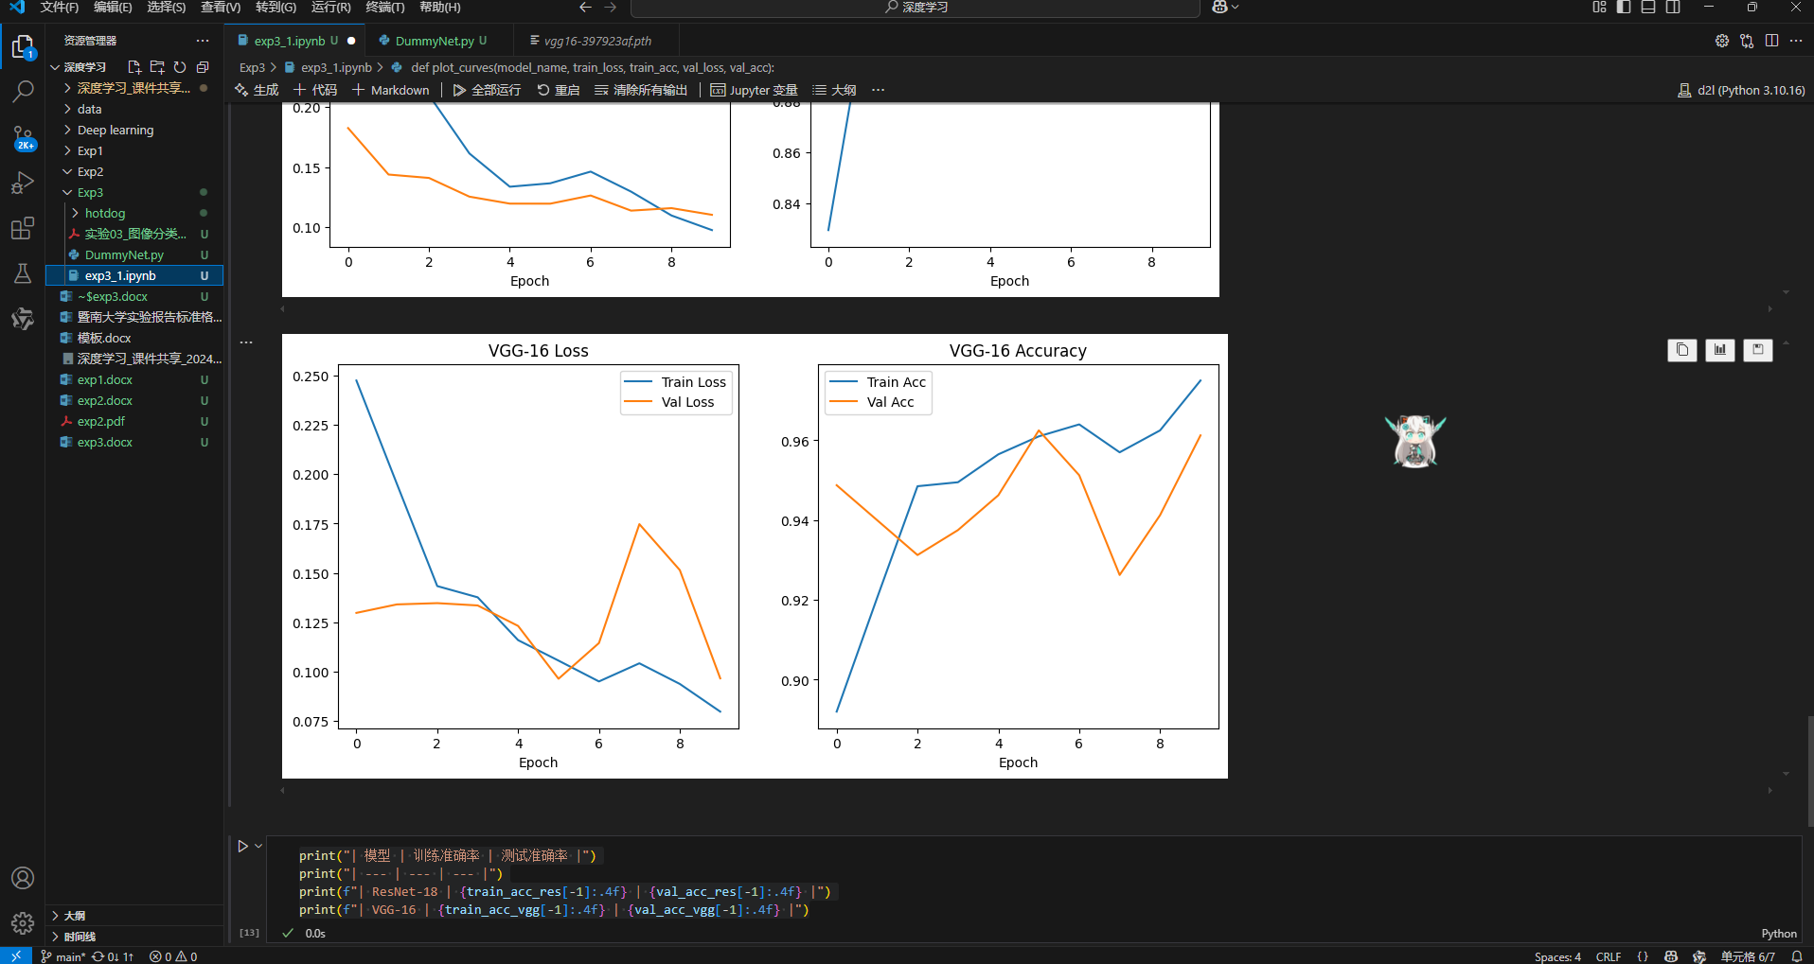

1. **结果输出**

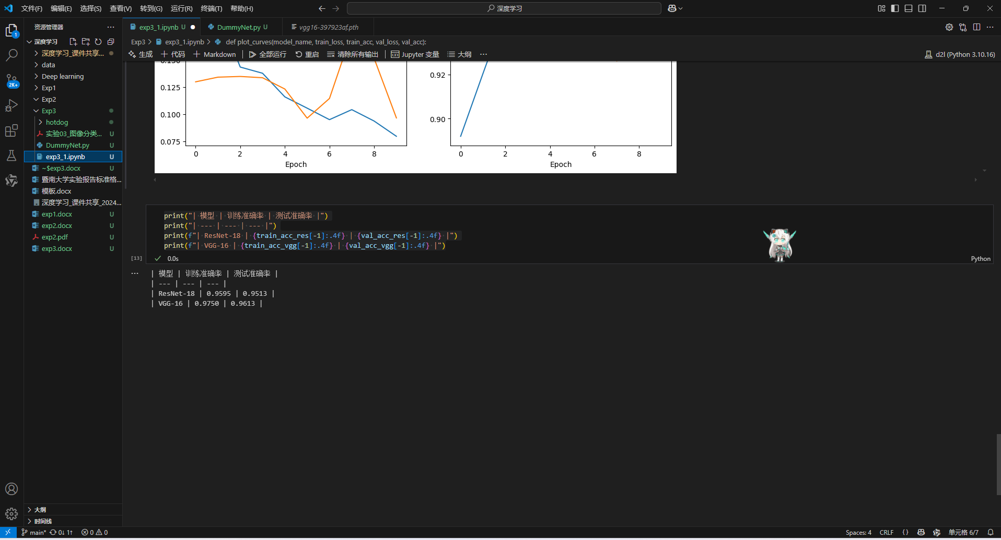

1. **完成表格**

|  |  |  |
| --- | --- | --- |
| 模型 | 训练准确率 | 测试准确率 |
| ResNet-18 | 0.9595 | 0.9513 |
| VGG-16 | 0.9750 | 0.9613 |