Macos have difficulties to use odoo. Use Docker or an other container apps

Welcome Page :

http://localhost:8069

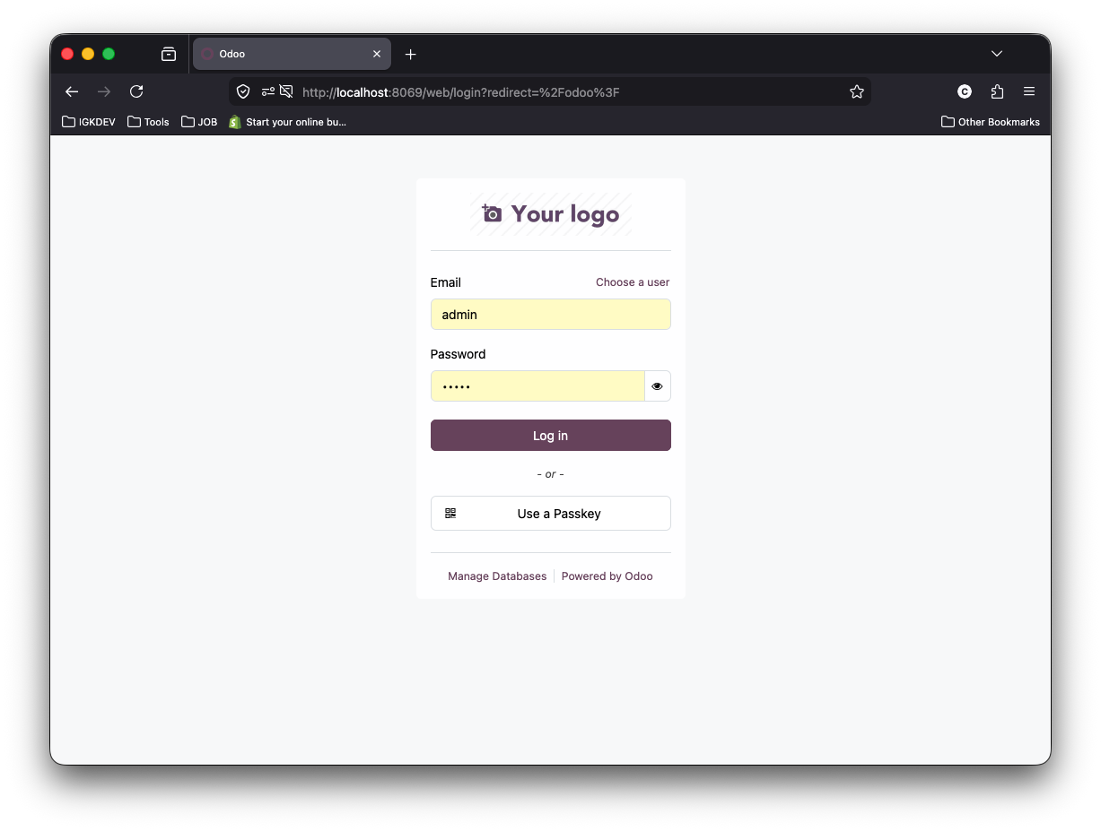
Default user and credentials

admin/admin

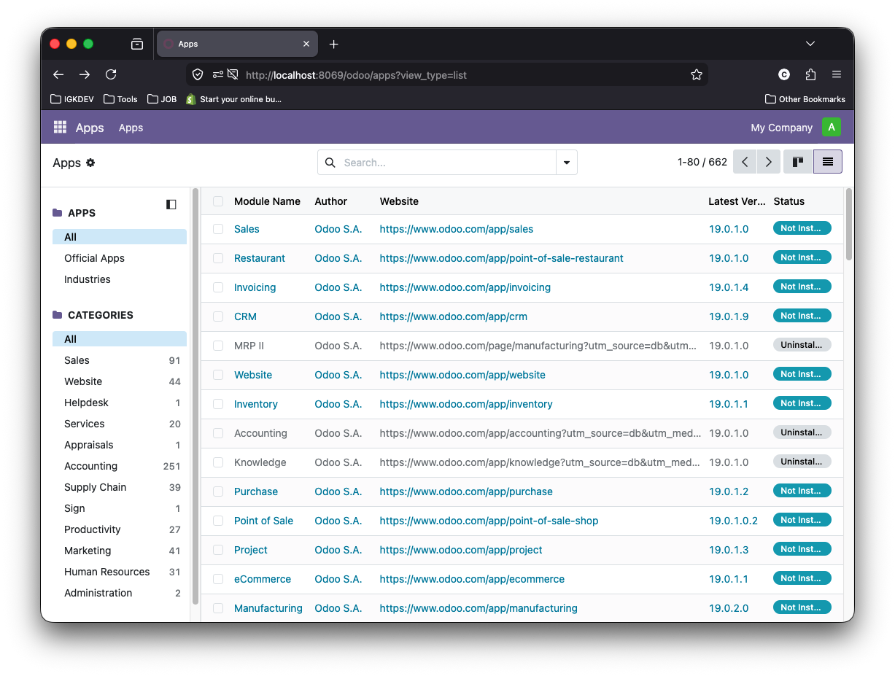

https://www.postgresql.org/docs/current/sql-createdatabase.html

