Introduction

In every Large Housing Complex Premise, people face the non-availability of local transportation vehicles for traveling inside the complex premises. CarO provides instant Toto/Auto support to persons residing inside the Housing Complex. To avail of this service, people need to install and login into this CarO application, then they need to set a source and destination location, and the nearby vehicle which is available at that time, will pick that person up from the Pickup Point and drop them at the Destination.

Project Activity :

- Problems :
- In a large complex sometimes a user has to wait for a local Toto/Auto to come if he/she wants to go to “Local Market” or has to go to take a Bus.
- A passenger is waiting for Auto/Toto and an empty Toto/Auto is waiting for passengers in the next lane and is completely unaware of the passenger who is waiting.

Every day many people are facing this problem in the “Shapoorji Pallonji Housing Complex”. CarO will help the Passenger to connect with the Toto/Auto driver so that the passenger does not need to wait for traveling.

Scalability:

- The project will be useful for other large societies where people face the same issue in their daily life.

- We can use this project also in village areas. Where Students, normal people kept on waiting for a transport car to arrive so that they could go to school, Market respectively.
Our project will connect them with the local Toto/auto services so that people don't need to keep waiting and the Toto/Auto driver no longer has to lose his passenger.

Working :
- From User Side :
- Users have to install our application and log in to it using Mobile Number or Email.
- Users have to open our application, turn on Location, and set “Pickup Point” and “Destination Point” every time he/she wants to use the local Auto/Toto service.

- From Driver Side :
- To Register a local driver to our application he needs to download our application and register himself using his Driving License, Car Number, phone number, and email.
- Every time a passenger searches for a Toto/Auto service inside the housing complex, the nearest Driver will get a notification inside the application, and based on his vehicle capacity he can accept or reject the request with a single click.

Project Flow Chart :
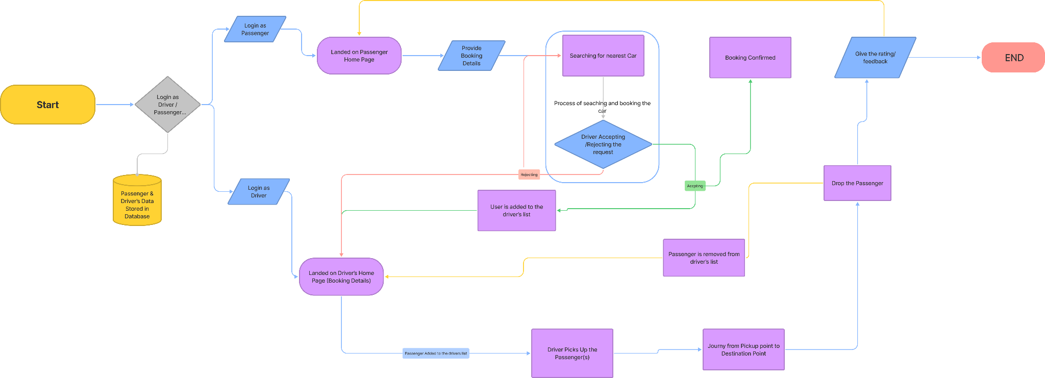

Using of Google Cloud Platform :
- Using Firebase for real-time Cloud Database and hosting our application.
- Using Firebase for login authentication.
- Using Google Map Services for tracking location.

Introduction
In every Large Housing Complex Premise, people face the non-availability of local transportation vehicles for traveling inside the complex premises. CarO provides instant Toto/Auto support to persons residing inside the Housing Complex. To avail of this service, people need to install and login into this CarO application, then they need to set a source and destination location, and the nearby vehicle which is available at that time, will pick that person up from the Pickup Point and drop them at the Destination.

Problems
In a large complex sometimes a user has to wait for a local Toto/Auto to come if he/she wants to go to “Local Market” or has to go to take a Bus. A passenger is waiting for Auto/Toto and an empty Toto/Auto is waiting for passengers in the next lane and is completely unaware of the passenger who is waiting.
Every day many people are facing this problem in the Shapoorji Pallonji Housing Complex. CarO will help the Passenger to connect with the Toto/Auto driver so that the passenger does not need to wait for traveling.

Working
From User Side
Users have to install our application and log in to it using Mobile Number or Email. Users have to open our application, turn on Location, and set “Pickup Point” and “Destination Point” every time he/she wants to use the local Auto/Toto service.
From Driver Side
To Register a local driver to our application he needs to download our application and register himself using his Driving License, Car Number, phone number, and email. Every time a passenger searches for a Toto/Auto service inside the housing complex, the nearest Driver will get a notification inside the application, and based on his vehicle capacity he can accept or reject the request with a single click.

Scalability
The project will be useful for other large societies where people face the same issue in their daily life.
We can use this project also in village areas. Where Students, normal people kept on waiting for a transport car to arrive so that they could go to school, Market respectively. Our project will connect them with the local Toto/auto services so that people don't need to keep waiting and the Toto/Auto driver no longer has to lose his passenger.

Using of Google Cloud Platform
- Using Firebase for real time Cloud Database and hosting our application.
- Using Firebase for login authentication.
- Using Google Map Services for tracking location.

