

**American International University- Bangladesh**

**CSC 3215: Web Technologies**

**CO1 and CO3 Evaluation**

**Project Report**

**Spring 2019-2020**

**Project Title: AIUB Gaggle**

**Section: J**

|  |  |
| --- | --- |
| Student Name | Student Id |
| Md.Salimullah | **18-37541-1** |
| Modak Gourango | **18-37102-1** |
| Zahin Awosaf | **18-37064-1** |

**Introduction:**

Aiub Gaggle is platform where student can communicate to help each other. When student face problem to understand anything in undergraduate level, he may find solution form Aiub Gaggle.

Some student may face problem in his course, seek advice and help for one’s preferable research field. One may seek for guideline, whenever a student face problem in particular topic, he can search for expertise in that particular topic. In the meantime, if any student who is free in campus and expert in that particular topic, can help that student.This opportunity will be made by Aiub Gaggle.

**Background Study**

The idea of this project we get from in our university (AIUB) where student face problem to understand anything in undergraduate level such as problem in curriculam course, seek advice and help for one’s preferable research field.

There are some students who wants to spend their free time in productivity, learning new thing and also do help others. On the other hand, there are some student who wants to spend his free time to learn and trying to solve problem by helping. So, why not if we meet these students together in their same free time then they can help each other and their skill, communication skill will also improve. This is the problem we face in our university to how do we can utilize our free time in productivity.

**Requirement Analysis:**

1. **User Category:**

There are 1-types of Users here. They are:

* Student

1. **Feature List:**

In this project the “Student” has the following features:

* Chatting
* Update Profile
* Add Status
* Upload file
* Change Password
* Add Ratting
* View Research paper
* Search by subject
* View Instructor Tutor by Category wise
* Quickly finding Instructor option

**Design:**

Draw an entity diagram of your project here. (DIA)

**ER Diagram**

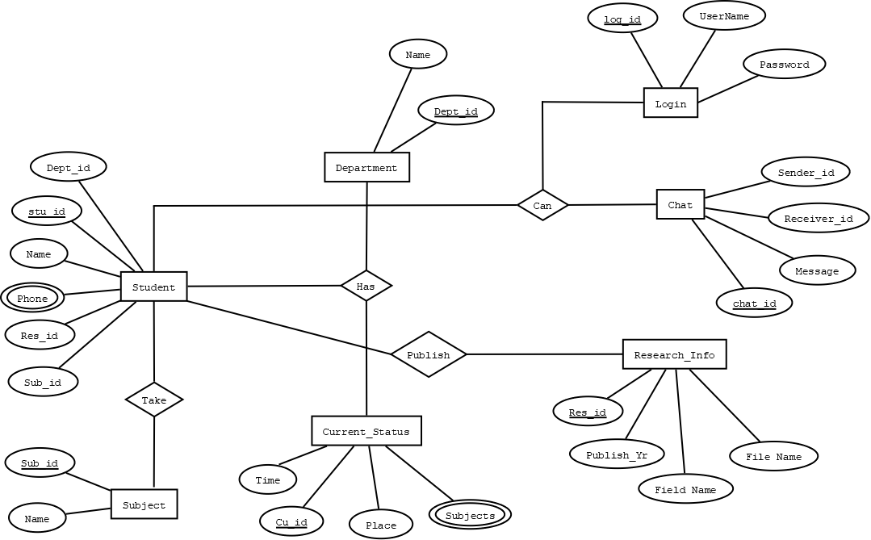

**Use Case**

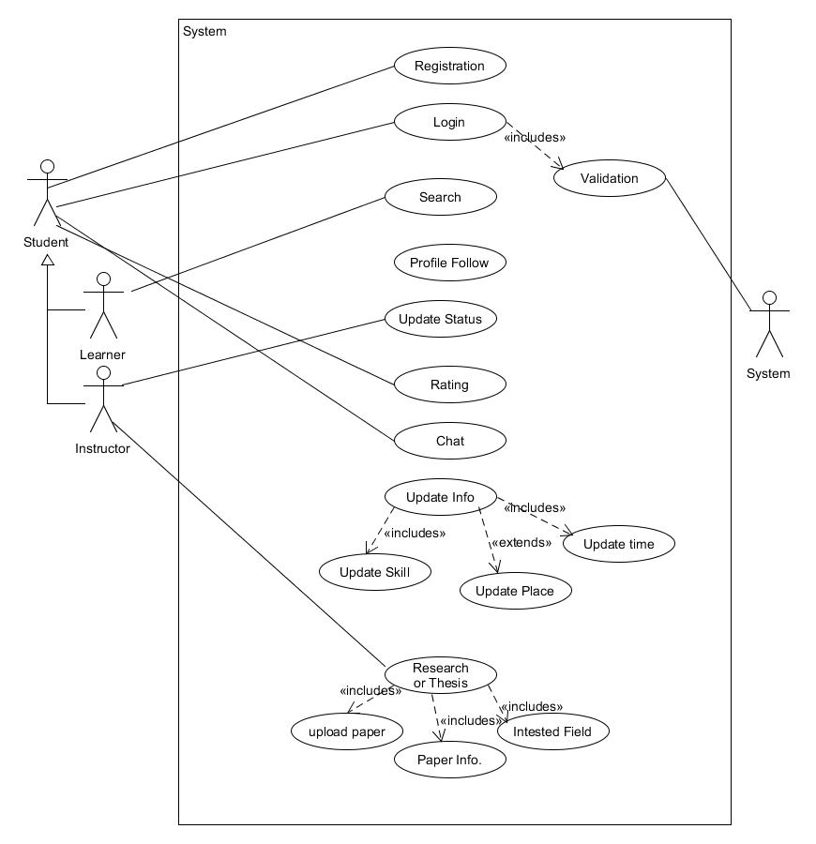

**Class Diagram**

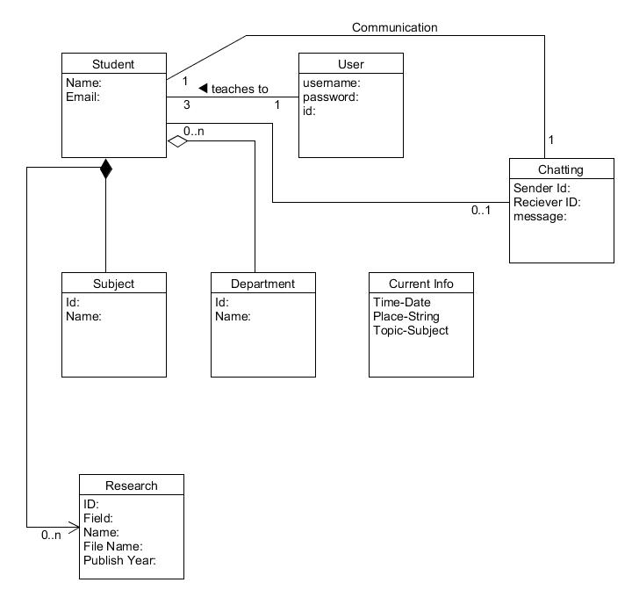

**Sequence**

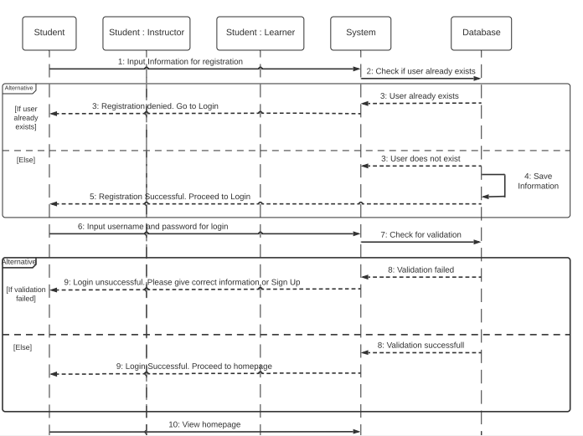

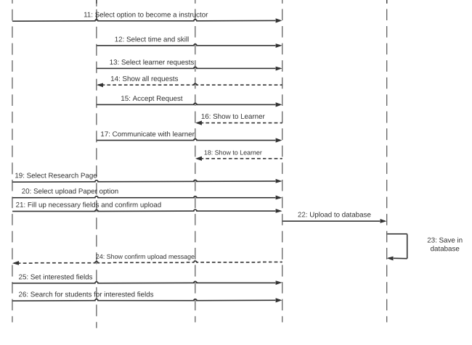

**Activity Diagram**

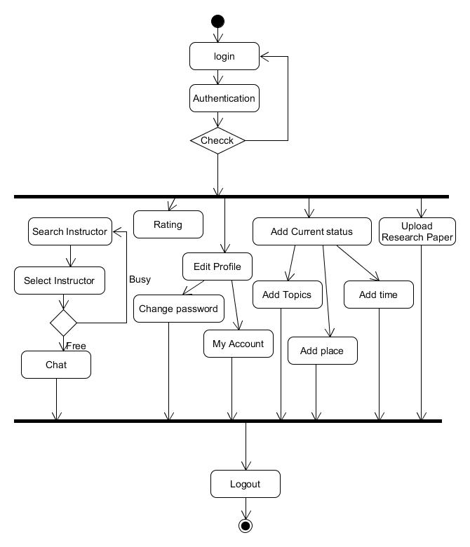

**State Diagram**

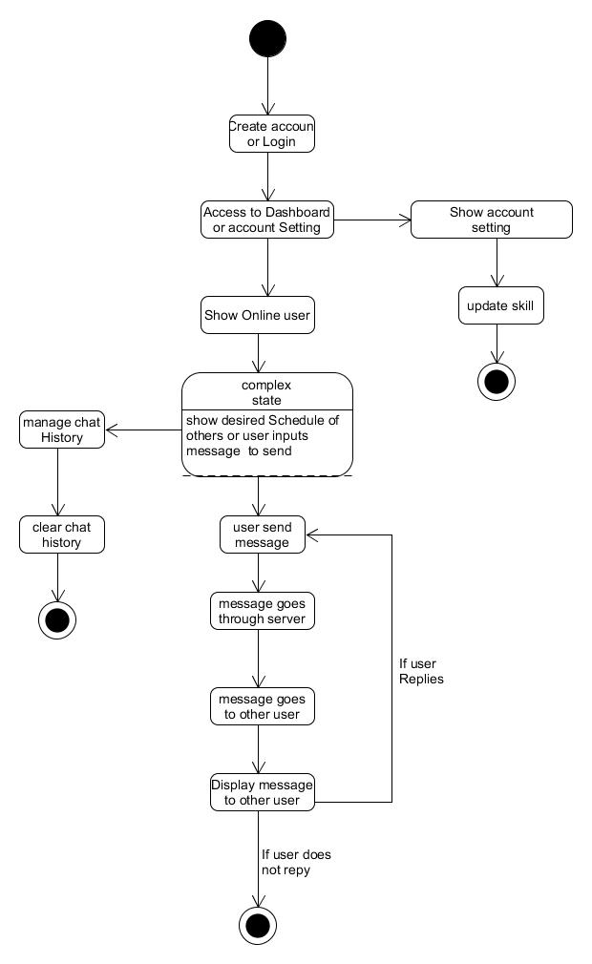

**Tools Used:**

To develop this project, we have used the following:

* Adobe XD
* Sublime
* DIA

**System Images against the Specification:**

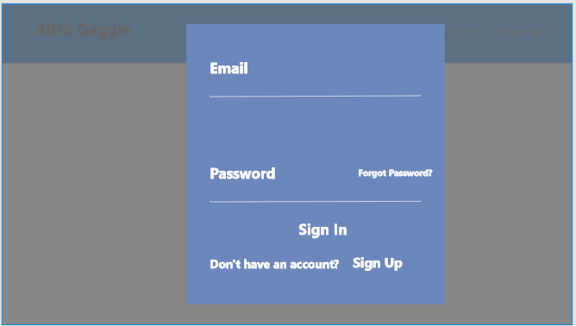

* **This is login Page where student will sign in his account.**

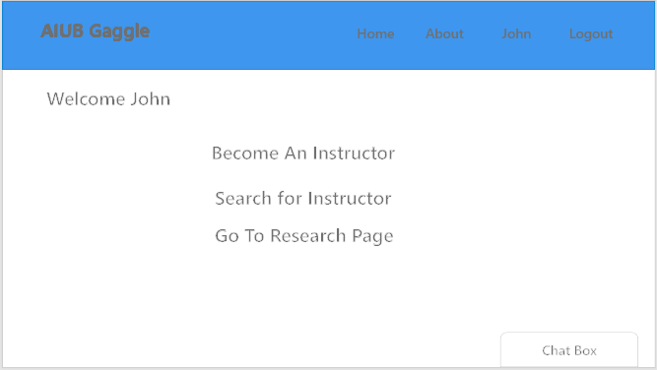

* **This is home Page. In this page, we have chatbox, About, Profile and logout options.**

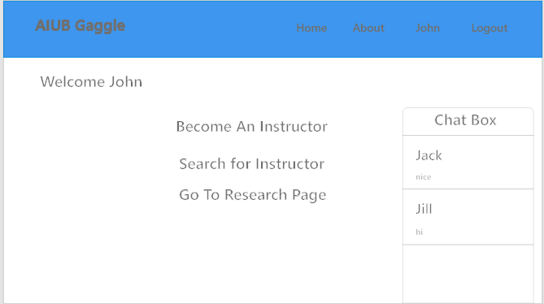

* **In this Home Page, All the active student list will be shown on chatbox.**

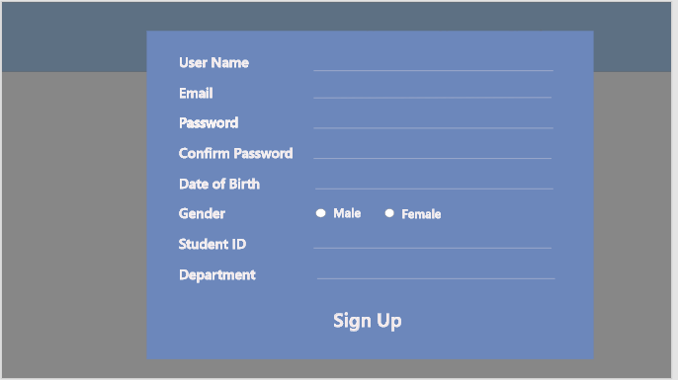

* **It is Registration page where Student will create an account using some information.**

**Impact of this Project:**

In university level, someone may want to help who seek according to his/her free time. But lack of communication between students, it is quite impossible. Through AIUB Gaggle, this problem can be solved. The main impact are students can help each other which enhance student’s skill. Through this, Student is able to utilize their free time. Also, Student is able to explore the thesis fields domain and by doing these they are able to find out thesis to find out thesis partner. By this software potential of students will be enhanced, and by this the morality of to help other will be exercised which will lead a betterment of society.And,In university, student will be engaged to study more in their leisure time, Respect between student will be increased.

**Limitations and Possible Future Improvements:**

In this project, there are some limitation where we can’t watch where does Tutor right now and what is the distance between tutor and learner. So, to solve this problem we can use Real time location tracking system using google API and also, we can get the distance between in these two persons. Besides, in this project we don’t get the access of AIUB student server otherwise Student don’t need to create an account or registration for access this platform. Registration will be Completed when he admitted in AIUB then Any student can access any time. Here also we can improve something such as In this project we have ratting system where learner can give rate for a tutor, So here when any student search by his subject then the active list tutor on particular subject can be sorted his ratting and also we can add some machine learning recommended algorithm to sort out using other some features.

***[Note: Make sure that your report is maximum 8 pages (including cover page). Print (Colored) the report and submit it with spiral bind as well as soft copy.]***

|  |  |  |  |  |  |
| --- | --- | --- | --- | --- | --- |
| **CO1 and CO3 Evaluation: Project Report Evaluation** | | | | | |
| **Project Proposal**  **(5)** | **Background**  **Study**  **(5)** | **Requirement Analysis**  **(5)** | **Entity**  **Diagram**  **(5)** | **System Images**  **against the**  **Specification (5)** | **Total (25)** |
|  |  |  |  |  |  |
|  | | | | | |