1. There is a bug in code which makes reality is NULL , there is two data pattern which can help developer to find root cause of it , can you identify it ?

* All are females
* UserID starting with B5A

1. What is significance relationship between Gender and Membership?

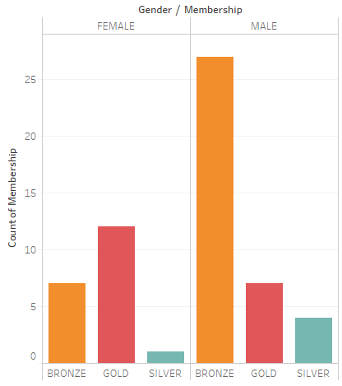

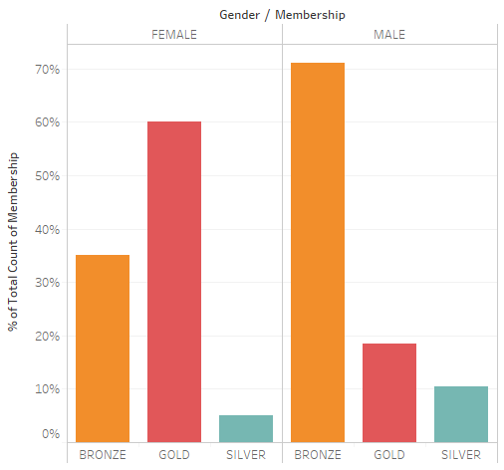

1. Find any pattern between date of user acquisition with LTV.

