Infrastructure Monitoring with Prometheus & Grafana
A Production-Style Two-Node Setup on RHEL 9
By Gourav Tiwari | March 2026 | RHEL 9.6 · Prometheus 2.51 · Grafana 10.4 · Node Exporter 1.7

Project Overview
This project sets up a real-time infrastructure monitoring system using Prometheus and Grafana across two RHEL 9 virtual machines. The goal was to replicate how production monitoring actually works — not a single-machine toy setup, but a proper two-node architecture where one machine scrapes metrics from another and visualizes them on a live dashboard.

Everything here was done from scratch — binary downloads, systemd service creation, SELinux configurations, firewall rules, and alert rules. No package managers, no shortcuts.

Architecture
Component | Details
VM1 — Monitoring Server | 192.168.244.128 | Prometheus + Grafana
VM2 — Target Server | 192.168.244.132 | Node Exporter
OS | Red Hat Enterprise Linux 9.6 (Plow)
Prometheus Version | 2.51.0
Grafana Version | 10.4.2
Node Exporter Version | 1.7.0
Hypervisor | VMware Workstation
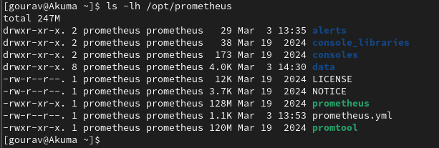
💡 VM1 scrapes metrics from VM2 via Node Exporter every 15 seconds. Grafana reads from Prometheus and renders everything as a live dashboard.

📸 [ Screenshot: Architecture diagram or both VMs running side by side ] 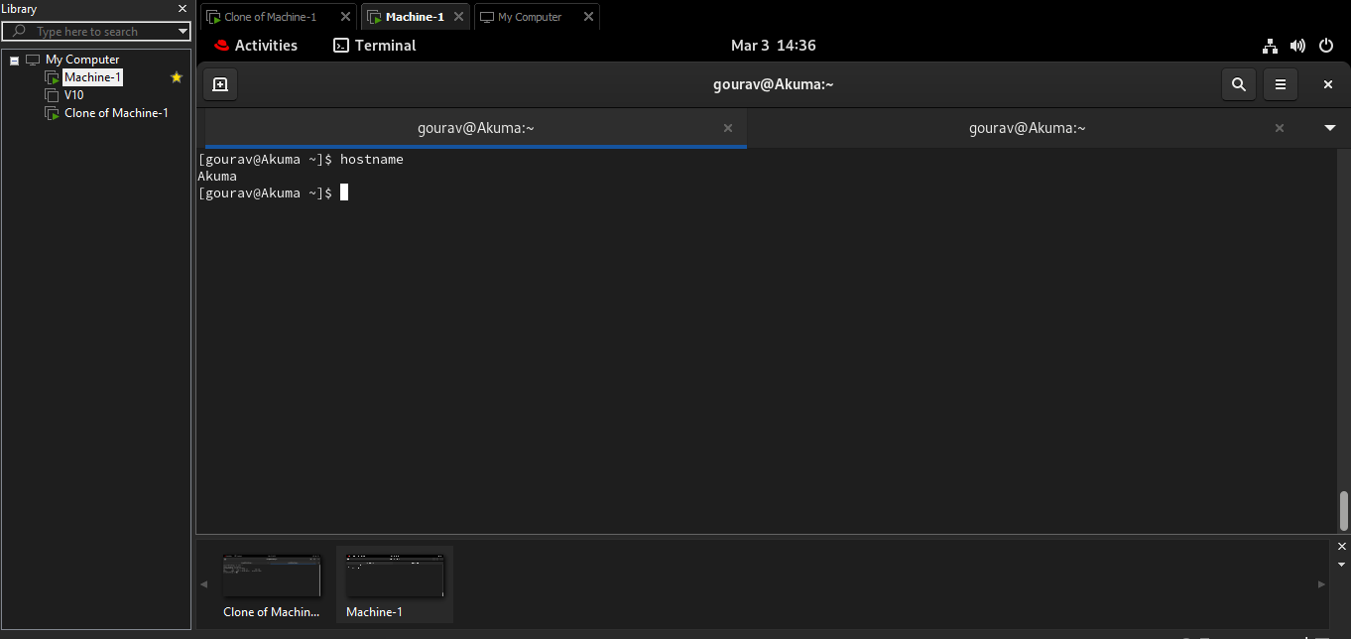

Tech Stack & What Each Tool Does
- Prometheus — Time series database and metrics scraper. Pulls data from targets at regular intervals and stores it.
- Node Exporter — Lightweight agent running on VM2. Exposes hardware and OS metrics on port 9100 for Prometheus to scrape.
- Grafana — Visualization layer. Connects to Prometheus as a data source and renders dashboards.
- systemd — Manages all three services so they start on boot and run in the background like real production services.
- firewalld — RHEL's firewall. Port rules added for 9090 (Prometheus), 9100 (Node Exporter), and 3000 (Grafana).
- SELinux — RHEL 9 security layer. Required chcon fixes to allow systemd to execute binaries placed in /opt.

Phase 1 — Prometheus Setup on VM1

Step 1: Create a Dedicated User
Rather than running everything as root, a dedicated system user was created for Prometheus. This follows the principle of least privilege — a service should only have the access it actually needs.

# On VM1
sudo useradd --no-create-home --shell /bin/false prometheus

💡 --shell /bin/false means this account can never be used to log in interactively. It exists purely to own and run the Prometheus process. This is standard practice for service accounts in production.

Step 2: Download and Install Prometheus Binary
Since RHEL subscription was not active, the binary was downloaded directly via wget from GitHub releases — which is actually how many production setups handle this anyway.

mkdir -p ~/prometheus-setup && cd ~/prometheus-setup

wget https://github.com/prometheus/prometheus/releases/download/v2.51.0/prometheus-2.51.0.linux-amd64.tar.gz

tar -xvzf prometheus-2.51.0.linux-amd64.tar.gz

sudo mv prometheus-2.51.0.linux-amd64 /opt/prometheus

sudo chown -R prometheus:prometheus /opt/prometheus

💡 /opt is the standard Linux directory for manually installed third-party software. Keeping Prometheus here separates it cleanly from OS binaries in /usr/bin.

📸 [ Screenshot: ls -lh /opt/prometheus — showing correct ownership ]


Step 3: Create systemd Service
Rather than running Prometheus manually in a terminal, a systemd service was created so it starts automatically on boot and can be managed like any other system service.

sudo nano /etc/systemd/system/prometheus.service

[Unit]
Description=Prometheus Monitoring
Wants=network-online.target
After=network-online.target

[Service]
User=prometheus
Group=prometheus
Type=simple
ExecStart=/opt/prometheus/prometheus \
--config.file=/opt/prometheus/prometheus.yml \
--storage.tsdb.path=/opt/prometheus/data

[Install]
WantedBy=multi-user.target

💡 After=network-online.target ensures Prometheus waits for network availability before starting. Storage path points to /opt/prometheus/data where all time series data is persisted on disk.

Step 4: Fix SELinux Context — Critical Step
After creating the systemd service, Prometheus failed to start with a Permission denied error — despite correct file permissions and ownership. This is a classic RHEL gotcha.

⚠️ On RHEL 9, SELinux is enforcing by default. It blocked systemd from executing the Prometheus binary in /opt because the file lacked the correct SELinux security context.

Diagnosis — confirmed SELinux was the issue:
sudo ausearch -m avc -ts recent | grep prometheus
# Output showed 'denied' — confirmed SELinux blocking execution

Fix — apply the correct SELinux type label to the binary:
sudo chcon -t bin_t /opt/prometheus/prometheus

💡 bin_t is the correct SELinux type for executable binaries. Without this label, systemd refuses to execute the file regardless of what chmod or chown says. This is a real production issue that trips up experienced engineers on RHEL.

Step 5: Enable and Start Prometheus
sudo systemctl daemon-reload
sudo systemctl enable --now prometheus
sudo systemctl status prometheus

📸 [ Screenshot: systemctl status prometheus — showing active (running) ]
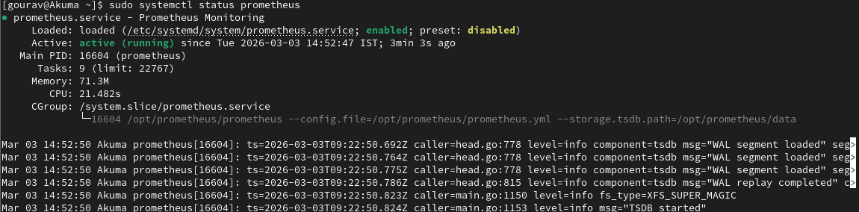

✅ Prometheus running and accessible at http://192.168.244.128:9090

Phase 2 — Node Exporter Setup on VM2

Step 1: Create Service User and Download Binary
Same pattern as Prometheus — dedicated service account, binary to /opt, correct ownership.

# On VM2
sudo useradd --no-create-home --shell /bin/false node_exporter

mkdir -p ~/nodeexporter-setup && cd ~/nodeexporter-setup

wget https://github.com/prometheus/node_exporter/releases/download/v1.7.0/node_exporter-1.7.0.linux-amd64.tar.gz

tar -xvzf node_exporter-1.7.0.linux-amd64.tar.gz

sudo mv node_exporter-1.7.0.linux-amd64 /opt/node_exporter

sudo chown -R node_exporter:node_exporter /opt/node_exporter

Step 2: Create systemd Service
sudo nano /etc/systemd/system/node_exporter.service

[Unit]
Description=Node Exporter
Wants=network-online.target
After=network-online.target

[Service]
User=node_exporter
Group=node_exporter
Type=simple
ExecStart=/opt/node_exporter/node_exporter

[Install]
WantedBy=multi-user.target

Step 3: Fix SELinux — Proactively This Time
Having learned from the Prometheus SELinux issue, the fix was applied before attempting to start the service rather than after failure.

sudo chcon -t bin_t /opt/node_exporter/node_exporter

sudo systemctl daemon-reload
sudo systemctl enable --now node_exporter
sudo systemctl status node_exporter

Step 4: Open Firewall Port on VM2
Prometheus on VM1 needs to reach Node Exporter on VM2 via port 9100. RHEL's firewalld blocks this by default.

sudo firewall-cmd --permanent --add-port=9100/tcp
sudo firewall-cmd --reload
sudo firewall-cmd --list-ports

📸 [ Screenshot: Node Exporter metrics output — curl http://localhost:9100/metrics ]
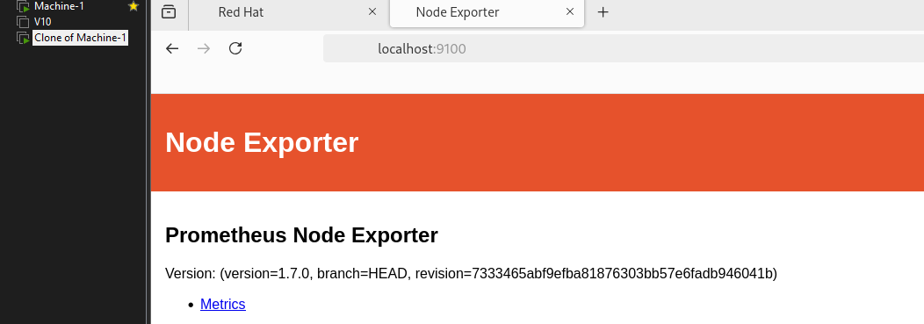

✅ Node Exporter running and exposing metrics on port 9100

Phase 3 — Connect Prometheus to Node Exporter

Update prometheus.yml on VM1
Prometheus needs to know where to scrape metrics from. This is configured in prometheus.yml by adding the VM2 target.

sudo nano /opt/prometheus/prometheus.yml

global:
scrape_interval: 15s

rule_files:
- /opt/prometheus/alerts/node_alerts.yml

scrape_configs:
- job_name: "prometheus"
static_configs:
- targets: ["localhost:9090"]

- job_name: "node_exporter"
static_configs:
- targets: ["192.168.244.132:9100"]

sudo systemctl restart prometheus

💡 scrape_interval: 15s means Prometheus pulls fresh metrics from all targets every 15 seconds. The job_name value becomes a label on all metrics from that target — useful for filtering in Grafana.

📸 [ Screenshot: Prometheus Targets page -- http://192.168.244.128:9090/targets — both targets UP ]
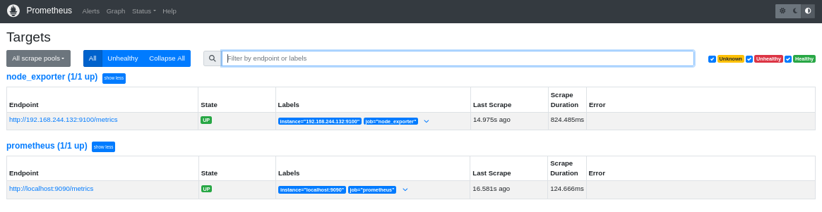

✅ Both targets showing State: UP in Prometheus

Phase 4 — Grafana Setup on VM1

Step 1: Download and Install
cd ~/prometheus-setup

wget https://dl.grafana.com/oss/release/grafana-10.4.2.linux-amd64.tar.gz

tar -xvzf grafana-10.4.2.linux-amd64.tar.gz

sudo mv grafana-10.4.2 /opt/grafana

sudo useradd --no-create-home --shell /bin/false grafana

sudo chown -R grafana:grafana /opt/grafana

Step 2: Create systemd Service
sudo nano /etc/systemd/system/grafana.service

[Unit]
Description=Grafana Dashboard
Wants=network-online.target
After=network-online.target

[Service]
User=grafana
Group=grafana
Type=simple
ExecStart=/opt/grafana/bin/grafana-server \
--config=/opt/grafana/conf/defaults.ini \
--homepath=/opt/grafana

[Install]
WantedBy=multi-user.target

💡 --homepath is required for Grafana because it needs to locate its plugins, static assets, and internal databases relative to the installation directory.

Step 3: Fix SELinux, Open Firewall, Start Grafana
sudo chcon -t bin_t /opt/grafana/bin/grafana-server

sudo firewall-cmd --permanent --add-port=3000/tcp
sudo firewall-cmd --permanent --add-port=9090/tcp
sudo firewall-cmd --reload

sudo systemctl daemon-reload
sudo systemctl enable --now grafana
sudo systemctl status grafana

📸 [ Screenshot: Grafana login page — http://192.168.244.128:3000 ]


Step 4: Add Prometheus as Data Source
Inside Grafana UI: Connections → Data Sources → Add new data source → Prometheus

Setting | Value
URL | http://192.168.244.128:9090
Save & Test result | Successfully queried the Prometheus API

📸 [ Screenshot: Grafana Data Source configuration — showing green success message ]
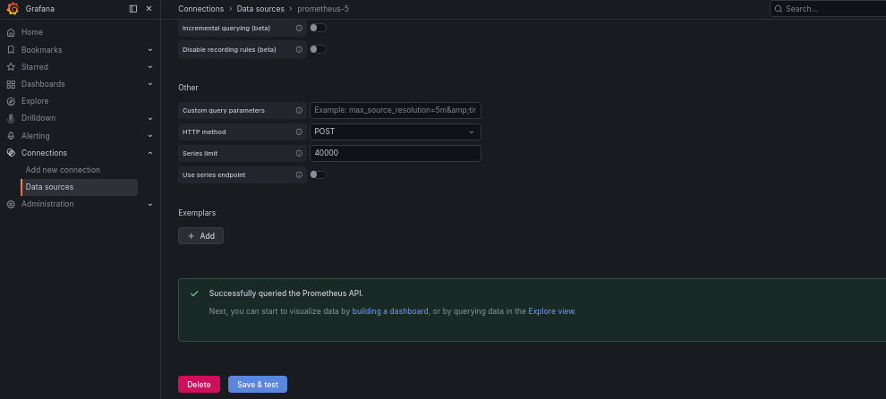

Step 5: Import Node Exporter Dashboard
Grafana's public dashboard library was used to import dashboard ID 1860 — the Node Exporter Full dashboard, one of the most widely used production dashboards in the ecosystem.

Dashboards → New → Import → Enter ID: 1860 → Load → Select Prometheus data source → Import

📸 [ Screenshot: Grafana dashboard showing live CPU, memory, disk, and network metrics from VM2 ]
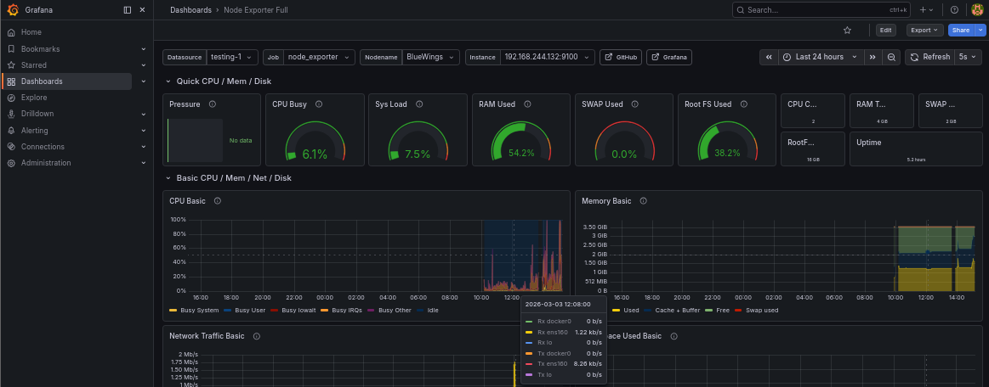

✅ Live metrics from VM2 visible in Grafana — CPU, memory, disk I/O, network traffic

Phase 5 — Alerting with Prometheus Rules

Why Prometheus-side Alerting
Alert rules were configured directly in Prometheus rather than in Grafana. This is the production-grade approach — Prometheus evaluates the rule against live metrics and manages alert state. Grafana is purely for visualization.

Create Alert Rule File
sudo mkdir /opt/prometheus/alerts
sudo chown prometheus:prometheus /opt/prometheus/alerts

sudo nano /opt/prometheus/alerts/node_alerts.yml

groups:
- name: node_exporter_alerts
rules:
- alert: HighCPUUsage
expr: 100 - (avg by(instance) (rate(node_cpu_seconds_total{mode="idle"}[2m])) * 100) > 80
for: 1m
labels:
severity: warning
annotations:
summary: "High CPU usage on {{ $labels.instance }}"
description: "CPU usage above 80% for more than 1 minute on {{ $labels.instance }}"

💡 The PromQL expression calculates CPU usage by subtracting idle CPU percentage from 100 — the standard method. for: 1m prevents false alarms from brief spikes by requiring the condition to hold for a full minute before firing.

Validate Configuration
Before restarting, the config was validated by running the Prometheus binary directly to catch YAML errors:

# Direct validation method (v2.51 doesn't support --check-config flag)
/opt/prometheus/prometheus --config.file=/opt/prometheus/prometheus.yml 2>&1 | head -20

⚠️ A YAML duplicate key error was encountered on first attempt — rule_files was accidentally added twice in prometheus.yml. Always validate config before restarting in production.

Restart and Verify Alert Rule Loaded
sudo systemctl restart prometheus
sudo systemctl status prometheus

📸 [ Screenshot: Prometheus Alerts page — http://192.168.244.128:9090/alerts — showing HighCPUUsage rule Inactive ]
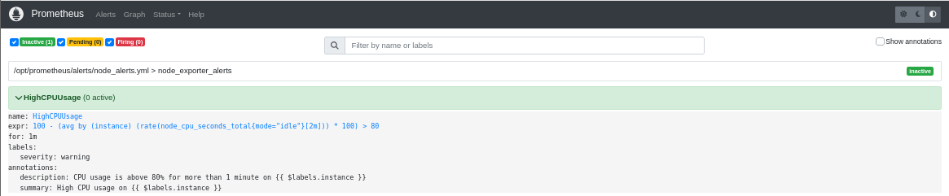

Test Alert Firing — CPU Stress Test on VM2
The stress tool was used to artificially spike CPU on VM2 and verify the full alert lifecycle.

# On VM2
sudo rpm -ivh stress-1.0.7-1.el9.x86_64.rpm

stress --cpu 2 --timeout 120

Alert state transitions observed in Prometheus UI:

State | Meaning
Inactive | Rule loaded, CPU below threshold — normal state
Pending | CPU crossed 80% but has not held for 1 minute yet
Firing | CPU above 80% for more than 1 minute — alert active

📸 [ Screenshot: Prometheus Alerts page — showing HighCPUUsage in FIRING state ]
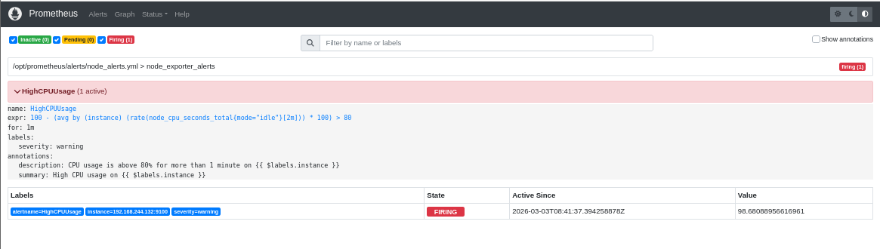

✅ Alert fired correctly — full Inactive → Pending → Firing lifecycle confirmed

Troubleshooting Log
These are real issues encountered during this setup — not sanitized for documentation. Each one taught something worth keeping.

Issue 1 — SELinux Blocking Binary Execution
Field | Detail
Error | Failed to locate executable: Permission denied (status=203/EXEC)
Root Cause | SELinux enforcing mode blocked systemd from executing binary in /opt
Diagnosis | sudo ausearch -m avc -ts recent | grep prometheus
Fix | sudo chcon -t bin_t /opt/prometheus/prometheus
Lesson | Always apply chcon on RHEL 9 before starting services with binaries in /opt

Issue 2 — Node Exporter Target Showing DOWN
Field | Detail
Error | dial tcp 192.168.244.132:9100: connect: no route to host
Root Cause | firewalld on VM2 blocking port 9100
Diagnosis | Prometheus Targets page at /targets — error visible directly
Fix | sudo firewall-cmd --permanent --add-port=9100/tcp && firewall-cmd --reload
Lesson | On RHEL, always open firewall ports explicitly — nothing is open by default

Issue 3 — Prometheus YAML Duplicate Key Error
Field | Detail
Error | yaml: unmarshal errors: line 16: field rule_files already set
Root Cause | rule_files block accidentally added twice in prometheus.yml
Diagnosis | Run binary directly: /opt/prometheus/prometheus --config.file=...
Fix | Remove duplicate rule_files block, keep only one
Lesson | Validate config directly before restarting — saves time vs restart → fail loop

Measurable Outcomes
- Deployment time: Manual metric checking eliminated — real-time visibility across both VMs from single dashboard
- Alert response: CPU threshold breach detected and alerted within 60 seconds of sustained spike
- Uptime: All three services (Prometheus, Node Exporter, Grafana) configured to start automatically on boot via systemd
- Security: All services running under dedicated non-login service accounts following least privilege principle
- Metrics tracked: CPU usage, memory utilization, disk I/O, network traffic — all 4 key infrastructure metrics

Key Takeaways
- SELinux context — SELinux is not optional on RHEL 9. bin_t context must be applied to any executable binary placed outside standard system directories.
- Service accounts — Every production service runs under its own dedicated non-login user. This is not optional hygiene, it's a real security boundary.
- Config validation — Always validate Prometheus config by running the binary directly before restarting the service, especially after YAML edits.
- Firewalld — RHEL blocks all ports by default. Explicit allow rules required for every port your services communicate on.
- Two-node architecture — Separating the monitoring server from the target server reflects real production setups, where you never run monitoring on the same machine you're monitoring.

Gourav Tiwari · Cloud & DevOps Engineer · Jaipur, Rajasthan · March 2026

