**TRAFFIC FLOW EFFIENECY USING SMART TECNOLOGY**

**VEHICLE-TO-EVERYTHING(V2X) TECHONOLOGY**

**INTRODUCTION**

Vehicle-to-everything technology consists of the sensors, cameras, and wireless connectivity – like Wi-Fi, radio frequencies and LTE and 5G cellular technology – that would allow cars to share information with each other, their drivers, and their surroundings.

Currently, V2X technology is very piecemeal. While sensors, cameras, and networks all exist, they are not really working together to link cars with one another or their surroundings to make driving safer. Many cars on the road today do not have the capability to send and receive data to one another unless they are the same model. And large-scale networks like LTE and 5g, which would effectively bridge the gap between vehicles, infrastructure, and pedestrians, so they could communicate, have not been fully adopted in the auto industry yet. For V2X to works at its full potential, it must be widespread.

**“Connectivity is really the holy Grail”**

“Typically, you have all this technology, but if it can’t communicate reliably, it’s hard to make the application work,” This phrase used by Todd Rigby, director of sales at Rajant, a mobile network infrastructure company.

He purposed the idea of using wireless mesh networks to manage and maintain broadband connectivity, Rajat connects vehicle to one another and to infrastructure for use in mining construction and logistics, specifically freight applications.

“Connectivity is a holy grail,” Rigby said. “Can you maintain continuous connectivity? And over what ranges? And can you reasonably consistent throughput?”

**MEANING OF EVERYTHING IN V2X**

**V2V: Vehicle to Vehicle:** Vehicle to vehicle, or V2V, communication is when cars can exchange data on speed, location, and direction with each other. The exchange happens wirelessly and in real – time. Many cars are equipped with this kind of technology already. Which can be seen through features like lane-change assistance and blind-spot detection.

**V2I: Vehicle to Infrastructure:** Vehicle to infrastructure, also known as V2I, is when cars can wireless share information between themselves and connected road infrastructure like smart traffic lights or road signs.

**V2P: Vehicle to Pedestrian:** Vehicle to pedestrian, or V2P, communication is when car can sense nearby pedestrian (this includes bicyclists, strollers, and wheelchairs).

**V2N: Vehicle to Network:** Vehicle to Network, or V2N, communication refers to when cars able to exchange data network system like LTE and 5G.

**V2X:** Vehicle to Vehicle, Infrastructure, Pedestrian, and Network: Vehicle to everything – V2X- technology is when car can recognize and communicate with all of these of transportation. Cars designed with V2X in mind serve as prime examples of connected Vehicle technology.

**AIM OF STUDY**

• To Improve safety for drivers and pedestrians.

• To increase more fuel efficiency.

• To Save time and money.

**TO IMPROVE SAFETY: -** The National Highway Traffic Administration (NHTSA) estimates that nearly 43,000 people died in car accidents in 2021 in the United States. But V2X technology may be able to help combat these numbers.

“There are so many accidents today that could be prevented,” Maite Bazerra, an automotive industry analyst told the New York Times. “And with advanced warnings of traffic jams and red lights reducing sudden braking, fuel efficiency will also be improved.”

NHTSA estimates that even adopting only two V2X safety features, Like LiDAR and radio communication between cars, could save 1,000 lives and prevent half a million crashes per year.

**TO INCREASE FUEL EFFICIENY: -** With V2X, cars can collect data on traffics jams, stop lights and speed zones. Then the cars can translate this data into a route that increases fuel efficiency and avoids unnecessary stopping. In the case electric cars, V2X connects with infrastructure to alert drivers where nearby charging stations are located.

**TO SAVE TIME AND MONEY: -** Since a car with V2X technology can be more fuel efficient, this also means it can a save driver time and money. Connected vehicle technology can suggest faster driving routes and help avoid incidents on the road. This can help drivers save money on gas and repairs in the long run.

**DATA COLLECTION**

**Vehicle Sensors:** Modem vehicles are equipped with various sensors, including GPS, cameras, radar, and LiDAR. These sensors collect data on the vehicle’s speed location, direction, and surrounding environment.

**Roadside Units (RUSs):** These are communication devices installed along the roadways. They gather data from vehicles and other sensors placed on the infrastructure, such as cameras and inductive loop traffic detectors.

**Smartphones and Apps:** Mobile applications that track user movement and provide navigation services also contribute to the pool of traffic data.

**Connected Infrastructure:** Traffic signals, streetlights, and other infrastructure elements equipped with sensors and communication devices provide additional data on traffic flow and road conditions.

**DATA TRANSMISSION**

**Dedicated Short-Range Communications (DSRC):** A wireless communication standard specifically designed for automotive use. It allows vehicle to communicate with each other (V2V) and with infrastructure (V2I) in real-time.

**Cellular Networks(C-V2X):** Uses existing cellular networks to enable communication between vehicles and infrastructure, providing a broader range and higher data capacity.

**DATA ANALYSIS**

**Edge Computing:** Initial data processing happens close to the data source (e.g., in the vehicle or at RSUs) to quickly filter and analyse the most critical information.

**Cloud Computing:** Aggregated data from multiple sources is sent to centralized servers where more complex analyses are performed using machine learning and artificial intelligence algorithms. This helps in identifying patterns, predicting traffic congestion, and determining optimal traffic signal timings.

**Real-time Analytics**: Traffic management systems continuously analyse the incoming data to understand current traffic conditions and predict future states. This allows for dynamic adjustments to traffic signals.

**OPTIMIZATION OF TRAFFIC SIGNALS**

**Adaptive Signal Control Technology (ASCT)**: This system adjusts the timing of red, yellow, and green lights to accommodate changing traffic patterns and ease traffic congestion. ASCT can reduce travel time, fuel consumption, and emissions by minimizing stop-and-go driving.

**Priority and Preemption**: Emergency vehicles, public transport, and other priority vehicles can be given green lights through V2X communication to ensure quicker and safer passage.

**Coordination**: Traffic signals along a corridor can be synchronized based on real-time traffic data to create green waves, allowing vehicles to pass through multiple intersections without stopping.

**PESUDO CODE**

**public class TrafficAnalysis {**

**public static void main(String[] args)**

**List<TrafficData> trafficDataList = new ArrayList<>();**

**trafficDataList.add(new TrafficData("Intersection 1", 500, 650, 120, 90));**

**trafficDataList.add(new TrafficData("Intersection 2", 600, 800, 150, 110));**

**trafficDataList.add(new TrafficData("Intersection 3", 700, 900, 200, 160));**

**generateReport(trafficDataList);**

**}**

**public static void generateReport(List<TrafficData> trafficDataList) {**

**System.out.println("Traffic Flow Improvements Report");**

**System.out.println("Location Before After Improvement");**

**for (TrafficData data : trafficDataList) {**

**System.out.printf("%-15s %-8d %-8d %-8d%n",**

**data.getLocation(), data.getBeforeTrafficFlow(), data.getAfterTrafficFlow(), data.getTrafficFlowImprovement());**

**}**

**System.out.println("\nAverage Wait Times Reduction Report");**

**System.out.println("Location Before After Reduction");**

**for (TrafficData data : trafficDataList) {**

**System.out.printf("%-15s %-8d %-8d %-8d%n",**

**data.getLocation(), data.getBeforeWaitTime(), data.getAfterWaitTime(), data.getWaitTimeReduction());**

**}**

**int totalBeforeFlow = 0;**

**int totalAfterFlow = 0;**

**int totalBeforeWait = 0;**

**int totalAfterWait = 0;**

**for (TrafficData data : trafficDataList)**

**totalBeforeFlow += data.getBeforeTrafficFlow();**

**totalAfterFlow += data.getAfterTrafficFlow();**

**totalBeforeWait += data.getBeforeWaitTime();**

**totalAfterWait += data.getAfterWaitTime();**

**}**

**double averageFlowImprovement = (totalAfterFlow - totalBeforeFlow) / (double) trafficDataList.size();**

**double averageWaitTimeReduction = (totalBeforeWait - totalAfterWait) / (double) trafficDataList.size();**

**System.out.println("\nOverall Congestion Reduction Report");**

**System.out.printf("Average Traffic Flow Improvement: %.2f vehicles/hour%n", averageFlowImprovement);**

**System.out.printf("Average Wait Time Reduction: %.2f seconds%n", averageWaitTimeReduction);**

**}**

**}**

**ALGORITHM**

Dynamic Road Lane Assignment (DRLA) in Vehicle-to-Everything (V2X) communication is a strategy that dynamically reallocates road lanes to optimize traffic flow, reduce congestion, and enhance safety. In V2X, vehicles, infrastructure, and other elements communicate with each other to provide real-time data, which DRLA uses to make informed decisions about lane usage. Here is an in-depth look at the use of DRLA in V2X:

**Role and Benefits of DRLA in V2X: -**

Traffic Flow Optimization

Safety Enhancements

Environmental Benefits

**VISUALIZATION AND REPORTING**

Ford and other automotive OEMs are interested in introducing V2V 5.9-GHz radio technology for safety and non-safety applications. Defining radio testing procedures is a prerequisite to comparing the candidate DSRC and C-V2X (PC5) radio technologies and performing validation. The initial V2V radio performance tests were conducted over a period spanning six months from March through September 2018, and those test results were documented in the 5GAA test report P-180106-V2X-Functional-and-Performance-TestReport.

In February 2019, it was discovered that a misconfiguration in the DSRC device resulted in receive diversity not being turned on. Since this is contrary to the expectation of the original test plan, all impacted tests were rerun with proper configuration enabled to turn on receive diversity.

**Scope: -**The current document describes tests and results comparing the two V2X radio technologies operating in the ITS band (5.850 GHz to 5.925 GHz) from the perspective of basic radio KPIs such as Packet Error Rate (PER) or Packet Reception Rate (PRR), latency or application end-to-end delay, Inter-Packet Gap (IPG), and Receive Signal Strength Indicator (RSSI). These tests are described in 5GAA test procedure documentation, but this document describes the test procedures specifically as they were executed in the lab and field environments.

**Key takeaways: -** We make the following observations based on the laboratory and field test results contained in this report

* Reliability
* End-to-End Latency
* Channel Congestion
* Resilience to Interference
* Resilience to Interference
* Near-Far Effect **Table**

**Table 1: Relative Performance of C-V2X and DSRC**

|  |  |  |
| --- | --- | --- |
| **Reliability** | **Lab** Cabled Tx and Rx Tests | C-V2X better |
| **Field** Line-of-Sight (LOS) Range Tests | C-V2X better |
| **Field** Non**-**Line-of-Sight (LOS) Range Tests | C-V2X better |
| **Interference** | **Lab** Cabled Test with Simulated Co-Channel Interference | C-V2X better |
| **Lab** Cabled Near-Far Test | Pass |
| **Field** Co-existence with Wi-Fi 80 MHz Bandwidth in UNII-3 | C-V2X better |
| **Field** Co-existing of V2X with Adjacent DSRC Carrier | Pass |
| **Congestion** | **Lab** Cabled Congestion Control | Pass |

In summary, the testing once again confirmed the suitability of C-V2X to deliver broadcast V2X safety messages in a variety of environments, both ideal and adversarial. The testing also showed that C-V2X still outperformed DSRC in range and reliability, while satisfying the requirements for latency and IPG.

Notably, the C-V2X devices used in the current tests were loaded with pre-commercial software. With commercial-grade software that has become available recently, C-V2X performance is expected to be better than what is characterized in this report.

**Test Overview: -**This chapter is an overview of the comparative tests and KPIs used in the test.

**KPIs Overview**

The KPIs used in testing included the Packet Error Rate (PER), Packet Reception Rate (PRR), Received Signal Strength Indicator (RSSI), Inter-Packet Gap (IPG), and Latency. This section defines these KPIs and clarifies the methods for post-processing collected data.

**Packet Error Rate (PER)**

The PER is the ratio, expressed as a percentage, of the number of missed packets at a receiver from a particular transmitter and the total number of packets queued at that transmitter.

A sliding window PER is used to smooth the sudden fluctuations and obtain an average PER. PER is calculated using the sequence number contained in each message between a receiving Host Vehicle (HV) and a transmitting Remote Vehicle(s) (RV). The PER is calculated and plotted versus time

The PER is then calculated for that index j at the centre of each j, using the surrounding n sub-windows as follows,

𝑚𝑖𝑠𝑠𝑒𝑑 # 𝑜𝑓 𝐵𝑆𝑀𝑠 𝑓𝑟𝑜𝑚 𝑣𝑒ℎ𝑖𝑐𝑙𝑒 𝑖 𝑑𝑢𝑟𝑖𝑛𝑔 [𝜔−(𝑗  𝑛) +1, 𝜔 (𝑗 +𝑛)]

𝑃𝐸𝑅𝑖(𝑗) = 2 2 (1)

𝑡𝑜𝑡𝑎𝑙 # 𝑜𝑓 𝐵𝑆𝑀𝑠 𝑓𝑟𝑜𝑚 𝑣𝑒ℎ𝑖𝑐𝑙𝑒 𝑖 𝑑𝑢𝑟𝑖𝑛𝑔 [𝜔−(𝑗 𝑛) +1, 𝜔 (+𝑗 2 𝑛)] 2

Where j ≥ n.

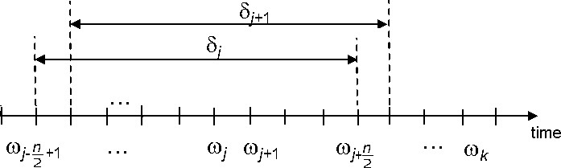

**Sliding Window (SAE J2945)**

Sliding window PER values are plotted against the duration of the test. In addition, all sliding window PER values are averaged and plotted on the same figure. The PER metric in this case includes:

* Packet loss due to packets that were dropped from the transmit queue because a newer BSM arrived in the queue before the previous BSM could be transmitted due to the medium being busy (the DSRC radio’s clear channel assessment could not detect that the medium was clear for transmitting before the next packet arrived)
* Packets lost over the air due to collisions or insufficient signal strength

**Packet Reception Rate (PRR)**

The PRR is the ratio, expressed as a percentage, of the number of packets received from a particular transmitter and the total number of packets queued at the transmitter. The PRR is, therefore, the complement of the PER defined in Section 5.1.1 and is defined as PRR = 1 – PER.

**Received Signal Strength Indicator (RSSI)**

For DSRC, RSSI is the Received Signal Strength Indicator. For Cellular, RSSI is the Reference Signal Received Power.

**Inter-Packet Gap (IPG) (Sourced from 5GAA TR P-170142)**

The IPG is the time, calculated at the receiver and expressed in milliseconds, betweensuccessive successful packet receptions from a particular transmitter. IPG is calculated at the receiver and expressed in milliseconds.

**Latency (Sourced from 5GAA TR P-170142)**

Latency represents the time interval, expressed in milliseconds, between the time instant when the transmitter application delivers the application layer packet (e.g., BSM) to the lower layers, and the time instant when the application layer packet is received by the application layer at the receiver.

**Differences between C-V2X and DSRC Regarding Latency**

**C**-V2X is a synchronous system that relies on a distributed scheduling mechanism for packet transmission. This mechanism enables very efficient allocation of resources to C-V2X devices

**LAB TEST PROVEDURES AND RESULT**

**Common Parameters and Setup**

Following are the common parameters used for lab testing. Any changes in test parameters are noted in respective sections.

**Table 2: Common Parameters**

|  |  |  |
| --- | --- | --- |
| **Configuration** | **DSRC** | **C-V2X (PC5 Mode 4)** |
| Channel | Channel 172 | 5860 MHz (Channel 172) |
| Bandwidth | 10 MHz | 10 MHz |
| Modulation | QPSK ½ (6 Mbps burst rate) | MCS 5 |
| Application Used | Savari | Savari |
| Tx/Rx Configuration | 1 Tx 2 Rx | 1 Tx 2 Rx |
| Device Details | Savari MW1000 | Qualcomm Roadrunner platform |
| Blind HARQ | NA | Enabled |
| Tx Power | 21 dBm | 21 dBm |
| Packet Size | 193 Bytes | 193 Bytes (5 Sub-Channels) * |

* Sub-Channel size = 5 RB

For GNSS, a signal drop from a rooftop antenna is used in all the lab tests.

**General Guidance on C-V2X and DSRC Device RF Power Management**

Equipment Used

1. Spectrum Analyzer (SA)
2. Power Sensor
3. Signal Generator (SG)

Table 3: Test Configuration

|  |  |  |
| --- | --- | --- |
| **Configuration** | **C-V2X** | **DSRC** |
| Packet Size | 193 and 270 Bytes | 193 and 270 Bytes |
| Number of Samples | 1000 | 1000 |
| Tx Power | 20 dBm | 20 dBm |

**Table 4: C-V2X Results – PER**

|  |  |  |  |  |
| --- | --- | --- | --- | --- |
|  | **No. of Transmitted pkts/s** | **No. of**  **Received pkts/s** | **Calculated at Receiver** | **Calculated at Receiver** |
| **Overall Path Loss (dB)** | **C-V2X**  **Transmit**  **Device** | **C-V2X**  **Receive**  **Device** | **CV2X PER %** | **CBR (%) for C-V2X** |
| **109.45** | **1000** | **1000** | **0** | **<1%** |
| **114.45** | **1000** | **1000** | **0.1** | **<1%** |
| **119.45** | **1000** | **987** | **1.3** | **<1%** |
| **120.45** | **1000** | **989** | **1.1** | **<1%** |
| **121.45** | **1000** | **941** | **5.9** | **<1%** |
| **122.45** | **1000** | **947** | **5.3** | **<1%** |
| **123.45** | **1000** | **920** | **8** | **<1%** |
| **124.45** | **1000** | **708** | **29.2** | **<1%** |
| **125.45** | **1000** | **633** | **36.7** | **<1%** |
| **127.45** | **1000** | **421** | **57.9** | **<1%** |
| **128.45** | **1000** | **0** | **100** | **<1%** |

**Table 5: C-V2X Results – IPG and Latency**

|  |  |  |  |  |  |  |
| --- | --- | --- | --- | --- | --- | --- |
|  | **No. of Transmitted pkts/s** | **No. of**  **Received pkts/s** | **Calculated at Receiver** | **Calculated at Receiver** | **Calculated at Receiver** | **Calculated at Receiver** |
| **Overall Path Loss (dB)** | **C-V2X**  **Transmit**  **Device** | **C-V2X**  **Receive**  **Device** | **95th**  **Percentile**  **IPG (ms)** | **Mean IPG** | **95th**  **Percentile**  **Latency**  **(ms)** | **Mean Latency** |
| **109.45** | **1000** | **1000** | **106** | **100** | **22** | **14** |
| **114.45** | **1000** | **1000** | **106** | **100** | **23** | **15** |
| **119.45** | **1000** | **987** | **107** | **101** | **25** | **15** |
| **120.45** | **1000** | **989** | **106** | **101** | **24** | **15** |
| **121.45** | **1000** | **941** | **106** | **106** | **24** | **15** |
| **122.45** | **1000** | **947** | **107** | **105** | **23** | **15** |
| **123.45** | **1000** | **920** | **108** | **106** | **25** | **16** |
| **124.45** | **1000** | **708** | **205** | **136** | **28** | **20** |

**Table 10: DSRC Results – PER**

|  |  |  |  |  |
| --- | --- | --- | --- | --- |
|  | **No. of Transmitted pkts/s** | **No. of**  **Received pkts/s** | **Calculated at Receiver** | **Calculated at Receiver** |
| **Overall Path Loss (dB)** | **DSRC**  **Transmit**  **Device** | **DSRC**  **Receive**  **Device** | **PER %** | **CBR (%) for DSRC** |
| **92.45** | **1000** | **1000** | **0** | **<1%** |
| **112.45** | **1000** | **1000** | **0** | **<1%** |
| **113.45** | **1000** | **1000** | **0** | **<1%** |
| **114.45** | **1000** | **1000** | **0** | **<1%** |
| **115.45** | **1000** | **988** | **1.2** | **<1%** |
| **116.45** | **1000** | **856** | **14.4** | **<1%** |
| **117.45** | **1000** | **434** | **56.6** | **<1%** |
| **119.45** | **1000** | **0** | **100** | **<1%** |

**Table 11: DSRC Results - IPG and Latency**

|  |  |  |  |  |  |  |
| --- | --- | --- | --- | --- | --- | --- |
|  | **No. of Transmitted pkts/s** | **No. of**  **Received pkts/s** | **Calculated at Receiver** | **Calculated at Receiver** | **Calculated at Receiver** | **Calculated at Receiver** |
| **Overall Path Loss (dB)** | **DSRC**  **Transmit**  **Device** | **DSRC**  **Receive**  **Device** | **95th**  **Percentile**  **IPG (ms)** | **Mean IPG** | **95th**  **Percentile**  **Latency**  **(ms)** | **Mean Latency** |
| **92.45** | **1000** | **1000** | **108** | **96.24** | **18** | **15.98** |
| **112.45** | **1000** | **1000** | **108** | **94.44** | **19** | **16.53** |
| **113.45** | **1000** | **1000** | **102** | **95.34** | **18** | **16.06** |
| **114.45** | **1000** | **1000** | **101** | **96.23** | **18** | **17.25** |
| **115.45** | **1000** | **988** | **102** | **96.28** | **19** | **17.21** |
| **116.45** | **1000** | **856** | **201** | **111.31** | **19** | **16.9** |

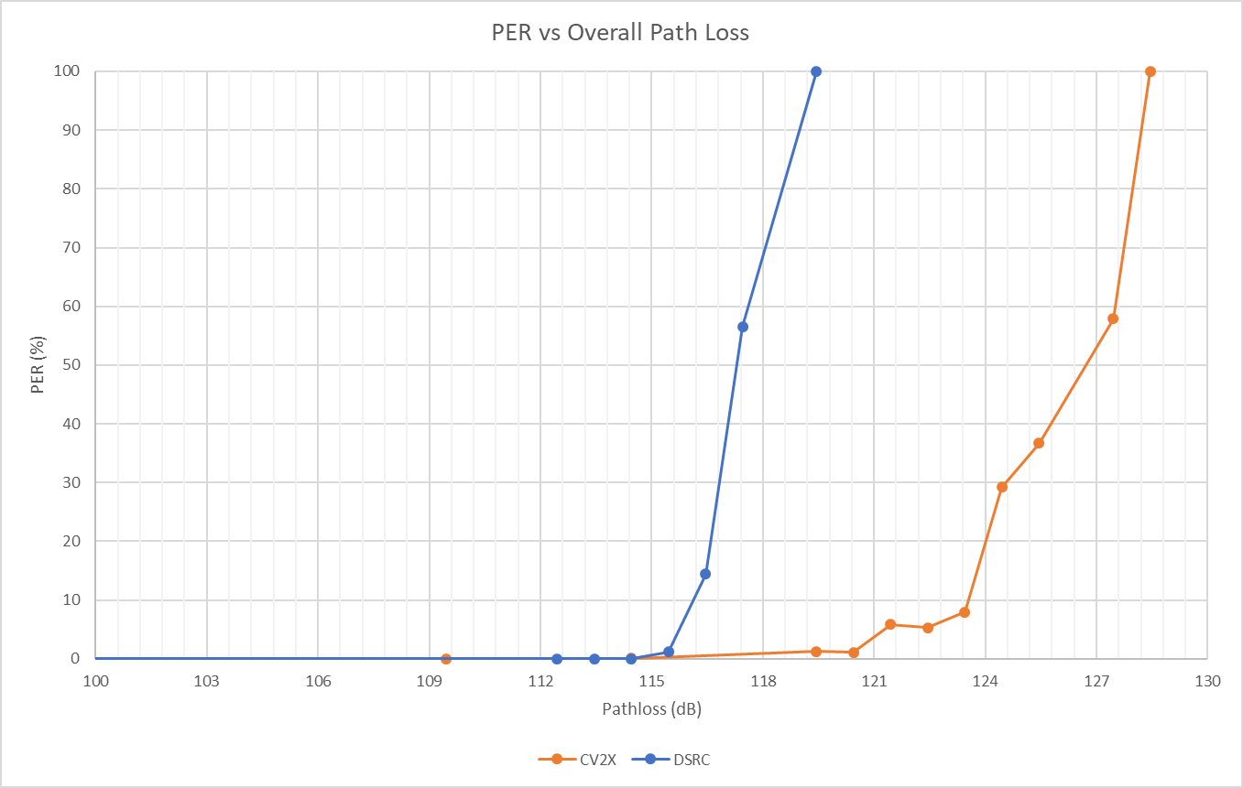

**Figure 1: PER vs Overall Path Loss**

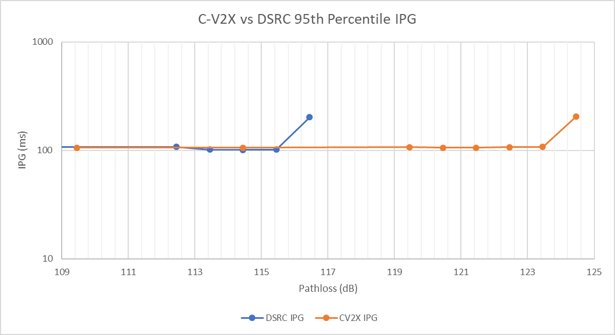

**Figure 2: 95th Percentile IPG**

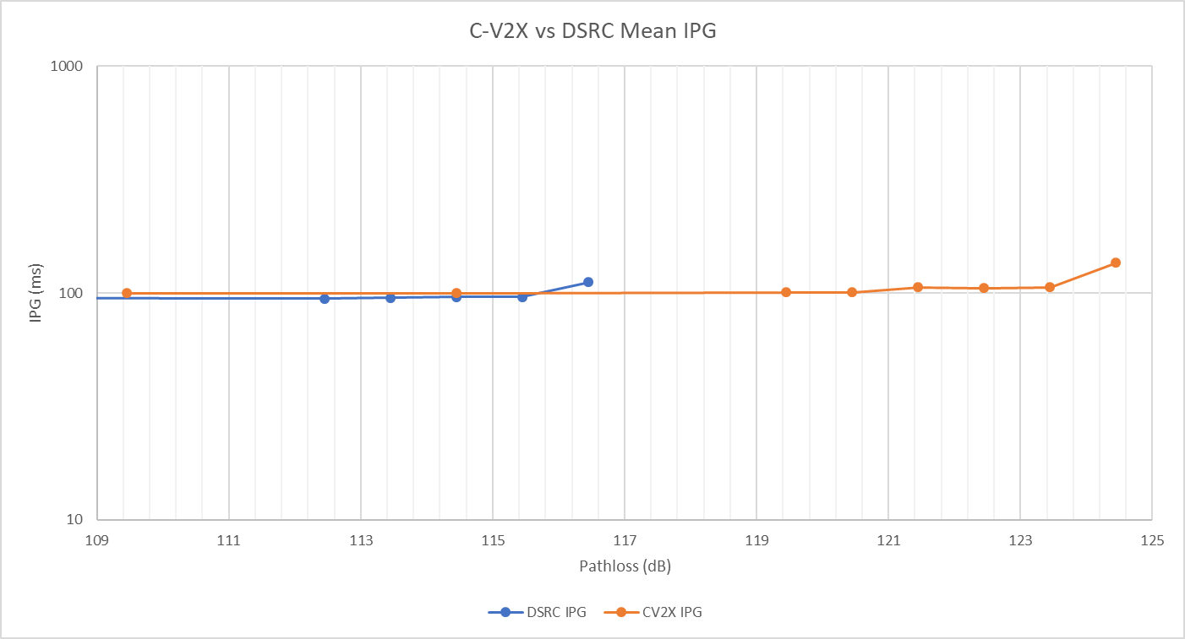

**Figure 3:Mean IPG**

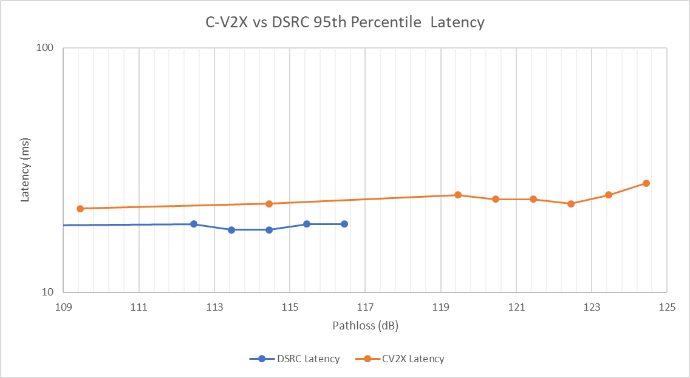

**Figure 4:95th Percentile Latency**

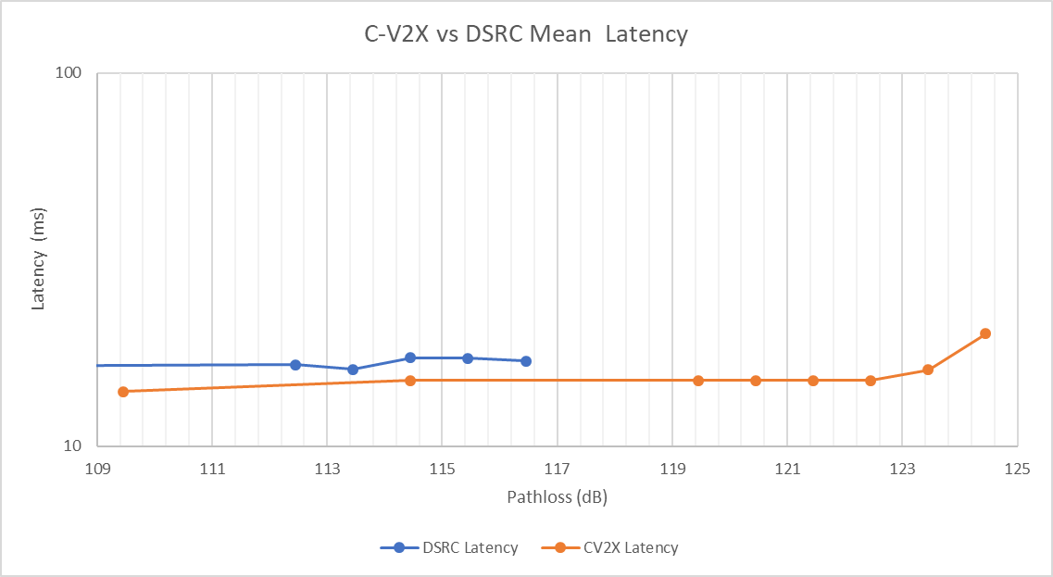

**Figure 5– Mean Latency**

**DRAWBACKS OF V2X TECHNOLOGY**

**UNRELIABLE SENSORS: -** For V2X to increase safety, vehicles, infrastructure, pedestrian, and cities will need to be equipped with sensors – and they will have to be reliable.

According to miles Flamenbaum, CEO of Actrasys, a company that specializes in maintaining sensors functionality and works with car manufactures like Volvo, sensors do not come without their issues.

“If that sensor is not properly prepared for adverse weather conditions or adverse operating conditions where it can widely operate without losing data then you have a challenge