**Calendar System-Lab2**

**Program Overview**

This C++ program implements a calendar scheduling system for managing venues and events. The system supports various operations like adding/deleting venues, adding/deleting events, displaying venues, showing events for a specific date, and viewing the entire event calendar for a specific venue. The core components of the system are the Event, Location, and Scheduler classes, which interact with each other to provide the necessary functionality.

**Classes:-**

1. Event Class:-

The Event class is responsible for representing an event with details such as the event date, start and end times, name, and a pointer to the next event in the list (linked list structure).

* Attributes:
  + int date: Date of the event (1-30).
  + int begin: Start hour of the event (0-24).
  + int end: End hour of the event (0-24).
  + string eventname: Name of the event.
  + Event* next: Pointer to the next event in the linked list.
* Methods:
  + Constructors (Event() and Event(int date, int begin, int end, std::string name)): Initialize the event attributes.
  + Destructor (~Event()): Deletes the attributes of the object when invoked.
  + Getter methods to access private attributes.
  + Setter method to modify eventlist pointer.

2. Location Class

The Location class represents a venue or stadium where events are held. It stores details about the stadium, its location, capacity, and a linked list of events associated with that venue.

* Attributes:
  + string stadium: Name of the stadium.
  + string location: Location of the stadium.
  + int capacity: Capacity of the stadium.
  + Event* list: Pointer to the linked list of events at this venue.
* Methods:
  + Constructors (Location() and Location(std::string stadium, std::string location, int capacity)): Initialize the venue attributes.
  + Destructor (~Location()): Handles cleanup of the event linked list.
  + Getter methods to access private attributes.
  + Setter method to modify private attributes.

3. Scheduler Class

The Scheduler class manages multiple venues and their associated events. It uses an array of pointers to Location objects and provides functions to add/delete venues, add/delete events, and display venue/event details.

* Attributes:
  + Location* locations[50]: Array of pointers to Location objects (maximum of 50 venues).
  + int count: Keeps track of the number of venues added.
* Methods:
  + Constructor (Scheduler()): Initializes the venue count to 0.
  + Destructor (~Scheduler()): Cleans up the Location objects.
  + addVenue(string stadium, string location, int capacity): Adds a new venue to the list.
  + delVenue(string name): Deletes a venue from the list.
  + showVenues(): Displays all the venues with their details.
  + addEvent(string stadium, int date, int begin, int end, string eventname): Adds a new event to a venue.
  + delEvent(string stadium, int date, int begin, string eventname): Deletes an event from a venue.
  + showEvents(string stadium, int date): Displays all events for a specific date at a venue.
  + showCalendar(string stadium): Displays the entire event calendar for a specific venue.

**UML DIAGRAMS:-**

**Class Diagram:-**

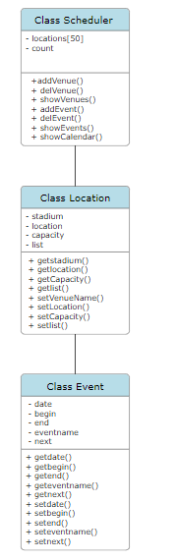

In the class Diagram aside the (+) indicates that the attribute or method is public

(-)Indicates that the attribute or method is private

Each class has a set of attributes and a set of methods

**Relationship Diagram**

The relationship between the Scheduler class and Location class is an association.

The relationship between the Location and Event class is a composition

The Event class and Scheduler class interact indirectly through the Scheduler class

