

Gourav ganguly

A00268742

Assignment Report

Weather App using openweathermapsapi

# Abstract

The objective of the project is to develop a Weather Application using openweathermaps.org API. The Web Application should provide relevant data from the API and it should be represented in a meaningful way. The project demonstrates current weather forecast for the world cities.

# Introduction

**OpenWeatherMaps** is a Weather APIs for developers Access to current weather, forecasts, maps and historical data in JSON, XML, and HTML formats. A variety of map layers are available including precipitation, clouds, pressure, temperature, wind, and many more.

Key features of the API which we are using:

* Day forecast is available at any location or city
* 5 day forecast includes weather data every 3 hours
* Forecast is available in JSON and XML
* Available for Free and all other paid accounts

The Weather App is designed using pure HTML, CSS and Vanilla JS. It uses only two libraries which is moment.js for getting the Day of Week and chart.js for displaying graphs of forecast data.

Using AJAX request to the openweathermaps.org API we are getting XML document from the Server which has Weather Forecast Data of 5 days with 3 hours interval. We parse the data obtained from the API and represent it in a meaningful way using HTML, CSS and JavaScript.

# Features

* AutoComplete feature by making an AJAX request to geodb.com API to get city list and country list and code. This data is parsed using JavaScript and displayed in the input field.
* Search City and Display current and 5day Forecast.
* Representation of Live Data
* Maximum and Minimum temperature Forecast
* Graph Plotting of temperatures.
* Background Image change according to the Weather conditions.
* Interactive Chart to display maximum, minimum or both.

# Code Snippets

Connecting to the API using AJAX

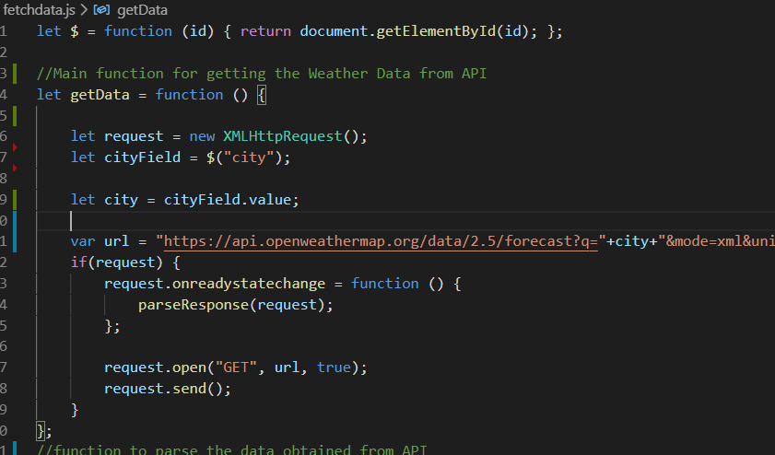

Parsing data and inserting to DOM

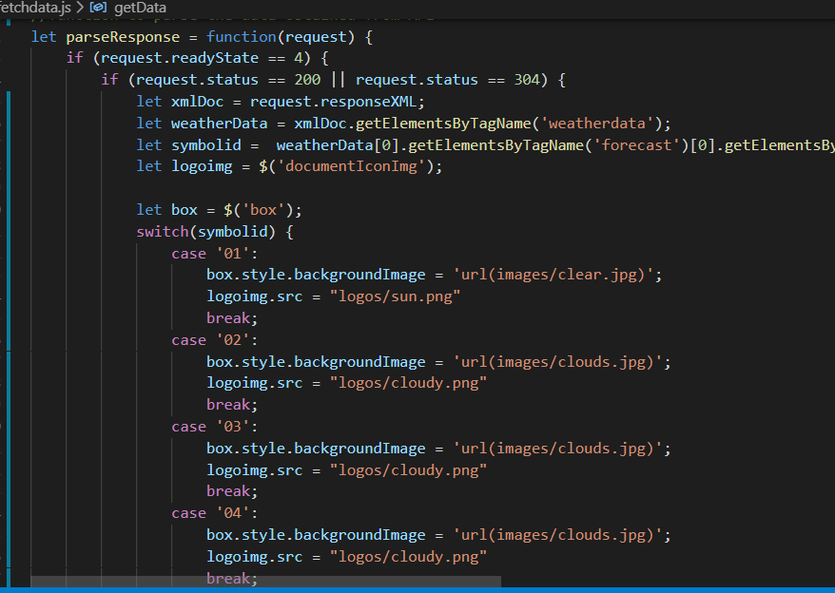

Calculating Minimum and Maximum Temperature

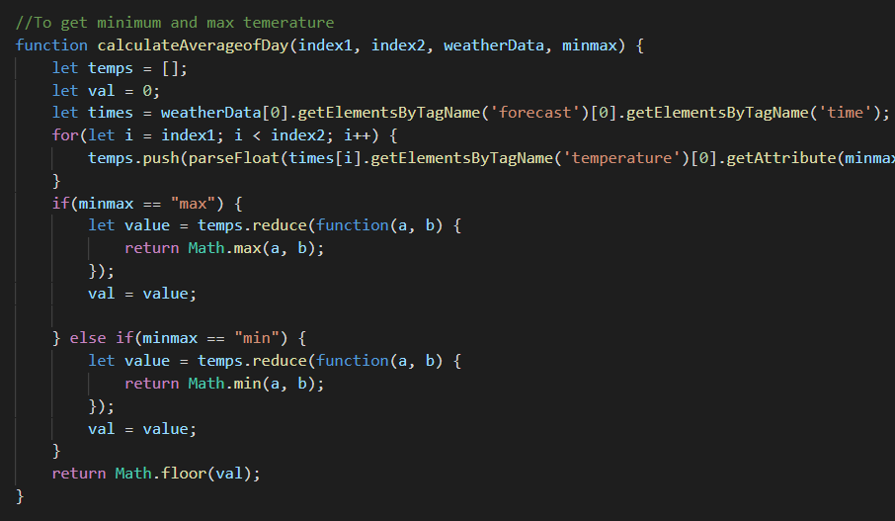

Display Chart Data using chartjs

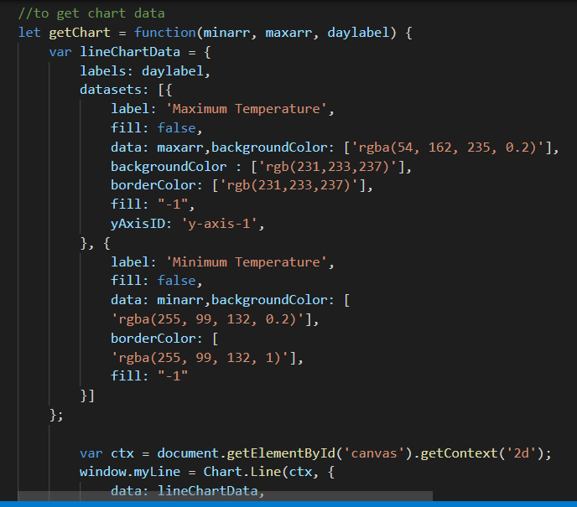

Using GeoDB API to get city list in Json format, parsing it and displaying city suggestions.

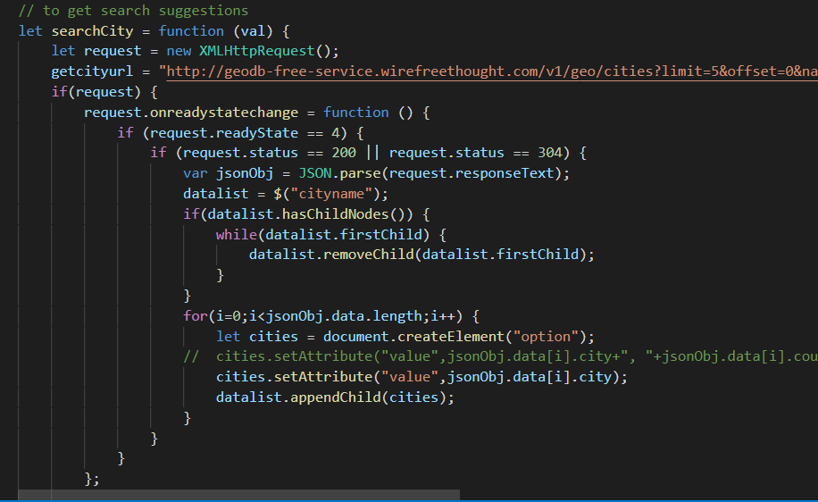

# Screenshots

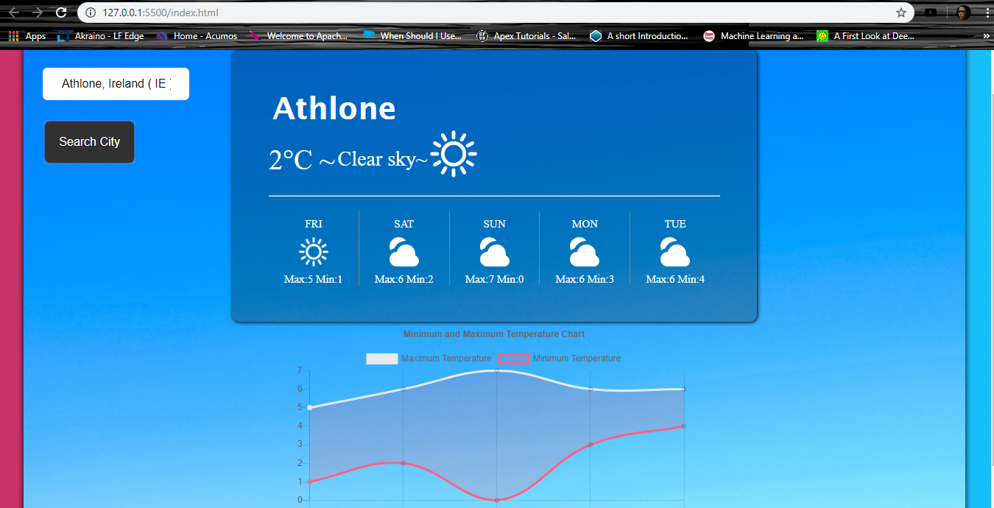

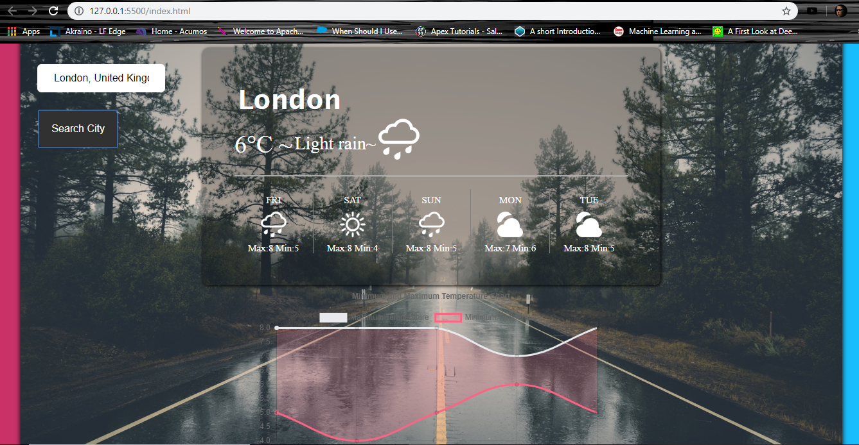

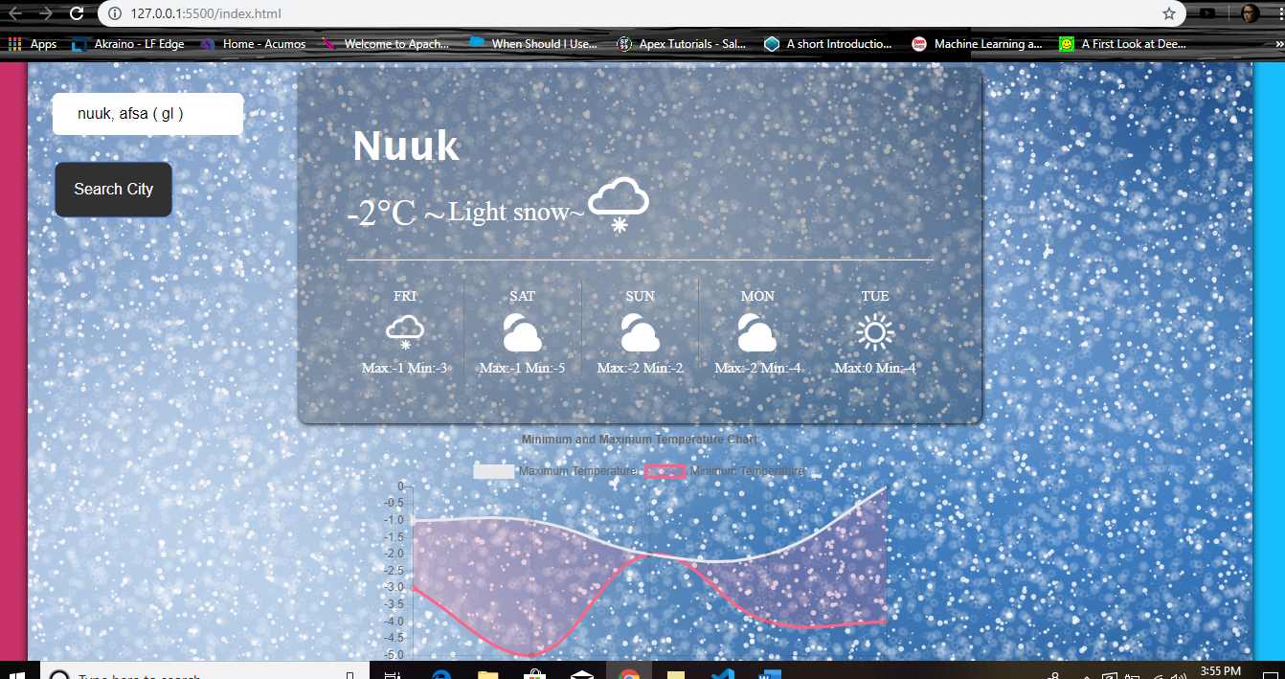

# Conclusion

### OpenWeatherMaps API is an provides us with amazing API and this demonstration shows how we can create very light weight Weather App using pure HTML, CSS and Vanilla JS.