Java Lab – Session 2: The Structure of Java Programs

# Assignment 1 – Student.java

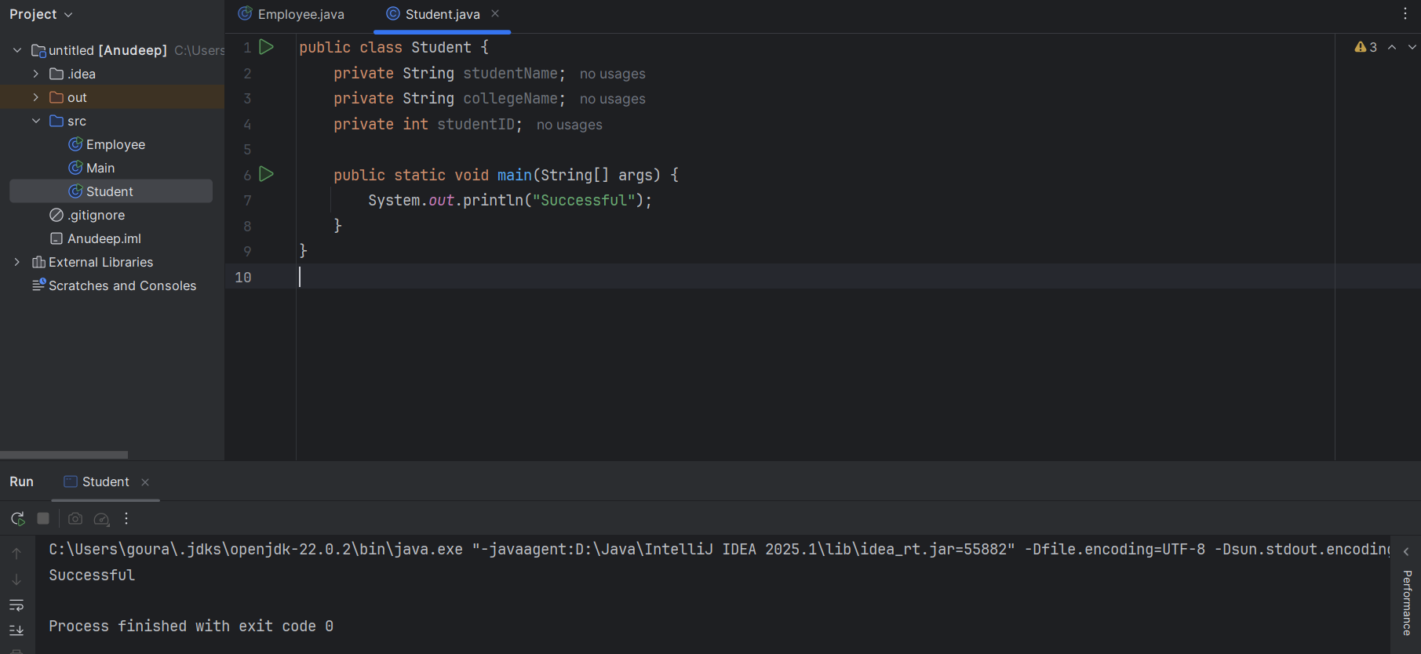

# Assignment 2 – Employee.java

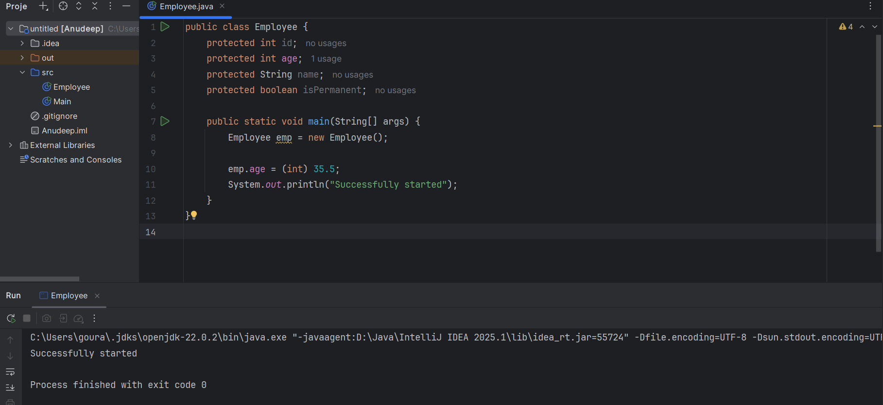

# Assignment 3 – Person.java

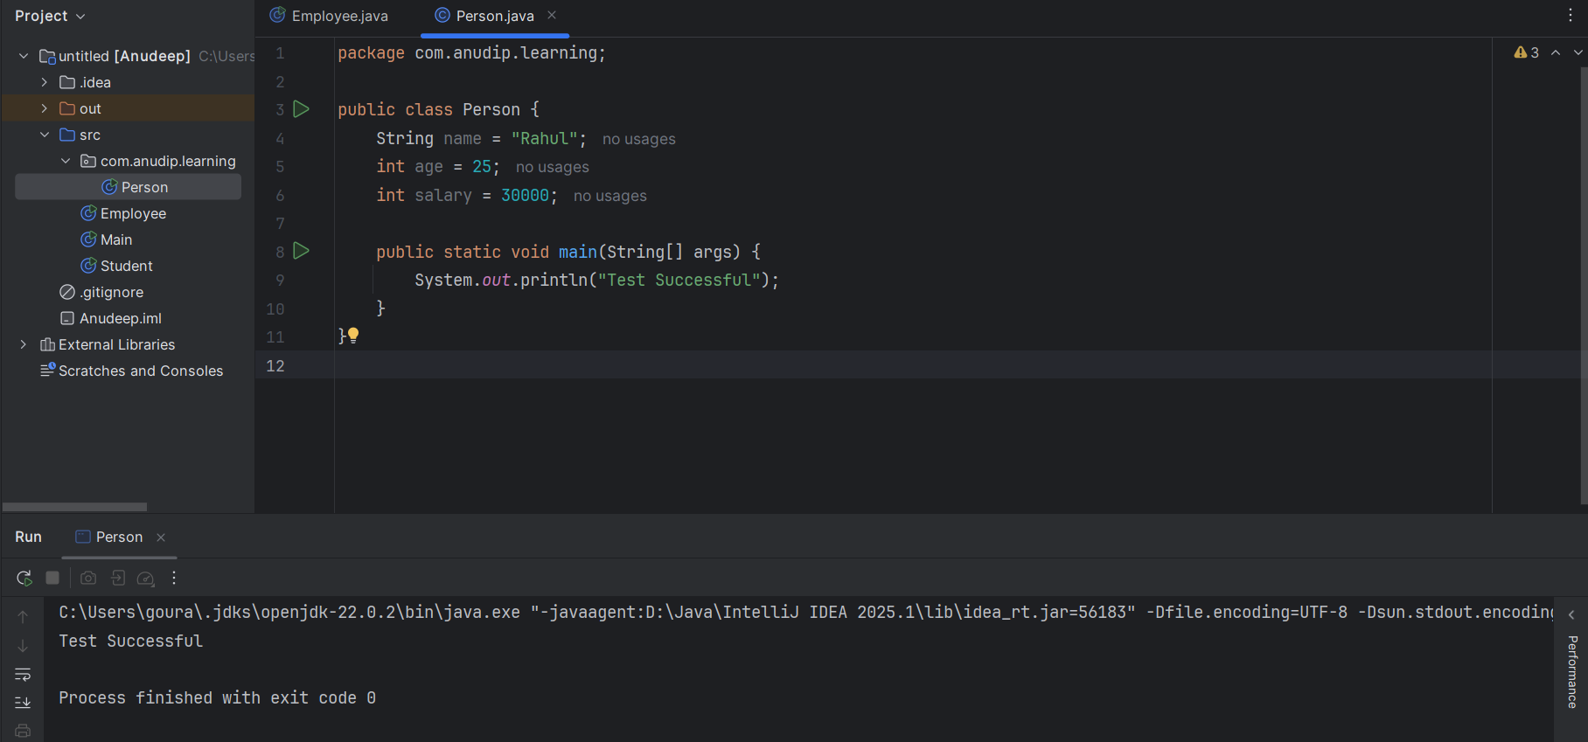

# Assignment 4 – Rectangle.java

