Java Lab – Session 3: More about Class

# Assignment 1 – Car.java

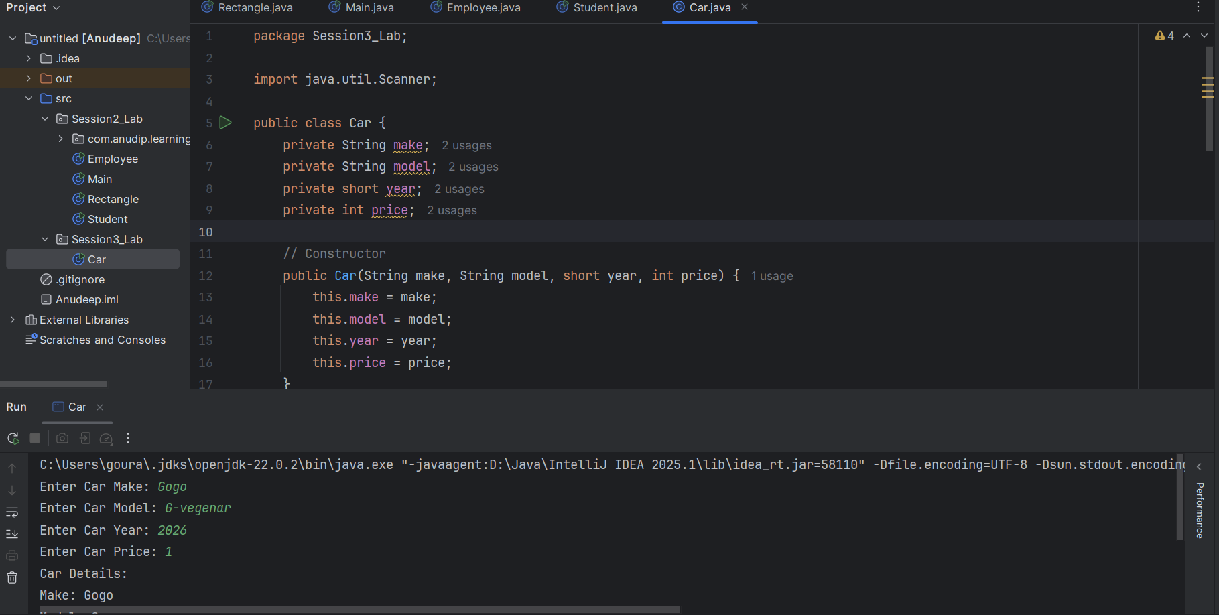

# Assignment 2 – Calculator.java

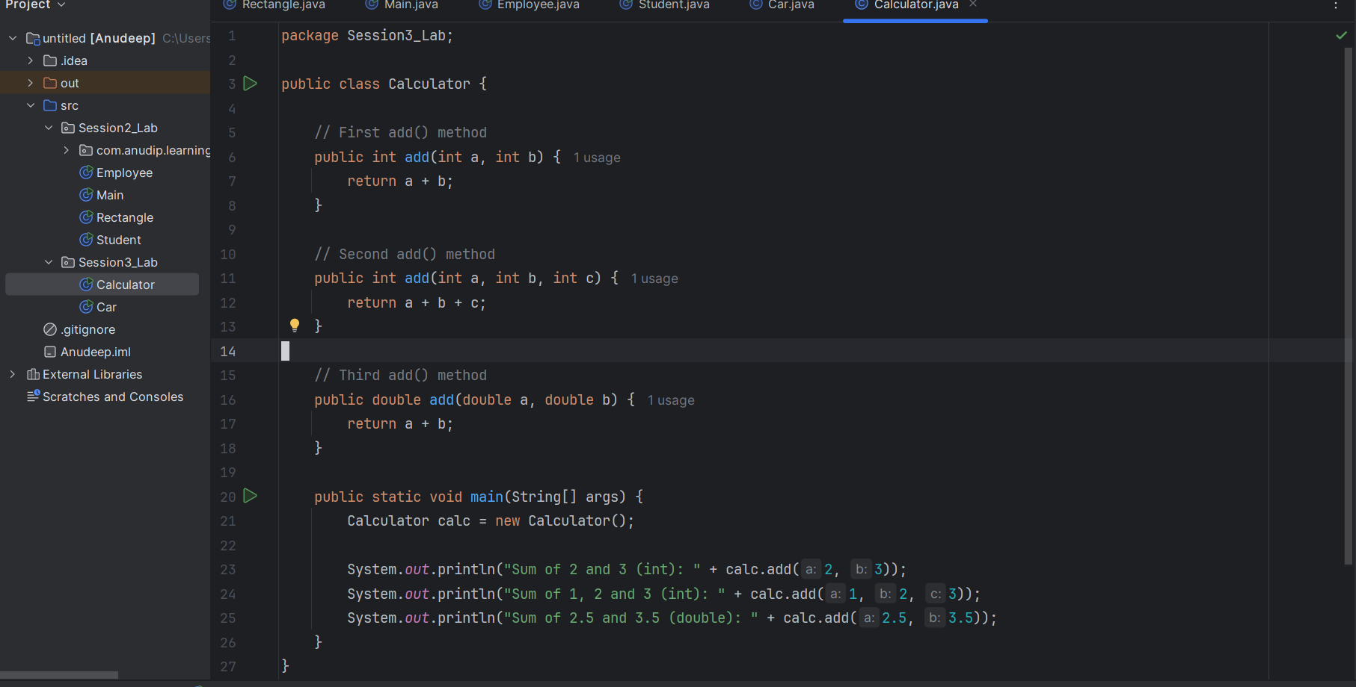

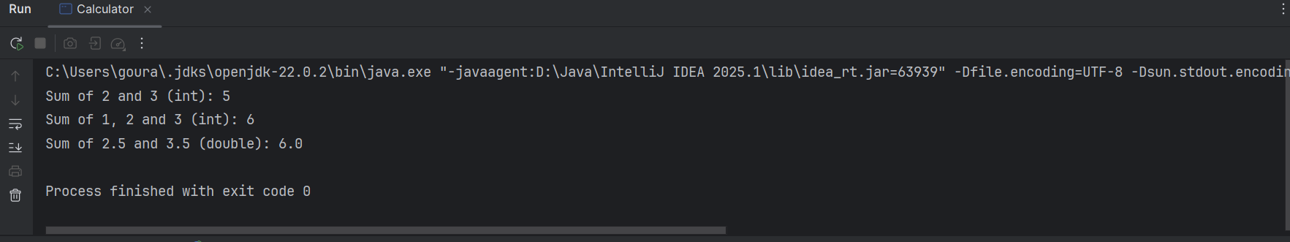

# Assignment 3 – Student.java

