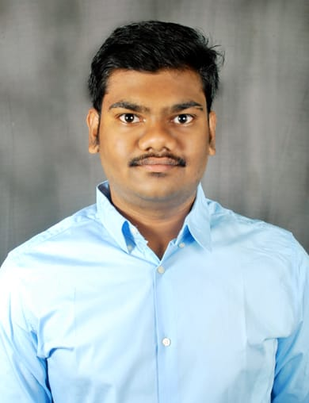

**Gourav komera**

Balagum satti vari street, Bheemana vari peta, Vijayawada 520009

(+91)7093522566 | [komeragourav@gmail.com](mailto:komeragourav@gmail.com)

**Objective**

To work in a professionally managed organization, which would provide me a chance to enrich

my knowledge and grow with the organization.

O

|  |  |
| --- | --- |
|  |  |
| **Education** |  |
| **Koneru Lakshmaiah Education Foundation , Vijayawada**  Bachelor of Technology (ECE), 7.77 CGPA | *2017-2021* |
| **Sri Chaitanya junior College, Vijayawada**  INTERMEDIATE , 78.2% | *2015-2017* |
| **Atkinson High School, Vijayawada**  10th standard , 8.6 CGPA | *2014-2015* |
|  |  |

# Computer proficiency

**Languages known :** Java , C

**IDE’s :** Eclipes

**Tools :** LabVIEW , MATLAB

**Projects**

1. **SMART CAP FOR PHYSICALY IMPARED PEOPLE.**

**Tools/Technologies** : Arduino uno

**Project Description** : The project is used to detect any object coming in the path. the cap can sense an object in all four directions. whenever the ultrasonic sensor finds anything in front of it generates a signal to Arduino. then the Arduino will send a signal to the vibrator and the vibrator starts vibrating.

1. **AUTOMATIC GARAGE DOOR SYSTEM USING BLUETOOTH.**

**Tools/Technologies** : Arduino uno.

**Project Description** : The project is used for the security of the garage. whenever an object is passed or stands in front of an ultrasonic sensor, it will send a signal to the Arduino board. the board will send a signal to the hc05 Bluetooth model which is paired with an app to send a notification to open or close the door.

**Achievements**

* NCC ‘B’ certificate holder
* Rank in collage NCC wing : sergeant
* Worked as RPCHM in CATC 4

**Personality Traits**

* Leadership skills
* Team player
* Optimistic
* Trustworthy
* Creative thinking

**Hobbies**

* + Playing carroms
  + Watching movies
  + Cooking

# Personal Details

**Father name :** K.VENKATESWAR RAO

**Date of birth :** 30th July 1999

**Gender :** male

**Languages known :** Telugu, English, Hindi