Software Requirement Specification(SRS) for

VehiVille-Online Car Rental Portal

# Introduction

### 1.1 Purpose:

This document is meant to delineate the features of VehiVille-online car rental Portal, so as to serve as a guide to the developers on one hand and software validation document for the prospective client on the other.

It is a system design especially for large, premium and small car rental business. The car rental system provides complete functionality of listing and booking car. In this system, Tourism and Travelling facilities also provide.

### 1.2 Scope:

This system allows the Customer can easily get the car whenever they need to on the rent with use of this system.

### 1.3 Definitions:

CRS- Car Rental System

SRS- Software Requirement Specification

GUI- Graphical User Interface

**1.5 Overview:**

It is a system design especially for large, premium and small car rental business. The car rental system provides complete functionality of listing and booking car. In this system, Tourism and Travelling facilities also provide.

This proposed system can be used by any naïve users and it does not require any educational level,experience or technical expertise in computer field but it will be of good use if user has the good knowledge of how to operate a computer.

**EXISTING SYSTEM**

* An existing system can provide manually paper work.
* The user has to go in the office where user can get the car on rent and book their car.
* In the existing system you cannot provide feedback of the user to the admin online.

**NEED FOR NEW SYSTEM**

* The new system is totally computerized system.
* A new system provides features like time efficiency to show car details, user profiles and whatever the customer will give the feedback to the admin.
* This system provides tourism and travelling facilities.
* An inquiry is easily done by user in the system.
* It is the most software application for managing online car rental business.

**2.Overall Description**:

The Car Rental System application enables admin to add a car, manage booking car and rent and also view feedback and enquiry, User to view information of available car, booking car, easily get the car on rent and also give feedback and can enquiry. Also the developer is designing an online car rental site to manage the cars in the portal and also help customers to purchase them online without visiting the center physically.The online car rental system will use the internet as the solemethod for booking cars on rent for customer.

**2.1 Product Perspective**:

This product aimed toward a person who don’t want to visit the center as he might don’t get time for that or might not interested in visiting there and dealing with lot of formalities.

**2.2 Product Functions**:

Car Rental System should support this use case:

**Use Case Diagrams** : A Use case is a description of set of sequence of actions. Graphically it is rendered as an ellipse with solid line including only its name. Use case diagram is a behavioral diagram that shows a set of use cases and actors and their relationship. It is an association between the use cases and actors. An actor represents a real-world object. Primary Actor - Sender, Secondary- Actor Receiver.

**Use case diagram for admin**

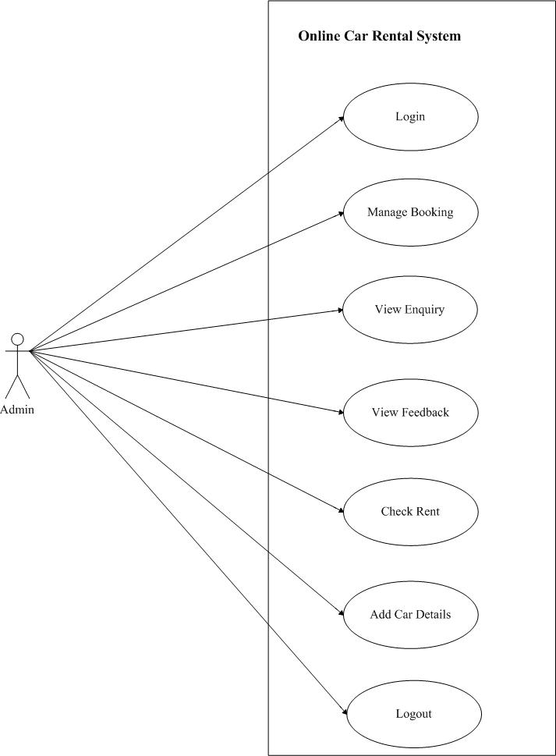

**Use Case diagram for User**

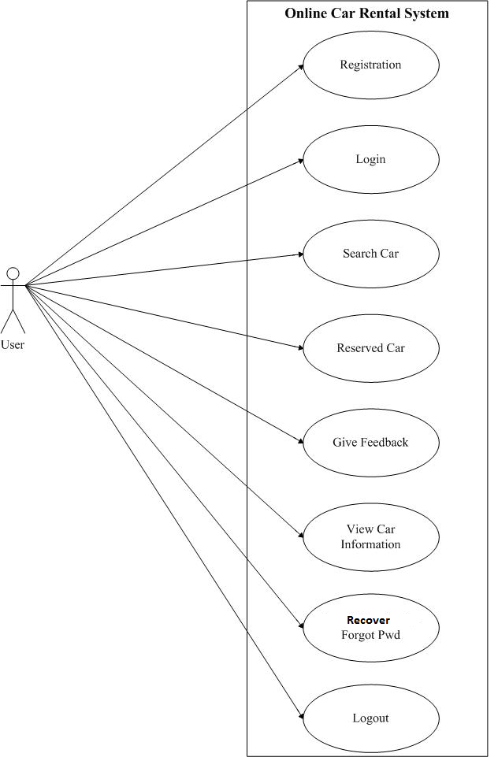

**2.3 User Characeristics**:

User should be familiar with the terms like login,register etc.

**2.4 Principle Actors**:

2 Principle Actors are Customer and Administrator.

**2.5 General Constraints**:

A full internet connection is required for CRS.

**2.6 Assumptions and Dependencies**:

Working of CRS need Internet Connection.

**3. Specific Requirements**:

3.1 **FUNCTIONAL SPECIFICATION**

User Specification

**Admin:**

Admin can add a car, manage booking car and rent and also view feedback and enquiry.

**User:**

User can view information of available car, booking car, easily get the car on rent and also give feedback and can enquiry.

**MODULE SPECIFICATION**

**User**

**•View Available Cars:**

It is a system design especially for large, premium and small car rental business. The user can view Available cars and user can book for that car.

**•Booking Car:**

The user can view Available cars and user can book for that car.

**•Easily Get the Car on rent:**

The Customer can easily get the car whenever they need to on the rent with use of this system.

**•Give Feedback:**

The customer will give the feedback to the admin.

**•Enquiry:**

The inquiry can easily do by user.

**Admin**

**Dashboard:**

In this section admin can view the overview of the carrental (Like total vehicles, total booking, brands enquiry)

**Vehicle Brand:**

Admin can create/edit/delete vehicle brands

**Vehicles:**

The Admin can add the car so that The user can see the available cars and book the car.

Admin can also edit and delete the cars.

**Bookings:**

Admin can manage the bookings (confirm and cancel the booking)

**Manage testimonials:**

Admin can manage the testimonials (Active and Inactive the testimonials).

**Manage Contact us query:**

Admin can manage Contact us query.

**View Feedback:**

The admin easily view the feedbacks and solve the query.

**Registered users:**

Admin can view the registered users.

**Manage pages:**

Admin can update the pages data information.

**Contact info:**

Admin can update the contact info.

**Manage Subscribers:**

Admin can manage subscribers.

**3.2 Non-Functional Requirements**:

Following Non-Functional Requirements will be there in the

insurance to the internet:

(i) Secure access to consumer’s confidential data.

(ii) 24X7 availability.

(iii) Better component design to get better performance at peak

time.

(iv) Flexible service based architecture will be highly desirable for

future extension.Non-Functional Requirements define system

properties and constraints.

Various other Non-Functional Requirements are:

➢ Security

➢ Reliability

➢ Maintainability

➢ Portability

➢ Extensibility

➢ Reusability

➢ Compatibility

➢ Resource Utilization

**3.3 Performance Requirements**:

In order to maintain an acceptable speed at maximum number of uploads allowed from a particular customer as any number of users can access to the system at any time. Also the connections to the servers will be based on the attributes of the user like his location and server will be working 24X7 times.

**3.4 Technical Issues**:

This system will work on client-server architecture. It will require an internet server and which will be able to run PHP application. The system should support some commonly used browser such as IE,mozzila firefox,chrome etc.

**HARDWARE REQUIREMENT**

Hardware requirements for insurance on internet

will be same for both parties which are as follows:

|  |  |
| --- | --- |
| **RAM** | 2 GB |
| **Hard disk** | 320 GB |
| **Processor** | Dual Core |

**Software Requirements**

**Client side:**

|  |  |
| --- | --- |
| **Web Browser** | Google Chrome or any  compatible browser |
| **Operating System** | Windows or any equivalent OS |

**Server side:**

|  |  |
| --- | --- |
| **Web Server** | TOMCAT |
| **Server side Language** | ANGULAR |
| **Database Server** | MYSQL |
| **Web Browser** | Google Chrome or any  compatible browser |
| **Operating System** | Windows or any equivalent OS |

**Communication Interfaces**:

The two parties should be connected by LAN or WAN for the communication purpose.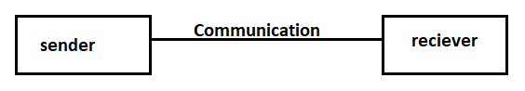

**5.System Design Specification:**

**System Flow Chart**

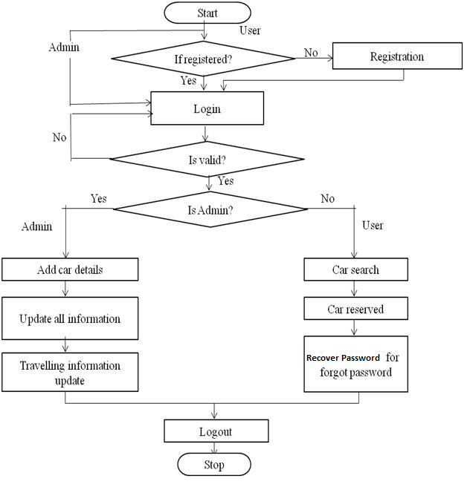

**ER DIAGRAM**

The Entity-Relationship (ER) model was originally proposed by Peter in 1976 [Chen76] as a way to unify the network and relational database views. Simply stated the ER model is a conceptual data model that views the real world as entities and relationships. A basic component of the model is the Entity-Relationship diagram which is used to visually represent data objects. Since Chen wrote his paper the model has been extended and today it is commonly used for database design for the database designer, the utility of the ER model is:

* It maps well to the relational model. The constructs used in the ER model can easily be transformed into relational tables.
* It is simple and easy to understand with a minimum of training. Therefore, the model can be used by the database designer to communicate the design to the end user.
* In addition, the model can be used as a design plan by the database developer to implement a data model in specific database management software.

.

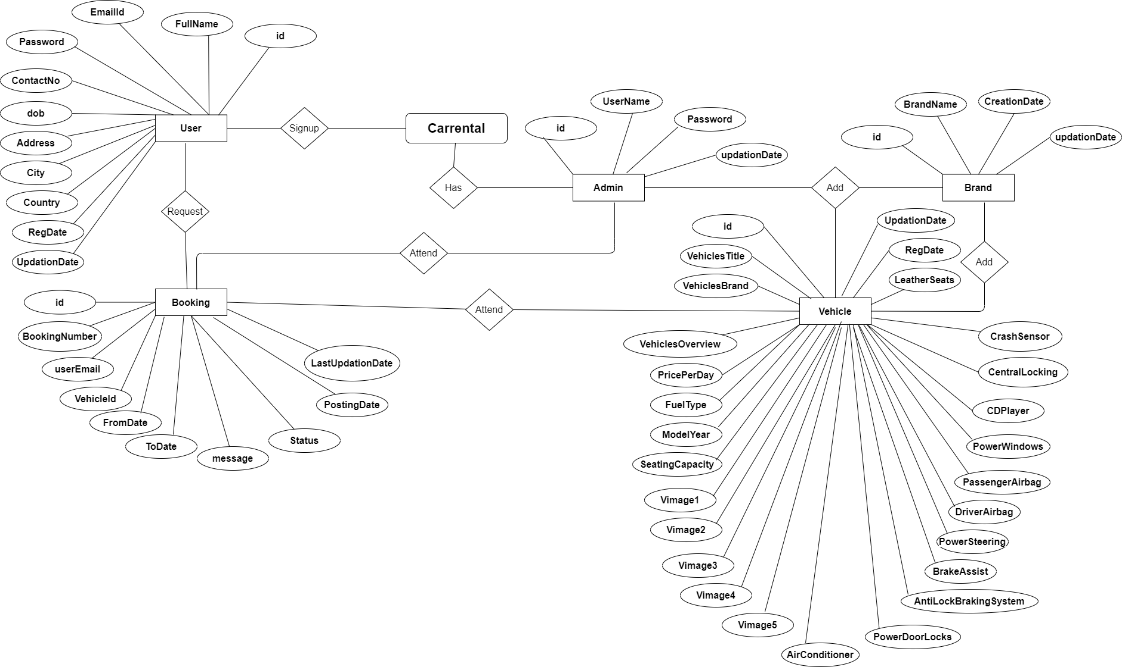

**Activity Diagram for admin**

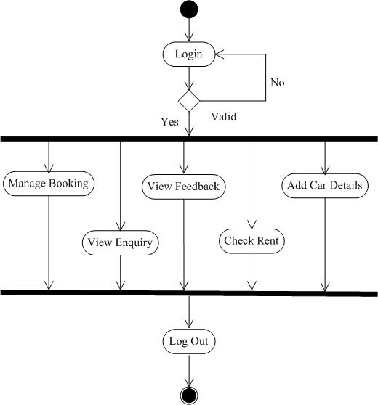

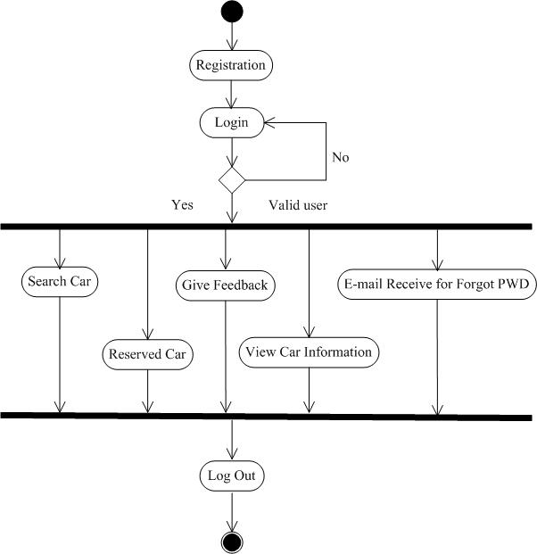**Activity Diagram for user**

**Sequence Diagram for admin**

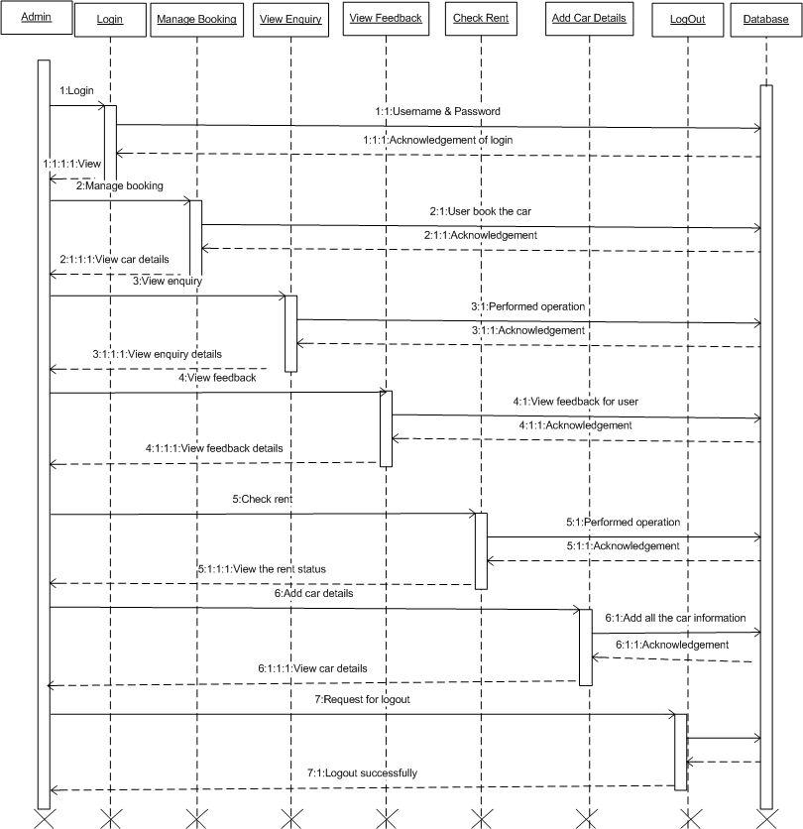

**Sequence Diagram for User**

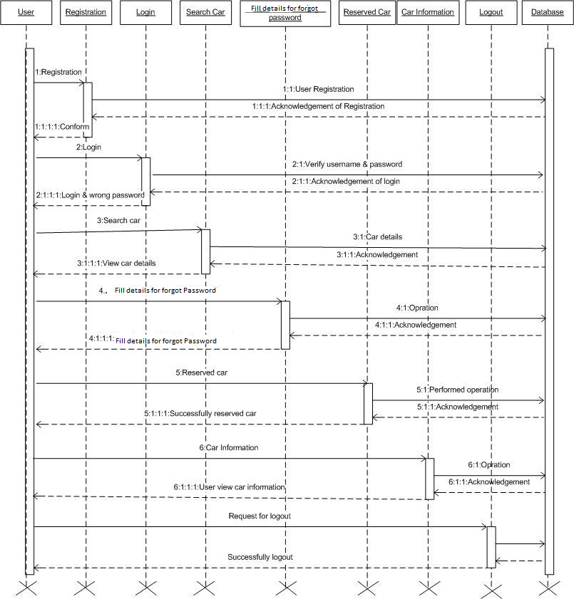

**DATABASE DESIGN**

The data in the system has to be stored and retrieved from database. Designing the database is part of system design. Data elements and data structures to be stored have been identified at analysis stage. They are structured and put together to design the data storage and retrieval system.

A database is a collection of interrelated data stored with minimum redundancy to serve many users quickly and efficiently. The general objective is to make database access easy, quick, inexpensive and flexible for the user. Relationships are established between the data items and unnecessary data items are removed. Normalization is done to get an internal consistency of data and to have minimum redundancy and maximum stability. This ensures minimizing data storage required, minimizing chances of data inconsistencies and optimizing for updates. The MS Access database has been chosen for developing the relevant databases.

**Admin:**

|  |  |
| --- | --- |
| **Table Name** | Admin |
| **Description** | This table is store information about Admin |
| **Primary Key** | id |
| **Foreign Key** | - |

|  |  |  |  |  |
| --- | --- | --- | --- | --- |
| **Sr. No** | **Field Name** | **Data type(Size)** | **Constraints** | **Description** |
|  |  |  |  |  |
| 1 | id (Primary) | int(11) | Primary Key | It is store Admin id |
|  |  |  |  |  |
| 2 | UserName | varchar(100) | Not Null | It is store admin user name |
|  |  |  |  |  |
| 3 | Password | varchar(100) | Not Null | It is store the password of Admin |
|  |  |  |  |  |
| 4 | updationDate | timestamp | NotNull | It is store the profile updating date |
|  |  |  |  |  |
|  |  |  |  |  |

**User Registration:**

|  |  |
| --- | --- |
| **Table Name** | tblusers |
|  |  |
| **Description** | This table is provide the information about User registration |
|  |  |
| **Primary Key** | Id |
|  |  |
| **Foreign Key** | - |
|  |  |

|  |  |  |  |  |
| --- | --- | --- | --- | --- |
| **Sr.** | **Field Name** | **Data type(Size)** | **Constraints** | **Description** |
| **No** |  |  |  |  |
|  |  |  |  |  |
| 1 | id (Primary) | int(11) | Primary Key | It is store User id |
|  |  |  |  |  |
| 2 | FullName | varchar(120) | Null | It is store User name |
|  |  |  |  |  |
| 3 | EmailId | varchar(100) | Null | It is store email address of User |
|  |  |  |  |  |
| 4 | Password | varchar(100) | Null | It is store Password |
|  |  |  |  |  |
| 5 | ContactNo | char(11) | Null | It is store Contact no |
|  |  |  |  |  |
| 6 | dob | varchar(100) | Null | It is store Birthdate |
|  |  |  |  |  |
| 7 | Address | varchar(255) | Null | It is store Address |
|  |  |  |  |  |
| 8 | City | varchar(100) | Null | It is store city |
| 9 | RegDate | timestamp | CURRRENT_TIMESTAMP | It is store CURRRENT_TIMESTAMP |
| 10 | UpdationDate | timestamp | Null | It store updation date |

**Brands Table:**

|  |  |
| --- | --- |
| **Table Name** | tblbrands |
|  |  |
| **Description** | This table is provide the information about Car brands |
|  |  |
| **Primary Key** | Id |
|  |  |
| **Foreign Key** | - |
|  |  |

|  |  |  |  |  |
| --- | --- | --- | --- | --- |
| Sr. No | **Field Name** | **Data type(Size)** | **Constraints** | **Description** |
|  |  |  |  |  |
| 1 | id (Primary) | int(11) | Primary Key | It is store brand id |
|  |  |  |  |  |
| 2 | BrandName | varchar(120) | Not Null | It is store Brand name |
|  |  |  |  |  |
| 3 | CreationDate | timestamp | CURRRENT_TIMESTAMP | It is store brand creation date |
|  |  |  |  |  |
| 4 | UpdationDate | timestamp | NotNull | It is store brand updation date |
|  |  |  |  |  |

**Contact us details Table:**

|  |  |
| --- | --- |
| **Table Name** | tblcontactusinfo |
|  |  |
| **Description** | This table is provide the contact information at website |
|  |  |
| **Primary Key** | id |
|  |  |
| **Foreign Key** | - |
|  |  |

|  |  |  |  |  |
| --- | --- | --- | --- | --- |
| **Sr. No** | **Field Name** | **Data type(Size)** | **Constraints** | **Description** |
|  |  |  |  |  |
| 1 | Id | Int | Primary Key | It is id of the record |
|  |  |  |  |  |
| 2 | Address | tinytext | Null | It is store name of the company |
|  |  |  |  |  |
| 3 | EmailId | varchar(255) | Null | It is store of the company email |
|  |  |  |  |  |
| 4 | ContactNo | char(11) | Null | It is store of the company contact no |
|  |  |  |  |  |

**Enquiry Table:**

|  |  |
| --- | --- |
| **Table Name** | tblcontactusquery |
|  |  |
| **Description** | This table will store the information of car enquiry of user |
|  |  |
| **Primary Key** | Id |
|  |  |
| **Foreign Key** | - |
|  |  |

|  |  |  |  |  |
| --- | --- | --- | --- | --- |
| **Sr. No** | **Field Name** | **Data type(Size)** | **Constraints** | **Description** |
|  |  |  |  |  |
| 1 | id (Primary) | int(11) | Primary Key | It is store enquiry id |
|  |  |  |  |  |
| 2 | name | varchar(100) | Null | It is store user |
|  |  |  |  |  |
| 3 | EmailId | varchar(120) | Null | It is store email id |
|  |  |  |  |  |
| 4 | ContactNumber | char(11) | Null | It is store contact no for user |
|  |  |  |  |  |
| 5 | Message | longtext | Null | It is store user message for enquiry |
|  |  |  |  |  |
| 6 | PostingDate | timestamp | CURRENT_TIMESTAMP | It store enquiry date |
|  |  |  |  |  |
| 7 | status | int(11) | NotNull | It is store status 0 for read and 1 for read |
|  |  |  |  |  |

**Feedback Table:**

|  |  |
| --- | --- |
| **Table Name** | tbltestimonial |
|  |  |
| **Description** | This table store information about feedback |
|  |  |
| **Primary Key** | F_Id |
|  |  |
| **Foreign Key** | - |
|  |  |

|  |  |  |  |  |
| --- | --- | --- | --- | --- |
| **Sr. No** | **Field Name** | **Data type(Size)** | **Constraints** | **Description** |
|  |  |  |  |  |
| 1 | id (Primary) | int(11) | Primary Key | It is store feedback id |
|  |  |  |  |  |
| 2 | UserEmail | varchar(100) | Not Null | It is store user email |
|  |  |  |  |  |
| 3 | Testimonial | mediumtext | Not Null | It is store feedback |
|  |  |  |  |  |
| 4 | PostingDate | timestamp | NotNull | It is store posting date of feedback |
|  |  |  |  |  |
| 5 | status | int(11) | NotNull | It is store staus(0 for inactive and 1 active) |
|  |  |  |  |  |

**Pages Content Table:**

|  |  |
| --- | --- |
| **Table Name** | tblpages |
|  |  |
| **Description** | This table store information about website pages |
|  |  |
| **Primary Key** | Id |
|  |  |
| **Foreign Key** | - |
|  |  |

|  |  |  |  |  |  |  |
| --- | --- | --- | --- | --- | --- | --- |
| **Sr. No** | **Field Name** | **Data type(Size)** | **Constraints** | **Description** | |  |
|  |  |  |  |  | |  |
| 1 | id (Primary) | int(11) | Primary Key | It is store page id | |  |
|  |  |  |  |  | |  |
| 2 | PageName | varchar(255 | Null | It is store page name | |  |
|  |  |  |  |  | |
| 3 | type | varchar(255) | Not Null | It is store page type | |
|  |  |  |  |  |  |
| 4 | detail | longtext | Not Null | It is store pages info |  |
|  |  |  |  |  |  |

**Subscriber Table:**

|  |  |
| --- | --- |
| **Table Name** | tblsubscribers |
|  |  |
| **Description** | This table store email address of subscriber |
|  |  |
| **Primary Key** | Id |
|  |  |
| **Foreign Key** | - |
|  |  |

|  |  |  |  |  |  |  |
| --- | --- | --- | --- | --- | --- | --- |
| **Sr. No** | **Field Name** | **Data type(Size)** | **Constraints** | **Description** | |  |
|  |  |  |  |  | |  |
| 1 | id (Primary) | int(11) | Primary Key | It is store subscriber id | |  |
|  |  |  |  |  | |  |
| 2 | SubscriberEmail | varchar(120) | Null | It is store subscriber email is | |  |
|  |  |  |  |  | | |
| 3 | PostingDate | timestamp | Null | It is store subscription date | | |
|  |  |  |  |  |  | |

**Vehicles Info Table:**

|  |  |
| --- | --- |
| **Table Name** | tblvehicles |
|  |  |
| **Description** | This table is provide the information about cars |
|  |  |
| **Primary Key** | Id |
|  |  |
| **Foreign Key** | - |
|  |  |

|  |  |  |  |  |
| --- | --- | --- | --- | --- |
| **Sr.** | **Field Name** | **Data type(Size)** | **Constraints** | **Description** |
| **No** |  |  |  |  |
|  |  |  |  |  |
| 1 | id (Primary) | int(11) | Primary Key | It is store User id |
|  |  |  |  |  |
| 2 | VehiclesTitle | varchar(150) | Null | It is store vehicle title |
|  |  |  |  |  |
| 3 | VehiclesBrand | int(11) | Null | It is store vehicle brand id |
|  |  |  |  |  |
| 4 | VehiclesOverview | longtext | Null | It is store vehicle overview |
|  |  |  |  |  |
| 5 | PricePerDay | int(11) | Null | It is store vehicle rent perday |
|  |  |  |  |  |
| 6 | FuelType | varchar(100) | Null | It is store fuel type of vehicle |
|  |  |  |  |  |
| 7 | ModelYear | int(6) | Null | It is store model year of vehicle |
|  |  |  |  |  |
| 8 | SeatingCapacity | int(11) | Null | It is store seating capacity of vehicles |
| 9 | Vimage1 | varchar(120) | Null | It is store vehicle image 1 |
| 10 | Vimage2 | varchar(120) | Null | It is store vehicle image 2 |

|  |  |  |  |  |
| --- | --- | --- | --- | --- |
|  |  |  |  |  |
|  |  |  |  |  |
|  |  |  |  |  |
| 11 | Vimage3 | varchar(120) | Null | It is store vehicle image 3 |
|  |  |  |  |  |
| 12 | Vimage4 | varchar(120) | Null | It is store vehicle image 4 |
|  |  |  |  |  |
| 13 | Vimage5 | varchar(120) | Null | It is store vehicle image 5 |
|  |  |  |  |  |
| 14 | AirConditioner | int(11) | Null | It is store availability of air conditioner in vehicle |
|  |  |  |  |  |
| 15 | PowerDoorLocks | int(11) | Null | It is store availability of power door locaks in vehicle |
|  |  |  |  |  |
| 16 | AntiLockBrakingSystem | int(11) | Null | It is store availability of Anti locak Braking System in vehicle |
|  |  |  |  |  |
| 17 | BrakeAssist | int(11) | Null | It is store availability of Brake Assist in vehicle |
| 18 | PowerSteering | int(11) | Null | It is store availability of Power steering in vehicle |
| 19 | DriverAirbag | int(11) | Null | It is store availability of Driver Airbag in vehicle |
| 20 | PassengerAirbag | int(11) | Null | It is store availability of Passenger airbag in vehicle |
|  |  |  |  |  |
| 21 | PowerWindows | int(11) | Null | It is store availability of Power windows in vehicle |
|  |  |  |  |  |
| 22 | CDPlayer | int(11) | Null | It is store availability of CD Player in vehicle |
|  |  |  |  |  |
| 23 | CentralLocking | int(11) | Null | It is store availability of Central locking in vehicle |
|  |  |  |  |  |
| 24 | CrashSensor | int(11) | Null | It is store availability of crash sensor in vehicle |
|  |  |  |  |  |
| 25 | LeatherSeats | int(11) | Null | It is store availability of leathers seats in vehicle |
|  |  |  |  |  |
| 26 | RegDate | timestamp | Null | It is store vehicle creation date |
| 27 | UpdationDate | timestamp | Null | It is store vehicle updation date |

**Booking table:**

|  |  |
| --- | --- |
| **Table Name** | tblbooking |
|  |  |
| **Description** | This table is provide the information about booking |
|  |  |
| **Primary Key** | Id |
|  |  |
| **Foreign Key** | - |
|  |  |

|  |  |  |  |  |
| --- | --- | --- | --- | --- |
| **Sr. No.** | **Field Name** | **Data type(Size)** | **Constraints** | **Description** |
| 1 | id (Primary) | int(11) | Primary Key | It is store booking id |
| 2 | BookingNumber | bigint(12) | Null | It is store Booking Number |
| **3** | userEmail | varchar(100) | Null | It is store User email |
| **4** | VehicleId | int(11) | Null | It is store vehicle id |
| **5** | FromDate | varchar(20) | Null | It is store booking from date |
| **6** | ToDate | varchar(20) | Null | It is store booking To date |
| **7** | message | varchar(255) | Null | It is store message |
| **8** | Status | int(11) | Null | It is store confirmation and cancellation status |
| **9** | PostingDate | timestamp | Null | It is store Booking date |