🧪 DNS Live Lab Worksheet

“Control the Internet Using DNS”
Duration: 30 minutes
Objective: Understand how DNS works by observing, testing, breaking, and fixing it on your own system.

🧠 Instructions
- Complete all parts in order
- Use only free tools (Command Prompt / Terminal)
- Take and attach screenshots where required
- Answer all validation questions

🧪 PART 1 — DNS Lookup (The Phonebook)

💻 Task:
Run the following command:
nslookup google.com

✍️ Record Your Observations:
- IP address of google.com: __142.251.215.78________________________
- DNS server used: _________ 10.255.255.254_________________
📸 Screenshot Required: Yes (attach your screenshot here)
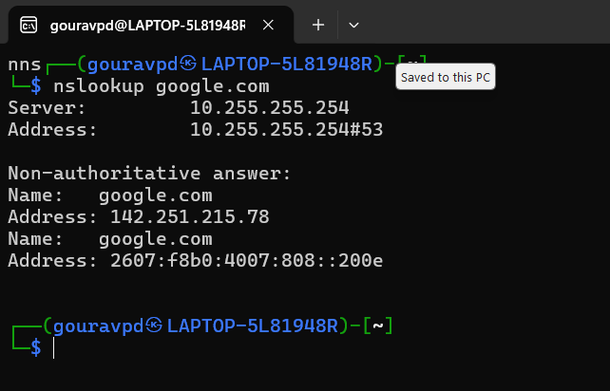

🔎 PART 2 — Compare Different DNS Servers

💻 Task:
Run:
nslookup google.com 8.8.8.8
nslookup google.com 1.1.1.1

✍️ Answer:
- Do both DNS servers return the same IP? ______yes____________________
- What does this indicate about DNS systems? ___Google at 8.8.8.8 and Google at 1.1.1.1 are just different public dns providers. They map same destination_______________________
📸 Screenshot Required: Yes (attach your screenshot here)

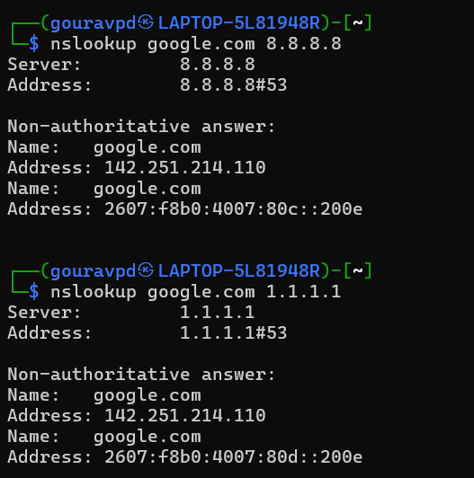

🌐 PART 3 — Explore Multiple Domains

💻 Task:
Run the following commands:
nslookup facebook.com
nslookup youtube.com
nslookup amazon.com

✍️ Answer:
- Write one IP address for each domain:
  - facebook.com: ____ 157.240.11.35______________________
  - youtube.com: ______ 142.251.214.110____________________
  - amazon.com: ______ 98.82.161.185____________________
- Do all websites have the same IP? ______NO____________________
- What does this tell you about how the internet is structured? (Describe in your own words) _There are many clusters of servers. Internet is wide. There are many systems which distribute work based on geography, load and and decentralization_
📸 Screenshot Required: Yes (attach your screenshot here)
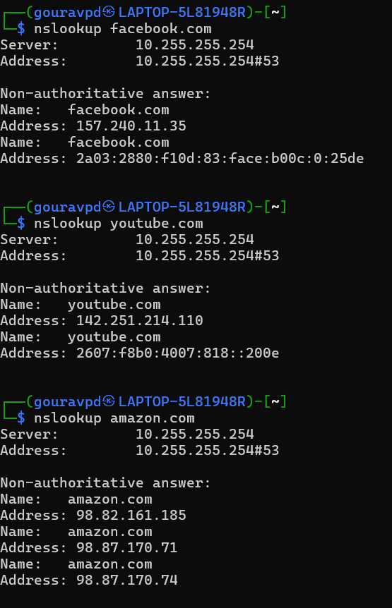

🔎 PART 4 — DNS Server Comparison

💻 Task:
Run:
nslookup youtube.com 8.8.8.8
nslookup youtube.com 1.1.1.1

✍️ Answer:
- Do different DNS servers return the same IP? ________NO__________________
- What does this indicate about DNS globally? ____Geographical load management and traffic management______________________

📸 Screenshot Required: Yes (attach your screenshot here)
