1. NOT Gate using NAND
A NAND gate with both inputs connected to the same input acts as a NOT gate.
Logic diagram
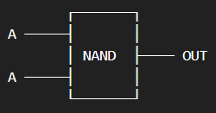
Both inputs of the NAND gate are connected to A.
Boolean expression
OUT=(A⋅A)′=A′

Truth Table
A | OUT
0 | 1
1 | 0
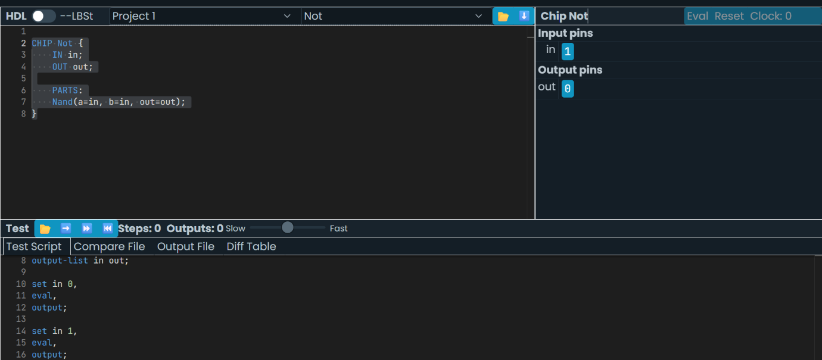
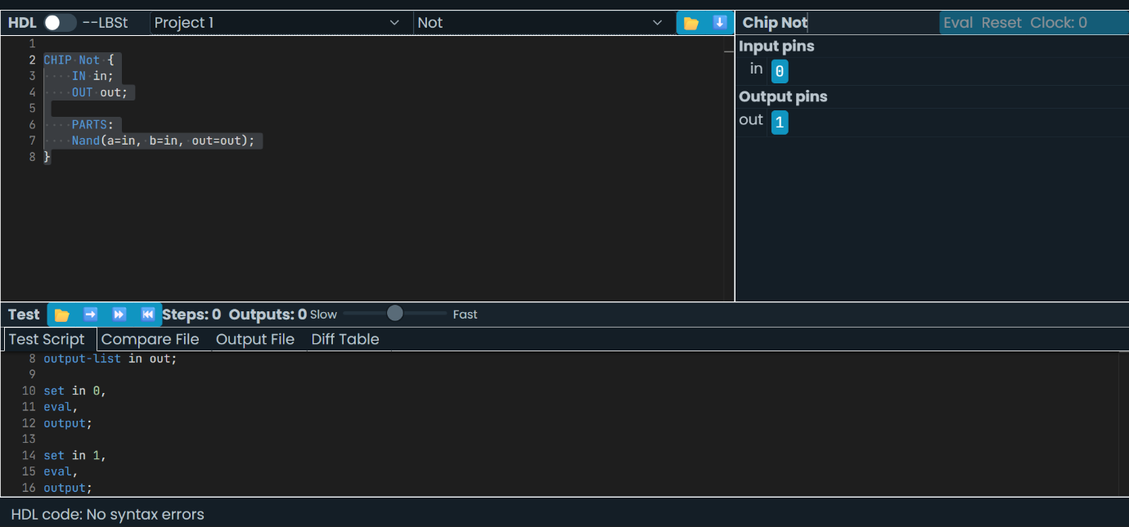

2. AND Gate using NAND
An AND gate can be constructed using two NAND gates.
Logic diagram
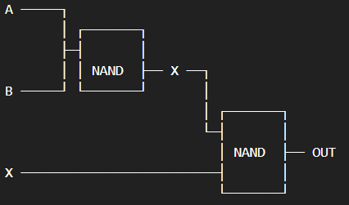
Boolean expression
First NAND: X=(A⋅B)′
Second NAND: OUT=(X⋅X)′=A⋅B

A |  |  |  |  |  |  |  |  |  |  |  | B |  |  |  |  |  |  |  |  |  |  |  |  | OUT
0 |  |  |  |  |  |  |  |  |  |  |  | 0 |  |  |  |  |  |  |  |  |  |  |  |  | 0
0 |  |  |  |  |  |  |  |  |  |  |  | 1 |  |  |  |  |  |  |  |  |  |  |  |  | 0
1 |  |  |  |  |  |  |  |  |  |  |  | 0 |  |  |  |  |  |  |  |  |  |  |  |  | 0
1 |  |  |  |  |  |  |  |  |  |  |  | 1 |  |  |  |  |  |  |  |  |  |  |  |  | 1
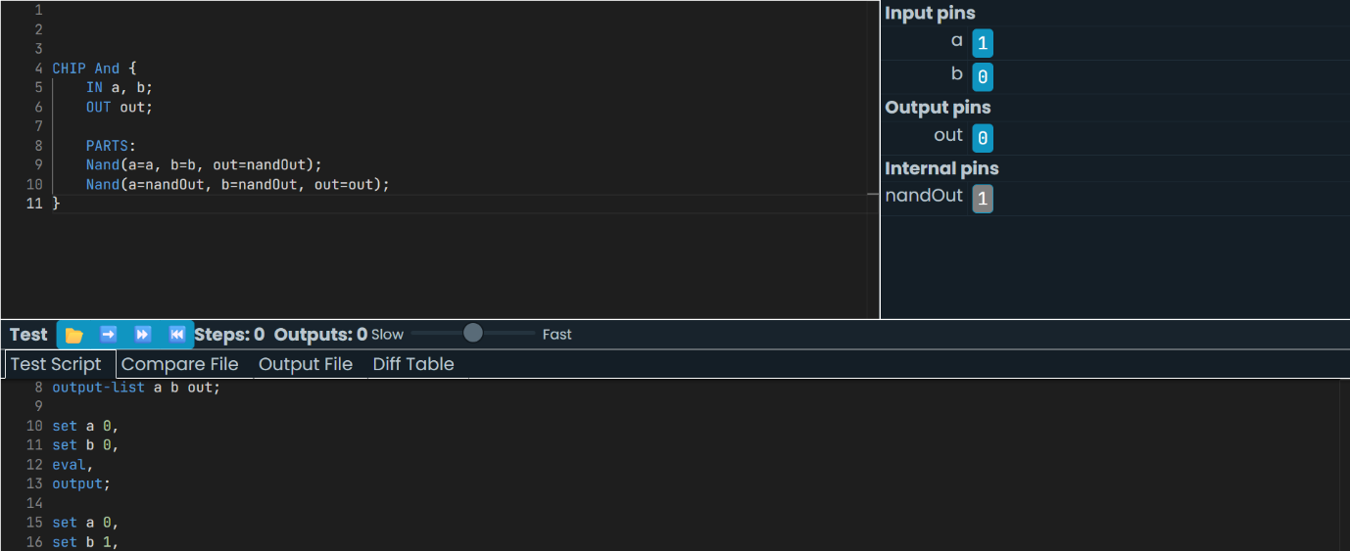
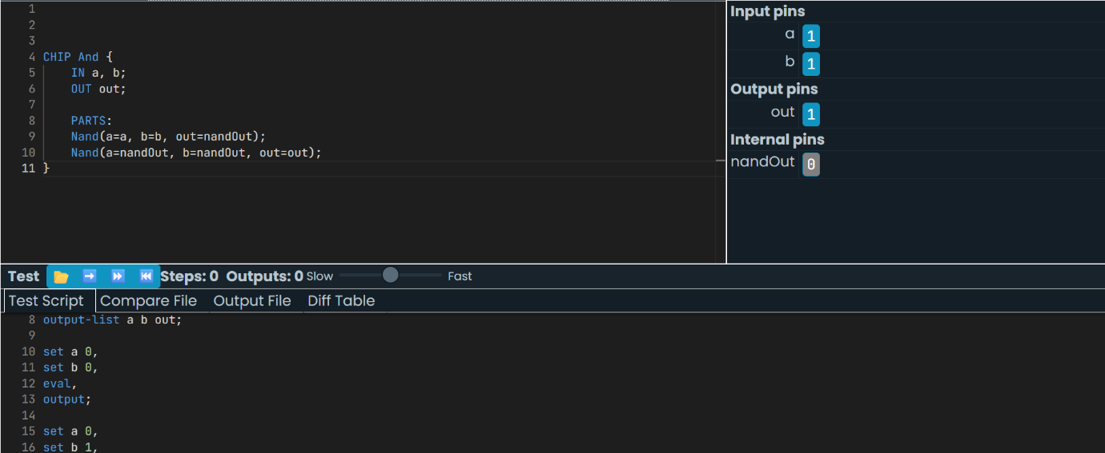
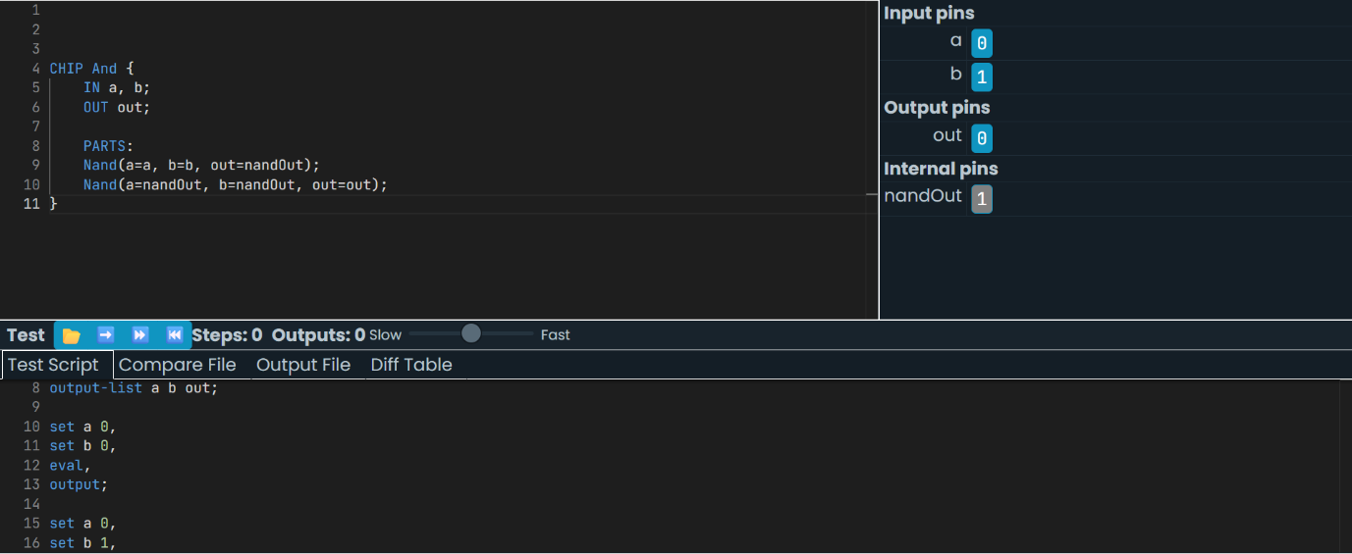


3. OR Gate using NAND
An OR gate can be constructed using three NAND gates.
Logic diagram
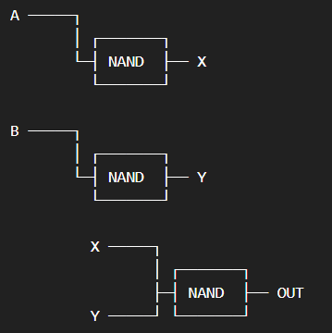

Boolean expression
First NAND: X=A′
Second NAND: Y=B′
Third NAND: OUT=(A′⋅B′)′
Using De Morgan's theorem: OUT=A+B​

A |  |  |  |  |  |  |  |  |  |  |  |  |  |  |  | B |  |  |  |  |  |  |  |  |  |  |  |  | OUT
0 |  |  |  |  |  |  |  |  |  |  |  |  |  |  |  | 0 |  |  |  |  |  |  |  |  |  |  |  |  | 0
0 |  |  |  |  |  |  |  |  |  |  |  |  |  |  |  | 1 |  |  |  |  |  |  |  |  |  |  |  |  | 1
1 |  |  |  |  |  |  |  |  |  |  |  |  |  |  |  | 0 |  |  |  |  |  |  |  |  |  |  |  |  | 1
1 |  |  |  |  |  |  |  |  |  |  |  |  |  |  |  | 1 |  |  |  |  |  |  |  |  |  |  |  |  | 1
