Documentation for creating the OLA Maintenance Jobs on Cloud SQL Server.
Ola Hallengren scripts are used by database administrators worldwide, from small businesses to large, mission-critical environments in major organizations, due to their robust, reliable, and highly customizable nature. We have also adopted this on our DB MSSQL on prem servers, and it has proven to be more efficient and more customizable as per application requirements.

This documentation covers the steps to create the Ola Jobs ,
Since Ola Maintenance solution offers complete maintenance which includes backups , indexing , statistics update and database integrity checks.
This doc initial draft is for creating the jobs for Indexing and update stats jobs .
So, for that we need 3 objects to be created. 1 Table, and 2 stored procedures, These objects can be created on master database, or incase master database is not accessible due to cloud sql limitations, a new database can be created with the name of dba or dbautilities which will contain these objects for creating the maintenance jobs .
- If master database is not accessible, then create a dba database with below query
Create database dba ;
Now, Create the objects in following order, note it’s important to follow order in creating these objects:
- STEP WISE IMPLEMENTATION Maintenance Jobs:
Step 1. Create the CommandLog Table
Create the table with the script attached - CommandLogtable.sql
This table stores the execution history of all Ola’s maintenance tasks — including which databases, commands, and parameters were executed.
Step 2. Create the CommandExecute Stored Procedure
Create the Stored proc with the script attached - sp_commandExec.sql
This procedure is used internally by Ola’s scripts to log execution details to the CommandLog table.
Step 3. Create the IndexOptimize Stored Procedure
Create the table with the script attached -sp_indexoptimize.sql
This is the main stored procedure that can be used to create a job that perform index rebuilds/reorganizes and statistics updates.

Now we have the high-level objects created on the instance, this has only to be created once .
We will refer to these stored procs and its parameters from the T-SQL script of the jobs according to the job requirement
FOR CREATING THE JOBS:
USING SSMS :
- Connect to the object explorer and you would see a SQL SERVER AGENT OPTION , which is the place where MSSQL lets you create the Jobs.
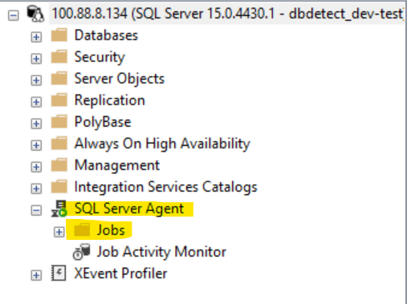

- Right click on the Jobs and select New Job
- Provide details such as Name of Job, description, Category
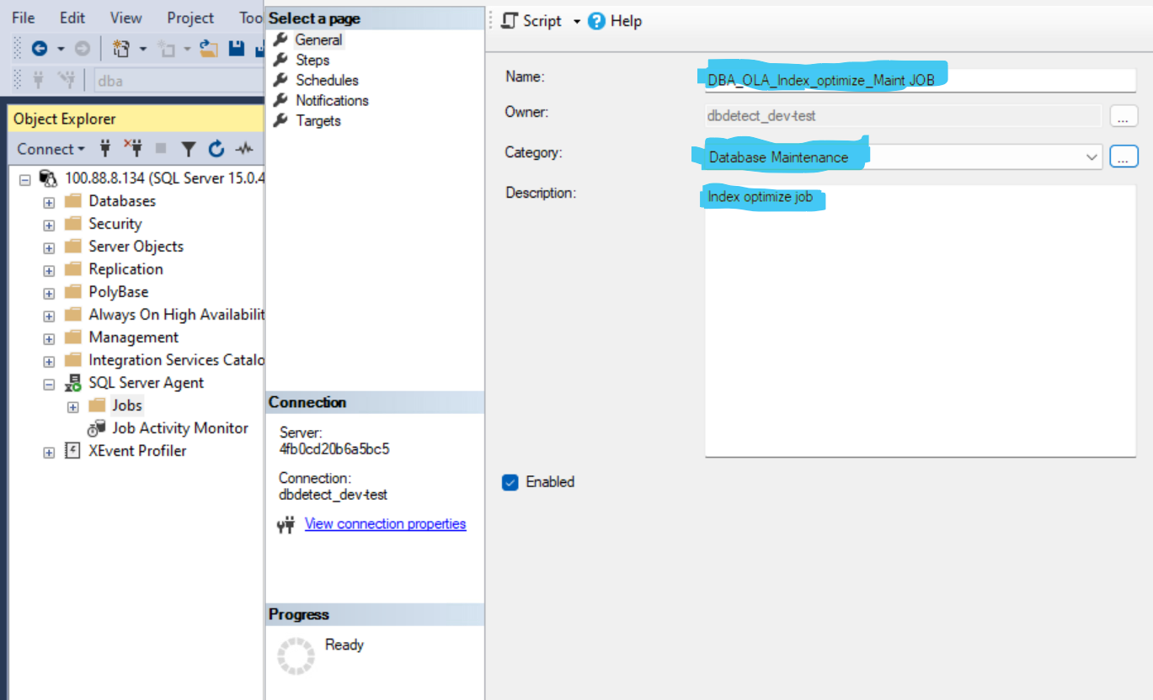

- Now on the same windows left side we have an option for steps, choose that and then click New
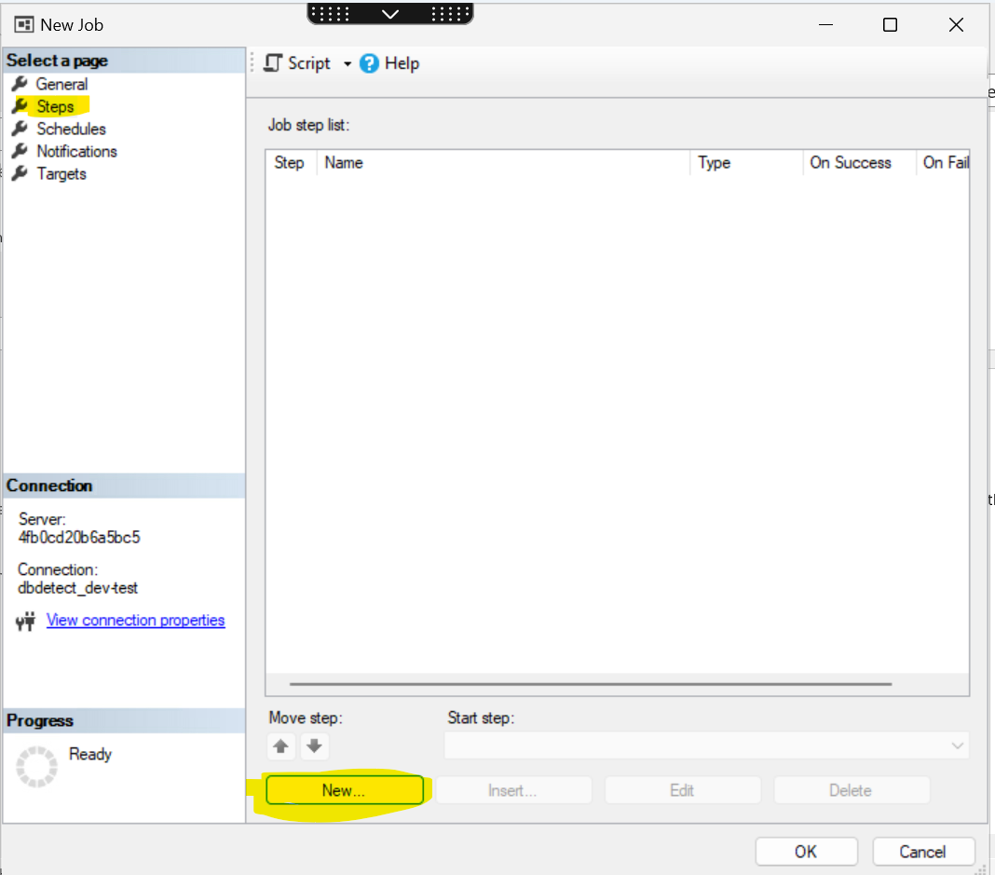

- Now Give the Name of the Step , Type as T-SQL Script , Database name where the objects were created initially in the above steps
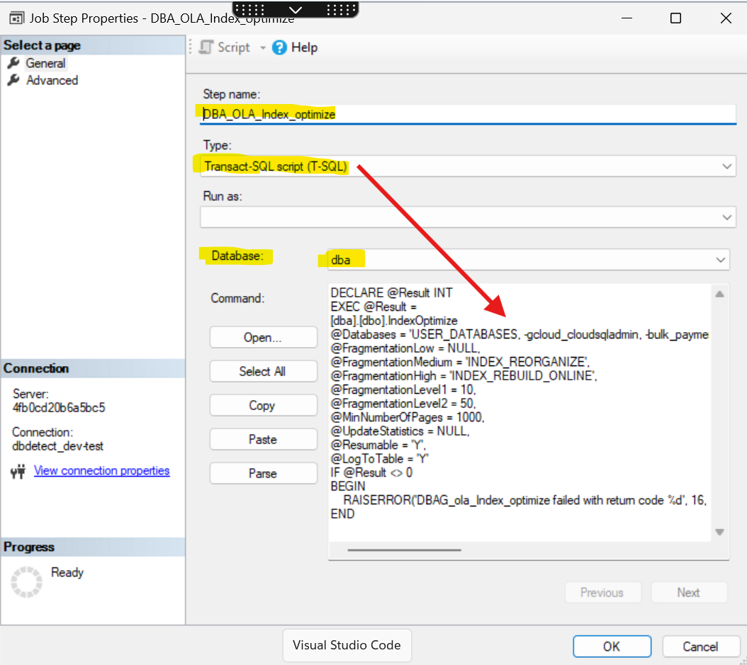
- In the Command window highlighted with red arrow above we have to give the T-SQL script with parameters which will be executed by the job. (Will share that in last of the document.)
- Click ok, the job step is created, now let’s create the scheduled
- Choose Schedules from left side and click New
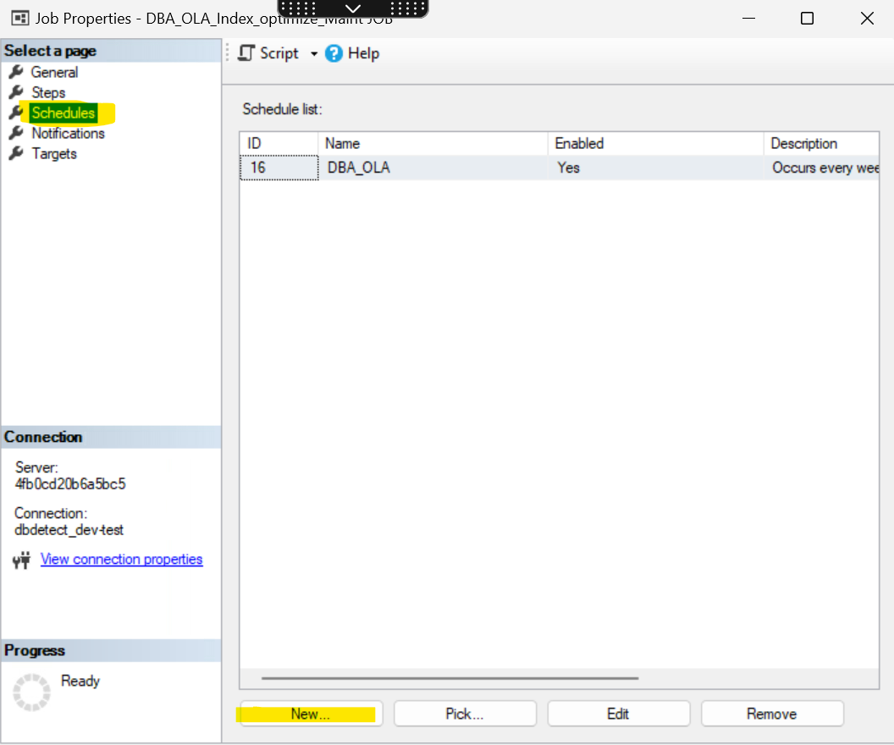

- Fill up the details as per the requirement, Maint jobs should usually run on weekends /off business hours.
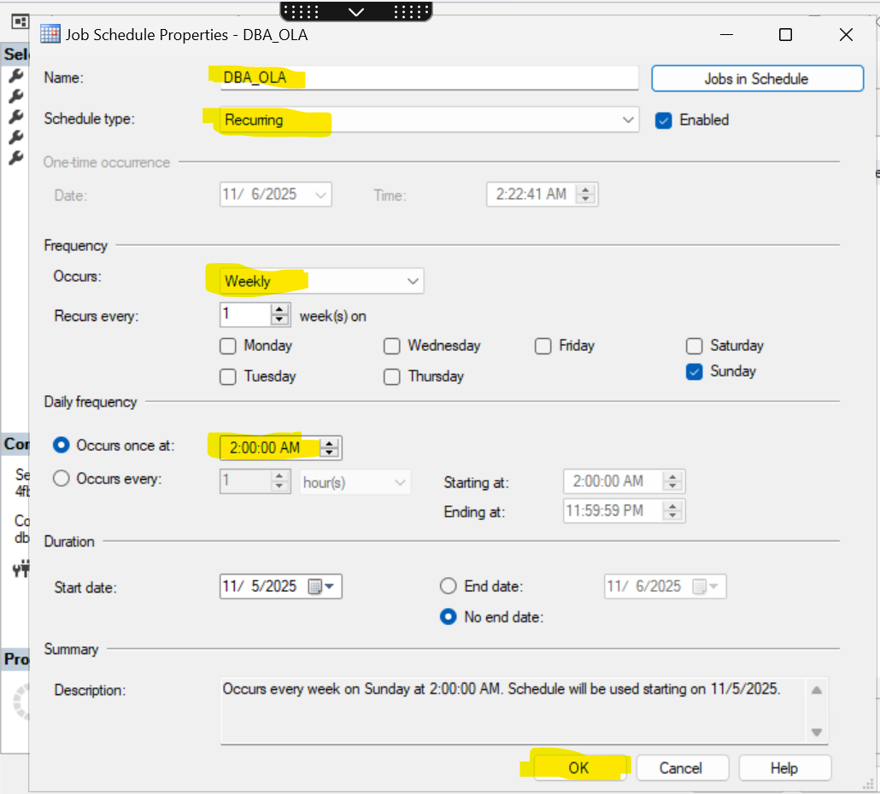

Click Ok The schedule for this job is created now and on the Final page again click OK, so the job is created in the SQL agent .

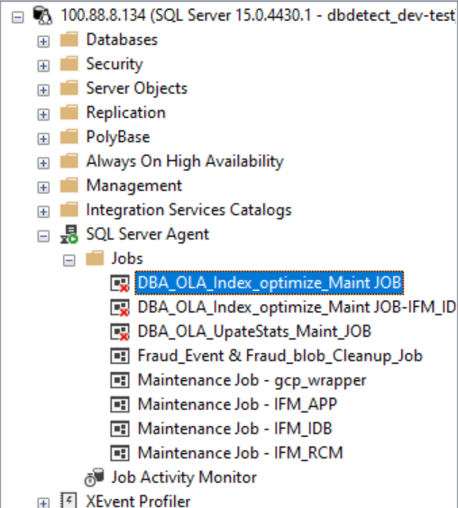
INDEX JOB CREATED SUCESSFULLY.
Same process needs to be followed to create the update stats job . just change the job name, job step name .

Now details on the basic T-SQL script to used in the Job Step

- For creating the Index job for all user databases
DECLARE @Result INT
EXEC @Result =
[dba].[dbo].IndexOptimize
@Databases = 'USER_DATABASES, -gcloud_cloudsqladmin, -gcloud_db_insights ',
@FragmentationLow = NULL,
@FragmentationMedium = 'INDEX_REORGANIZE',
@FragmentationHigh = 'INDEX_REBUILD_ONLINE',
@FragmentationLevel1 = 10,
@FragmentationLevel2 = 50,
@MinNumberOfPages = 1000,
@UpdateStatistics = NULL,
@Resumable = 'Y',
@LogToTable = 'Y'
IF @Result <> 0
BEGIN
RAISERROR('DBA_ola_Index_optimize failed with return code %d', 16, 1, @Result)
END

- For creating the Update Stats job for all user databases

DECLARE @Result INT
EXEC @Result =
[dba].[dbo].IndexOptimize
@Databases = 'USER_DATABASES, -gcloud_cloudsqladmin, -gcloud_db_insights ',
@FragmentationLow = NULL,
@FragmentationMedium = NULL,
@FragmentationHigh = NULL,
@UpdateStatistics = 'ALL',
@Resumable = 'Y',
@LogToTable = 'Y'
IF @Result <> 0
BEGIN
RAISERROR('DBA_ola_update_statistics failed with return code %d', 16, 1, @Result)
END

- For creating the Full Maint Job (Index + Update Stats) only for a selected database such as IFM_IDB or selected table such as IFM_IDB.DATA_IDB.FF_ALL_TRANSACTIONS

DECLARE @Result INT
EXEC @Result =
[dba].[dbo].IndexOptimize
@Databases = 'IFM_IDB',
@Indexes = 'IFM_IDB.DATA_IDB.FF_ALL_TRANSACTIONS',
@FragmentationLow = NULL,
@FragmentationMedium = 'INDEX_REORGANIZE',
@FragmentationHigh = 'INDEX_REBUILD_ONLINE',
@FragmentationLevel1 = 10,
@FragmentationLevel2 = 30,
@MinNumberOfPages = 1000,
@UpdateStatistics = 'ALL',
@Resumable = 'Y',
@LogToTable = 'Y'
IF @Result <> 0
BEGIN
RAISERROR('DBA_ola_Index_optimize failed with return code %d', 16, 1, @Result)
END

NOTE:
- The user which is creating the job should have access to the database else the job would fail with error :
The server principal "dbdetect_dev-test" is not able to access the database "bulk_payments_in" under the current security context. [SQLSTATE 08004] (Error 916). The step failed.
- You can customize the parameters as per the requirements from the job step only , there is not need to change anything int the stored procs .
- I am including some parameters here below for reference , so if jobs has to be customized it could be done .

- Parameters
@Databases
Select databases. The keywords SYSTEM_DATABASES, USER_DATABASES, ALL_DATABASES are supported. The hyphen character (-) is used to exclude databases, and the percent character (%) is used for wildcard selection. All of these operations can be combined by using the comma (,).

Value | Description
SYSTEM_DATABASES | All system databases (master, msdb, and model)
USER_DATABASES | All user databases
Db1 | The database Db1
Db1, Db2 | The databases Db1 and Db2
USER_DATABASES, -Db1 | All user databases, except Db1
%Db% | All databases that have “Db” in the name
%Db%, -Db1 | All databases that have “Db” in the name, except Db1
ALL_DATABASES, -%Db% | All databases that do not have “Db” in the name

@FragmentationLow
Specify index maintenance operations to be performed on a low-fragmented index.
@FragmentationMedium
Specify index maintenance operations to be performed on a medium-fragmented index.
@FragmentationHigh
Specify index maintenance operations to be performed on a high-fragmented index.
@FragmentationLevel1
Set the lower limit, as a percentage, for medium fragmentation. The default is 5 percent.
@FragmentationLevel2
Set the lower limit, as a percentage, for high fragmentation. The default is 30 percent.
Suppose you give Level1 =10 and Level2 =40 then the FragLow is Index with Fragmentation lesa than 10% , FragMedium is Fragmentation between 10%-40% and FragHigh is Fragmentation greater than 40% .
Value | Description
INDEX_REBUILD_ONLINE | Rebuild index online.
INDEX_REBUILD_OFFLINE | Rebuild index offline.
INDEX_REORGANIZE | Reorganize index.
INDEX_REBUILD_ONLINE,INDEX_REBUILD_OFFLINE | Rebuild index online. Rebuild index offline if online rebuilding is not supported on an index. This is the default for a high-fragmented index.
INDEX_REBUILD_ONLINE,INDEX_REORGANIZE | Rebuild index online. Reorganize index if online rebuilding is not supported on an index.
INDEX_REORGANIZE,INDEX_REBUILD_ONLINE,INDEX_REBUILD_OFFLINE | Reorganize index. Rebuild index online if reorganizing is not supported on an index. Rebuild index offline if reorganizing and online rebuilding are not supported on an index.
NULL | Do not perform index maintenance.

@UpdateStatistics
Value | Description
ALL | Update index and column statistics.
INDEX | Update index statistics.
COLUMNS | Update column statistics.
NULL | Do not perform statistics maintenance. This is the default.

@OnlyModifiedStatistics
Update statistics only if any rows have been modified since the most recent statistics update.
Value | Description
Y | Update statistics only if any rows have been modified since the most recent statistics update.
N | Update statistics regardless of whether any rows have been modified.

@Indexes
Select indexes. If this parameter is not specified, all indexes are selected. The hyphen character (-) is used to exclude indexes, and the percent character (%) is used for wildcard selection. All these operations can be combined by using the comma (,).
Value | Description
ALL_INDEXES | All indexes
Db1.Schema1.Tbl1.Idx1 | The index Idx1 on the object Schema1.Tbl1 in the database Db1
Db1.Schema1.Tbl1.Idx1, Db2.Schema2.Tbl2.Idx2 | The index Idx1 on the object Schema1.Tbl1 in the database Db1 and the index Idx2 on the object Schema2.Tbl2 in the database Db2
Db1.Schema1.Tbl1 | All indexes on the object Schema1.Tbl1 in the database Db1
Db1.Schema1.Tbl1, Db2.Schema2.Tbl2 | All indexes on the object Schema1.Tbl1 in the database Db1 and all indexes on the object Schema2.Tbl2 in the database Db2
Db1.Schema1.% | All indexes in the schema Schema1 in the database Db1
%.Schema1.% | All indexes in the schema Schema1 in all databases
ALL_INDEXES, -Db1.Schema1.Tbl1.Idx1 | All indexes except the index Idx1 on the object Schema1.Tbl1 in the database Db1
ALL_INDEXES, -Db1.Schema1.Tbl1 | All indexes except indexes on the object Schema1.Tbl1 in the database Db1

@LogToTable
Log commands to the table dbo.CommandLog.
Value | Description
Y | Log commands to the table.
N | Do not log commands to the table. This is the default.

@OnlyModifiedStatistics
Update statistics only if any rows have been modified since the most recent statistics update.
Value | Description
Y | Update statistics only if any rows have been modified since the most recent statistics update.
N | Update statistics regardless of whether any rows have been modified.
@Resumable = 'Y'
This is indeed very useful feature especially for very large databases or limited maintenance windows. Resumable index rebuilds allow large or long-running index operations to be paused and resumed without losing progress.
How it works:
When @Resumable = 'Y' is used in Ola Hallengren’s IndexOptimize, it adds the SQL option
RESUMABLE = ON to the ALTER INDEX ... REBUILD command.
If a rebuild is interrupted (e.g., due to restart, failover, or manual stop), SQL Server pauses the operation instead of rolling it back.
The rebuild can later be resumed manually from the exact point it stopped using:
ALTER INDEX [IndexName] ON [Schema].[Table] RESUME;

