A Cryptologic Method for Preventing Unauthorized Outbound
Network Traffic via Authenticating Network Devices

Subcontract LATEC 13-S567-020-02-C2

Final Report

2014-02-18

Dr. Jean Gourd
Assistant Professor of Computer Science
Program Chair of Computer Science
College of Engineering & Science
Louisiana Tech University
318.257.4301
jgourd@latech.edu

Table of Contents
1.0 INTRODUCTION AND SUMMARY 4
1.1 Introduction 4
1.2 Summary 4
1.2.1 Why This Project is Novel 5
2.0 Technical Discussion of Approach 5
2.1 Technical Objectives 5
2.2 Approach 9
2.2.1 Application identification 10
2.2.2 SNIC—AS Communication 10
2.2.3 SNIC Algorithm 11
2.2.4 AS Algorithm 11
2.3 Schedule and Milestones 13
3.0 CONCLUSIONS AND FUTURE WORK 14
3.1 Students 15
3.2 Scaled implementation 15
3.3 Situational awareness module 16
4.0 REFERENCES 16

INTRODUCTION AND SUMMARY

Introduction
The bulk of the cyber security discussion is focused on threat detection and protection [6]. This is evidenced by the proliferation of signature-based anti-malware tools and IDPS (Intrusion Detection and Prevention Systems) [e.g., 1, 2]. Very little actually concerns threat avoidance [see 3, 4]; that is, a focus on internal vulnerabilities as opposed to specific threats in order to render them inconsequential. Attackers will always have some motivation to attack; they will always attempt to remain a step of ahead of their targets. Perhaps the goal should not be to try to stop them; rather, it may be much easier to simply make them (and consequently their threats) not matter.
This project falls under the category of threat avoidance and specifically addresses the threat of unauthorized outbound network access. This includes any entity (whether malicious in intent or not) situated on a host that attempts unauthorized outbound network access; for example, Trojan horses, botnet client malware, keyloggers that remotely transfer keystrokes, data-stealing spyware, and automatically updating software.

Summary
Our method relies on the host-based encryption of network traffic via specialized middleware and its subsequent decryption at the switch level via a specialized switch. Figure 1 shows a high-level overview. A specialized Authentication Switch (AS) synthesized on an FPGA that only accepts correctly encrypted outbound network traffic is integrated in the network. All applications (including malware) that beacon will generate network traffic, but only applications validated by the AS will have their traffic encrypted by the middleware ideally embedded in the host's SNIC (Sentinel Network Interface Card) synthesized on an FPGA and subsequently decrypted by the AS. Unencrypted outbound network traffic is simply dropped by the SNIC or the AS. Treatment of inbound network traffic is unchanged; our method handles it as typical network switches do.
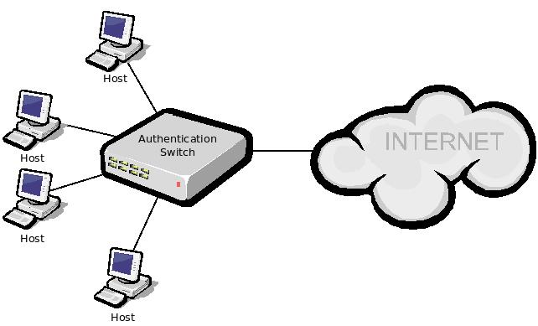
Figure 1: Overview

Why This Project is Novel
To our knowledge, very little work is being done that directly focuses on threat avoidance. Recent techniques primarily focus on detecting and preventing threats and utilize signature-based methods or integrity checking to accomplish this. As new threats emerge, these methods must be modified to detect them. Current methods use behavior-based detection and heuristics. IDPSs use signature-based analysis at a network level to detect threats. Additionally, there is some measure of avoidance built into modern browsers, but it is limited as it relies on a database that must remain updated. These methods are all reactive in nature; they require the malware to act first.
In contrast, our method is proactive and completely neutralizes the threat of beaconing malware as well as certain active approaches an adversary may take while attempting to compromise a system. Moreover, it involves no change to the applications on an existing host. The simple addition of the AS and SNIC to an existing network adequately supports the encryption and decryption of outbound network traffic and avoids the threat of unauthorized outbound network access. This presents a hardware-based solution that minimizes attack vectors because it requires physical access to the host in order to attempt compromise. Furthermore, our method maintains a form of privacy protection in that only authorized outbound network traffic is routed. An added benefit is that organizations can control which applications are allowed outbound network access, including specific versions of each application.

Technical Discussion of Approach

Technical Objectives
At a high level, we implement the encryption of network traffic generated by registered applications on a local host and subsequent decryption at the switch level for the purpose of thwarting beaconing malware and other forms of unauthorized outbound network access. The following main components provide this capability:
  - A middleware on the local host that is responsible for: (a) computing application hashes for the purpose of validation; (b) encrypting application-specific network traffic for applications that have been validated; and (c) dropping network traffic for applications that have not been validated. This middleware can be implemented in software (as shown in Figure 2) or hardware (as shown in Figure 3). A software-based approach is easier to deploy simply by pushing the middleware to each host on the network but is more susceptible to compromise as it resides in memory and on disk. A hardware-based approach (as a SNIC) is more difficult to deploy because it requires installation of a physical device on each host and is more costly; however, it provides increased security in that compromise requires physical access to the device. Due to the nature of software-based versus hardware-based middleware, and for flexibility, we are developing both implementations.
  - An AS in the network that is responsible for (a) validating applications for outbound network access; (b) decrypting encrypted outbound network traffic; and (c) performing other typical functions of a network switch. The AS is designed to only accept correctly encrypted outbound network traffic. It drops any unencrypted or incorrectly encrypted outbound traffic. Inbound network traffic is handled normally.
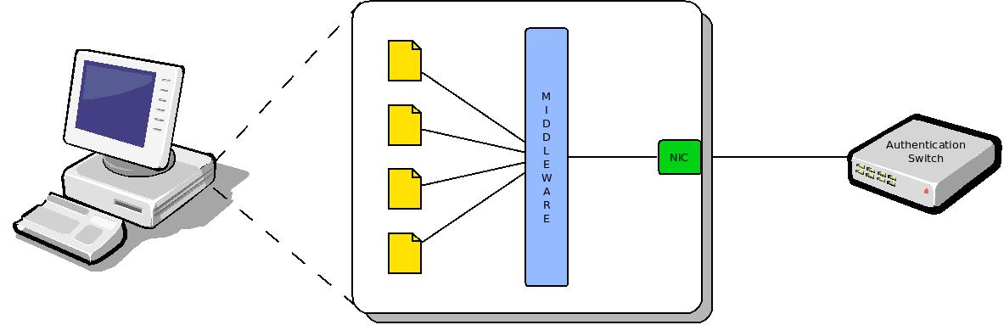
Figure 2: Middleware Implemented in Software
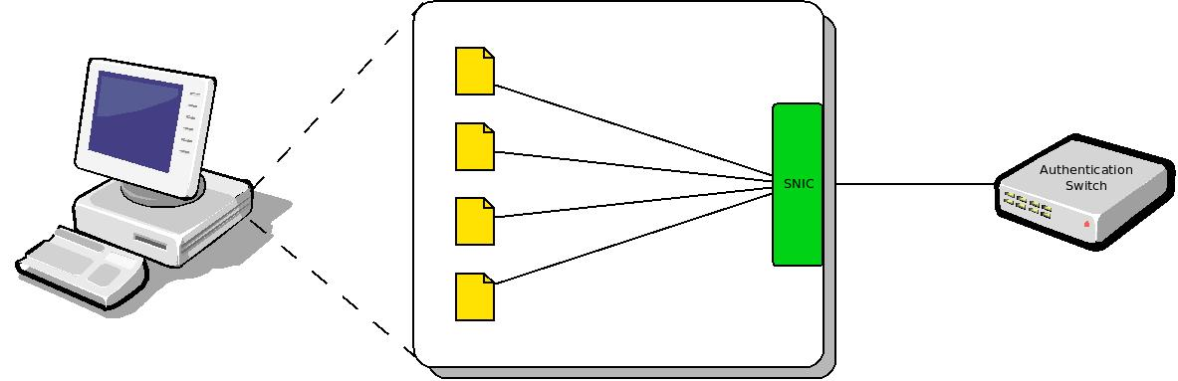
Figure 3: Middleware Implemented in Hardware (i.e., SNIC)
The basic process that enables the method involves the following actions:
- Application identification;
- Application authentication;
- Traffic encryption at the host;
- Traffic transport through the LAN;
- Traffic decryption at the AS; and
- Traffic transport to the WAN.
In addition, return traffic is handled as normal network traffic on unmodified networks.
Figure 4 illustrates a typical outbound network traffic scenario (and subsequent inbound response) for an application performing an update via a remote server on the Internet. Note that arrows in black represent the application’s request, those in red represent the remote server’s response, and those in green represent the negotiation between the SNIC and AS).
  - The application attempts outbound remote access (through the SNIC). If the traffic coming from the application is already encrypted (e.g., an attacker is attempting to compromise the method or an application is utilizing security such as SSL), it is treated like regular (non-encrypted) traffic (i.e., the SNIC will simply hash the application as normal and, if validated, encrypt the outbound traffic).
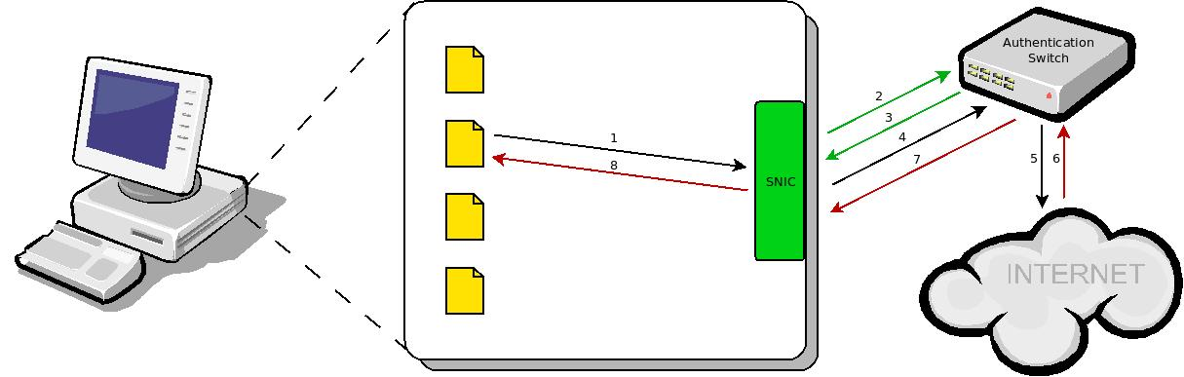
Figure 4: Example Scenario
  - The SNIC computes a hash of the application, encrypts the hash and a session ID with an organizationally-specific mutating key, k, shared by the SNIC and the AS, and requests validation of the application from the AS.
  - The AS decrypts the SNIC’s message, thereby extracting the application’s hash and the session ID, and attempts to find the application in its application table. If no match is made, it replies with an encrypted packet notifying the SNIC; the SNIC then drops the application’s request. If a match is made, the AS generates a public-private key pair for the application, then stores the hash, session ID, and private key in its application table, and finally replies back to the SNIC with an encrypted packet containing the hash, session ID, and public key.
  - The SNIC encrypts the application’s outbound network traffic with the public key, then encrypts the hash and session ID along with the encrypted traffic with the key it shares with the AS, k, and routes it to the AS.
  - The AS decrypts the SNIC’s message, extracting the application's hash, session ID, and encrypted traffic. The hash/session ID pair is matched in its application table, the traffic is decrypted with the application's private key and routed remotely as usual. The private key and session ID are then thrown away.
  - The remote server responds as usual, and the AS receives the inbound traffic.
  - The AS forwards the inbound traffic to the appropriate host as usual.
  - The SNIC forwards the inbound traffic to the appropriate application as usual.
This project four main objectives:
  - Implement the software-based host middleware. Include application hashing, negotiation with the AS, and network traffic encryption.
  - Implement the AS in hardware synthesized on an FPGA. We are leveraging ongoing research that aims to synthesize network devices on FPGAs for the purpose of layering a multi-agent system for network situational awareness and intrusion detection and protection. Devices currently involved with this research include NICs, switches, routers, and even lengths of Ethernet cable. These devices are being prototyped on the NetFPGA development platform developed by Stanford University. For this objective, include negotiation with the host middleware, application table for application registration and validation, public-private key pair generation, outbound network traffic decryption, and a method to register applications in the application table.
  - Implement the hardware-based host middleware synthesized on an FPGA-based NIC (as a SNIC). Include application hashing, negotiation with the AS, and network traffic encryption.
  - Scale the implementation to multiple hosts, multiple ASs, and increased frequency of outbound network traffic.

Approach
This work presents an unconventional approach to network security that relies on a partial or complete hardware implementation. Specifically application hashing, encryption, and decryption are performed in FPGA-based hardware (on the SNIC and AS) which minimally impact the host (for the benefit of other programs or processes) because it uses separate processing resources. Furthermore, FPGAs benefit from rapid prototyping and reconfigurability.
Note that we make the assumption that the proposed method is not known to the malware author; however, should it become known, the attacker still has to deal with the hashing and encryption problem (i.e., how to hash to a valid application and what encryption key and method to use). This would require compromising the AS (in hardware) or the host middleware (in hardware or software depending on the implementation) of the target organization; general solutions would be insufficient.
A side benefit of our method is that an organization that implements it now has control over which applications (and even which versions of those applications) can remotely communicate on the network. Furthermore, any third party that introduces a system in the network (e.g., a laptop brought in from the outside) will not be granted outbound network access since the host middleware is not installed. Controlling applications and their versions restricts the user; however, it can be used to increase security in the network. Downstream entities (outside of the AS) notice nothing as all packets are decrypted prior to that point, and the network behaves as normal when communicating with trusted applications.

Application identification
In order to identify applications requesting outbound network traffic on the host, network packets are captured at the SNIC level. Packets are sniffed on the host and are stored in pcap format on the host machine. This provides a useful look at historical network data and additionally helps with testing and verification. Note that we make use of python-scapy [9] and NFQUEUE [5] for interactive packet manipulation. Cleanup occurs once the SNIC—AS negotiation is complete and the traffic is routed out of the host.

Established connections are identified on the host system via python-psutil [8]. It is well known that several strains of malware make use of typically benign (and often allowed) applications to beacon. For example, malware could spawn a popular Web browser (e.g., Mozilla Firefox, Google Chrome, Internet Exploder) in order to connect to a predefined Web page. To thwart this, our method attempts to identify the originating process; that is, the underlying process that originated the request for outbound network access. Once matches are made between outbound network traffic and the originating process, the process can then be authenticated at the AS.

SNIC—AS Communication
All communication that occurs between the SNIC and the AS is encrypted. This helps thwart packet sniffers. The Advanced Encryption Standard (AES) is used for all symmetric key encryption, and the RSA algorithm is used for all asymmetric key encryption. All communication between the SNIC and AS is encrypted symmetrically with a organization-specific key, k.

We define a set of tags that help to identify the current stage in the process:
- AUTH indicates a request for authentication. The SNIC would send this tag in order to request that an application be authenticated by the SNIC.
- FWD indicates that traffic originating from a specified application can be forwarded. That is, the application is authenticated.
- END indicates the end of SNIC—AS negotiation.

SNIC Algorithm
The SNIC utilizes the following algorithm to identify a requesting application, negotiate with the AS, handle traffic generated by applications, and cleanup:

Authenticate(p,t)
hash ← compute H(p)
sid ← H(timestamp)
tag ← AUTH
msg ← encrypt {hash,sid,tag,NULL,NULL} with K
send msg to AS

resp ← receive response from AS
{sid,tag,AK+} ← decrypt resp with K
if tag = FWD
then SK ← new symmetric key
t’ ← encrypt t with SK
SK’ ← encrypt SK with AK+
msg ← encrypt {NULL,sid,tag,t’,SK’} with K
send msg to AS
else
cleanup on sid

AS Algorithm
The AS requires a hash list and a session table in order to authenticate applications and properly forward the network traffic of authenticated applications. The hash list is simply a list of valid application hashes that the AS can use to compare to application hashes provided by the SNIC in the authentication process. The following table illustrates a sample hash list:

HASH
123abc
456xyz
337fgi
590dbo

In addition, the AS uses an application session table that correlates session IDs with the private keys of authenticated applications. This is used to determine the originating application of traffic forwarded by the SNIC and to properly route the traffic. The following table illustrates a sample session table:

SID | AK-
1 | 3df
2 | 6fr
3 | 7ju
4 | 9sw

The AS uses the following algorithm to authenticate applications, negotiate with the SNIC, and route network traffic:

Negotiate(msg)
{hash,sid,tag,t’,SK’} ← decrypt msg with K
if tag = AUTH
then verify hash in list
if hash exists
then {AK+,AK-} ← new asymmetric key
store {sid,AK-} in session table
tag ← FWD
msg ← encrypt {sid,tag,AK+} with K
else tag ← END
msg ← encrypt {sid,tag,NULL} with K
send msg to SNIC
else k ← retrieve AK- in session table at sid
SK ← decrypt SK’ with k
t ← decrypt t’ with SK
tag ← END
msg ← encrypt {sid,tag,NULL} with K
send msg to SNIC
forward t

Although we plan to create a graphical situational awareness module to help with testing and to provide a “view” of the network traffic, we have developed preliminary textual logging that allows us to see what is happening as the SNIC and AS are negotiating. Figure 5 shows part of a log file of application identification, SNIC—AS negotiation, and traffic routing from the SNIC's perspective, and Figure 6 shows the same from the AS' perspective.

Schedule and Milestones
As proposed, the overall project was to be completed in a total of twelve months, but our delayed start has shortened this to nine months. There are four main milestones (with a fifth projected future milestone). Table 1 summarizes the project's schedule and milestones.
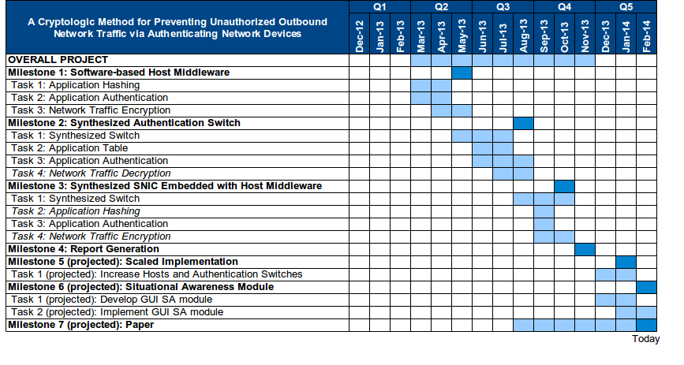Table 1: Schedule and Milestones
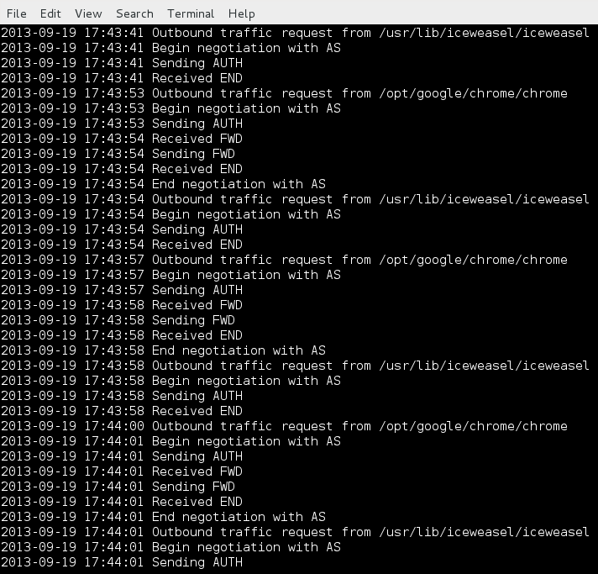Figure 5: Sample run (SNIC POV)
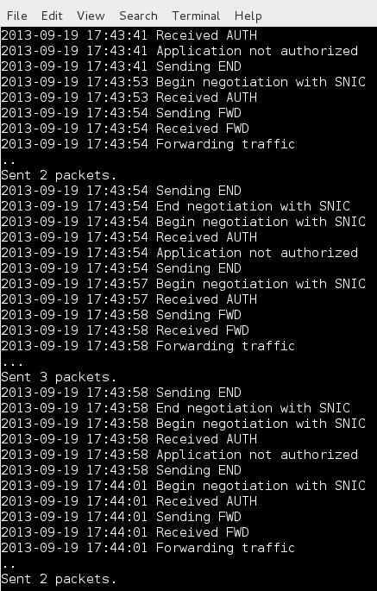Figure 6: Sample run (AS POV)

CONCLUSIONS AND FUTURE WORK
The project began on 06 Mar 2013 due to a delay in obtaining funds and subsequently in obtaining students to work on the project. Related research allowed us to make indirect progress before officially starting work on this project. In addition, this research is interesting to our research group. Therefore, we plan to continue to develop and extend this work.

This work has a variety of applications in many areas of research. It can apply to fixed or mobile devices, cloud security, secure network management, secure mobile computing, and resilient mechanisms. Moreover, the method can be partially or completely implemented in hardware (on FPGAs) if desired. This has benefits in that FPGAs minimally impact the hosts, provide rapid prototyping, are easily and quickly reconfigurable, and can speed up and isolate the components [e.g., in 10] in the framework. Isolation is not new and has been done before (e.g., virtualization [7]), but this is different in that it is an isolation provided in hardware. There is, however, a trade-off of ease of implementation vs. increased robustness. It is much easier to implement and deploy the method in software; however, the result is less secure and robust than a hardware implementation.

We have completed the software implementation of the framework (i.e., both the SNIC and AS are implemented in software). Each component is on its own Linux server. We have a variety of validated applications that are used to test network routing throughout the LAN, and we have tested and verified the framework with authenticated and unauthenticated applications.

Students
At the beginning of this project, five students were actively participating in the work. All of the students were undergraduates, four in Computer Science (all juniors) and one in Cyber Engineering (also a junior). Over the course of the project, one student left due to prior obligations. The students working on this project near its conclusion are shown on the following page.

Scaled implementation
In the immediate future, we plan to scale the implementation across more hosts and increase the number of AS' in the LAN to see how the framework behaves and if derivative issues arise (e.g., network traffic latency). Figure 7 illustrates a model of the planned scaled implementation.

Situational awareness module
In addition, we plan to develop a graphical situational awareness module in the near future. This would replace the current textual log file based method.


Regan Carver
Skylar McLean
Leo Gourrier
Ryan Tiedeman
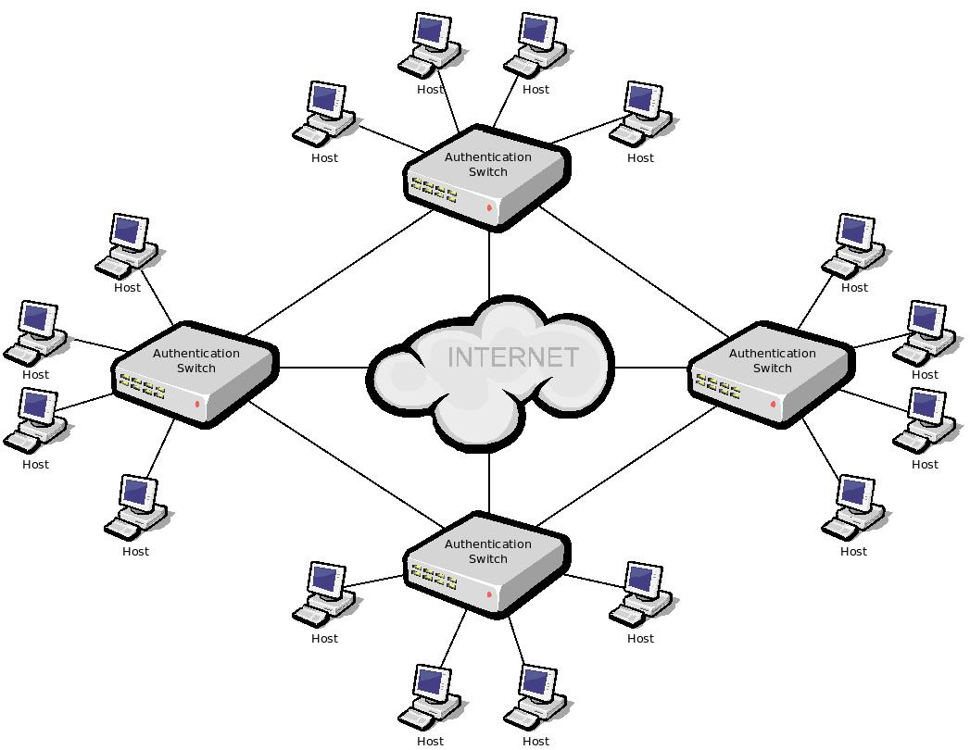Figure 7: Scaled implementation

REFERENCES

[1] EMC. 2008. Detection of beacon trojans and designer malware.
[2] EMC. 2012. Rsa netwitness: network security monitoring platform. Datasheet.
[3] Liang, H. and Xue, Y. 2009. Avoidance of information technology threats: a theoretical perspective. MIS Q. 33(1):71-90.
[4] Manzano, D. 2012. The cybercitizen dimension: a quantitative study using a threat avoidance perspective. Ph.D. Dissertation.
[5] NetfilterQueue. 2013. Retrieved on 2013-07-31 from https://pypi.python.org/pypi/NetfilterQueue.
[6] Palo Alto Networks. 2011. Integrated threat prevention. Datasheet.
[7] Pearce, M., Zeadally, S., and Hunt, R. 2013. Virtualization: Issues, security threats, and solutions. ACM Comput. Surv. 45(2):1-39.
[8] Psutil. Retrieved on 2014-02-17 from https://code.google.com/p/psutil/.
[9] Scapy. Retrieved on 2013-07-31 from http://www.secdev.org/projects/scapy/.
[10] Yumbul, K. and Savaş, E. 2009. Efficient, secure, and isolated execution of cryptographic algorithms on a cryptographic unit. In Proceedings of the 2nd international Conference on Security of information and Networks. ACM, New York, NY, 143-151.

