AFRL Research Collaboration Program

Contract: FA8650-13-C-5800

Project Title: Extraction of Social Context via Synthetic
Pollination for Information Tracking and Control

University: Louisiana Tech University

REPORT COVERS PERIOD 01-JAN-14 THROUGH 01-APR-14

PROJECT TEAM MEMBERS

Lead University POC
Dr. Jean Gourd
318-257-4301
jgourd@latech.edu

Students
Thomas Bozeman
Computer Science undergraduate student, senior

Shawn Killeen
Computer Science undergraduate student, sophomore

AFRL Technical POC
Kenneth Littlejohn

TECHNICAL DISCUSSION

Background
This work centers around a synthetic biological mechanism that is based on the collection and analysis of network data designed to assist in the tracking and control of information flow in a LAN. This mechanism can be used to aid in the detection and mitigation of insider threats, for example, through the early prediction of adversarial behavior. Behaviorally, it generates additional context from base information in the form of social meta-data mined from interactions between users and nodes in the network. There is an ancillary benefit in that the additional context is expected to reduce the effective capabilities of the insider threat due to the increased risk of detection.

At the core of this mechanism is a concept called “pollination” that is modeled biologically after the activities of bees. In the course of utilizing a node, users will leave “pollen” indicating their interests in terms of other nodes, users, and external entities. This meta-data is distinct in that it is contextual in nature and ultimately reduces the amount of information an analyst must process while providing contextual connections that are either missing from data or difficult and expensive to correlate. Once analyzed, it can be used for early prediction of malicious behavior for the purpose of detecting insider threats early enough to assist in preventing attacks.

The proposed work centers on a mechanism called “pollination,” a distributed host-based sensor network that utilizes intelligent agents to dynamically process raw network data into meta-data. This meta-data is not designed to replace existing data, but is rather intended to provide additional context via distributed preprocessing. The goal is to measure specific social behaviors as they happen, as opposed to measuring everything and then proceeding to work backwards as is typically done in traditional forensics. This data takes the form of social context and provides information about the relationships formed between nodes and users, and allows the tracking of information through the network.

Pollination is a scheme that relies upon the biological metaphor of bees. For the sake of the metaphor, messages within the network implementing pollination are bees while nodes are flowers. This allows for the tracking of communicating peers at the end points. This concept can be extended to infer the entire social network of a machine; however, the purpose of this work is to track and provide some measure of control of the flow of information in the network. To that end, the linking of pollen to a specific user identity within the local network is conceived. This is an additional tier of information that lies beyond the host. In essence, both the operator and the machine used are recorded. Thus, for every machine and user a set of pollen will exist at the network barrier indicating the other users and machines that form its peer group. A more thorough introduction of the pollination scheme and its potential applications can be found in our introductory paper on the topic [3].

The inclusion of host classification can allow for a less social- and more activity-oriented view of a user’s communications. Additionally, pollen does not present a binary record of social interactions, and the quantity of pollen present would be indicative of the relative strength of a social connection. The pollen collected on individual messages provides for additional forensics capabilities in the form of a visit history. This visit history of individual packets could potentially be used to detect attackers or insiders trying to stealthily sniff packets even if they were not necessarily changing them. In addition, the need to pollinate incoming information at the network edge leads to the opportunity to automatically classify WAN (wide area network) traffic and thus generate a social selection of users that are interested in that traffic. This idea can also be applied to LAN traffic, with its simplest implementation being functional in that these groups of users have functional reasons to associate.

A major component of the pollination mechanism revolves around an intelligent agent-based command and control (C2) system. This component is necessary to house and display the aggregated information from the pollination network. Through the mechanism of collecting the information, data can be correlated providing for additional context and some data integrity checking. There is an inherent anomaly detection included in this correlation. Because of the double-ended nature of pollination, the reports from sender and receiver should more or less agree. Furthermore, this data can be used as a behavioral use pattern although it does not give insight into whether these patterns are normal or abnormal. However, it is likely that classification mechanisms will assist with this. The meta-data provides additional information that would normally be time-consuming to mine out of lower level data. This leads to a net reduction in the amount of data a higher level algorithm would have to consider in a first pass situation particularly with the inclusion of more sophisticated classification algorithms. Via user input and interaction, the classification mechanisms can be further modified allowing for the dynamic tweaking of the distributed sensor network.

Once a comprehensive view of the system is aggregated, other techniques can be applied to the meta-data. One application is the creation of valid pollen patterns. This can be accomplished by simply keeping track of all valid types of pollen. If a packet is encountered with invalid pollen, it would be a very strong indicator of malicious behavior. In fact, it would most likely be an indicator of either an intruder who did not understand pollen or an insider attempting to cover his tracks.

Although there are clear social context aspects of pollination, at its technical core it is a mechanism for tracking packets through the network. Thus it is closely linked to digital forensics, and one of the aspects of interest is the ability to backtrack the path of information in the network. That is, it is conceivable that, should information be leaked from the network (or even simply reach the network edge), its exact path back to the point of origin could be easily mapped via pollination (see Figure 1). This is because pollen is bidirectional: in addition to dropping off pollen, it can be picked up by a packet. Thus, for every packet we have a trace of its travels through the network. This trace would, at a minimum, provide the order of nodes visited. By combining a higher level algorithm, it would be possible to observe irregularities in the pollen pattern. There are some technical questions of the possible granularity this trace can take while not affecting performance; however, should the performance costs be significant, granularity can be varied depending upon the origin of the message. That is, packets originating from machines with more sensitive data or from machines exhibiting suspicious information may have greater granularity.

The uniqueness in our approach centers on the pollination mechanism. It provides socially-oriented data as opposed to traditional approaches to data organization (e.g., topographic or temporal). The key advantage of this is that it allows for the study and observation of collaborative efforts. This can directly be used to detect and mitigate insider threats in addition to controlling the flow of information. The pollination mechanism also provides for bidirectional interest tracking from both the source and destination without significant additional computational overhead or data processing. It is extremely scalable both with respect to the size of both the computing infrastructure and potential user base while also being widely deployable on a diverse variety of complex computer environments. This is largely due to the system-neutral nature of the mobile agent infrastructure. This infrastructure provides for its own security as well as a great deal of potential integration with existing and future algorithms.
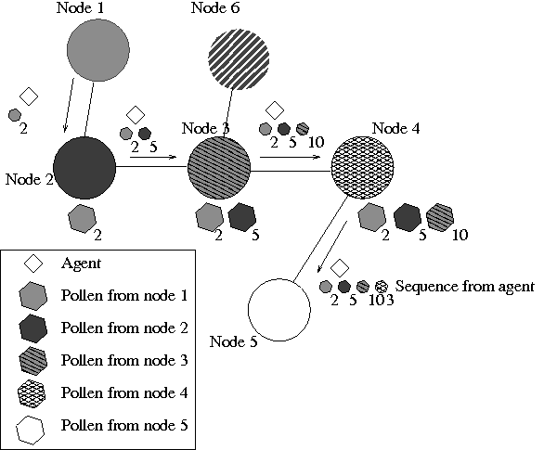Figure 1: Path of information flow via pollination

Current Work
There are three main goals of the project this year (01-SEP-2013 through 31-DEC-2014):
- Develop and analyze the optimal technical implementation for pollination.
- Design the multi-agent system (MAS) that will ultimately form the C2 system.
- Generate appropriate network traffic data for testing the pollination scheme on a testbed.

Specifically during the current period 01-JAN-2014 through 01-APR-2014, tasks have primarily covered item (1) above. Note that there has been concurrent work, primarily related to item (2) above; that is, we are simultaneously designing the MAS that will implement pollination. In many respects, both must be designed together.

We have identified several technical implementations for pollination. At this time, both seem to possess the ability to provide the desired functionality.

Method #1: call it something, Shawn
Shawn, insert your section here (we're looking for about 1-2 pages).

Method #2: call it something, Thomas
Thomas, insert your section here (we're looking for about 1-2 pages).

Conclusions/Analysis to Date
Shawn, provide a brief analysis of your method and its prospects for use as the final pollination method (we're looking for about 1 paragraph.

Thomas, provide a brief analysis of your method and its prospects for use as the final pollination method (we're looking for about 1 paragraph.

WORK FORECAST AND PLANS
Immediate work will focus on continuing to analyze the proposed technical implementations of pollination in order to better establish which works best. This will require the full implementation of a network testbed (an additional task over the next quarter).

In addition, we plan to investigate another unique method for implementing pollination, in addition to a variety of methods related to the two proposed above.

Figure 2 provides a planned schedule for the project throughout its duration this year (01-SEP-2013 through 31-DEC-2014).

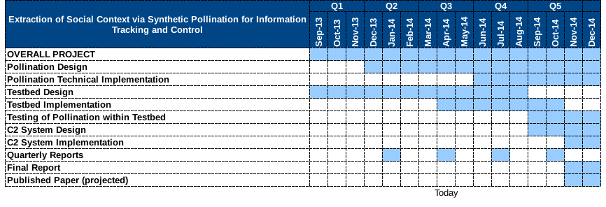Figure 2: Project schedule

