AFRL Research Collaboration Program

Contract: FA8650-13-C-5800

Project Title: Extraction of Social Context via Synthetic
Pollination for Information Tracking and Control

University: Louisiana Tech University

REPORT COVERS PERIOD 01-APR-14 THROUGH 01-JUL-14

PROJECT TEAM MEMBERS

Lead University POC
Dr. Jean Gourd
318-257-4301
jgourd@latech.edu

Students
Thomas Bozeman
Computer Science undergraduate student, senior

Shawn Killeen
Computer Science undergraduate student, sophomore

AFRL Technical POC
Kenneth Littlejohn
TECHNICAL DISCUSSION

Background
This work centers around a synthetic biological mechanism that is based on the collection and analysis of network data designed to assist in the tracking and control of information flow in a LAN. This mechanism can be used to aid in the detection and mitigation of insider threats, for example, through the early prediction of adversarial behavior.

At the core of this mechanism is a concept called “pollination” that is modeled biologically after the activities of bees. In the course of utilizing a node, users will leave “pollen” indicating their interests in terms of other nodes, users, and external entities. This meta-data is distinct in that it is contextual in nature and ultimately reduces the amount of information an analyst must process while providing contextual connections that are either missing from data or difficult and expensive to correlate. Once analyzed, it can be used for early prediction of malicious behavior for the purpose of detecting insider threats early enough to assist in preventing attacks.

The proposed work centers on a mechanism called “pollination,” a distributed host-based sensor network that utilizes intelligent agents to dynamically process raw network data into meta-data. This meta-data is not designed to replace existing data, but is rather intended to provide additional context via distributed preprocessing. The goal is to measure specific social behaviors as they happen, as opposed to measuring everything and then proceeding to work backwards as is typically done in traditional forensics. This data takes the form of social context and provides information about the relationships formed between nodes and users, and allows the tracking of information through the network.

Pollination is a scheme that relies upon the biological metaphor of bees. For the sake of the metaphor, messages within the network implementing pollination are bees while nodes are flowers. This allows for the tracking of communicating peers at the end points. A more thorough introduction of the pollination scheme and its potential applications can be found in our introductory paper on the topic [3].

Pollen does not present a binary record of social interactions, and the quantity of pollen present would be indicative of the relative strength of a social connection. The pollen collected on individual messages provides for additional forensics capabilities in the form of a visit history. This visit history of individual packets could potentially be used to detect attackers or insiders trying to stealthily sniff packets even if they were not necessarily changing them. In addition, the need to pollinate incoming information at the network edge leads to the opportunity to automatically classify WAN (wide area network) traffic and thus generate a social selection of users that are interested in that traffic.

A major component of the pollination mechanism revolves around an intelligent agent-based command and control (C2) system. This component is necessary to house and display the aggregated information from the pollination network. Through the mechanism of collecting the information, data can be correlated providing for additional context and some data integrity checking. There is an inherent anomaly detection included in this correlation. Because of the double-ended nature of pollination, the reports from sender and receiver should more or less agree. Furthermore, this data can be used as a behavioral use pattern although it does not give insight into whether these patterns are normal or abnormal. However, it is likely that classification mechanisms will assist with this. The meta-data provides additional information that would normally be time-consuming to mine out of lower level data. This leads to a net reduction in the amount of data a higher level algorithm would have to consider in a first pass situation particularly with the inclusion of more sophisticated classification algorithms. Via user input and interaction, the classification mechanisms can be further modified allowing for the dynamic tweaking of the distributed sensor network.
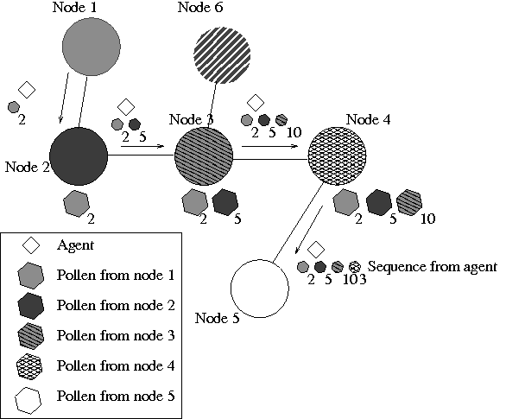Figure 1: Path of information flow via pollination

It is conceivable that, should information be leaked from the network (or even simply reach the network edge), its exact path back to the point of origin could be easily mapped via pollination (see Figure 1). This is because pollen is bidirectional: in addition to dropping off pollen, it can be picked up by a packet. Thus, for every packet we have a trace of its travels through the network. This trace would, at a minimum, provide the order of nodes visited. By combining a higher level algorithm, it would be possible to observe irregularities in the pollen pattern.

Current Work
There are three main goals of the project this year (01-SEP-2013 through 31-DEC-2014):
- Develop and analyze the optimal technical implementation for pollination.
- Design the multi-agent system (MAS) that will ultimately form the C2 system.
- Generate appropriate network traffic data for testing the pollination scheme on a testbed.

The efforts of the last two periods (01-JAN-14 through 01-JUL-14) have been concentrated on items (1) and (2) above.

Method #2: Cascading Signatures
Work has been done to create a proof-of-concept implementation of the Cascading Signatures method, whose protocol involves a list of visited hosts along with a cryptographic signature renewed at each hop in the transmission. in the networking domain-specific language Scapy, which is built on top of the high-level programming language Python. Scapy was designed to be able to sniff and forge packets from the data-link layer and up, and by default has much functionality that will aid in testing or observing a network or a network protocol.

