**Front-End UI/UX Mini Project**

**Project Title**: **"Responsive Portfolio Website for a Restaurant Menu Page”**

**Submitted By**:

Team Members- GouriLekshmi.S (2461010)

Ria Lalichen (2461024)

Sneha Jibi (2461027)

* + College-E-mailid: [gourilekshmi.s@btech.christuniversity.in](mailto:gourilekshmi.s@btech.christuniversity.in)

[ria.lalichen@btech.christuniversity.in](mailto:ria.lalichen@btech.christuniversity.in)

[sneha.jibi@btech.christuniversity.in](mailto:sneha.jibi@btech.christuniversity.in)

* **Course**: Front End *UI/UX Development*
* **Instructor Name**: *Mr. Dhiraj*
* **Institution**:  *Christ University*
* **Date of Submission**: *12/08/2025*

**Abstract**

This project involves designing and developing a visually engaging and responsive restaurant menu landing page. The primary goal is to present the restaurant’s offerings, ambiance, and contact information in an appealing and organized manner that draws customer interest. The page is built using HTML and CSS, with a focus on responsive design principles to ensure optimal viewing on desktops, tablets, and mobile devices. Key features include categorized menu sections, enticing food imagery, thematic color schemes, and smooth hover effects to enhance interactivity. Typography and layout choices reflect the restaurant’s branding, creating a cohesive and professional look. The final outcome is a functional and attractive web page that not only showcases the restaurant’s dishes but also improves user experience, encourages reservations, and strengthens the restaurant’s online presence.

**Objectives**

* Design a visually appealing and user-friendly interface following modern UI/UX principles.
* Develop a fully responsive restaurant menu page using only HTML and CSS.
* Implement structured HTML5 semantic elements for better readability and SEO.
* Apply CSS styling to establish consistent branding, attractive layouts, and smooth responsive behavior.
* Incorporate clear typography, color schemes, and imagery that reflect the restaurant’s theme.
* Ensure accessibility features for all users, including proper contrast, alt text for images, and readable font sizes.
* Optimize layout for seamless navigation across desktops, tablets, and mobile devices.

**Scope of the Project**

This project is limited to the **front-end design and development** of a restaurant menu landing page. It focuses solely on creating an engaging, responsive, and visually appealing interface without incorporating any JavaScript functionality or server-side integration. The design is optimized for desktop, tablet, and mobile viewports to ensure a seamless user experience across devices. Only pure HTML5 and CSS3 are used, adhering to semantic structure and responsive design principles. No external frameworks, libraries, or paid tools are implemented—only open-source tools and custom-written code are utilized. The scope includes layout design, branding through typography and color schemes, and the integration of high-quality imagery to effectively represent the restaurant’s offerings.

**Tools & Technologies Used**

|  |  |
| --- | --- |
| Tool/Technology | Purpose |
| HTML5 | Markup and content structure |
| CSS3 | Styling and layout management |
| VS Code | Code editor |
| Chrome DevTools | Testing and debugging |

**HTML Structure Overview**

* Used semantic HTML5 tags: <header>, <nav>, <main>, <section>, and <footer> for better structure, accessibility, and SEO.
* Structured into reusable sections such as **Home**, **About Us**, **Menu**, **Gallery**, and **Contact**.
* Implemented a navigation menu using <ul> and <li> elements with anchor links for smooth navigation between sections.
* Organized menu items within <section> tags, using headings, paragraphs, and images to clearly present each dish.
* Footer section includes contact details, social media links, and copyright information.

**CSS Styling Strategy**

* Used an external CSS file (**style.css**) for maintaining clean and modular code.
* Organized the stylesheet with clear comments and section divisions for easy maintenance.
* Applied **Flexbox** and **CSS Grid** for creating responsive and well-structured layouts.
* Used **media queries** to ensure the design adapts seamlessly to desktop, tablet, and mobile viewports.
* Implemented **CSS variables** to manage color schemes, typography, and spacing for easy theme customization.
* Added **hover effects** and **smooth transitions** to enhance interactivity and user engagement.
* Followed a **mobile-first design approach**, building the core layout for smaller screens and scaling up for larger devices.

**Key Features**

|  |
| --- |
|  |
| | **Feature** |  | **Description** | | --- | --- | --- | | Responsive Design |  | Adapts seamlessly to desktop, tablet, and mobile screen sizes using media queries. | | Smooth Navigation |  | Fixed top navigation bar with anchor links for quick access to different sections. | | Menu Sections |  | Categorized food and drink items displayed in a flex/grid layout with hover effects. | | Image Gallery |  | High-quality food and ambiance images presented in a responsive grid. | | Accessible Fonts & Colors |  | High-contrast color schemes and clear typography for improved readability and accessibility. | | Contact Information |  | Footer with location, phone number, email, and social media links. | |

**Challenges Faced & Solutions**

|  |  |
| --- | --- |
| Challenge | Solution |
| Overlapping elements on small screens | Used media queries to stack elements |
| Difficulty aligning items using float | Shifted to Flexbox and Grid |
| Typography scaling issue | Used relative units (em/rem) instead of px |

**Outcome**

* Achieved a clean, consistent, and visually engaging front-end layout that effectively showcases the restaurant’s menu and branding.
* All key components, including responsive navigation, menu sections, and imagery, function smoothly using only HTML and CSS.
* Gained in-depth understanding of responsive design techniques and UI hierarchy, enhancing skills in creating user-friendly interfaces across devices.

**Future Enhancements**

* Add JavaScript functionality to enhance interactivity, such as form validation and dynamic content updates.
* Integrate smooth animations and transitions to improve user engagement and visual appeal.
* Implement backend integration to enable features like contact form submission and reservation handling.
* Introduce a theme toggler to switch between light and dark modes, improving user customization and accessibility.

**SAMPLE CODE**

*<!DOCTYPE html>*

*<html lang="en">*

*<head>*

*<meta charset="UTF-8">*

*<meta name="viewport" content="width=device-width, initial-scale=1.0">*

*<title>Taste Haven - Menu</title>*

*<style>*

*/* RESET */*

*\* {*

*margin: 0;*

*padding: 0;*

*box-sizing: border-box;*

*}*

*/* BACKGROUND */*

*body {*

*font-family: 'Segoe UI', sans-serif;*

*background: url('https://images.unsplash.com/photo-1504674900247-0877df9cc836') no-repeat center center fixed;*

*background-size: cover;*

*color: #333;*

*}*

*body::before {*

*content: "";*

*position: fixed;*

*inset: 0;*

*background: rgba(255, 255, 255, 0.8);*

*z-index: -1;*

*}*

*/* HEADER */*

*header {*

*text-align: center;*

*padding: 2rem 1rem;*

*background: rgba(255, 112, 67, 0.9);*

*color: white;*

*box-shadow: 0 3px 8px rgba(0,0,0,0.2);*

*}*

*header h1 {*

*font-size: 2.5rem;*

*letter-spacing: 1px;*

*}*

*header p {*

*font-size: 1.1rem;*

*opacity: 0.9;*

*}*

*/* FILTERS */*

*.filters {*

*display: flex;*

*align-items: center;*

*gap: 1rem;*

*padding: 1rem;*

*background: rgba(255, 255, 255, 0.95);*

*position: sticky;*

*top: 0;*

*z-index: 100;*

*backdrop-filter: blur(6px);*

*flex-wrap: wrap;*

*}*

*.filters label {*

*background: #ffe0b2;*

*padding: 0.5rem 1rem;*

*border-radius: 20px;*

*cursor: pointer;*

*font-weight: 500;*

*transition: 0.3s;*

*}*

*.filters label:hover {*

*background: #ffb74d;*

*}*

*.filters input[type="radio"] {*

*display: none;*

*}*

*.price-slider {*

*margin-left: auto;*

*}*

*.price-slider input {*

*accent-color: #ff7043;*

*}*

*/* MENU GRID */*

*.menu-grid {*

*display: grid;*

*grid-template-columns: repeat(auto-fit, minmax(280px, 1fr));*

*gap: 2rem;*

*padding: 2rem;*

*}*

*/* DISH CARD */*

*.dish {*

*background: rgba(255, 255, 255, 0.9);*

*border-radius: 15px;*

*overflow: hidden;*

*position: relative;*

*box-shadow: 0 4px 10px rgba(0,0,0,0.15);*

*transition: 0.3s;*

*}*

*.dish:hover {*

*transform: translateY(-5px);*

*}*

*.dish img {*

*width: 100%;*

*height: 200px;*

*object-fit: cover;*

*}*

*.dish h2 {*

*padding: 0.8rem 1rem 0;*

*font-size: 1.2rem;*

*}*

*.ingredients {*

*padding: 0 1rem;*

*font-size: 0.9rem;*

*color: #666;*

*opacity: 0;*

*height: 0;*

*overflow: hidden;*

*transition: 0.4s;*

*}*

*.dish:hover .ingredients {*

*opacity: 1;*

*height: auto;*

*margin-bottom: 0.5rem;*

*}*

*.price {*

*display: block;*

*padding: 0.5rem 1rem 1rem;*

*font-weight: bold;*

*color: #ff7043;*

*}*

*/* CHEF'S SPECIAL BADGE */*

*.special::before {*

*content: "Chef's Special";*

*position: absolute;*

*top: 10px;*

*right: -40px;*

*background: #ff7043;*

*color: white;*

*padding: 5px 50px;*

*transform: rotate(45deg);*

*font-size: 0.8rem;*

*font-weight: bold;*

*animation: spinBadge 6s linear infinite;*

*}*

*@keyframes spinBadge {*

*0% { transform: rotate(45deg) scale(1); }*

*50% { transform: rotate(45deg) scale(1.05); }*

*100% { transform: rotate(45deg) scale(1); }*

*}*

*/* FIXED ORDER BUTTON */*

*.order-btn {*

*position: fixed;*

*bottom: 20px;*

*right: 20px;*

*background: #ff7043;*

*color: white;*

*padding: 1rem 1.5rem;*

*border: none;*

*border-radius: 50px;*

*font-size: 1.2rem;*

*cursor: pointer;*

*box-shadow: 0 4px 12px rgba(0,0,0,0.2);*

*transition: 0.3s;*

*}*

*.order-btn:hover {*

*background: #f4511e;*

*}*

*.cart-counter {*

*background: white;*

*color: #ff7043;*

*border-radius: 50%;*

*padding: 0.3rem 0.6rem;*

*margin-left: 8px;*

*font-size: 0.9rem;*

*display: inline-block;*

*}*

*/* FILTER FUNCTIONALITY (CSS-ONLY) */*

*input[value="vegan"]:checked ~ main .dish:not(.vegan) { display: none; }*

*input[value="gf"]:checked ~ main .dish:not(.gf) { display: none; }*

*input[value="all"]:checked ~ main .dish { display: block; }*

*/* SECTION DIVIDER */*

*.divider {*

*text-align: center;*

*font-size: 2rem;*

*color: #ff7043;*

*margin: 1rem 0;*

*}*

*</style>*

*</head>*

*<body>*

*<header>*

*<h1>Taste Haven</h1>*

*<p>Fresh • Flavorful • Memorable</p>*

*</header>*

*<!-- FILTERS -->*

*<section class="filters">*

*<label>*

*<input type="radio" name="diet" value="all" checked>*

*All*

*</label>*

*<label>*

*<input type="radio" name="diet" value="vegan">*

*Vegan*

*</label>*

*<label>*

*<input type="radio" name="diet" value="gf">*

*Gluten-Free*

*</label>*

*<div class="price-slider">*

*<label>Price Range</label>*

*<input type="range" min="5" max="50">*

*</div>*

*</section>*

*<!-- MENU GRID -->*

*<main class="menu-grid">*

*<article class="dish vegan special">*

*<img src="https://images.unsplash.com/photo-1546069901-ba9599a7e63c" alt="Fresh Green Salad">*

*<h2>Green Garden Salad</h2>*

*<p class="ingredients">Lettuce, cucumber, avocado, lemon dressing</p>*

*<span class="price">$12</span>*

*</article>*

*<article class="dish gf">*

*<img src="https://images.unsplash.com/photo-1551183053-bf91a1d81141" alt="Juicy Steak">*

*<h2>Grilled Ribeye</h2>*

*<p class="ingredients">Beef, garlic butter, herbs</p>*

*<span class="price">$28</span>*

*</article>*

*<article class="dish vegan">*

*<img src="https://images.unsplash.com/photo-1604908177070-dc1e940d1eaf" alt="Vegan Pasta">*

*<h2>Vegan Pesto Pasta</h2>*

*<p class="ingredients">Zucchini noodles, basil pesto, cherry tomatoes</p>*

*<span class="price">$15</span>*

*</article>*

*<article class="dish gf special">*

*<img src="https://images.unsplash.com/photo-1600891964599-f61ba0e24092" alt="Chocolate Dessert">*

*<h2>Chocolate Lava Cake</h2>*

*<p class="ingredients">Dark chocolate, vanilla ice cream</p>*

*<span class="price">$10</span>*

*</article>*

*</main>*

*<!-- FIXED ORDER BUTTON -->*

*<button class="order-btn">Order Now <span class="cart-counter">3</span></button>*

*</body>*

*</html>*

**Screenshots of Final Output**

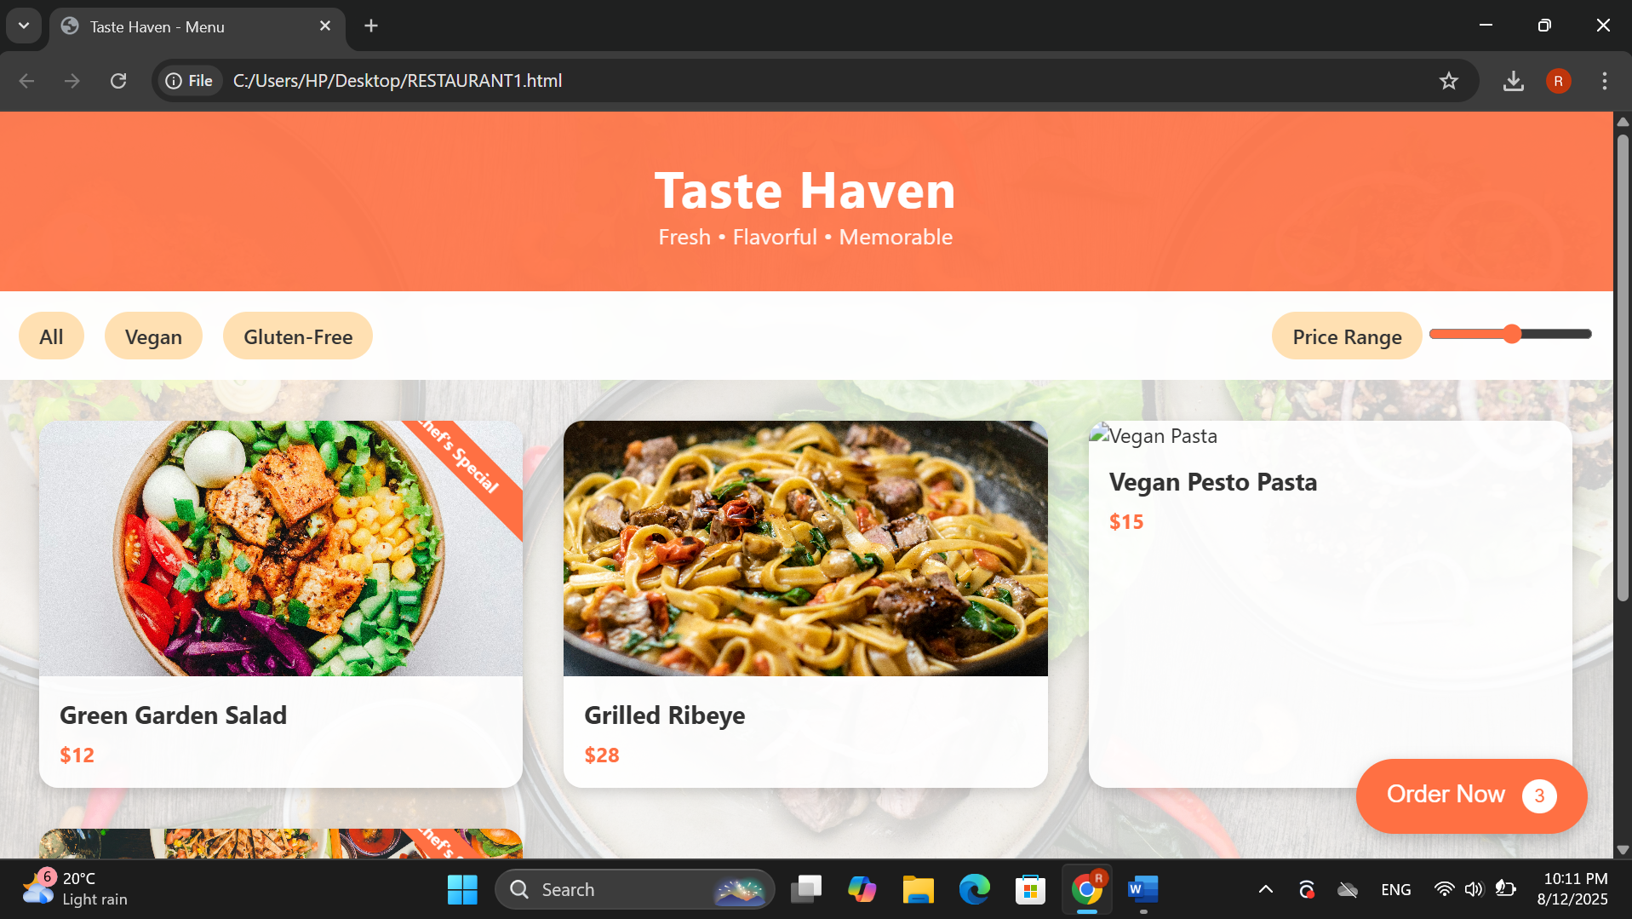

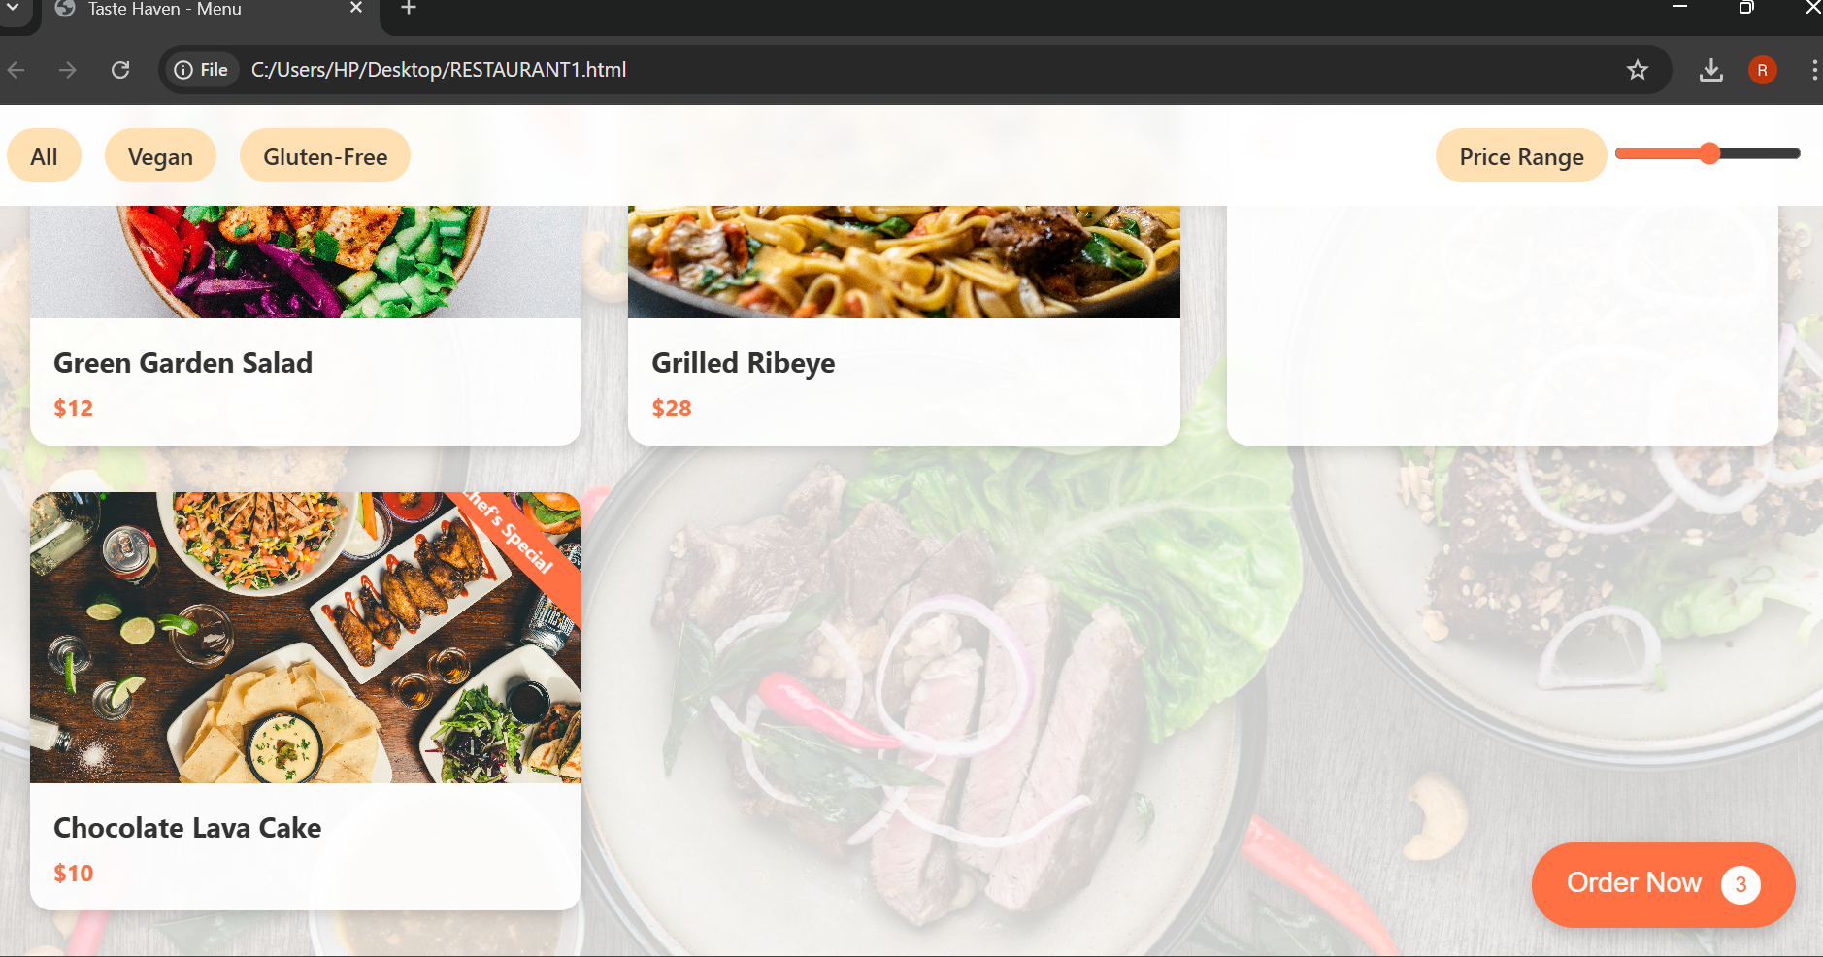

**Conclusion**

This project successfully demonstrates the design and development of a responsive, visually appealing restaurant menu page using only HTML and CSS. By focusing on semantic structure, modern layout techniques, and accessibility, the page provides an engaging user experience across devices. The project strengthened foundational web development skills, particularly in responsive design and UI hierarchy, while delivering a practical and professional front-end solution for showcasing restaurant offerings. Future enhancements involving interactivity and backend integration can further elevate the website’s functionality and user engagement.

**References**

* L&T LMS : <https://learn.lntedutech.com/Landing/MyCourse>
* ChatGPT