COMPANY PROFILE

Company Name : EZ trainings and Technologies Pvt.Ltd

**Introduction:**

EZ Trainings and Technologies Pvt. Ltd. is a dynamic and innovative organization dedicated to providing comprehensive training solutions and expert development services. Established with a vision to bridge the gap between academic learning and industry requirements, we specialize in college trainings for students, focusing on preparing them for successful placements. Additionally, we excel in undertaking development projects, leveraging cutting-edge technologies to bring ideas to life.

**Mission:**

Our mission is to empower the next generation of professionals by imparting relevant skills and knowledge through specialized training programs. We strive to be a catalyst in the career growth of students and contribute to the technological advancement of businesses through our development projects.

**Services:**

**College Trainings:**

• Tailored training programs designed to enhance the employability of students.

• Industry-aligned curriculum covering technical and soft skills.

• Placement assistance and career guidance.

**Development Projects:**

• End-to-end development services, from ideation to execution.

• Expertise in diverse technologies and frameworks.

• Custom solutions to meet specific business needs.

**Locations:** Hyderabad | Delhi NCR

At EZ Trainings and Technologies Pvt. Ltd., we believe in transforming potential into excellence

ABSTRACT

1. User-Friendly Interface: The tool offers a simple interface through which broadcasters can easily manage their broadcasting schedules.

2. Event Creation: Users can effortlessly create new events by providing details like time, date, location, team, and team leader.

3. Real-Time Updates: Changes made to event details are instantly reflected, allowing for timely adjustments.

4. Comprehensive Management: The tool enables users to create, update, and delete events seamlessly, all from a sidebar menu.

5. Detailed Event Viewing: Users can view detailed information about scheduled events, including time, location, team, and team leader.

6. Feedback Mechanism: A built-in feedback system allows users to share their thoughts or report issues directly within the tool.

7. Data Persistence: Event data is securely stored and retrieved using JSON files, ensuring continuity in event management across sessions.

INTRODUCTION OF THE PROJECT

* Scheduling is vital in sports broadcasting for audience engagement, revenue generation, and operational efficiency.
* Managing schedules involves complexities like event timings, venue availability, team schedules, viewer demographics, and advertising commitments.
* Technology advancements have led to sophisticated tools that automate, optimize, and customize scheduling decisions.
* Effective scheduling captures audience attention, boosts viewership, and increases audience satisfaction.
* It also maximizes advertising revenues by strategically placing events and optimizing ad placements.
* Streamlining scheduling processes improves operational efficiency for broadcasters.
* Modern scheduling tools use AI, machine learning, and data analytics for insights and optimization.
* These tools encompass features like event management, real-time updates, analytics, advertising integration, and feedback mechanisms.
* They benefit broadcasters, advertisers, sports leagues, and audiences by enhancing coordination, revenues, and viewer experience.
* Sports broadcasting scheduling tools are essential assets shaping the future of sports media for captivating content delivery and maximizing stakeholder value.

MODULE DESCRIPTION

1. **SportsBroadcastSchedulingTool Class**:
   * **Initialization**: Upon instantiation, the class loads event data from a JSON file and initializes an empty dictionary for storing event information.
   * **Event Management Functions**:
     + **create_event()**: Presents a sidebar interface for users to input event details (time, date, location, team, team leader) and saves the event data.
     + **update_event()**: Allows users to select a date, retrieve existing event details, update them as needed, and save the changes.
     + **delete_event()**: Enables users to select a date and delete the corresponding event data.
     + **show_event_details()**: Displays event details (time, location, team, team leader) for a selected date.
   * **Feedback Function**:
     + **feedback()**: Provides a text area for users to submit feedback or report issues, with a button to submit the feedback.
2. **Main Function (main())**:
   * Initializes the Streamlit application and creates an instance of the SportsBroadcastSchedulingTool class.
   * Presents a sidebar menu with options to create, update, delete, or view event details, as well as submit feedback.
   * Calls corresponding methods based on the user's selection to perform the desired actions.
3. **Data Management**:
   * **load_event_data()**: Loads event data from a JSON file when the class is instantiated.
   * **save_event_data()**: Saves event data to a JSON file after any modifications are made.
4. **User Interface**:
   * Utilizes Streamlit to create a user-friendly interface with a sidebar menu for easy navigation.
   * Provides input fields and buttons for users to interact with and perform various scheduling tasks.
5. **Feedback Handling**:
   * Allows users to submit feedback directly within the application, promoting user engagement and continuous improvement.
6. **Error Handling**:
   * Provides warnings or success messages to users based on the outcome of their actions (e.g., event creation, deletion, feedback submission).
7. **Scalability**:
   * Designed to accommodate potential future enhancements or additional features to meet evolving user needs or industry requirements.

ALGORITHM:

**1.Import Libraries:** The code starts by importing necessary libraries, such as streamlit and json.

**2.Define the Class SportsBroadcastSchedulingTool:**

* This class contains methods for managing event data, such as loading, saving, adding, updating, and deleting events.
* It also has methods for displaying event details and handling feedback.

**3.Define the main Function:**

* This function is the entry point of the Streamlit application.
* It creates an instance of the SportsBroadcastSchedulingTool class and defines the layout of the web app.

**4.User Interface:**

* The user interface is built using Streamlit widgets such as st.title, st.date_input, st.image, st.columns, st.selectbox, st.subheader, st.text_input, st.button, and st.text_area.
* Users can select a date, add events, update events, delete events, show event details, and provide feedback.

**5.Menu Actions:**

* Based on the selected menu option, appropriate actions are taken:
* Add Event: Allows users +to add a new event for the selected date.
* Update Event: Enables users to update an existing event for the selected date.
* Delete Event: Lets users delete an event for the selected date.
* Show Event Details: Displays details of events scheduled for the selected date.
* Feedback: Allows users to submit feedback or report issues.

**6.Execution:**

The main function is executed if the script is run as the main program.

OUTPUT

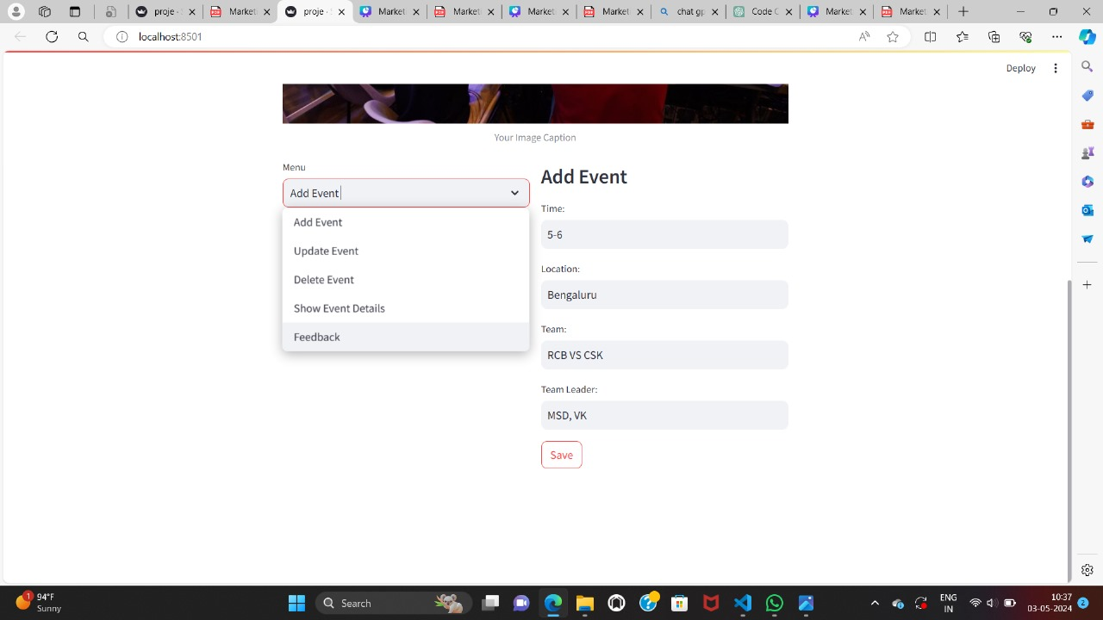

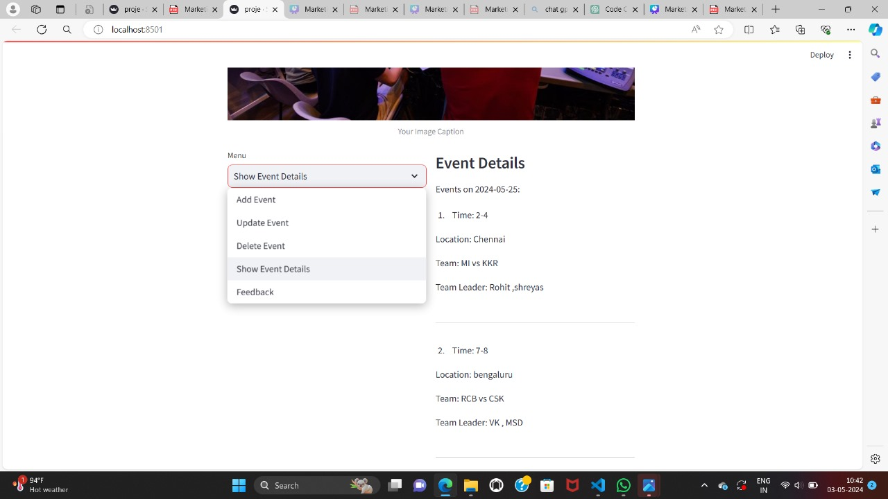

CONCLUSION

The Sports Broadcasting Scheduling Tool provides a streamlined solution for managing sports event schedules. Its intuitive interface allows users to effortlessly add, update, and delete events, while also providing easy access to event details for specific dates. With reliable data management and effective error handling, it offers a user-friendly experience. Potential enhancements, such as implementing additional validation measures and refining feedback mechanisms, could further enhance its functionality. Overall, it's a valuable tool for efficiently organizing sports broadcasts.

**REFERENCES:**

• https://chat.openai.com/c/fd7b734f-d486-4848-9fe2-1e3b8045facc

• google,class notebook