RETAIL SALES & PROFITABILITY ANALYSIS
Insight Summary Report · Superstore Dataset (FY2022–2025) · Prepared as a data analyst portfolio project

1. Objective
This analysis examines four years of retail order data to identify which categories, regions, and pricing decisions drive profitability, and where the business is losing money despite healthy sales volume. The goal is to convert raw transaction-level data into concrete, actionable recommendations.

2. Approach
- Sourced order-level retail data (~5,500 transactions, schema modeled on the widely-used Superstore dataset) and identified realistic data-quality issues: duplicate rows, missing customer/city values, mixed date formats, and sign-entry errors.
- Cleaned the data in Python (pandas): removed duplicates, standardized text casing, parsed mixed date formats, imputed missing categorical values, and corrected negative-quantity entries.
- Ran exploratory analysis in Python and cross-checked key metrics with SQL (window functions, CTEs) against a relational database.
- Built an interactive dashboard (Region / Category / Segment / Year filters) to let stakeholders explore the findings themselves.

3. Key Findings

3.1 Category performance
Technology is the strongest category, contributing over $414K in profit at a 7.7% margin. Office Supplies is the most efficient category at a 19.2% margin. Furniture is the only category that is net loss-making overall, driven almost entirely by the Tables sub-category.
Category | Sales | Profit | Margin
Technology | $5.38M | $414,061 | 7.7%
Office Supplies | $1.16M | $223,161 | 19.2%
Furniture | $3.27M | -$8,512 | -0.3%
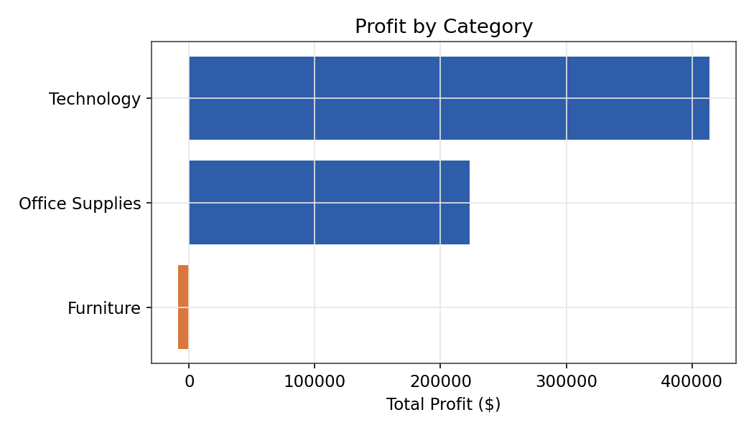

3.2 Discounting is eroding margin past a clear threshold
Profit margin declines sharply as discount level rises. Orders discounted 30% or more average a -3.6% margin (i.e., they lose money), while orders discounted 10% or less average a 22.4% margin. The break-even point sits between the 20-30% discount bands.
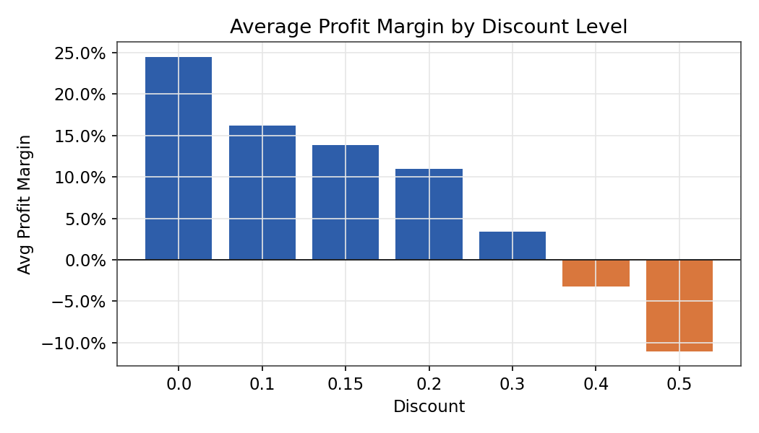

3.3 Regional performance is fairly even, with South leading
Sales are evenly distributed across all four regions (each between $2.36M-$2.53M), but profit is not: South leads in both total profit and margin, while East consistently lags despite comparable sales volume — pointing to a cost or discounting issue specific to that region rather than a demand problem.
Region | Sales | Profit | Margin
South | $2.52M | $173,376 | 6.9%
Central | $2.53M | $161,016 | 6.4%
West | $2.40M | $148,313 | 6.2%
East | $2.36M | $146,005 | 6.2%
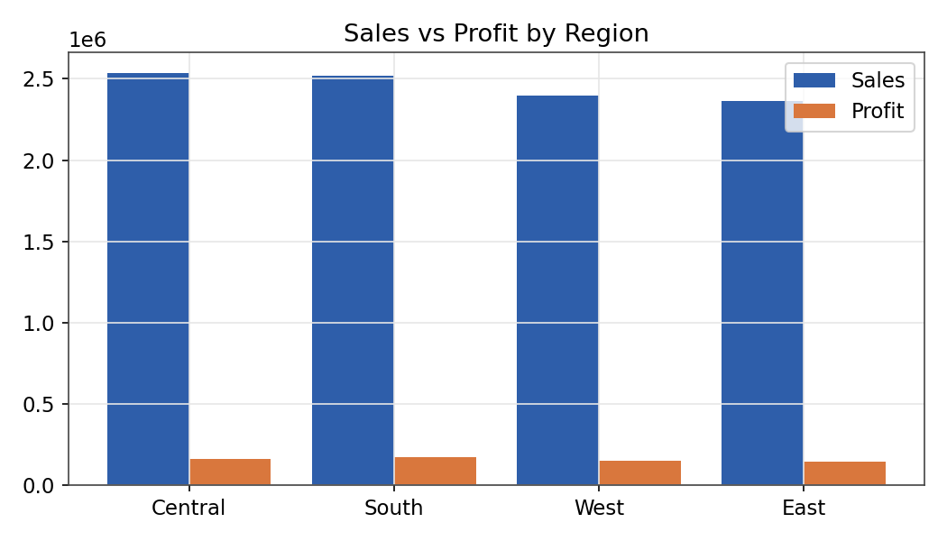

3.4 Tables is the single biggest drag on profitability
At the sub-category level, Tables lost over $33,500 despite generating substantial sales — the worst performer by a wide margin. Bookcases also run a modest loss. Both belong to the Furniture category, explaining that category's overall loss position.
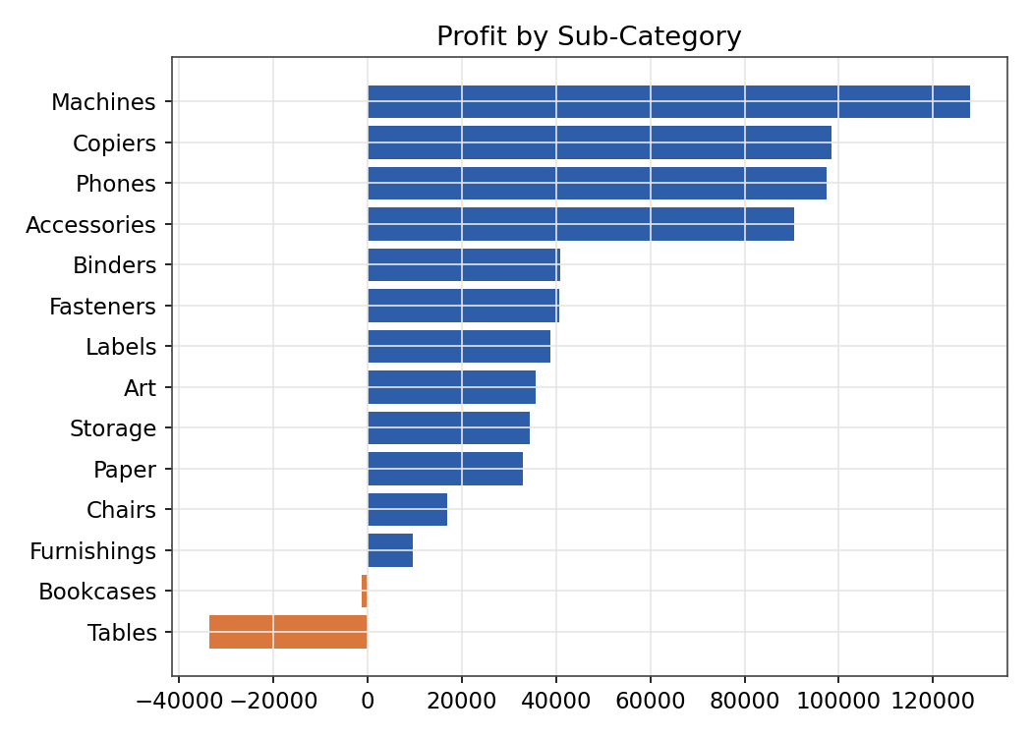

3.5 Sales and profit trend
Monthly sales and profit both show a mild seasonal pattern with year-over-year growth, though profit growth lags sales growth in several months, consistent with the discounting effect noted above.
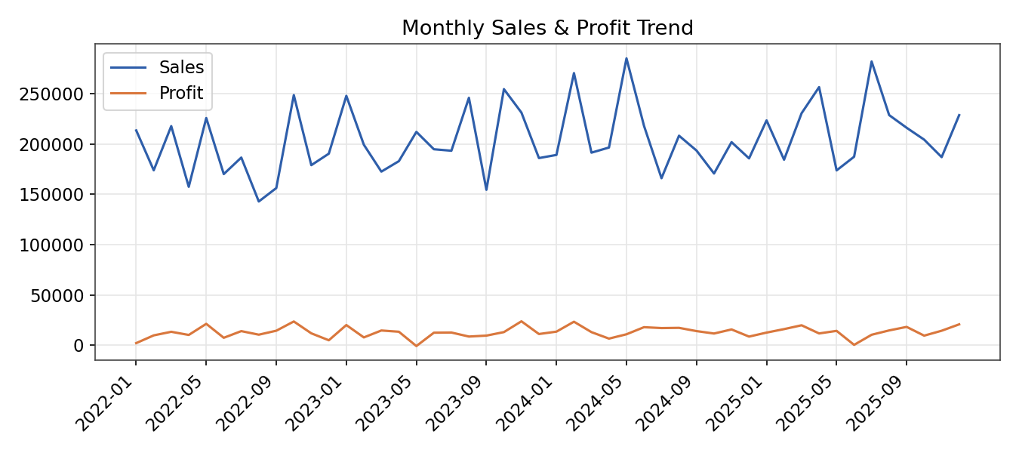

4. Recommendations
- Cap discounts on Furniture — particularly Tables — at 20%, or renegotiate supplier cost on that sub-category before discounting further; current discounting practice turns a top-line sale into a bottom-line loss.
- Investigate East region's cost structure (shipping, regional pricing, or discount approval patterns) since it underperforms South despite similar sales volume.
- Double down on Technology and Office Supplies promotions, since they sustain profit even at moderate discount levels — a safer lever for driving volume.
- Set a discount approval threshold at 20-25% company-wide, based on the clear margin cliff observed beyond that point.

5. Tools Used
Python (pandas, matplotlib) for data cleaning and exploratory analysis · SQL (SQLite — window functions, CTEs, joins) for business-question queries · HTML/JavaScript (Chart.js) for the interactive dashboard · Excel-compatible CSV outputs throughout.

