# TERMINAL COMMANDS

* *Installation of wsl in windows*

First get to the windows store and install ubuntu18.0 LTS

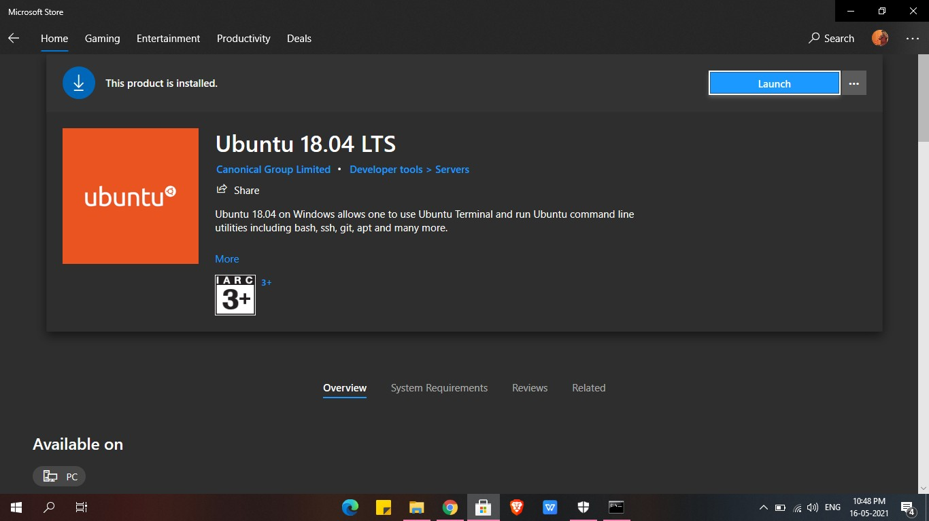

After installing it make sure u enable the wsl from turn on and off

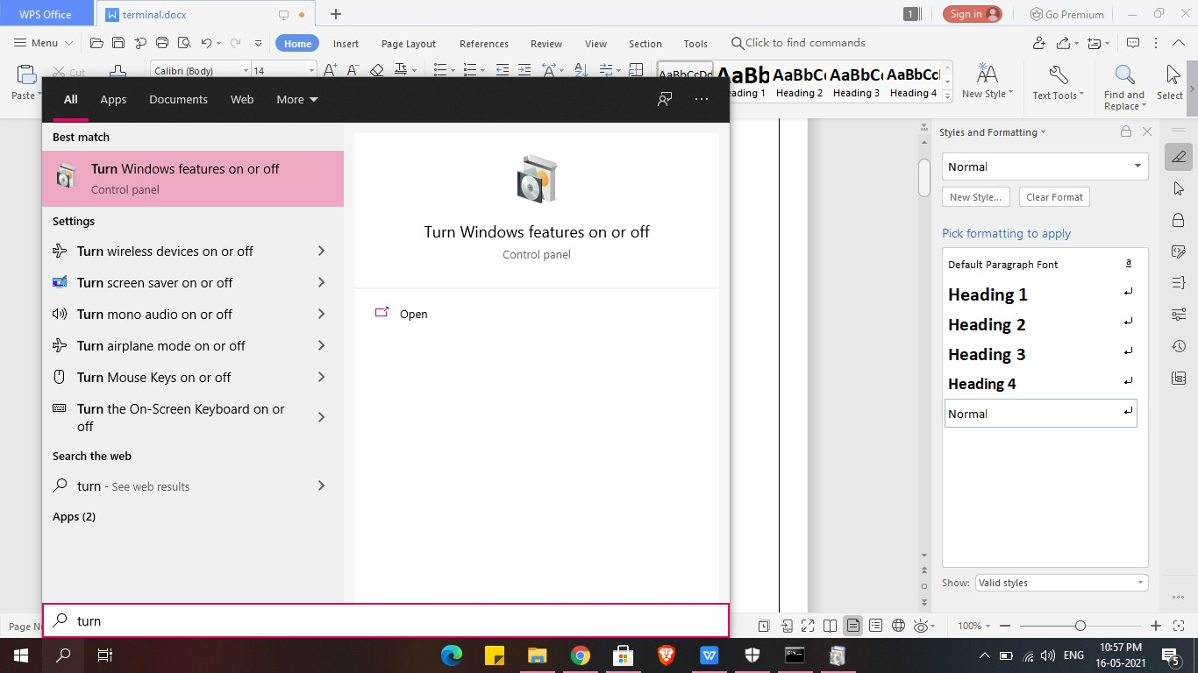

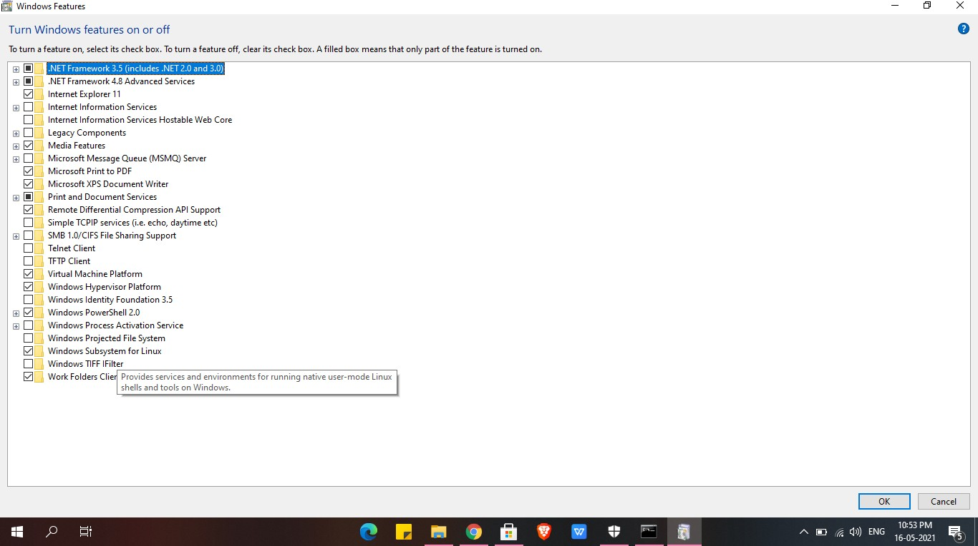Enabling windows subsystem for linux

Now u can search ubuntu 18.0 LTS and use it.

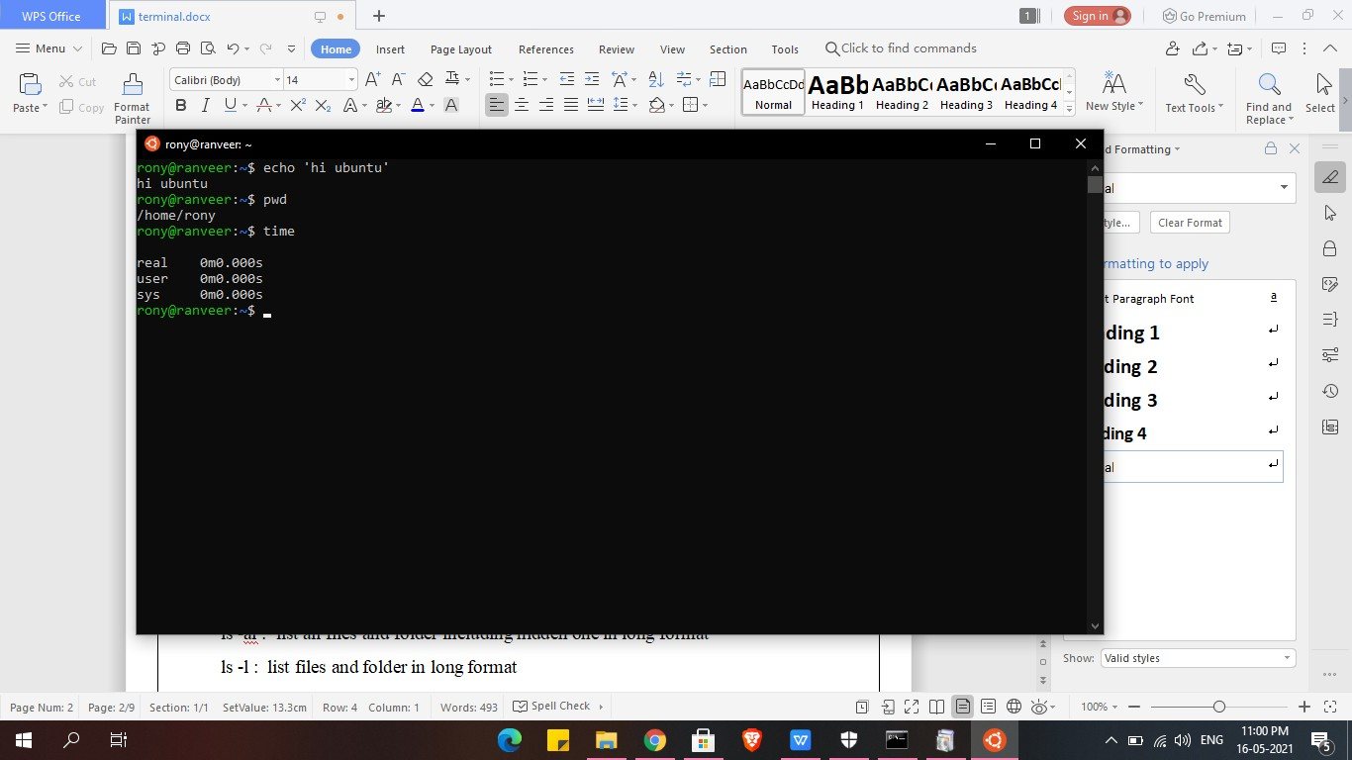

*Terminal Commands:*

* pwd

show present working directory

* ls

show content of the respective directory

* ls ~: gives/jump all file present in system or all home directory
* ls .. : give content or file present in parent directory
* ls . : List files and folder in current directory
* ls ~ : show u all content in home directory
* ls -a : list all files and folder including hidden one
* ls -al : list all files and folder including hidden one in long format
* ls -l : list files and folder in long format
* ls -p :give all files in current directory
* ls -p | grep pdf : gives if any pdf file is present (you can write whatever type of file in place of pdf like txt n all)

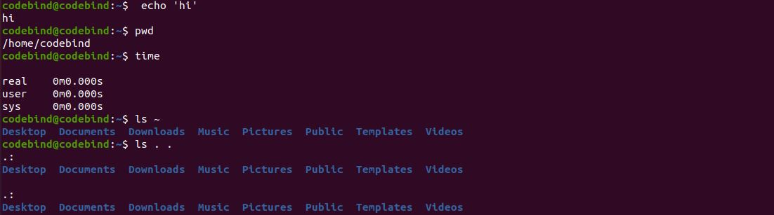

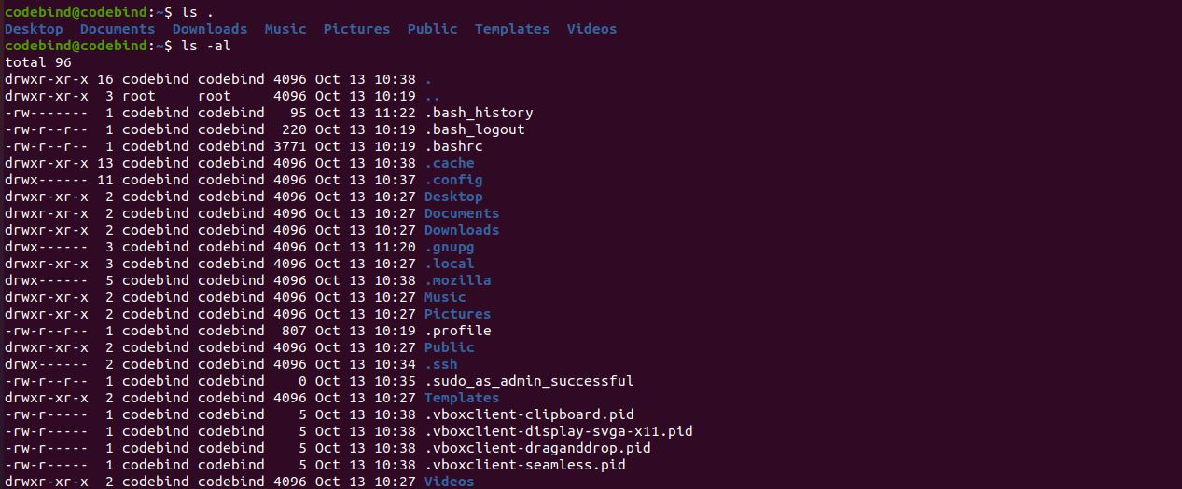

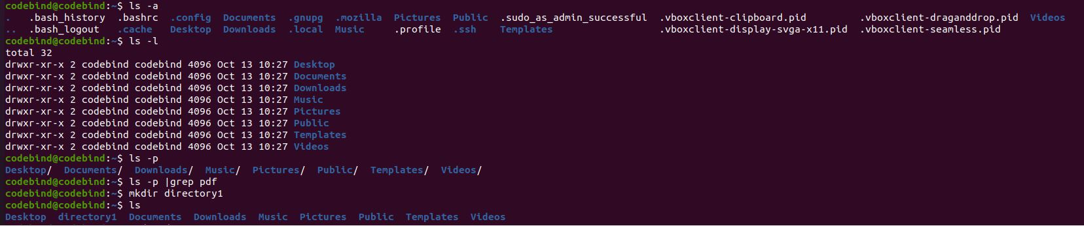

* mkdir
* mkdir directory_name : create directory
* rmdir dire_name : removes that particular directory
* mkdir -p directory_name1/directory_name2 : create nested directory
* cd
* cd directory_name/ : take u to that directory
* cd .. : take u to one directory before
* cd - : take u to previous working directory

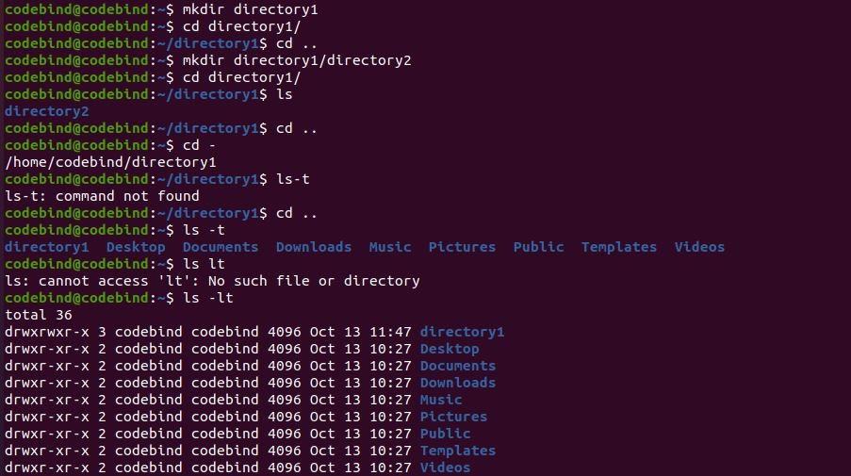

* touch
* touch file_name : create empty file
* cd /etc/ :take u to home directory directly
* ls -t : gives highlight on last modified directory
* ls -lt :give complete details about recent modified file plus other file present
* touch file_name : create file name of file_name
* rm
* rm -r file_name : deletes that perticular file_name
* rm -i file_name : ask user permission before deletion
* rm -I file_name : doesn’t ask user before deletion
* grep
* The grep filter searches a file for a particular pattern of characters, and displays all lines that contain that pattern. SYNTAX: grep [options] ‘patterns’ [files]
* Chmod
* In Unix-like operating systems, the chmod command is used to change the access mode of a file.The name is an abbreviation of change mode.
* SYNTAX: chmod [reference][operator][mode] file...

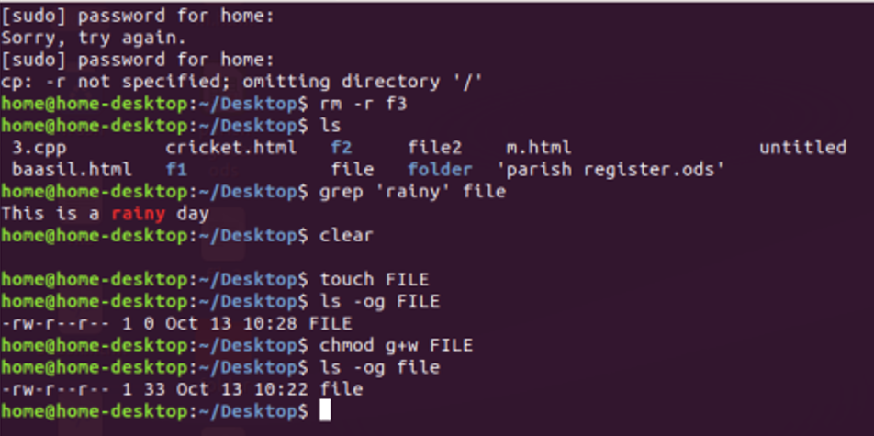

* Chown
* This command is used to change the file Owner or group. Whenever you want to change ownership you can use chown command.
* SYNTAX chown owner_name file_name
* Head and Tail
* As their names imply, the head command will output the first part of the file (10 lines), while the tail command will print the last part of the file (10 lines). Both commands write the result to standard output.
* SYNTAX OF HEAD: head [options] files
* SYNTAX OF TAIL: tail[options] files

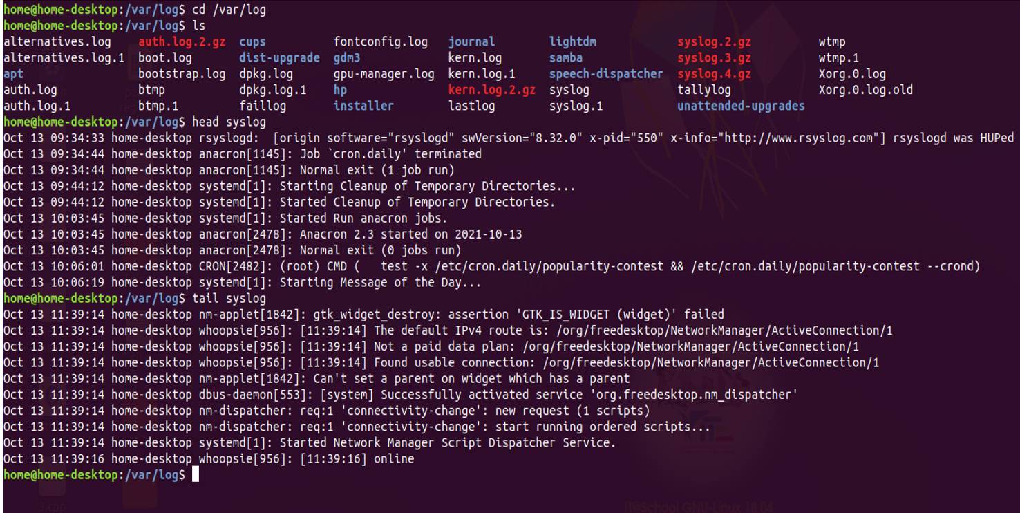

* Sudo
* The sudo command allows you to run programs with the security privileges of another user (by default, as the superuser). It prompts you for your personal password and confirms your request to execute a command by checking a file which the system administrator configures.

