SAINTGITS COLLEGE OF ENGINEERING, KOTTAYAM (AUTONOMOUS)
Kottukulam Hills, Pathamuttom, Kottayam

REPORT
on
INDUSTRIAL READINESS TRAINING
(20IMCAN402)

Aamina Shareef – MGP21NMC001
Abel Babu Paul - MGP21NMC002
Abel Eapen Jacob - MGP21NMC003
2024-2025
TABLE OF CONTENTS

Sl No | Content | Page No
1 | Project Abstract - Virtual Personal Assistant | 1
2 | Tabulated list of activities for Virtual Personal Assistant
3 | Formal project plan / schedule (GANTT chart).
4 | PERT diagram and activities in the critical path.
5 | Use case diagram.
6 | Conclusion

Virtual Personal Assistant

This project aims to develop a versatile virtual personal assistant for desktop and mobile devices, enabling users to manage tasks, access information, and interact with their devices through voice and text commands, mirroring the functionality of popular assistants like Siri and Alexa.

Core Functionality:
- Voice and Text Input:
- The assistant will be capable of understanding and responding to both voice and text-based commands, providing flexibility for different user preferences and environments.
- Task Management:
- Users will be able to set reminders, create to-do lists, schedule appointments, and manage their calendars.
- Information Retrieval:
- The assistant will be able to search for information on the web, provide weather updates, define words, and access other relevant data.
- Media Control:
- Users will be able to play music, control media playback, and access other media-related functions.
- Device Control:
- The assistant will be able to open applications, control volume, and perform other device-specific actions.
- Communication:
- Users will be able to send emails, text messages, and make calls through the assistant.
- Personalized Experience:
- The assistant will learn user preferences and tailor its responses accordingly, offering a more personalized and efficient experience.

Technology Stack:
- Natural Language Processing (NLP):
- The assistant will utilize NLP techniques to understand user commands and requests.
- Speech Recognition:
- The assistant will use speech recognition technology to convert spoken commands into text.
- Machine Learning:
- The assistant will employ machine learning algorithms to learn user preferences and improve its performance over time.
- Cloud Services:
- The assistant will leverage cloud services for storage, processing, and communication.

Target Audience:
- The assistant is designed for a wide range of users, including students, professionals, and individuals seeking to improve their productivity and efficiency.

- It will be particularly useful for users who are busy or have limited mobility, allowing them to manage their tasks and access information hands-free.
Expected Outcomes:
- Improved user productivity and efficiency.
- Enhanced accessibility for users with limited mobility.
- A more personalized and seamless user experience.
- A valuable tool for managing daily tasks and accessing information quickly and easily.

Project Plan For The Virtual Personal Assistant

Major Task | Activity | Description | Steps Involved Estimated Time
Project Planning and Requirement Analysis | Define Project Scope | Outline the goals, features, and limitations of the assistant. | Identify core features  Define user scenarios  Set project boundaries  1 week
Project Planning and Requirement Analysis | Requirement Gathering | Identify user needs and system requirements. | Conduct surveys  Interview stakeholders  Analyze market trends 2 weeks
Project Planning and Requirement Analysis | Feasibility Study | Assess technical and financial feasibility. | Evaluate technology stack  Estimate costs  Identify risks 1 week
Project Planning and Requirement Analysis | Project Plan Creation | Develop a detailed project timeline and resource allocation. | Create Gantt chart  Assign team roles  Allocate resources 1 week
Design | System Architecture Design | Design overall system architecture and data flow. | Create data flow diagrams  Design system components  Define API specifications 2 weeks
Design | User Interface (UI) Design | Design user interaction flow and UI elements. | Create wireframes  Design mockups  Conduct usability tests 2 weeks
Design | Database Design | Design database schema for storing user data and interactions. | Define entities and relationships  Normalize database  Create ER diagrams 1 week
Development | Backend Development | Develop server-side logic, APIs, and database integration. | Implement APIs  Set up server environment  Develop database queries 6 weeks
Development | Frontend Development | Develop client-side interface and user experience. | Implement UI components  Integrate APIs  Optimize for different devices 4 weeks
Development | Natural Language Processing (NLP) | Implement NLP  models for understanding user queries. | Preprocess text data  Train NLP models  Implement intent recognition 8 weeks

 | Voice Recognition and Synthesis | Integrate voice input/output capabilities. | Implement speech-to-text  Integrate text-to-speech  Optimize for different accents 6 weeks
 | Machine Learning | Train models for | - Collect training data
 | Model Training | personalized assistant responses. | Train machine learning models  Validate model accuracy 8 weeks
Integration and Testing | System Integration | Integrate all system components. | Integrate frontend with backend  Connect external APIs  Ensure smooth data flow 2 weeks
Integration and Testing | Unit Testing | Test individual components for functionality. | Write test cases  Execute tests  Fix identified bugs 2 weeks
Integration and Testing | Integration Testing | Test interactions between integrated components. | Develop integration test cases  Conduct end-to-end testing  Resolve integration issues 2 weeks
Integration and Testing | User Testing | Conduct testing with real users to gather feedback. | Recruit test users  Collect feedback  Make necessary adjustments 3 weeks
Deployment and Maintenance | Deployment | Deploy the system to production environment. | Set up production servers  Deploy codebase  Conduct final testing in production environment  1 week
Deployment and Maintenance | Post-Deployment Monitoring | Monitor system performance and user feedback. | Implement monitoring tools  Track performance metrics  Respond to user feedback Ongoing
Deployment and Maintenance | Maintenance and Updates | Provide regular updates and maintenance. | Schedule regular updates  Fix bugs and issues  Enhance features based on feedback Ongoing
 | User Documentation | Prepare user manuals and guides. | Write user guides  Create FAQs  Develop tutorials 2 weeks

Documentation and Training | Technical Documentation | Document system design, APIs, and codebase. | Write API documentation - Create system architecture  document  Document codebase
 |  |  | 3 weeks
 | Training | Train support and | - Prepare training materials
 |  | maintenance teams. | - Conduct training sessions
 |  |  | - Provide ongoing support
 |  |  | 2 weeks

Project Timeline and Key Phases
The project spans approximately four months, beginning in mid-December and concluding in mid-April. Each phase is sequential, ensuring smooth workflow progression.
- Define Project Scope (Mid-December – Late January)
  - The initial phase establishes the project’s objectives, deliverables, and constraints.
  - It sets the foundation for resource allocation and scheduling.
- Define Project Schedule (Late January – Early February)
  - This step involves creating a structured timeline for tasks, dependencies, and resource assignments.
- Resource Allocation (Early February – Mid-February)
  - Identifying and distributing human, technical, and financial resources.
  - Ensures the right personnel and tools are assigned to each task.
- Risk Management Planning (Mid-February – Late February)
  - This phase anticipates potential risks and develops mitigation strategies.
  - Risk assessment safeguards the project's timeline and budget.
- Communication Plan (Late February – Early March)
  - Outlines how stakeholders will be informed and updated throughout the project.
  - Ensures transparency and collaboration.
- Development and Testing (Early March – Late March)
  - Core development of the personal assistant, including coding, integration, and initial testing.
  - This phase is crucial for functionality verification.
- Deployment and Training (Late March – Early April)
  - Deployment of the system and user training.
  - Ensures end-users can effectively operate the personal assistant.
- Project Approval (Early April – Mid-April)
  - Final review and approval of the project.

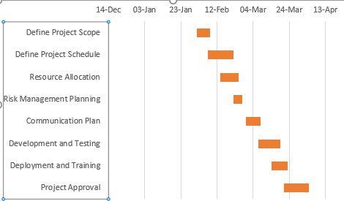

PERT Diagram for Virtual Personal Assistant Project

Project Phases:

- Project Initialization:
  - Define project scope and objectives.
  - Select the technology stack.
  - Gather user requirements and analyze feasibility.
- System Design:
  - Design system architecture and workflow.
  - Define core functionalities and data flow.
  - Plan integrations for voice/text processing, machine learning, and cloud services.
- Development Phase:
  - Implement Natural Language Processing (NLP) and Speech Recognition.
  - Develop modules for Task Management, Information Retrieval, and Media Control.
  - Implement Communication and Device Control functionalities.
  - Integrate machine learning for personalized experiences.
- Testing & Debugging:
  - Conduct functional and performance testing.
  - Perform user testing and collect feedback.
  - Optimize system for better accuracy and efficiency.
- Deployment & Maintenance:
  - Deploy the assistant on desktop and mobile platforms.
  - Monitor performance and fix issues.
  - Provide continuous updates and feature enhancements.

Task Dependencies:

- The System Design phase begins after Project Initialization is completed.
- The Development Phase starts once the System Design is finalized.
- Testing & Debugging follows after the Development Phase to ensure functionality.
- The final step, Deployment & Maintenance, begins after successful testing and debugging.

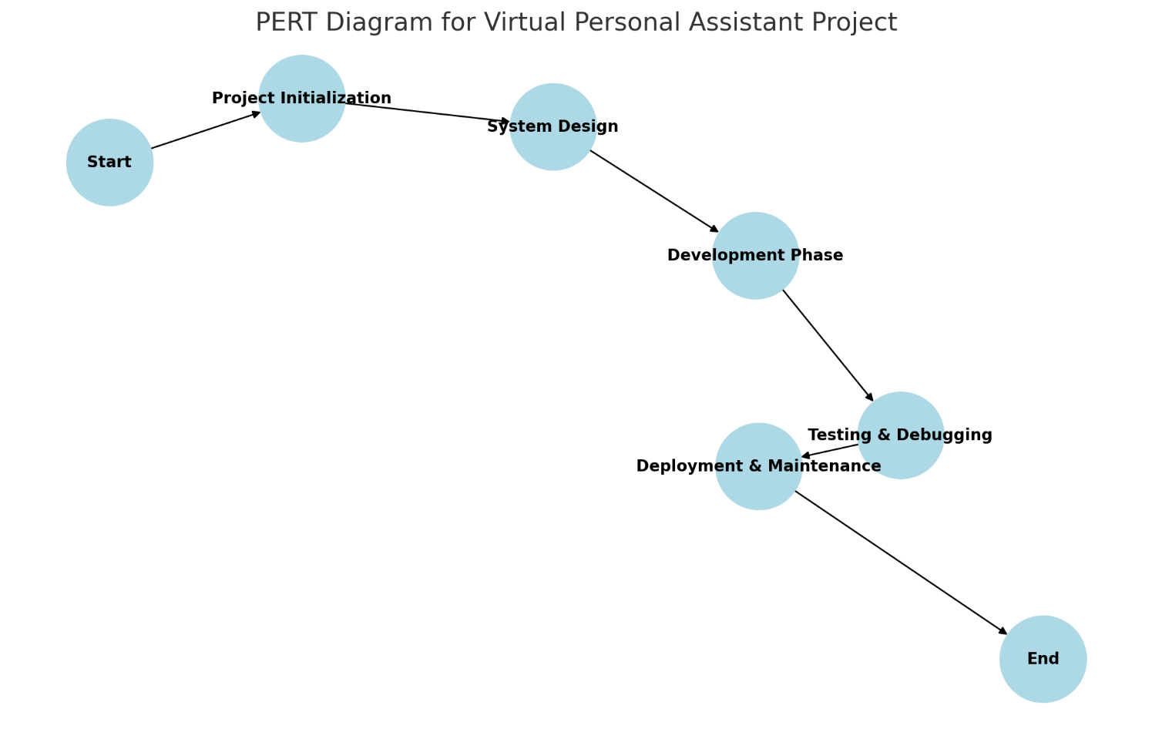

Use Case Diagram for Virtual Personal Assistant

Actors:
- User: The main actor who interacts with the virtual assistant using voice or text commands.
Use Cases:
- Voice/Text Input: The user can provide commands using speech recognition or text input.
- Task Management: The assistant helps the user set reminders, create to-do lists, and schedule appointments.
- Information Retrieval: The assistant fetches information from the web, provides weather updates, and defines words.
- Media Control: The user can play music, pause, resume, or stop media content through voice or text commands.
- Device Control: The assistant can execute commands such as opening applications, adjusting volume, or controlling system settings.
- Communication: The user can send emails, text messages, or make calls using the assistant.

Relationships:
- The User interacts with all use cases, using either voice or text input.
- The Use Cases are interconnected, ensuring a seamless and personalized experience.

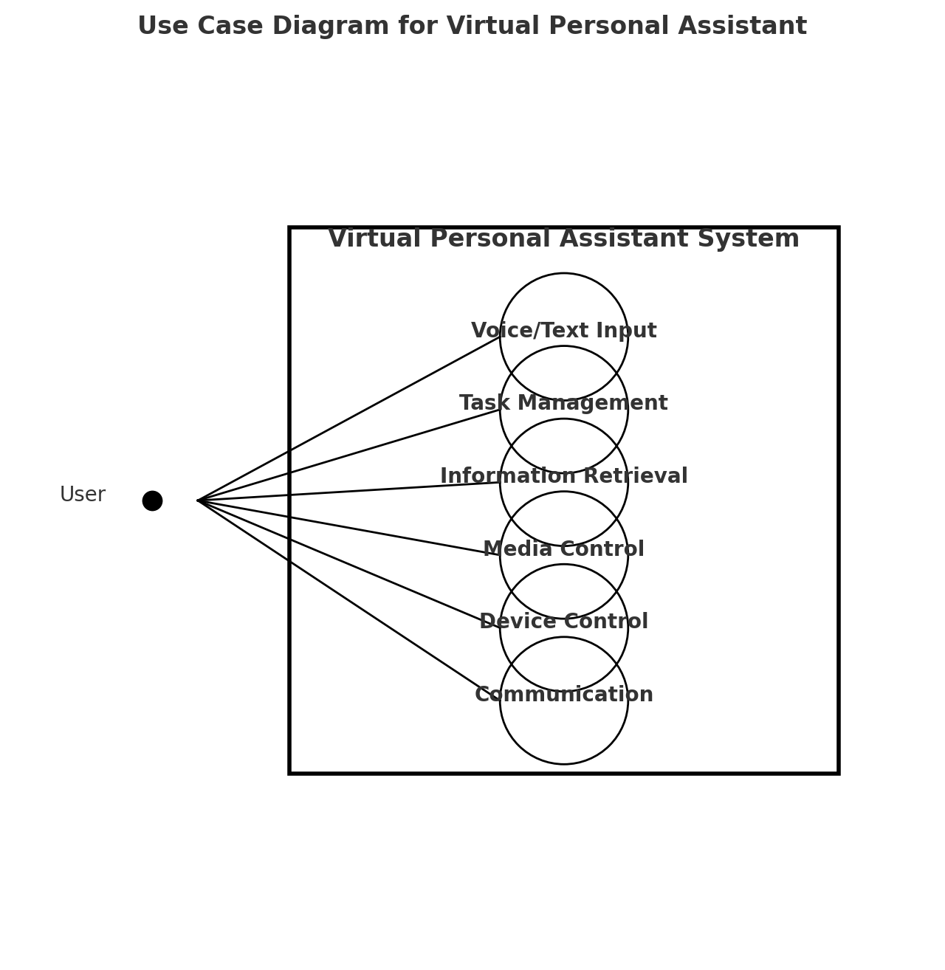

Conclusion
Virtual Personal Assistants (VPAs) have emerged as powerful tools that enhance human-computer interaction by enabling users to perform tasks using natural language commands, either through voice or text. These intelligent systems are designed to simplify daily activities such as setting reminders, managing tasks, retrieving information, controlling devices, and handling communication—all in a hands-free and efficient manner. By integrating technologies like Natural Language Processing (NLP), Speech Recognition, Machine Learning, and cloud-based services, VPAs offer a personalized and responsive user experience.
Their growing popularity reflects the increasing demand for convenience, accessibility, and smart automation in both personal and professional settings. VPAs not only save time but also improve productivity by reducing the need for manual input. As the technology continues to evolve, these assistants are becoming more adaptive and intuitive, capable of learning user behavior and preferences over time.
In conclusion, Virtual Personal Assistants represent a significant step toward intelligent and context-aware computing. They are transforming how users interact with digital systems, making technology more accessible, especially for those with limited mobility or busy schedules. As innovation progresses, VPAs are expected to play an even more central role in our daily lives, seamlessly integrating with smart environments and contributing to a more connected and efficient future.

