Task 1: Basic Logic Gates and Half Adder using Logisim
Name: Gouri Yadravi
Department: Electronics Engineering (VLSI Design & Technology)
Semester: 7th Semester
College: KLE Technological University, Hubballi

AIM:
To design and simulate the basic logic gates (AND, OR, NOT, NAND, NOR, XOR) and Half Adder using Logisim software and verify their outputs using truth tables.

Software Used
- Logisim
- Java Runtime Environment (JRE)
- Windows Operating System

VLSI Design Flow
VLSI (Very Large Scale Integration) design flow is the process of designing an integrated circuit from specification to fabrication.
Steps of VLSI Design Flow
- Specification
  - Define the circuit requirements and functionality.
- Architecture Design
  - Decide the overall structure of the digital circuit.
- RTL Design
  - Write the hardware description using Verilog or VHDL.
- Functional Simulation
  - Verify the logic using simulation tools such as Logisim.
- Logic Synthesis
  - Convert RTL code into gate-level netlist.
- Physical Design
  - Perform floorplanning, placement, and routing.
- Verification
  - Check timing, functionality, and power.
- Fabrication
  - Manufacture the integrated circuit.
- Testing
  - Test the fabricated chip for correct operation.

TRUTH TABLE:

AND Gate
A | B | OUTPUT
0 | 0 | 0
0 | 1 | 0
1 | 0 | 0
1 | 1 | 1

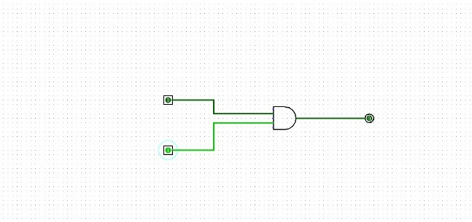
OR GATE
A | B | OUTPUT
0 | 0 | 0
0 | 1 | 1
1 | 0 | 1
1 | 1 | 0

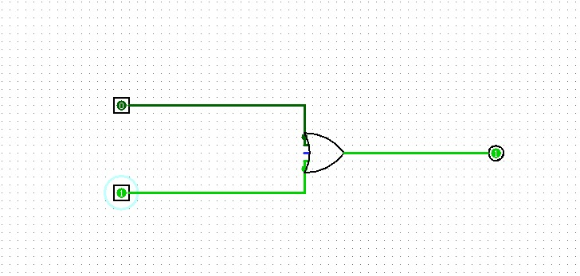

NOR GATE
A | B | OUTPUT
0 | 0 | 1
0 | 1 | 0
1 | 0 | 0
1 | 1 | 1

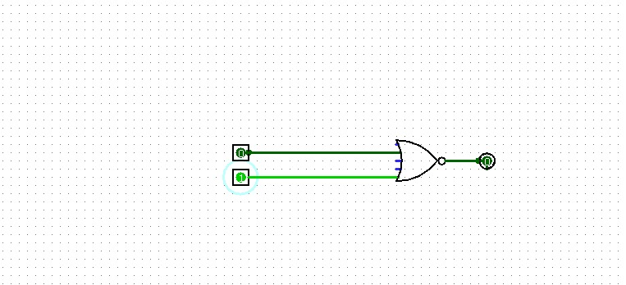

NOT GATE
A | OUTPUT
1 | 0
0 | 1

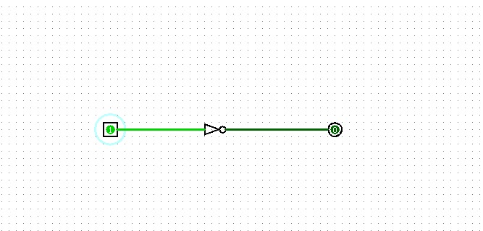

NAND GATE

A | B | OUTPUT
0 | 0 | 1
0 | 1 | 1
1 | 0 | 1
0 | 1 | 0

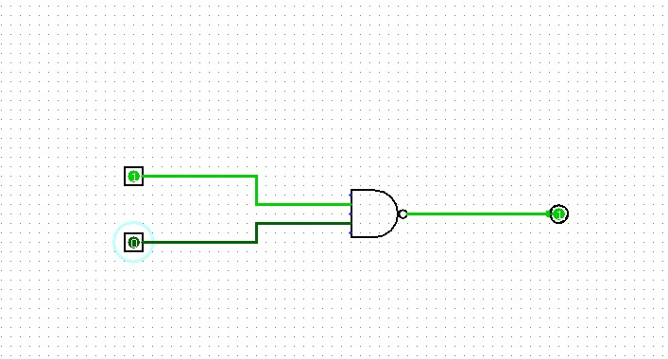

XOR GATE
A | B | OUTPUT
0 | 0 | 0
0 | 1 | 1
1 | 0 | 1
0 | 1 | 0

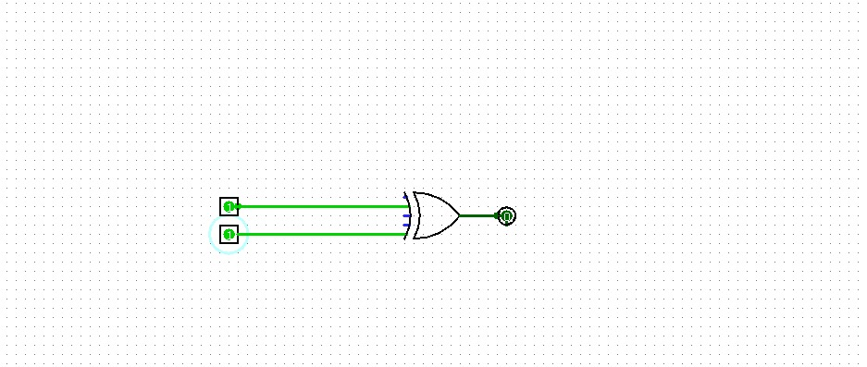

XNOR GATE

A | B | OUTPUT
0 | 0 | 1
0 | 1 | 0
1 | 0 | 0
0 | 1 | 1

HALF ADDER
SUM = A XOR B
CARRY = A AND B
TRUTH TABLE
A | B | SUM | CARRRY
0 | 0 | 0 | 0
0 | 1 | 1 | 0
1 | 0 | 1 | 0
1 | 1 | 0 | 1

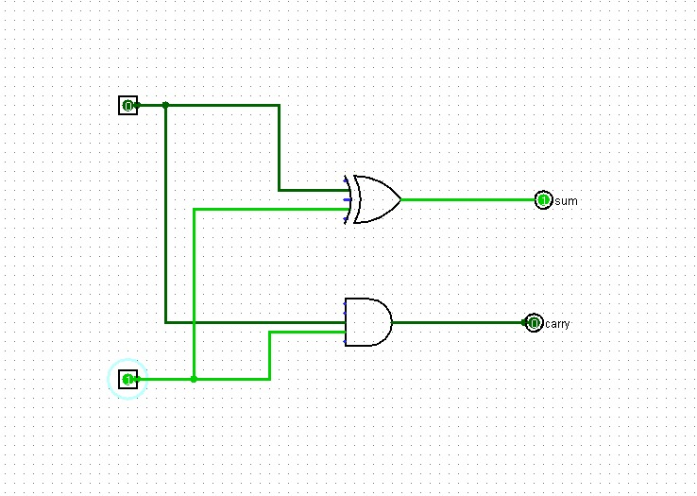

FULL ADDER
SUM = A XOR B XOR Cin
Cout = (A AND B) OR (Cin AND (A XOR B ))
TRUTH TABLE
A | B | Cin | SUM | Cout
0 | 0 | 0 | 0 | 0
0 | 0 | 1 | 1 | 0
0 | 1 | 0 | 1 | 0
0 | 1 | 1 | 0 | 1
1 | 0 | 0 | 1 | 0
1 | 0 | 1 | 0 | 1
1 | 1 | 0 | 0 | 1
1 | 1 | 1 | 1 | 1

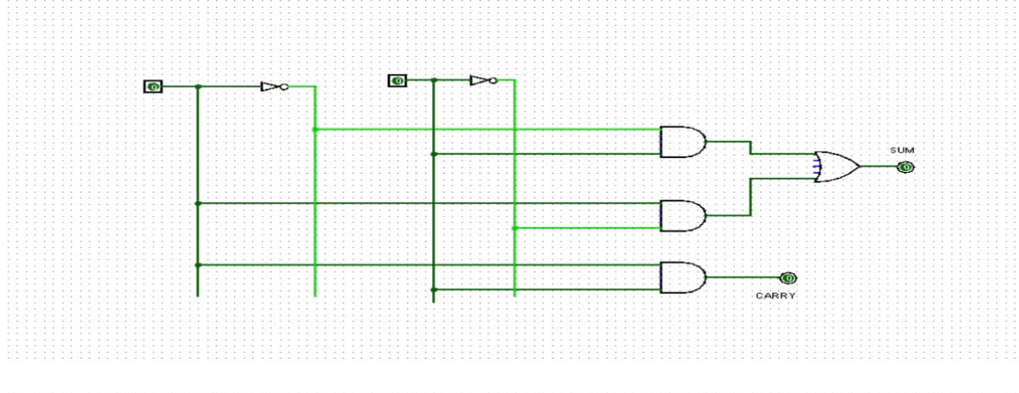

Software Used : Logism

Observations
- All logic gates were successfully implemented using Logisim.
- The outputs matched the expected truth tables.
- The Half Adder correctly generated the Sum and Carry outputs.
- Logisim is useful for understanding and verifying digital logic circuits before hardware implementation.

