program 1: create the project and classes as defined in the structure
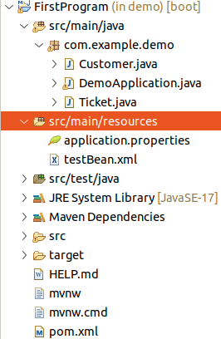

Creation of the Bean:  package com.example.demo;  public class Customer {  String name, address;  Ticket tick;  public Ticket getTick() {  return tick;  }  public void setTick(Ticket tick) {  this.tick = tick;  }  public String getName() {  return name;  }  public void setName(String name) {  this.name = name;  }  public String getAddress() {  return address;  }  public void setAddress(String address) {  this.address = address;  }  } | Ticket Bean class:  package com.example.demo;  public class Ticket {  int ticno,price,seatno;  String ticktype;  public int getTicno() {  return ticno;  }  public void setTicno(int ticno) {  this.ticno = ticno;  }  public int getPrice() {  return price;  }  public void setPrice(int price) {  this.price = price;  }  public int getSeatno() {  return seatno;  }  public void setSeatno(int seatno) {  this.seatno = seatno;  }  public String getTicktype() {  return ticktype;  }  public void setTicktype(String ticktype) {  this.ticktype = ticktype;  }  }

Demo or Main Class:
package com.example.demo;
//imports

@SpringBootApplication
public class DemoApplication {

public static void main(String[] args) {
Scanner sc = new Scanner(System.in);
SpringApplication.run(DemoApplication.class, args);
ApplicationContext ac = new ClassPathXmlApplicationContext("testBean.xml");
Customer c = (Customer) ac.getBean("customer");
Ticket t = (Ticket) c.getTick();
while(true) {
System.out.println("1. insert the details\n 2. Display details \n"
+ "3. exit");
System.out.println("enter the choice");
int a = sc.nextInt();
switch(a) {
case 1:
System.out.println("enter the customer name");
c.setName(sc.next());
System.out.println("enter the customer address");
c.setAddress(sc.next());
System.out.println("enter the ticket number");
t.setTicno(sc.nextInt());
System.out.println("enter the ticket seat no");
t.setSeatno(sc.nextInt());
System.out.println("enter the ticket price");
t.setPrice(sc.nextInt());
System.out.println("enter the ticket Type - economic/gold/platinum");
t.setTicktype(sc.next());
c.setTick(t);
System.out.println("thanks for input");
break;
case 2:
System.out.println("Customer Details:");
System.out.println("Name:"+c.getName()+" "+" Address:"+c.getAddress());
System.out.println("Ticket Details");
t = c.getTick();
System.out.println("Ticket No: "+t.getTicno());
System.out.println("Ticket Type: "+t.getTicktype());
System.out.println("Ticket Seat No: "+t.getSeatno());
System.out.println("Ticket Price: "+t.getPrice());
break;
case 3:
System.exit(0);
}
}
}
}

TeamBean.xml

<?xml version="1.0" encoding="UTF-8"?>
<beans xmlns="http://www.springframework.org/schema/beans"
xmlns:xsi="http://www.w3.org/2001/XMLSchema-instance"
xsi:schemaLocation="http://www.springframework.org/schema/beans
https://www.springframework.org/schema/beans/spring-beans.xsd">

<bean id="customer"
class="com.example.demo.Customer"
scope="prototype">
<property name="tick" ref="ticket"></property>
</bean>

<bean id="ticket" class="com.example.demo.Ticket" scope="prototype"/>
</beans>

--------------------------------end of the program---------------------------------------------------------------

