Trigger function => 5

Trigger => 5

Total function => 15(5 + 10)

Important(complex) function => 10

Non-important(normal) function => 5 (for reducing redundant query)

Procedure => 3

Total query => 50+

Advance query => 30+

Complex query => 17+

Functions

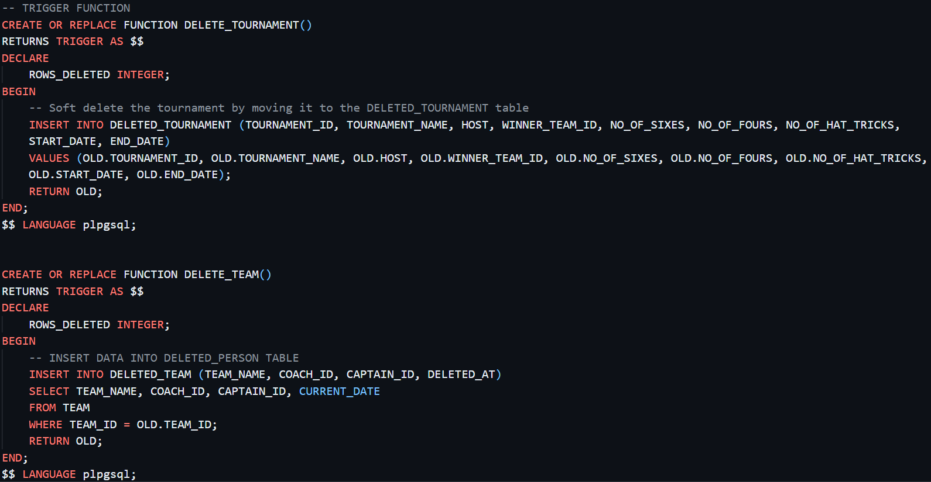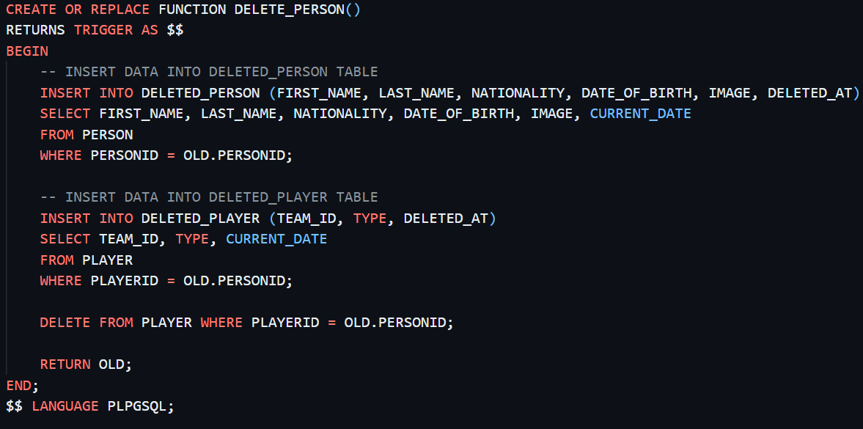

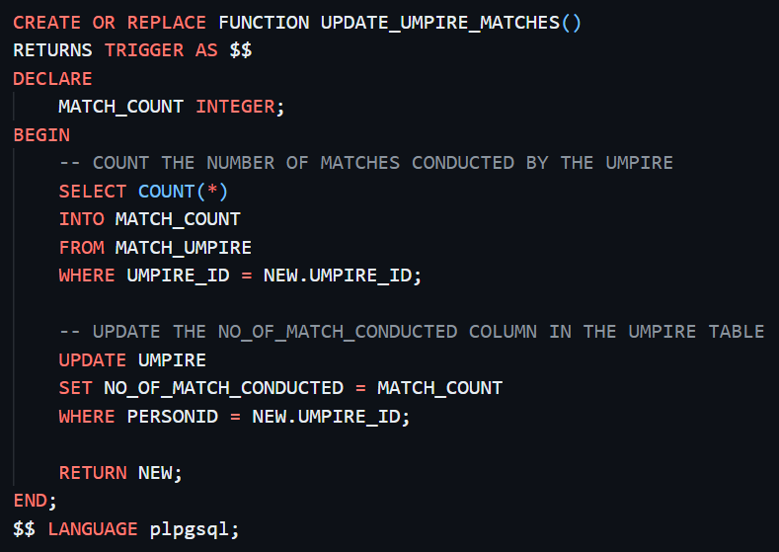

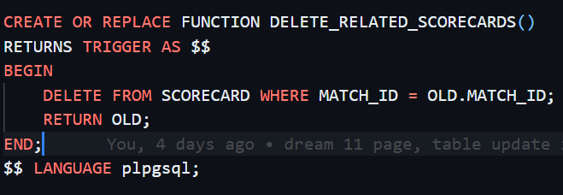

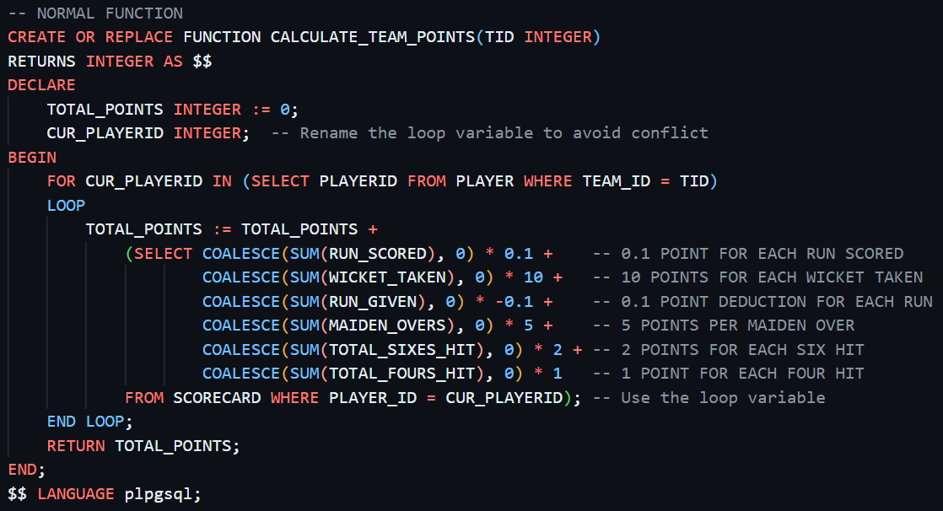

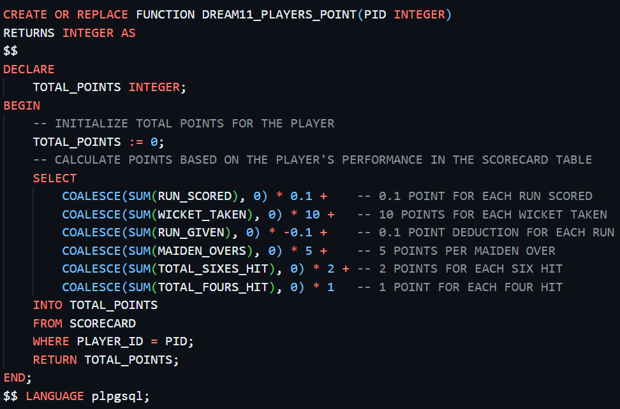

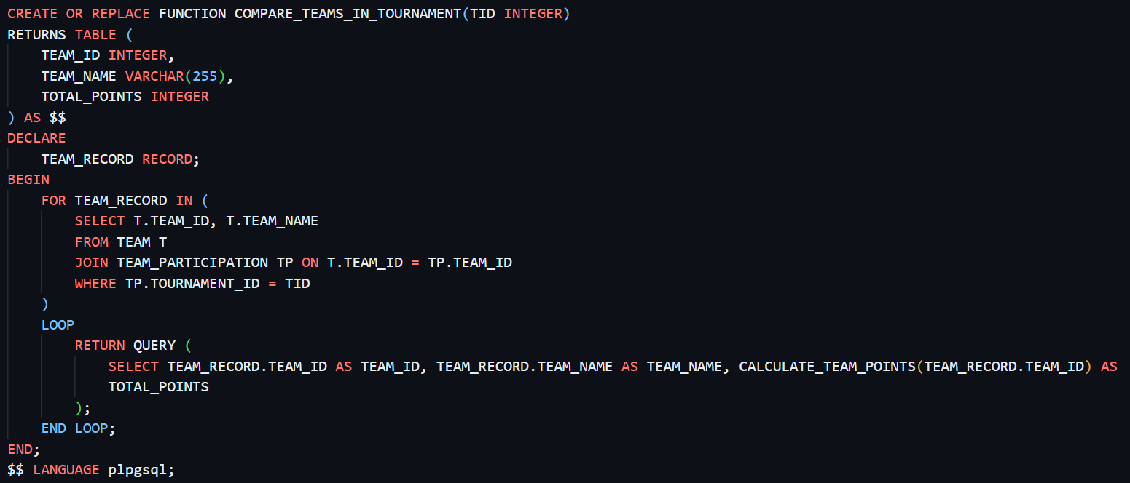

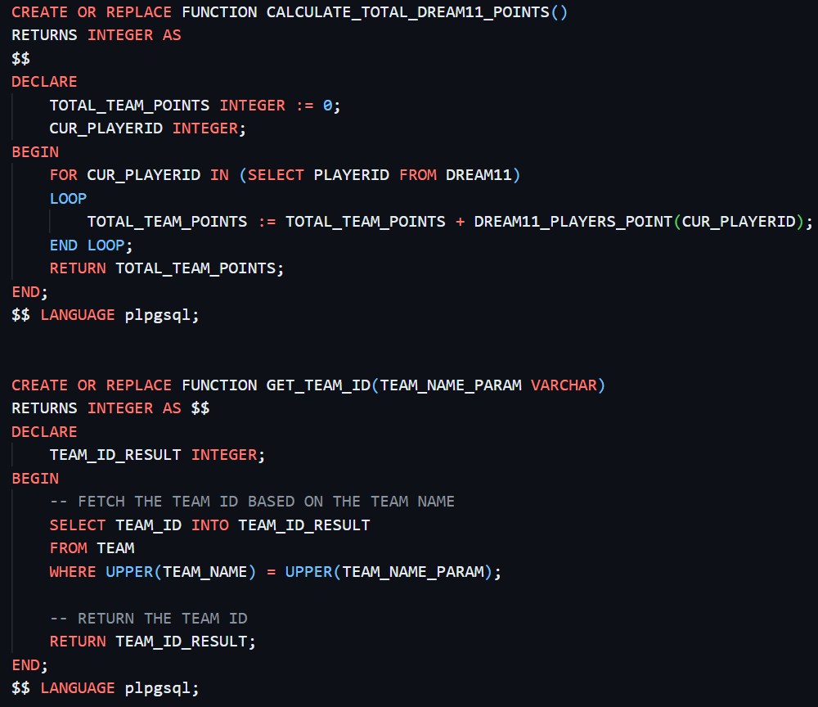

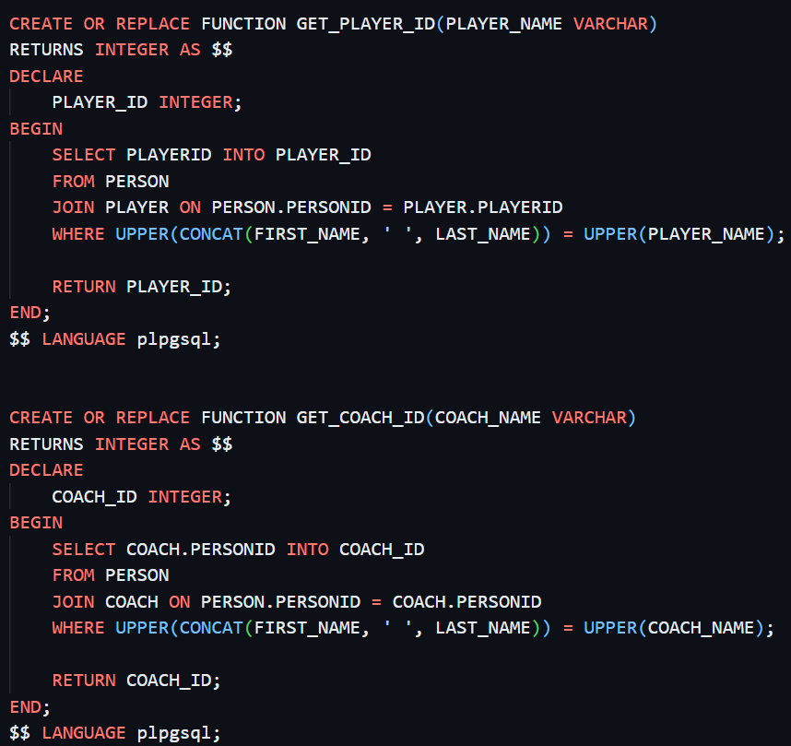

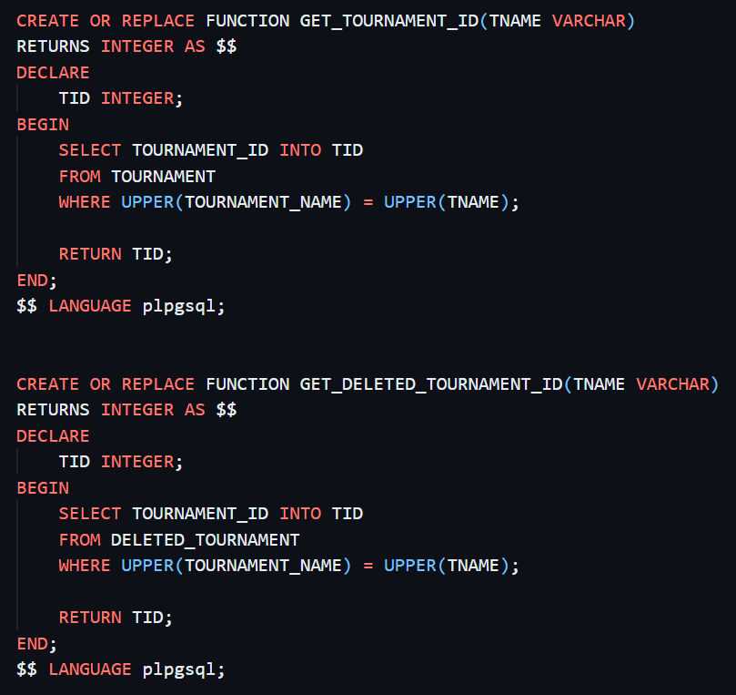

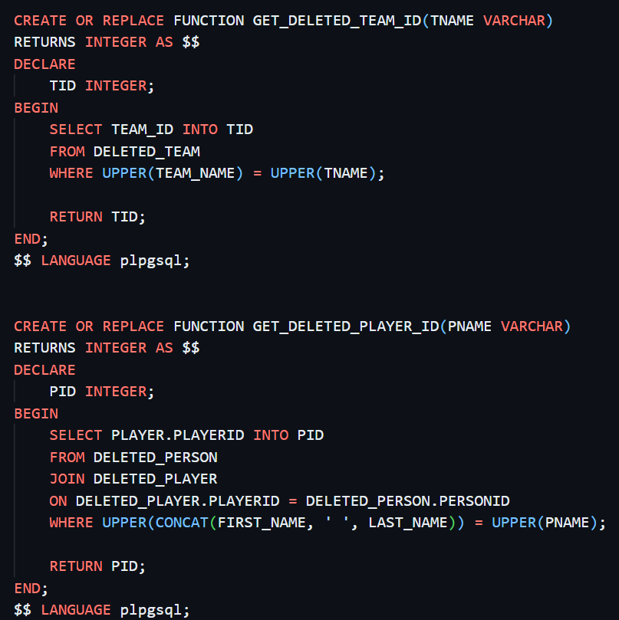

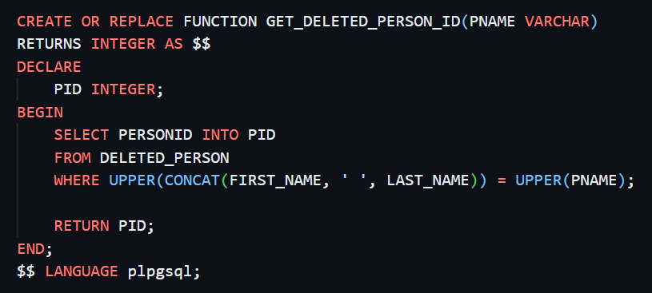

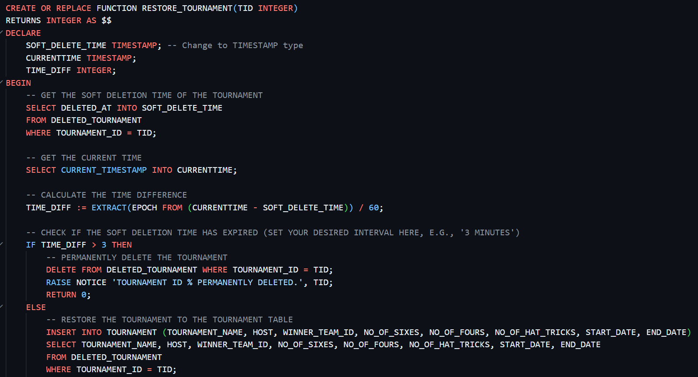

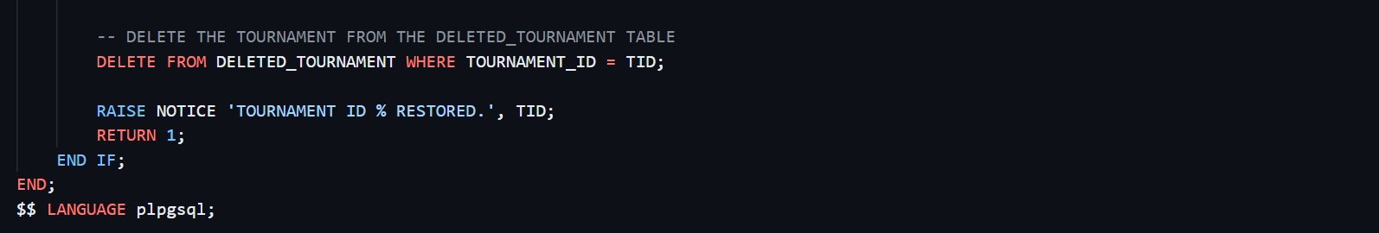

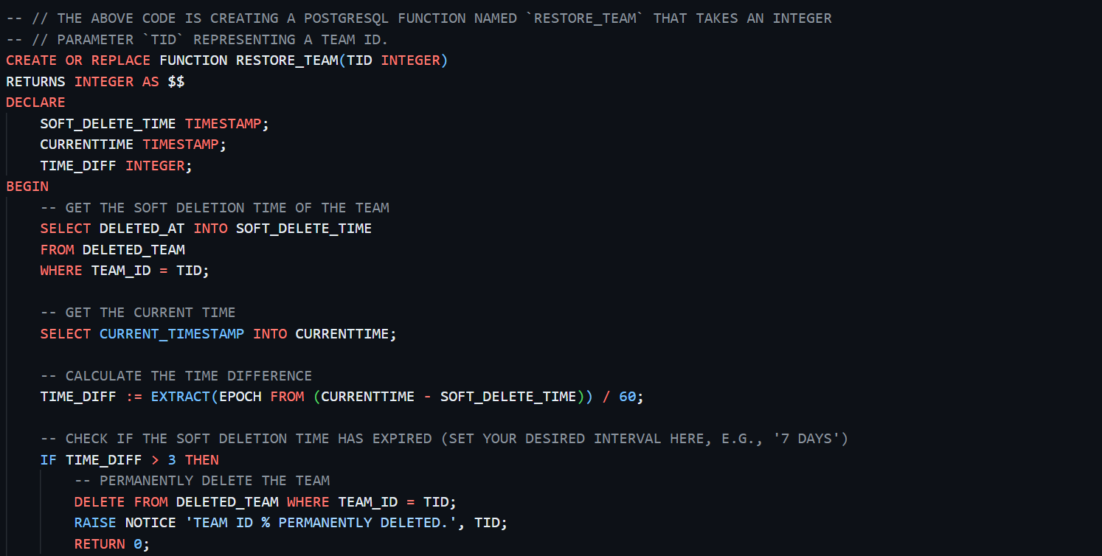

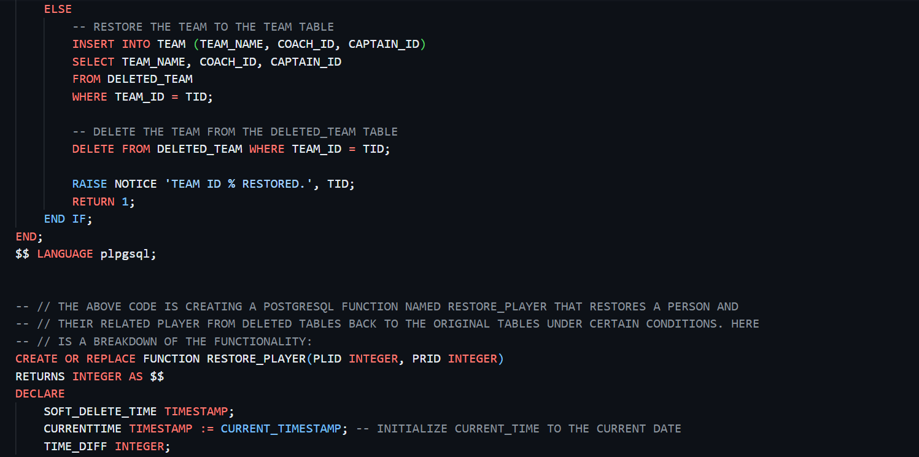

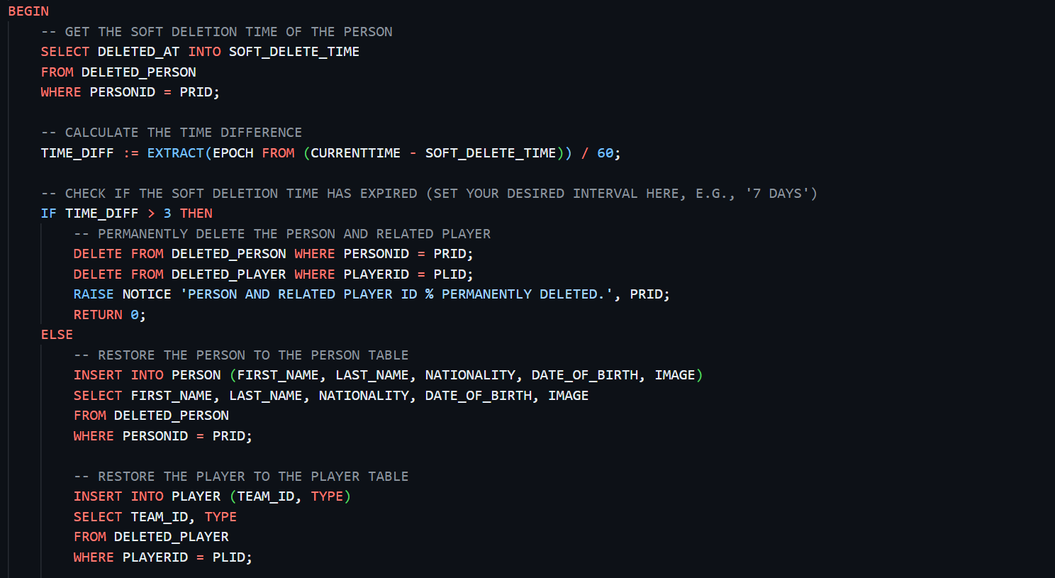

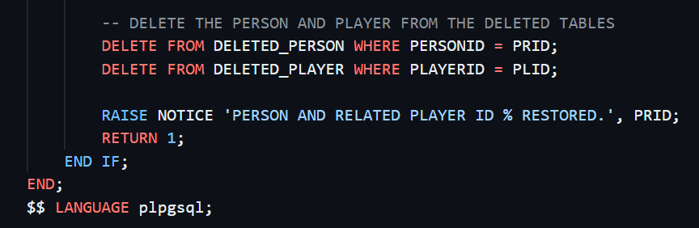

Procedures

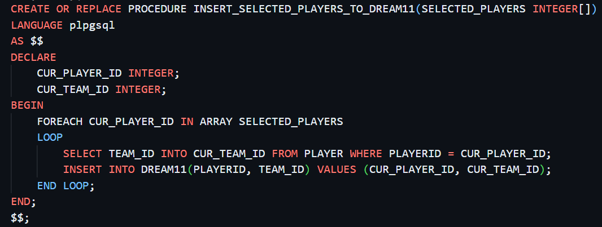

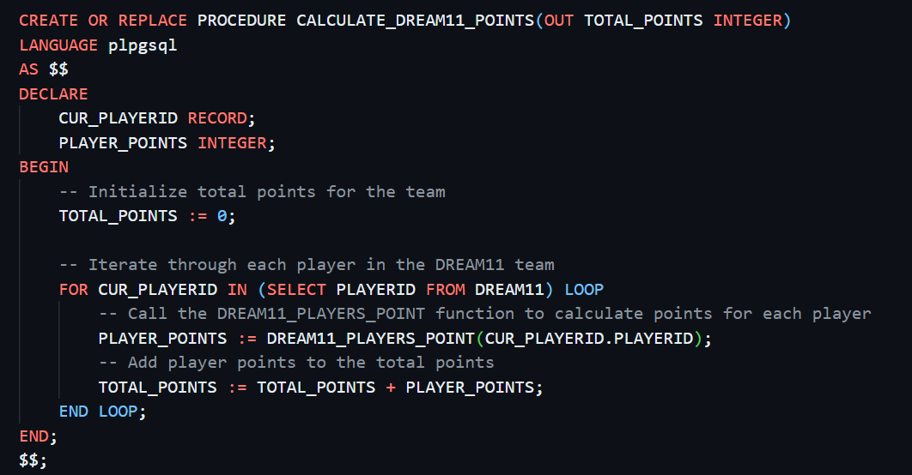

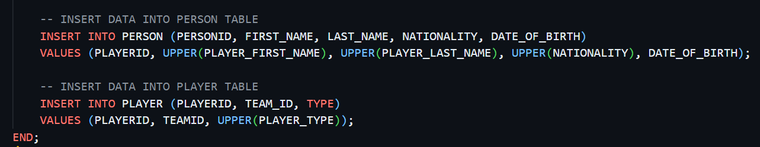

Triggers

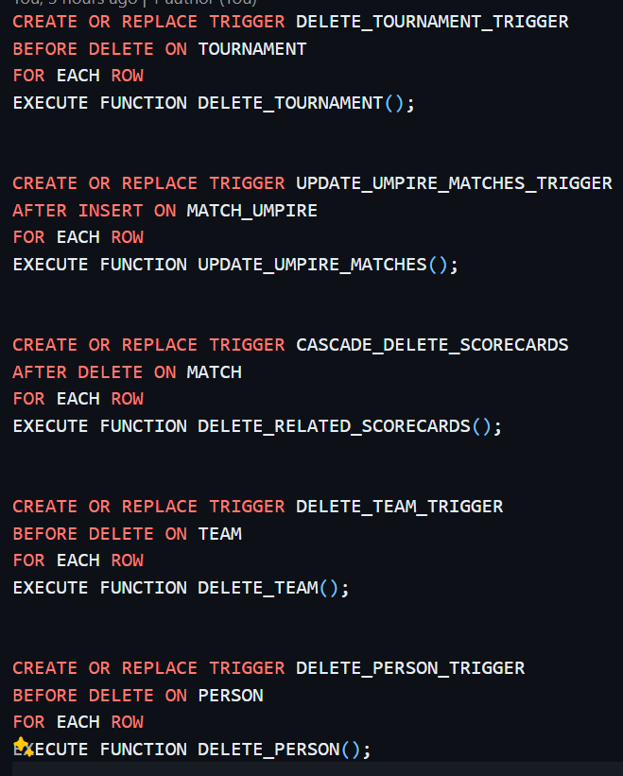

Project Summery

Cricket Legue

Our cricket management system aims to streamline the management of cricket tournaments, teams, players, and matches. The system provides functionalities for creating, updating, and deleting tournaments, teams, and players, as well as recording match results and player statistics. Key features include:

1. **Tournament Management**: Users can create, edit, and delete cricket tournaments, specifying details such as tournament name, host, start and end dates, and participating teams.
2. **Team Management**: Teams can be created, edited, and deleted, with information such as team name, coach, and roster of players.
3. **Player Management**: Players can be managed within teams, with details including player name, date of birth, nationality, and player type (e.g., batsman, bowler, all-rounder).
4. **Match Management**: Matches between teams are recorded, with features for inputting match details, including venue, date, participating teams, and match outcome.
5. **Player Statistics**: The system tracks player statistics such as runs scored, wickets taken, and catches, providing insights into player performance throughout the tournament.
6. **Soft Deletion and Restoration**: Soft deletion functionality allows users to delete tournaments, teams, and players temporarily, with the option to restore them if needed within a specified timeframe.
7. **User Interface**: The system features a user-friendly interface for easy navigation and management of cricket-related data. Users can interact with the system through a web-based application.
8. **Admin Interface**: Admin can add or delete any tournament, team or player. Also admin can restores data from the database as after deletion of any data will be softly deleted. Admin can see over the website so that he can change anything or debug any bug.