* The development of vehicle electrics and electronics plays an important role in the planning of vehicles, different model series or different vehicle variants.
* Main parts of the vehicle electrics and electronics are control units and their interconnectedness, for which several technologies are available (and used).
* XDIS provides a uniform view on all of these technologies and processes them uniformly.
* A bus is a wired path(hardware component) to transmit data between multiple points.
* CAN(controlled area network) bus speed 1Mbit/s , frame size 8 bytes
* The CAN bus is a broadcast type of bus.
* Can fd advanced verison of can . supports frames longer than 8 bytes
* LiN bus(local interconnect Network), used for interconnection of ecu.
* Lin is slower than CAN
* . The LIN bus is a “recipient selective” system, i.e. principally a message can be read by every control unit. The control unit decides whether it is interested in receiving the message.
* Flexray, faster than can and lin. Speed of 10Mbits/s
* **Ethernet** is a bus system which is even significantly faster than FlexRay: 100 MBit/s.
* **Ethernet inside car is a adjusted variant : automotive Ethernet**
* The switches in Ethernet allow the creation of something like subnets called VLANs (Virtual LANs
* The configuration of the switches controls that data sent on a certain VLAN is only tranferred to ECUs which belong to this VLAN.
* so that communication of certain data does not reach all ECUs within a network.
* While in other bus systems the sender doesn't know the receiver (all ECUs on the network are receiving the data and from IDs or slots know whether the data is relevant for them), in Ethernet the sender needs to know the receiver and use the receiver's IP address to send the data
* The MOST bus (Media Oriented Systems Transport) is a serial bus for transferring audio, video, language and data signals via optic fibre. MOST is used for the transfer of multi-media data in vehicle
* 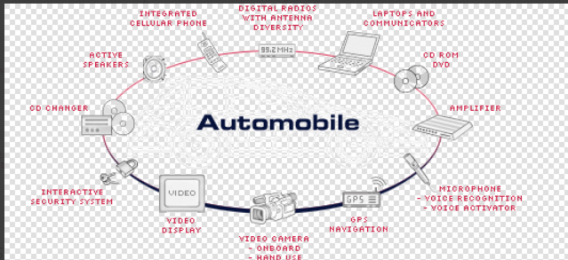
* **Networking Project**
* The Networks of one vehicle are united in a **Networking Project**.
* Consists of multiple NETWORKS made up of different buses

It is described by

* A Release Date Type (e.g. start of series)
* A Body Variant (e.g. Coupé, Sedan (German: Limousine), Station wagon (German: Kombi), Convertible (German: Cabrio)).
* A Model Series (e.g. 204 (= C class), 221 (= S class of 2008), 222 (= S class of 2013))

To a Networking Project are assigned

* ECU Communications
* ECU Interfaces (ECU Ifcs)
* Networks

### They can be assigned repeatedly, e.g. the same ECU Communication

### Networking Platform

Several Networking Projects which share a lot of similarities are combined in one **Networking Platform**. Examples: Smart, VAN.