Product Design
Team | 32 ( Gaurav Mittal, Goutam Nair, Apaar Garg, Anurag Gupta, Saksham Aggarwal )

Architectural Model
Register Component | Component State:  - Register new administrator and users. This stores the information of all the employees of a new startup, there allocated seats, joining dates, etc.  Component behavior  - Saves the data in the database.
Space Addition Component | Component state:  - Create new co-working spaces and rooms and store their information.  Component behavior:  - Saves the information in the database.
Database Component | Component state:  - Maintained to keep the list of users, desks allocated to them, resources scheduled, events organized, invoices generated.  Component behavior  - Database for the administrator's as well as the users’ reference.

Class Diagram(s)

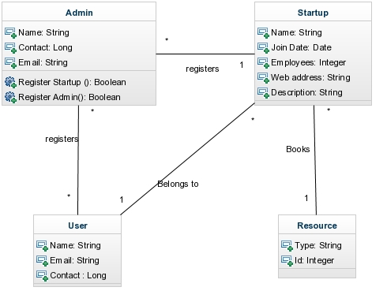

Sequence Diagram(s)

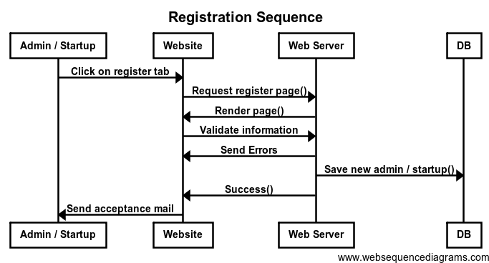

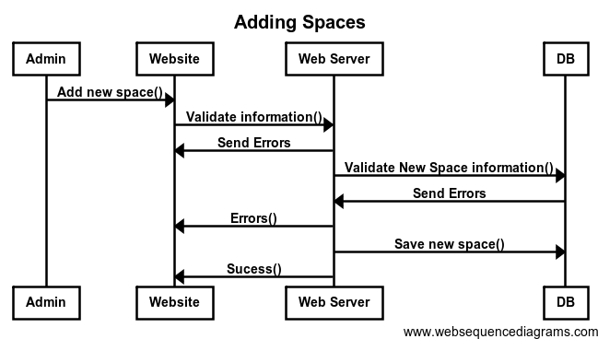

Design Rationale

The Problems initially faced by the team was that everybody was new to the technology being addressed to. So measures were taken to substantially break down work for different members of the team so as to give a more productive output.
In the initial stages it was more focused towards the startup and the functionalities the users of the startup could access, then the focus shifted to the administrator and his functionalities.

